VisaReady™
Customer Application
Predict. Prepare. Travel with Confidence.

Product Requirements Document

Platform | iOS, Android & WhatsApp
Phase | MVP
Version | v5.0
Status | Final — For Client Approval
Audience | Customer Application
Powered by | Tech2Go
Date | 29 June 2026

Contents
1. Product Overview
2. User Types & Journeys
3. WhatsApp Referral Flow
4. Screen Specifications
4.1 Splash
4.2 Onboarding
4.3 Login & Sign Up
4.4 Terms of Use & Consent
4.5 Home Dashboard
4.6 Profile
4.6.1 Edit Profile
4.6.2 Notification Settings
4.6.3 Privacy Settings
4.6.4 Personal Information
4.6.5 Passport Information
4.6.6 Address Information
4.6.7 Travel Preferences
4.6.8 Plan
4.6.9 Support
4.6.10 Logout
4.7 Passport (Application Step 1)
4.7a Co-Applicant / Family Management
4.8 Country, Visa & Trip Details (Step 2)
4.9 Applicant Details (Step 3)
4.10 Financial Profile (Step 4)
4.11 Travel History (Step 5)
4.12 Home Ties (Step 6)
4.13 Agency Code & VisaScore™ Lite
4.14 Document Checklist & Upload
4.15 Payment
4.16 Final Score & VisaMatrix™ Report
4.16a Score Improvement
4.17 My Applications & Conclusion
4.18 Reports
4.19 Library
4.20 Automatic Flags & Warnings
4.21 Field Validation
5. Business Rules
6. Integrations & Compliance
7. Client Inputs Required & Open Questions
Appendix B — Admin Portal & Agency Portal Dependencies

1. Product Overview
VisaReady is an AI-powered visa readiness platform that helps travellers understand and improve their visa eligibility before they apply. The customer application guides each user through a structured assessment, produces an indicative readiness score (VisaScore™ Lite), supports document upload and verification, and delivers a comprehensive readiness report (VisaMatrix™) with clear, personalised recommendations.

1.1 The Experience
- Assess — A guided self-declaration covering passport, destination, profile, finances, travel history and home ties.
- Score — An instant VisaScore™ Lite indicative result showing Low / Medium / High likelihood.
- Verify — Document upload with OCR and integrity checks for a verified, decision-grade assessment.
- Report — A multi-page VisaMatrix™ readiness report, shareable by WhatsApp, email, link or PDF.
- Refer — Agents can onboard clients through a WhatsApp link; every application maps back to the agent.

1.2 Platform Context
Product | Audience | Role
Customer Application | Travellers / applicants | This document — the mobile app, WhatsApp experience, and the customer web app (full parallel web application with the same features as the mobile app).
Agency Dashboard | Travel agencies & consultants | Manage clients, credits and reports.
Super Admin Portal | VisaReady platform team | Configure scoring, countries, pricing and content.

2. User Types & Journeys

2.1 User Types
- New User — First-time visitor with no prior application.
- Returning User — Has saved or completed applications; resuming or starting fresh.
- Agency-Referred User — Arrived through an agent's WhatsApp link or agency code.
- Direct (B2C) User — Self-registered without an agency code.

2.2 End-to-End Journey
Step | Stage
1 | Splash — routes to onboarding or login based on session
2 | Onboarding — three slides; one is a “How VisaReady Works” flowchart (first-time users only)
3 | Login / Sign Up — First & Last name, then email or mobile OTP, or Google
4 | Terms & Conditions + Privacy Policy — accept after reading
5 | Home Dashboard — begin from ‘Start New Application’
6 | Step 1 — Passport (OCR; co-applicant scan + form when multi)
7 | Step 2 — Country & Visa (multi-select; Schengen footnote)
8 | Step 3 — Applicant Details (passport auto-fill; user-type routing)
9 | Step 4 — Financial Profile (incl. gross income / ITR range)
10 | Step 5 — Travel History (existing-visa capture)
11 | Step 6 — Home Ties (multi-select commitments)
12 | Agency Code (optional) → VisaScore™ Lite (Indicative)
13 | Document Checklist & Upload (intelligent organisation + flags)
14 | Payment (token consumption per plan)
15 | Final VisaScore™ & VisaMatrix™ Report
16 | Application tracking → Conclusion (outcome capture)

Note — After the indicative score, the applicant uploads documents and completes payment to unlock the verified score and full report. Two regenerations are free; the third onward is paid.

3. WhatsApp Referral Flow
Agents can invite clients to begin entirely within WhatsApp. The VisaReady bot guides the client through the assessment conversationally, then hands off to the web application for the score, documents and report. Every application is automatically attributed to the referring agent.

Step | Actor | Action
1 | Agent | In the Agency Dashboard, enters the client’s WhatsApp number; the system generates a unique link.
2 | Agent | Shares the link with the client over WhatsApp.
3 | Client | Taps the link; a chat opens with the VisaReady bot.
4 | Bot | Guides the client through the steps first 6(visa lite onea), confirming each answer and showing progress.
5 | Bot | On completion sends a deep link: ‘Tap to see your VisaScore™ Lite.’
6 | Client | Opens the web application (not asked to download the app); the agency code is pre-filled and the indicative score is shown and details mapped to the customer portal which he fills .
7 | System | Maps all captured detail to the agency, the application and Super Admin wherever needed; notifies the agent.

After the WhatsApp flow the user is redirected to the customer web application and can view the score there; they are not prompted to install the mobile app.

⚠ Client Input Required — WhatsApp Business API credentials and the bot conversation script (question set and replies).

4. Screen Specifications
All screens in this section apply to both the mobile app and the customer web app; the web app is a full parallel application with the same features.

4.1 Splash
01 | Splash

Purpose — First screen on launch; routes the user by session state.

Layout
- Brand logo (PNG) positioned at the top of the screen.
- Enlarged shield icon with a tick mark, reinforcing trust and readiness.
- Tagline ‘AI-Powered Visa Readiness Platform’ beneath the shield.
- ‘Powered by Tech2Go’ footnote at the bottom.
- Slim loading indicator.

Behaviour
- Valid session → Home Dashboard. No session → Onboarding (first-time) or Login (returning).
- On first run, applicant details are populated from the passport via OCR — no manual key-in of passport fields.

Element Detail — 4.1 Splash
Element Type | Element ID | Label | Type | M/O/C | Auto-Populate Source | Visible When | Enabled When | Validation / Precondition | On Click / On Change | Next / Result | Source (config) | Editable By | Error / Fallback | Dev Notes
Image | spl_logo | VisaReady logo | Image | — | — | Always | — | — | Auto-advance after asset load + session check | Home (valid session) / Onboarding (first) / Login | App asset | — | Retry on asset load failure | Max splash 2.5s; then route
Process | spl_session | Session check | Process | — | — | On launch | — | Valid JWT & not expired | Evaluate token, route | Home / Onboarding / Login | Auth service | — | No/expired session → Login/Onboarding | Check secure storage token; refresh if near expiry

Mockups (just ui reference may need to add element mention in req , or remove extra applied for all screens

4.2 Onboarding
02 | Onboarding Carousel

Purpose — Introduces the value of VisaReady to first-time users only.

Slides (three total)
- Know Your Chances — readiness scoring.
- How VisaReady Works — a simple flowchart slide (Fill Steps → Score → Upload Docs → Verified Report).
- Submit Smarter, Travel More — confident applications.

Navigation
- Dot indicators; ‘Next’ on the first two slides, ‘Get Started’ on the last. ‘Skip’ goes straight to Login.

Element Detail — 4.2 Onboarding
Element Type | Element ID | Label | Type | M/O/C | Auto-Populate Source | Visible When | Enabled When | Validation / Precondition | On Click / On Change | Next / Result | Source (config) | Editable By | Error / Fallback | Dev Notes
Carousel | onb_slides | Feature slides | Carousel | O | — | First launch only | — | — | Swipe / Next | Next slide → Login | Admin content | Admin (content) | Skip → Login | 3–4 slides; store 'seen' flag so shown once
Button | onb_skip | Skip / Get Started | Button | M | — | Always | Always | — | On click → Login | Login & Sign Up | App | — | — | Persist onboarding-complete flag

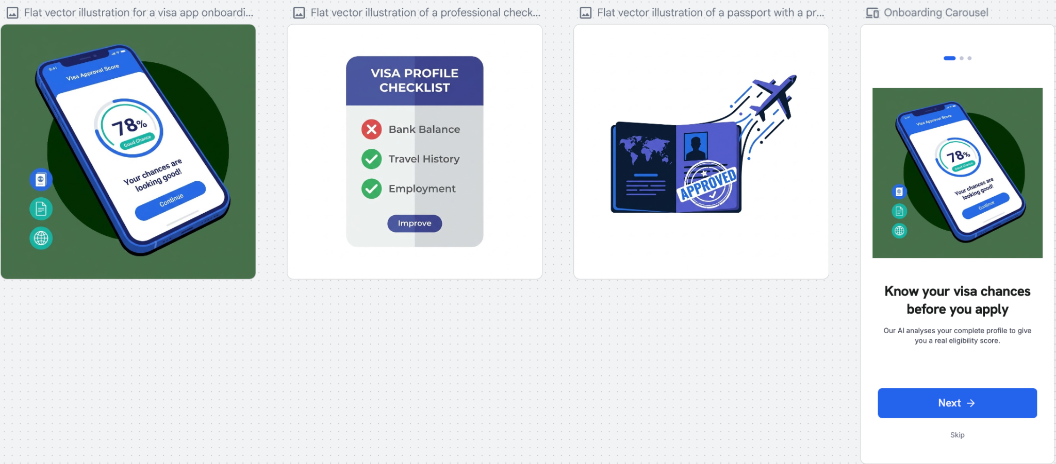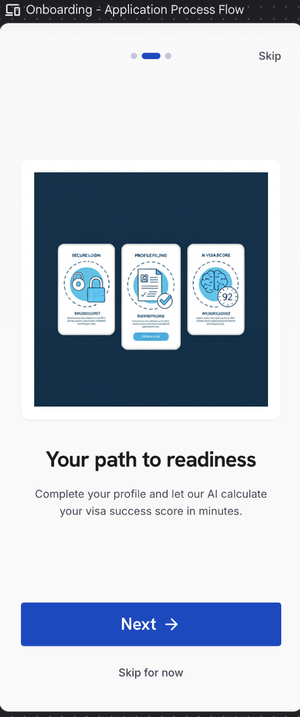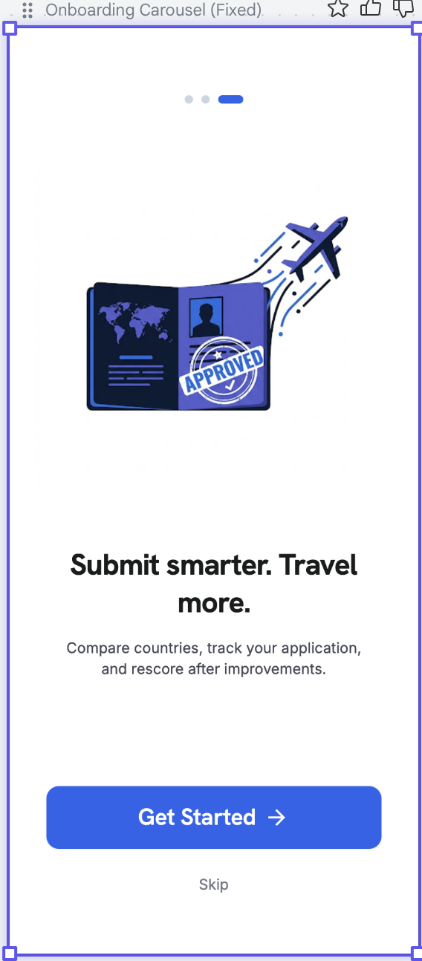

4.3 Login & Sign Up
03 | Login & Sign Up

Purpose — Authenticates users through OTP — no passwords.

Sign-In Options
- Email + 4-digit OTP (primary)
- Mobile number + 4-digit OTP
- Google Sign-In

Sign-Up Fields
- First Name (mandatory) and Last Name (optional).

Behaviour
- OTP screen: four digit fields, 30-second resend timer, up to three attempts, then account verification.
- On first sign-up, the user accepts the Terms of Use, Privacy Policy and Disclaimer via a single consent checkbox (see 4.4) before proceeding.

Element Detail — 4.3 Login & Sign Up
Element Type | Element ID | Label | Type | M/O/C | Auto-Populate Source | Visible When | Enabled When | Validation / Precondition | On Click / On Change | Next / Result | Source (config) | Editable By | Error / Fallback | Dev Notes
Input | log_email | Email | Email | C | From Google profile if Google path | Email path chosen | Always | Valid email; unique; OTP-verified | On submit send 4-digit OTP | OTP entry | User | User | Invalid format inline error | Rate-limit OTP sends
Input | log_mobile | Mobile number | Phone | C | — | Mobile path chosen | Always | Country code + 10 digits; OTP-verified | On submit send OTP | OTP entry | User | User | Invalid number inline error | E.164 storage
Button | log_google | Google Sign-In | OAuth | O | — | Always | Always | Google account auth | Launch Google OAuth | Home / Terms (first time) | Google | — | OAuth fail → retry | Pull name+email to prefill sign-up
Input | log_first | First name | Text | M | Google profile / passport OCR (later) | Sign-up | Always | Letters/spaces/hyphen; ≥ 2 chars | On change validate | — | User / Google | User | Required error if empty | Prefill from Google given_name
Input | log_last | Last name | Text | O | Google profile | Sign-up | Always | Letters/spaces/hyphen | On change validate | — | User / Google | User | — | Prefill from Google family_name
Input | log_otp | OTP | Numeric | M | — | After OTP sent | After send | 4 digits; 30s resend; max 3 attempts then verify block | Verify OTP | Terms (first) / Home | Auth service | — | Wrong OTP → attempts remaining; lock after 3 | Server-side OTP validation & attempt counter

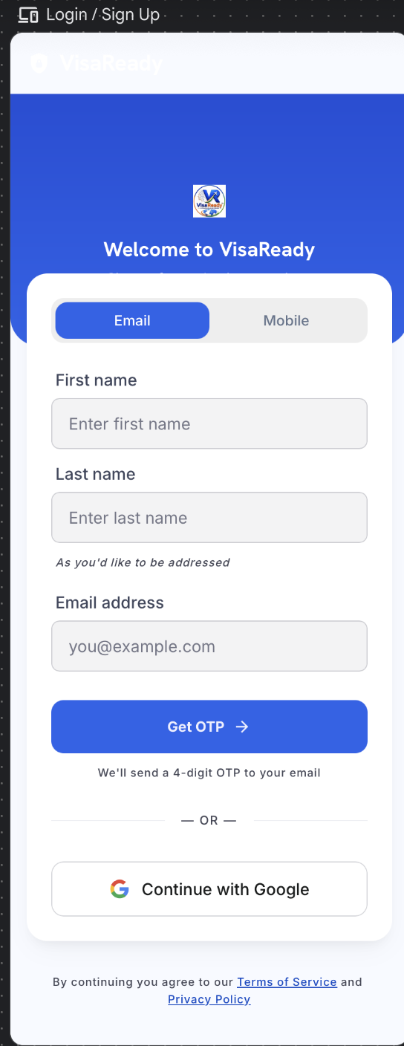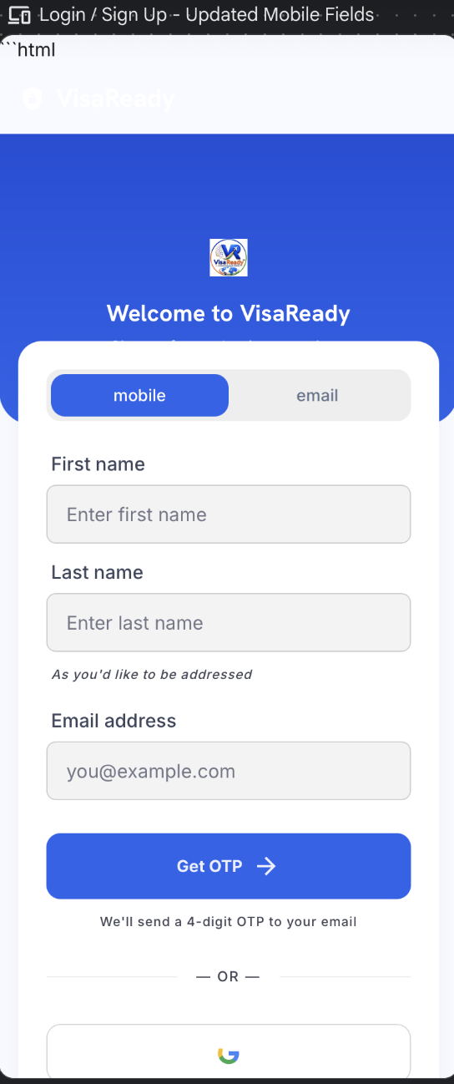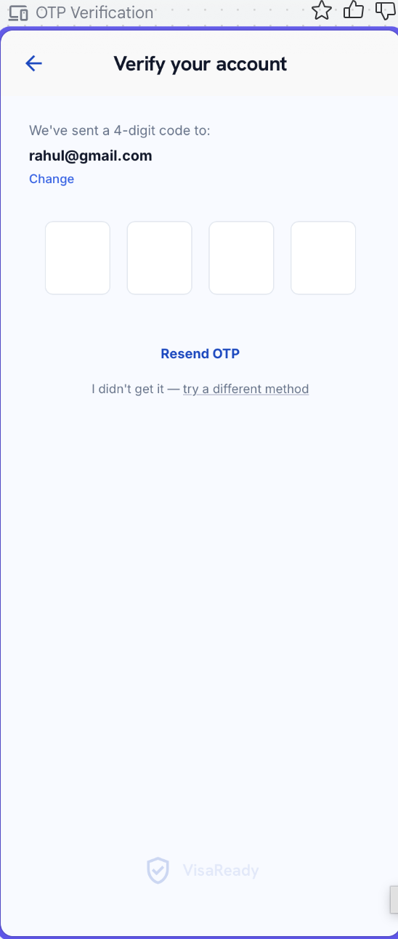

4.4 Terms of Use, Consent & Disclaimer
04 | Terms of Use & Consent

Purpose — Captures informed consent before any data is processed. Presented after sign-up and linked from Profile › Privacy.

Terms of Use (confirmed copy)
- Accurate Information — Users must provide accurate, complete and truthful information. VisaReady relies on submitted details to generate reliable AI-powered visa readiness assessments and recommendations.
- Service Disclaimer — VisaReady provides predictive guidance, document assistance and preparedness insights only. It does not offer legal advice or guarantee visa approvals, appointments or outcomes.
- User Responsibilities — Users must review all recommendations before submission. Fraudulent documents, false information or misuse of the platform may result in account suspension or termination.
- Acceptance of Terms — By accessing or using VisaReady, the user confirms acceptance of these Terms of Use, the Privacy Policy and all applicable platform policies.

Consent Checkbox (required to proceed)
☑ CONSENT — “I have read and agree to the Terms of Use, Privacy Policy and Disclaimer. I understand that VisaReady provides predictive guidance only and does not guarantee visa approval.”

Behaviour & Validation
- The full policy is scrollable; ‘Accept & Continue’ activates only after the user scrolls to the end and ticks the consent checkbox. Permissions (camera, storage, notifications) are requested in context.
- Acceptance is timestamped and stored against the user record (consent log) for compliance (DPDPA).

⚠ Client Input Required — Final Terms of Use, Privacy Policy and Disclaimer copy (the wording above is the client-approved draft).

Element Detail — 4.4 Terms of Use, Consent & Disclaimer
Element Type | Element ID | Label | Type | M/O/C | Auto-Populate Source | Visible When | Enabled When | Validation / Precondition | On Click / On Change | Next / Result | Source (config) | Editable By | Error / Fallback | Dev Notes
Rich text | tou_policy | Terms / Privacy / Disclaimer | Rich text | — | — | After sign-up; Profile › Privacy | — | Scroll-to-end tracked before enabling Accept | Track scroll position | — | Admin — Legal CMS (AD-64) | Admin | — | Version each doc; store version accepted
Checkbox | tou_consent | Consent checkbox | Checkbox | M | — | Always | After full scroll | Must be ticked | On tick enable Accept | — | User | User | Cannot proceed until ticked | —
Button | tou_accept | Accept & Continue | Button | M | — | Always | After scroll + tick | Writes consent log (user, version, timestamp) — DPDPA | On click store consent | Home Dashboard | App | — | Blocked until enabled | Re-prompt if legal version changes
Prompt | tou_perm | Runtime permissions | System prompt | C | — | In context (camera/storage/notif) | — | OS-level permission | Request when feature used | — | OS | — | Denied → feature-specific fallback | Ask at point-of-use, not upfront

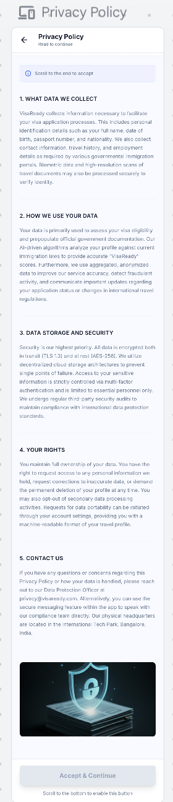

4.5 Home Dashboard
05 | Home Dashboard

Purpose — The user’s home base for starting and resuming applications.

Header
- VisaReady branding on the left; notification bell and profile icon on the right.
- The score is shown consistently across screens on the 0–100 scale. The Home Dashboard "Preliminary Eligibility Score" is the indicative (Lite) read; Score Improvement operates on the application's fuller score. Display format (with "%") is standardised across both.

New User
- Greeting ‘Hi [First Name]’; application overview showing the steps; primary action ‘Start New Application’.
- Trust line reads ‘Protected — your data is encrypted.’

Returning User
- Active application cards with ‘Continue’ and current step; quick actions(start application view reports); current score with ‘View Improvement Score’.,Visa Readiness card — shows the preliminary eligibility score with a readiness label (e.g. "Needs Improvement") and an Improve Score button that opens Score Improvement (4.16a).

Bottom Navigation
- Home · My Applications · Reports · Library · Profile

Co-Applicant
- When the user selects multi-applicant / co-applicant, they can scan each co-applicant’s passport and complete a separate form for each — opened after the primary applicant’s form is done.
- Scoring is calculated for the primary applicant only. An ⓘ info icon next to the score notifies the user of this. Tapping reveals: ‘The VisaScore reflects the primary applicant’s profile. Co-applicants are captured for the application record but are not individually scored.’

Element Detail — 4.5 Home Dashboard
Element Type | Element ID | Label | Type | M/O/C | Auto-Populate Source | Visible When | Enabled When | Validation / Precondition | On Click / On Change | Next / Result | Source (config) | Editable By | Error / Fallback | Dev Notes
Button | hom_new | Start New Application | Button | M | — | Always | Always | — | On click → Passport Step 1 | Passport (Step 1) | App | — | — | Primary CTA
List | hom_apps | Applications summary | List | O | User applications | Has applications | — | — | On tap open case | My Applications | User data | — | Empty state if none | Show latest status per case
Card | hom_score | Latest VisaScore card | Card | O | Scoring engine (last score) | Score exists | — | — | On tap open report | Final Score & Report | Scoring engine | — | Hidden if no score | Show band + date
Tab bar | hom_nav | Bottom navigation | Tabs | M | — | Always | Always | — | On tap switch tab | Home/Reports/Library/Profile | App | — | — | Persist last tab

Element Type | Element ID | Label | Type | M/O/C | Auto-Populate Source | Visible When | Enabled When | Validation | On Click/Change | Next / Result | Source | Editable By | Error/Fallback | Dev Notes
Button | hom_improve | Improve Score | Button | O | Scoring engine (last score) | Score exists | Always | — | On click → Score Improvement | Score Improvement (4.16a) | App | — | Hidden if no score | On the Visa Readiness card

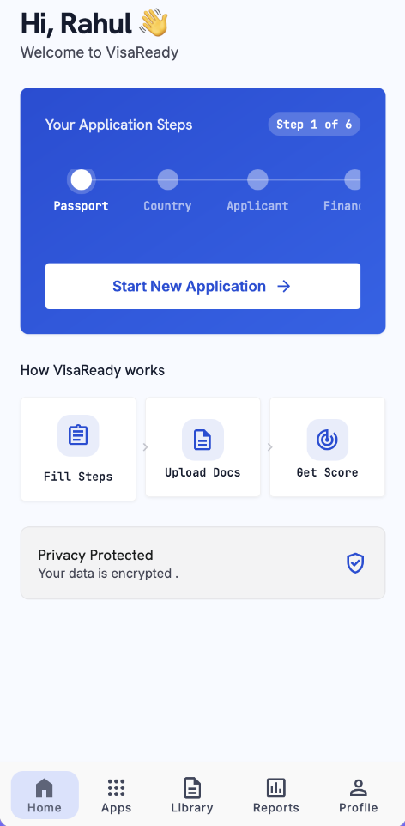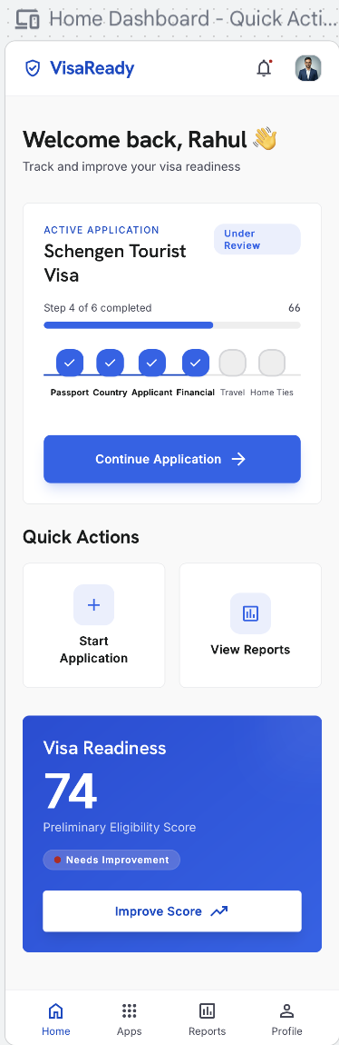

4.6 Profile
06 | Profile

Purpose — Account management hub reached from the profile icon. Displays the user’s photo, name and email at the top, with a menu of sub-sections below.

4.6.1 Edit Profile
- The user can edit their profile photo, first name, last name, email address and mobile number directly — no OTP re-verification required.
- Photo upload supports camera capture or gallery selection.
- Changes are saved immediately on confirmation.

4.6.2 Notification Settings
- Allows the user to manage which notifications they receive and through which channels.
- Notification categories include: Application status updates, VisaScore result alerts, Document verification status, Promotional offers and plan renewals.
- Channels available per category: In-App, WhatsApp, Email.
- Each category can be toggled on or off per channel independently.
- Master toggle at the top to enable or disable all notifications at once.
Notifications the customer receives. The app sends notifications across in-app, WhatsApp and email (per the user's toggles) for the following events:
- Application status — each status change (Submitted, Under Review, Document Requested, Submitted to Embassy, Visa Granted, Visa Rejected).
- Score ready — VisaScore Lite generated; Final VisaScore ready after payment.
- Document status — document verified, or a re-upload requested.
- Payment & invoice — payment success and invoice available.
- Promo — a promo code received/applied.
- Plan — plan purchase, renewal reminder, expiry.
- Agency updates — when an agency acts on the customer's application (status change, decision uploaded).
- Account — deletion-request submitted and deletion-request completed.

4.6.3 Privacy Settings
- Data-sharing consent toggle — controls whether the user’s anonymised data may be used for platform improvement.
- View Terms of Use — opens the full Terms of Use text (same as 4.4).
- View Privacy Policy — opens the full Privacy Policy.
- View Disclaimer — opens the platform disclaimer.
- Request Data Export — user can request a download of all their stored data (DPDPA compliance).
- Request Account Deletion —Request Account Deletion — the user submits an account-deletion request from here. The request is raised to VisaReady and appears in the Admin Portal for review; the user sees a confirmation that the request has been submitted. The account is not removed immediately — an admin reviews and actions the deletion (Delete / DPDPA Erasure). The user is notified when the request is completed..

4.6.4 Personal Information
- Displays and allows editing of: First Name, Last Name, Date of Birth, Gender, Marital Status, Nationality, Mobile Number, Email Address.
- Fields pre-populated from the sign-up and passport OCR data.
- Editable directly; changes saved on ‘Save’.

4.6.5 Passport Information
- Displays passport details captured via OCR at Step 1: Passport Number, Place of Issue, Date of Issue, Date of Expiry.
- The user can update these fields if details have changed (e.g., passport renewed).
- An advisory banner is shown if the passport is within six months of expiry.

4.6.6 Address Information
- Current residential address: Address Line 1, Address Line 2 (optional), City / Town, State, PIN / Postal Code, Country.
- All address fields are editable and saved for reuse across future applications.

4.6.7 Travel Preferences
- Preferred destinations (multi-select from the active country list).
- Preferred visa type (Tourist / Business / Student).
- Typical travel party size (Solo / Couple / Family).
4.6.8 Plan
- Displays the user’s current plan: Lite / Starter / Advance.
- Shows plan status (Active / Expired), validity period, renewal date, tokens or scores remaining, and purchase history.
- Actions available: Renew (current plan), Upgrade / Change Plan (opens the plan-purchase modal — see 4.15), View Invoices.
- When an agency/customer purchases a plan, the plan is auto-assigned to their account on successful payment. AD-09 (agency) / plan override (AD-16 for customer) is used only to manually change or override the auto-assigned plan.
- 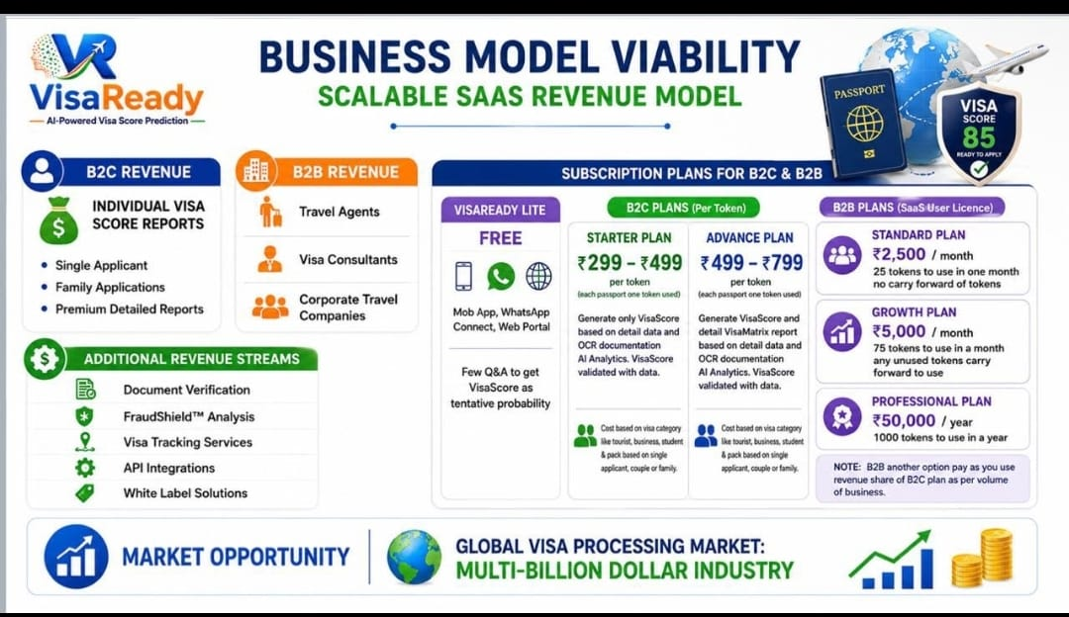

4.6.9 Support
- A single ‘Chat with us on WhatsApp’ button that opens WhatsApp directly with the VisaReady support number pre-loaded.
- No in-app FAQ or other contact options in this phase; these are deferred to a later release.

4.6.10 Logout
- Signs the user out of the application immediately.
- A confirmation prompt is shown: ‘Are you sure you want to log out?’ with Confirm and Cancel actions.
- After logout, the next launch returns to the Login screen.

⚠ Client Input Required — Final list of editable profile fields, the support WhatsApp number, and the plan-status fields (validity, renewal, usage) to display.

Element Detail — 4.6 Profile
Profile — Header & Menu
Element Type | Element ID | Label | Type | M/O/C | Auto-Populate Source | Visible When | Enabled When | Validation / Precondition | On Click / On Change | Next / Result | Source (config) | Editable By | Error / Fallback | Dev Notes
Header | pf_header | Photo / Name / Email | Display | — | Sign-up + Edit Profile | Always | — | — | — | — | User record | — | — | Header shows across sub-screens
Menu | pf_menu | Sub-section menu | Nav list | M | — | Always | Always | — | On tap open sub-screen | 4.6.1–4.6.10 | App | — | — | Deep-link each sub-screen

4.6.1 Edit Profile
Element Type | Element ID | Label | Type | M/O/C | Auto-Populate Source | Visible When | Enabled When | Validation / Precondition | On Click / On Change | Next / Result | Source (config) | Editable By | Error / Fallback | Dev Notes
Image | pf_photo | Profile photo | Image upload | O | — | Always | Edit mode | Camera or gallery; image type/size limits | On save persist | — | User | User | Upload error → retry | No OTP re-verify needed
Input | pf_first | First name | Text | M | Sign-up / OCR | Always | Edit mode | ≥ 2 chars | On save persist | — | User | User | Required error | —
Input | pf_last | Last name | Text | O | Sign-up / OCR | Always | Edit mode | Letters/spaces | On save persist | — | User | User | — | —
Input | pf_email | Email | Email | M | Sign-up | Always | Edit mode | Valid email; no OTP re-verify | On save persist | — | User | User | Invalid format | —
Input | pf_mobile | Mobile | Phone | M | Sign-up | Always | Edit mode | Country code + 10 digits; no OTP re-verify | On save persist | — | User | User | Invalid number | —

4.6.2 Notification Settings
Element Type | Element ID | Label | Type | M/O/C | Auto-Populate Source | Visible When | Enabled When | Validation / Precondition | On Click / On Change | Next / Result | Source (config) | Editable By | Error / Fallback | Dev Notes
Toggle | pf_notif_master | Master notifications | Toggle | O | — | Always | Always | — | On change cascade to all | — | App | User | — | Off disables all channels
Matrix | pf_notif_matrix | Category × Channel toggles | Toggle grid | O | — | Always | Master on | Per category per channel (In-App/WhatsApp/Email) | On change persist | — | Admin (categories) | User | — | Categories: App status, Score alerts, Doc status, Promo, Renewals
Element TypeElement IDLabelTypeM/O/CAuto-Populate SourceVisible WhenEnabled WhenValidation / PreconditionOn Click / On ChangeNext / ResultSource (config)Editable ByError / FallbackDev NotesFeednotif_customerCustomer notificationsFeed—System eventsAlwaysPer user togglesStatus, score, document, payment, promo, plan, agency, account eventsOn tap open itemRelevant screenSystem — Notification templates (AD-46–49)—Empty stateChannels: in-app / WhatsApp / email per 4.6.2 toggles
4.6.3 Privacy Settings
Element Type | Element ID | Label | Type | M/O/C | Auto-Populate Source | Visible When | Enabled When | Validation / Precondition | On Click / On Change | Next / Result | Source (config) | Editable By | Error / Fallback | Dev Notes
Toggle | pf_data_consent | Data-sharing consent | Toggle | O | — | Always | Always | Controls anonymised data use | On change persist to consent log | — | User | User | — | DPDPA log
Link | pf_view_legal | View Terms / Privacy / Disclaimer | Link | O | — | Always | Always | — | On tap open 4.4 content | Terms & Consent | Admin — Legal CMS | Admin | — | Same source as 4.4
Action | pf_export | Request data export | Action | O | — | Always | Always | DPDPA export job | On tap raise export request | Confirmation | Backend | — | Job failure → retry | Async; notify when ready
Element TypeElement IDLabelTypeM/O/CAuto-Populate SourceVisible WhenEnabled WhenValidation / PreconditionOn Click / On ChangeNext / ResultSource (config)Editable ByError / FallbackDev NotesActionpf_deleteRequest account deletionActionO—AlwaysAlwaysRaises a deletion request to admin (not instant delete); confirmation requiredOn tap submit requestRequest queued for admin (AD-15)BackendUserRequest-failed → retryAdmin reviews & actions; user notified on completion
4.6.4 Personal Information
Element Type | Element ID | Label | Type | M/O/C | Auto-Populate Source | Visible When | Enabled When | Validation / Precondition | On Click / On Change | Next / Result | Source (config) | Editable By | Error / Fallback | Dev Notes
Input | pf_pi_first | First / Last name | Text | M | Sign-up + passport OCR | Always | Edit mode | ≥ 2 chars | On save persist | — | User / OCR | User | Required error | Pre-populated from sign-up & OCR
Date | pf_pi_dob | Date of birth | Date | M | Passport OCR | Always | Edit mode | Valid; age check | On save persist | — | User / OCR | User | Invalid date | Reused in Step 3
Dropdown | pf_pi_gmn | Gender / Marital / Nationality | Dropdown | M | Passport OCR (nationality) | Always | Edit mode | From configured lists | On save persist | — | Admin — Field Sets | User | Required error | Reused in Step 3
Input | pf_pi_contact | Mobile / Email | Mixed | M | Sign-up | Always | Edit mode | Format validation | On save persist | — | User | User | Invalid format | —

4.6.5 Passport Information
Element Type | Element ID | Label | Type | M/O/C | Auto-Populate Source | Visible When | Enabled When | Validation / Precondition | On Click / On Change | Next / Result | Source (config) | Editable By | Error / Fallback | Dev Notes
Input | pf_pp_num | Passport number | Alphanumeric | M | Passport OCR (Step 1) | Always | Edit mode | 8–9 chars uppercase | On save persist | — | OCR / User | User | Format error | Reused across applications
Text | pf_pp_issue | Place / Date of issue | Mixed | M | Passport OCR | Always | Edit mode | Issue ≤ today | On save persist | — | OCR / User | User | Future date error | —
Date | pf_pp_expiry | Date of expiry | Date | M | Passport OCR | Always | Edit mode | > issue | On save persist; recheck expiry advisory | Advisory banner if < 6 mo | OCR / User | User | — | Advisory banner when within 6 months

4.6.6 Address Information
Element Type | Element ID | Label | Type | M/O/C | Auto-Populate Source | Visible When | Enabled When | Validation / Precondition | On Click / On Change | Next / Result | Source (config) | Editable By | Error / Fallback | Dev Notes
Input | pf_addr1 | Address line 1 | Text | M | Prior application | Always | Edit mode | Non-empty | On save persist | — | User | User | Required error | Saved for reuse across applications
Input | pf_addr2 | Address line 2 | Text | O | Prior application | Always | Edit mode | — | On save persist | — | User | User | — | —
Mixed | pf_addr_city | City / State / PIN / Country | Mixed | M | Prior application | Always | Edit mode | PIN 6 digits | On save persist | — | User / Admin (lists) | User | PIN format error | Reused in Step 3 residence

4.6.7 Travel Preferences
Element Type | Element ID | Label | Type | M/O/C | Auto-Populate Source | Visible When | Enabled When | Validation / Precondition | On Click / On Change | Next / Result | Source (config) | Editable By | Error / Fallback | Dev Notes
Multi-select | pf_tp_dest | Preferred destinations | Multi-select | O | — | Always | Edit mode | From active country list | On save persist | — | Admin — Countries | User | — | Prefills Step 2 destination
Dropdown | pf_tp_visa | Preferred visa type | Dropdown | O | — | Always | Edit mode | Tourist/Business/Student | On save persist | — | Admin — Visa Types | User | — | Prefills Step 2 visa type
Choice | pf_tp_party | Typical party size | Choice | O | — | Always | Edit mode | Solo/Couple/Family | On save persist | — | App | User | — | Hints multi-applicant default

4.6.8 Plan
Element Type | Element ID | Label | Type | M/O/C | Auto-Populate Source | Visible When | Enabled When | Validation / Precondition | On Click / On Change | Next / Result | Source (config) | Editable By | Error / Fallback | Dev Notes
Display | pf_plan_cur | Current plan | Display | — | Billing record | Always | — | — | — | — | Billing | — | — | Lite/Starter/Advance + status/validity/renewal/usage
Button | pf_plan_renew | Renew | Button | O | — | Plan active/expired | Always | — | On click open purchase modal | Payment (4.15) | Billing | User | — | —
Button | pf_plan_upgrade | Upgrade / Change plan | Button | O | — | Always | Always | — | On click open plan modal | Payment (4.15) | Admin — Pricing | User | — | —
Link | pf_plan_inv | View invoices | Link | O | Billing record | Has invoices | Always | — | On tap open invoice list | Invoice (view/download PDF) | Billing | — | Empty state if none | Same invoice as 4.15

4.6.9 Support
Element Type | Element ID | Label | Type | M/O/C | Auto-Populate Source | Visible When | Enabled When | Validation / Precondition | On Click / On Change | Next / Result | Source (config) | Editable By | Error / Fallback | Dev Notes
Button | pf_support_wa | Chat on WhatsApp | Button | O | — | Always | Always | Opens WhatsApp with support number pre-loaded | On click open WhatsApp deep link | WhatsApp | Admin — Platform Settings | — | WhatsApp not installed → fallback link | No in-app FAQ this phase

4.6.10 Logout
Element Type | Element ID | Label | Type | M/O/C | Auto-Populate Source | Visible When | Enabled When | Validation / Precondition | On Click / On Change | Next / Result | Source (config) | Editable By | Error / Fallback | Dev Notes
Button | pf_logout | Logout | Button | M | — | Always | Always | Confirmation prompt (Confirm/Cancel) | On confirm clear session | Login screen | App | — | — | Clear secure token; next launch → Login

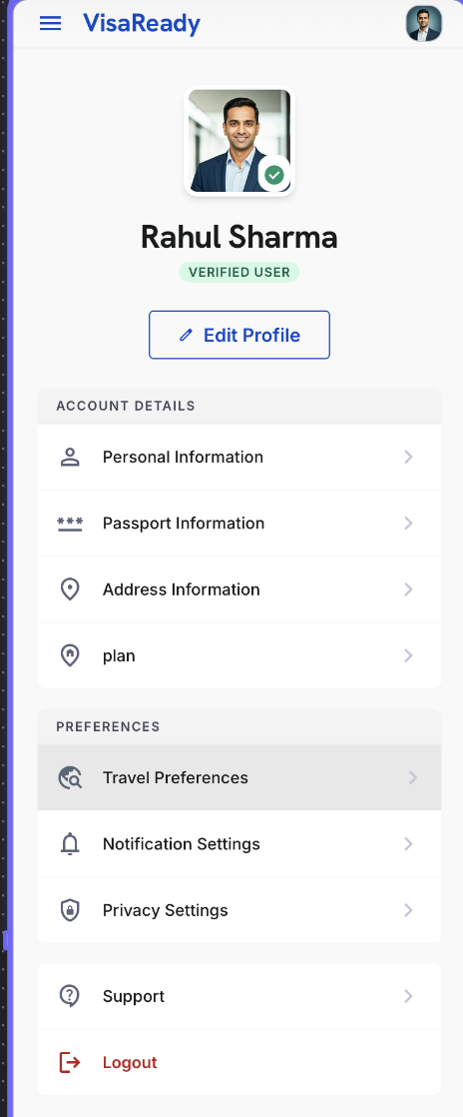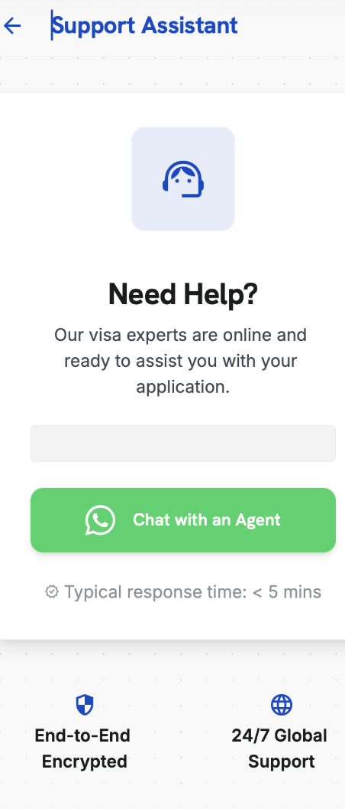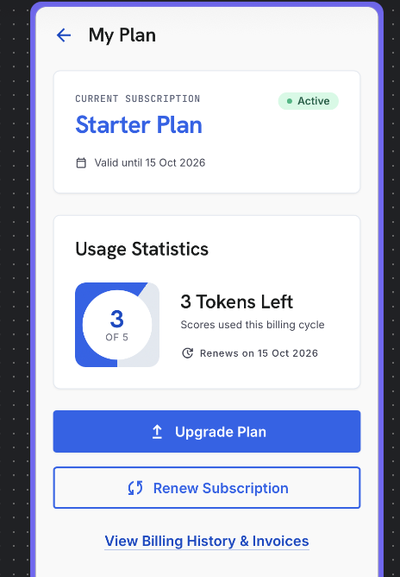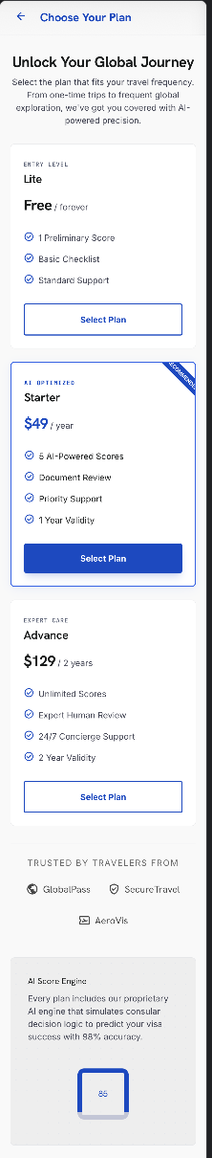(only for ui reference)

4.7 Passport — Application Step 1
07 | Passport

Purpose — Captures passport details and sets single- or multi-applicant mode.

Applicant Mode
- Single — one primary applicant.
- Multi — reveals the co-applicant capture flow. Up to five applicants can be added; each co-applicant’s passport is scanned and a separate form completed. The VisaScore is calculated for the primary applicant only.

Capture
- ‘Scan Now’ auto-fills fields using OCR; manual entry remains available. Scanning tips shown below the button.

Fields
- Passport number, place of issue, date of issue, date of expiry.
- Previous passport — declaration only (Yes / No).

OCR Review & Co-Applicant
- After a scan, an OCR Review screen lets the applicant confirm or correct extracted data (confidence indicator shown per field).
- In Multi mode, each co-applicant is scanned and reviewed, then a separate form is completed per co-applicant (‘Add Co-Applicant’, up to five).
Note — Passport validity is checked against the travel end date; the user is warned if validity is under six months beyond return (advisory; see 4.20).
Element Detail — 4.7 Passport — Application Step 1
Element Type | Element ID | Label | Type | M/O/C | Auto-Populate Source | Visible When | Enabled When | Validation / Precondition | On Click / On Change | Next / Result | Source (config) | Editable By | Error / Fallback | Dev Notes
Toggle | pp_mode | Applicant mode | Toggle | M | Profile › Travel Preferences (party size hint) | Always | Always | Single / Multi (default Single) | On change reveal co-applicant flow | Co-applicant mgmt (4.7a) if Multi | User | User | — | Party-size pref can hint default
Camera/File | pp_ocr | Passport scan (OCR) | Camera/File | O | — | Always | Always | OCR confidence threshold per Admin | On scan prefill fields | Populates fields below | OCR engine | User | Low confidence → manual entry | Prefills name, number, dates, nationality
Input | pp_number | Passport number | Alphanumeric | M | Passport OCR → also fills Profile 4.6.5 | Always | Always | 8–9 chars uppercase | On change validate | — | OCR / User | User | Format error inline | Write-back to profile passport info
Input | pp_issue_place | Place of issue | Text | M | Passport OCR | Always | Always | Non-empty | On change | — | OCR / User | User | Required error | —
Date | pp_issue_date | Date of issue | Date | M | Passport OCR | Always | Always | ≤ today | On change | — | OCR / User | User | Future date error | —
Date | pp_expiry | Date of expiry | Date | M | Passport OCR | Always | Always | > issue; flag if < 6 mo beyond travel end | On change run passport-expiry risk check | Risk flag if triggered | OCR / User | User | Expiry-risk flag/advisory | Feeds Document Readiness + risk layer
Text | pp_name | Name (as in passport) | Text | M | Passport OCR → prefills Step 3 & Profile | Always | Always | Matches passport MRZ where available | On change | — | OCR / User | User | Required error | Single source for applicant name
Dropdown | pp_nationality | Nationality | Dropdown | M | Passport OCR → prefills Step 3 | Always | Always | From list | On change | — | OCR / User | User | Required error | —
Yes/No | pp_prev | Previous passport held | Yes/No | O | — | Always | Always | Declaration | On change | — | User | User | — | —
Group | pp_coapp | Co-applicant passport | Group | C | Per co-applicant OCR | Multi mode | Multi mode | Same rules; up to 5 co-applicants | Add/edit co-applicant | Co-applicant mgmt (4.7a) | User | User | Max 5 enforced | Each co-applicant is own OCR

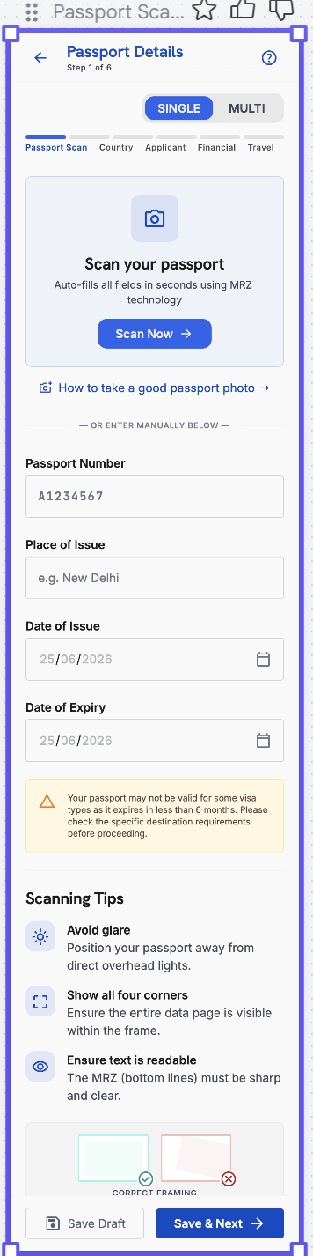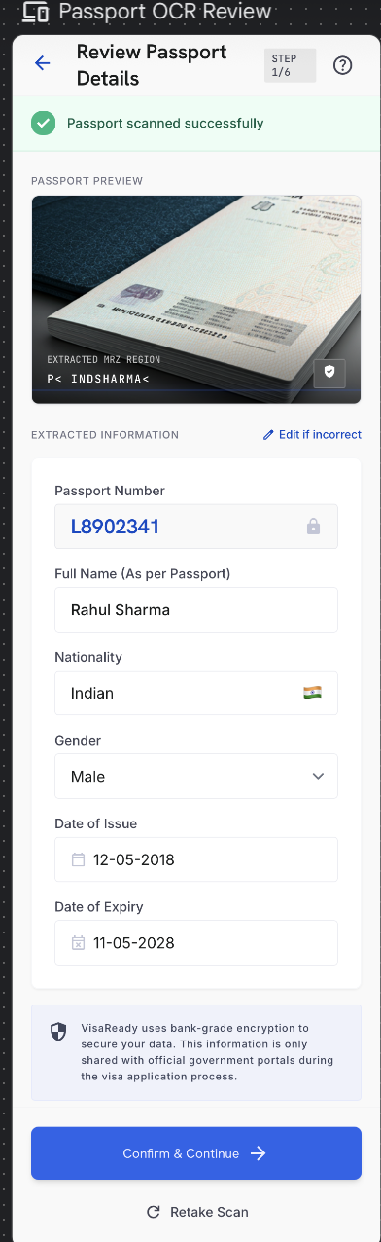

4.7a Co-Applicant / Family Management (Multi-Applicant)
07a | Co-Applicant / Family Management

Purpose — A hub to add and manage every person travelling on one application — the primary applicant plus co-applicants. It appears when the user chooses Multi-applicant at Step 1 and can be reopened any time before Payment.

WHERE IT FITS IN THE FLOW
- Opens immediately after the primary applicant’s passport scan (Step 1) when Multi-applicant is selected; the user can return to it at any point before Payment (4.15) to add or complete applicants.
- Each applicant’s own six-step form (Passport to Home Ties) is launched from this hub; on completion the user returns here.
SCREEN LAYOUT (per the family-management UI)
- Primary Applicant card — name, ’Passport Verified’, a READY badge and the VisaScore (e.g. 84%). Only the primary applicant shows an actual VisaScore.
- Co-Applicant cards — each shows name, relationship (Spouse / Child / Parent / Other), passport status (Passport Added / Passport Pending), a profile-completion ring (e.g. 79%), a warning icon when something is missing, and an action button: ’Complete Profile’ (passport added, details pending) or ’Add Passport’ (passport pending).
- Add Co-Applicant tiles — Add Spouse, Add Child, Add Parent, Add Other.
- Footer — a progress bar with ’X of 5 seats filled’ and the note ’Maximum 5 co-applicants allowed.’
Note — The percentage shown on a co-applicant card is profile completeness, not a VisaScore. Only the primary applicant is scored (see 4.5, 5.3); co-applicants are captured for the application record and are not individually scored.

ADDING A CO-APPLICANT
- Selecting a tile (Spouse / Child / Parent / Other) sets the relationship and opens that co-applicant’s form. The passport scan (OCR) is captured first, then the type-specific details below.
- A co-applicant can be removed, which frees a seat. The primary applicant cannot be removed.
Common fields — all co-applicant types
Field | Type | M/O/C | Validation
Passport scan (OCR) | Capture | M | OCR-prefilled: number, place, issue & expiry
First / Last name | Text | M / O | OCR-prefilled; first name mandatory
Date of birth | Date | M | Valid; drives minor logic for Child
Gender | Dropdown | M | From list
Nationality | Dropdown | M | From list
Relationship to primary | Auto | M | Set by the selected tile
Passport photo | Image | M | JPG / PNG up to 5 MB

Add Spouse
Field | Type | M/O/C | Validation
Marriage / relationship proof | File | M | Marriage certificate
Occupation / user type | Dropdown | M | Salaried / Self-employed / etc.
Monthly income | Range dropdown | O | For documentation only (not scored)
Shares finances with primary | Yes/No | O | —

Add Child
Field | Type | M/O/C | Validation
Minor (under 18) | Auto | — | Derived from date of birth
Birth certificate (relationship proof) | File | M | —
School / institution | Text | C | If of school age
Guardian / parent on application | Dropdown | M | Link to primary or a co-applicant
Parental consent / NOC | File | C | Required if travelling without a parent

Add Parent
Field | Type | M/O/C | Validation
Relationship proof | File | M | Document linking to the primary applicant
Dependency status | Dropdown | M | Dependent / Independent
Pension / income | Yes/No + range | O | For documentation
Funding source for trip | Dropdown | M | Self / Sponsored by primary

Add Other
Field | Type | M/O/C | Validation
Relationship description | Text | M | Free text (e.g. sibling, relative, friend)
Relationship / association proof | File | M | Supporting document
Funding source for trip | Dropdown | M | Self / Sponsored

Rule — Each co-applicant must have a passport added and the mandatory fields completed before the application can proceed to Payment. Co-applicants do not each consume a scoring token; one token is consumed for the primary applicant (see 4.15, 5.3).

⚠ Client Input Required — Confirm the maximum number of co-applicants (the UI shows up to 5 co-applicants in addition to the primary), the relationship-proof document required per type, and which co-applicant fields are mandatory versus optional.
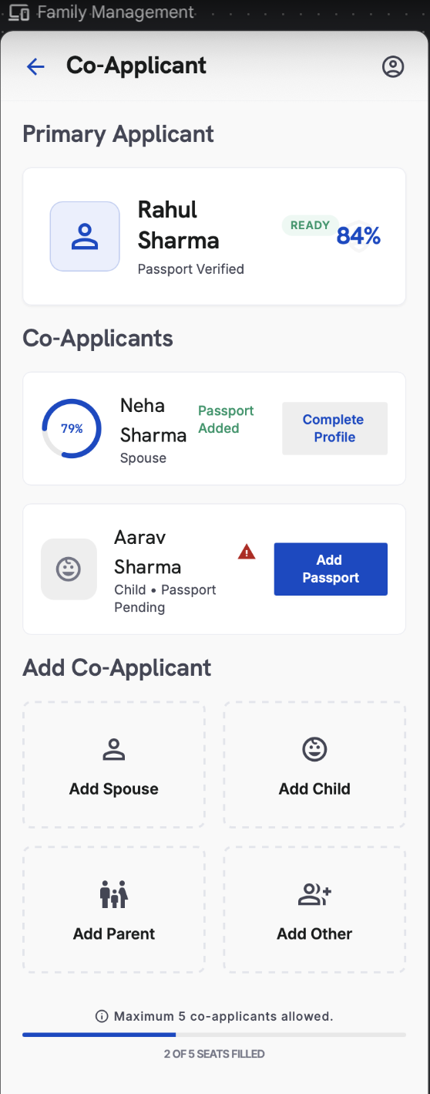

Element Type | Element ID | Label | Type | M/O/C | Auto-Populate Source | Visible When | Enabled When | Validation / Precondition | On Click / On Change | Next / Result | Source (config) | Editable By | Error / Fallback | Dev Notes
Card | ca_primary | Primary applicant card | Display | — | Step 1 passport + primary score | Multi-applicant mode | — | Shows name, 'Passport Verified', READY badge, VisaScore (e.g. 84%) | On tap open primary form | Primary six-step form | Shared record | User | — | Only the primary shows an actual VisaScore
Card | ca_coapp | Co-applicant card | Display | — | Co-applicant OCR + completion state | Co-applicant exists | — | Shows name, relationship, passport status, profile-completion ring, warning icon | On tap open action | Complete Profile / Add Passport | Shared record | User | — | Ring % = profile completeness, NOT a VisaScore
Tile | ca_add | Add Co-Applicant tiles | Action | O | — | Seats remaining | < 5 co-applicants | Add Spouse / Child / Parent / Other; sets relationship | On tap open co-applicant form (OCR first) | Co-applicant form | App | User | Blocked at 5 seats | Tile choice sets relationship
Capture | ca_ocr | Passport scan (OCR) | Camera/File | M | — | Adding co-applicant | Always | OCR-prefills number, place, issue, expiry | On scan prefill fields | — | OCR engine | User | Low OCR → manual entry | Per co-applicant
Input | ca_name | First / Last name | Text | M/O | Passport OCR | Adding co-applicant | Always | First name mandatory; letters/spaces | On change | — | OCR / User | User | Required error | —
Date | ca_dob | Date of birth | Date | M | Passport OCR | Adding co-applicant | Always | Valid; drives minor logic for Child | On change | — | OCR / User | User | Invalid date | —
Dropdown | ca_gender | Gender | Dropdown | M | Passport OCR | Adding co-applicant | Always | From list | On change | — | Admin — Field Sets | User | Required error | —
Dropdown | ca_nat | Nationality | Dropdown | M | Passport OCR | Adding co-applicant | Always | From list | On change | — | Admin — Field Sets | User | Required error | —
Auto | ca_rel | Relationship to primary | Auto | M | Set by selected tile | Adding co-applicant | — | Spouse / Child / Parent / Other | — | — | System | — | — | Determines type-specific fields below
Image | ca_photo | Passport photo | Image | M | — | Adding co-applicant | Always | JPG/PNG ≤ 5 MB | On upload | — | User | User | Type/size error | —
Group | ca_typefields | Type-specific fields | Group | C | — | Per relationship | After relationship set | Spouse/Child/Parent/Other fields (relationship proof, occupation, guardian, funding source, etc.) | On save | — | Admin — Field Sets | User | Required per type | See per-type field lists in 4.7a prose
Action | ca_remove | Remove co-applicant | Action | O | — | Co-applicant exists | Not primary | Frees a seat; primary cannot be removed | On click confirm remove | Seat freed | App | User | Primary block message | —
Progress | ca_seats | Seats-filled progress | Display | — | Auto from co-applicants added | Always | — | 'X of 5 seats filled'; max 5 | — | — | System | — | — | Footer progress bar
Gate | ca_gate | Proceed-to-Payment gate | Rule | — | Auto from completion | Always | All applicants complete | Each co-applicant needs passport + mandatory fields before Payment | On proceed validate all | Payment (4.15) | System | — | Blocks if any incomplete | Co-applicants don't each consume a token; 1 token = primary

4.8 Country, Visa & Trip Details — Application Step 2
08 | Country & Visa Selection

Purpose — Selects the destination(s) and visa type; drives the dynamic form that follows.

2a — Country Selection
- Screen heading: “Where do you want to apply for a visa? Select the country.”
- Popular destinations include UK, Canada, Europe (Schengen), Australia, Japan and Korea; full list configured by Super Admin where all destinations will be displayed.
- Multiple countries can be selected; a selected country can be changed via ‘Change’.
- Schengen jurisdiction footnote shown on this screen (see below).

Schengen Jurisdiction Footnote
Decision is based on your itinerary, not your preferred embassy. (1) Main destination: apply to the country of most nights. (2) Equal stay: apply to the country of first entry. (3) Single country: apply to that country’s embassy / visa centre.

2b — Visa Type
Heading: ‘What type of visa do you need?’ with the helper line ‘Select one — this determines your required documents.’ The selected destination is shown at top with a ‘Change’ action.
- Visa type (single-select, mandatory): Tourist / Visitor · Student · Business.
- Each option shows an icon and a one-line descriptor (e.g. Tourist — ‘Holidays, sightseeing, visiting family’; Student — ‘Full-time study at a recognised institution’; Business — ‘Meetings, conferences, professional visits’).
Note — Work / Employment visa type is not offered in this version.

2c — Trip / Travel Details
Heading: ‘Provide your planned travel dates and logistics to determine visa eligibility and validity requirements.’

Field | Type | M/O | Validation
Travel start date | Date | M | ≥ today; before end date
Travel end date | Date | M | After start; trip within passport validity
Trip duration | Auto (read-only) | — | Computed from dates (e.g. ‘15 Days’)
Primary destination city | Dropdown | M | From destination’s city list
Cities to be visited | Multi-select + Add City | O | From destination; de-duplicated
Hotel booking status | Confirmed / Not yet / Reserved | M | Single-select; ‘Not yet’ allowed
Flight booking status | Confirmed / Not yet / Reserved | M | Single-select; ‘Not yet’ allowed

Note — A Trip Summary card shows trip duration, main destinations, and a ‘booking documents ready for upload in next step’ note. ‘Save Draft’ and ‘Save & Next’ actions available.
⚠ Client Input Required — Full supported-country list and display order, the all-destinations list, the per-destination city lists, and confirmation of the three booking-status options.

Element Detail — 4.8 Country, Visa & Trip Details — Application Step 2
Step 2a — Destination Country
Element Type | Element ID | Label | Type | M/O/C | Auto-Populate Source | Visible When | Enabled When | Validation / Precondition | On Click / On Change | Next / Result | Source (config) | Editable By | Error / Fallback | Dev Notes
Multi-select | cv_dest | Destination country | Multi-select | M | Profile › Travel Preferences (preferred dest) | Always | Always | ≥ 1 from active list; Schengen footnote | On change load city list + adjust checklist | Enables city + visa | Admin — Countries (AD-20/21) | User | Required error | Prefill from saved preferences

Step 2b — Visa Type
Element Type | Element ID | Label | Type | M/O/C | Auto-Populate Source | Visible When | Enabled When | Validation / Precondition | On Click / On Change | Next / Result | Source (config) | Editable By | Error / Fallback | Dev Notes
Single-select | cv_visa | Visa type | Single-select | M | Profile › Travel Preferences (preferred visa) | Destination chosen | After destination | Tourist / Student / Business | On change rebuild document checklist | Applicant Details path | Admin — Visa Types (AD-22/23) | User | Required error | Drives checklist (AD-34) & path

Step 2c — Trip Details
Element Type | Element ID | Label | Type | M/O/C | Auto-Populate Source | Visible When | Enabled When | Validation / Precondition | On Click / On Change | Next / Result | Source (config) | Editable By | Error / Fallback | Dev Notes
Multi-select | cv_cities | Cities to be visited | Multi-select | O | Destination selection | Destination chosen | After destination | From destination's city list | On change update Trip Summary | — | Admin — Countries | User | — | City list keyed to destination
Date | cv_start | Travel start date | Date | M | — | Trip Details | Always | Valid; ≤ end date | On change compute duration | — | User | User | Start > end error | —
Date | cv_end | Travel end date | Date | M | — | Trip Details | Always | ≥ start date | On change compute duration | — | User | User | End < start error | —
Computed | cv_duration | Trip duration | Computed | — | Auto from start/end dates | After dates | — | Derived (end − start) | Recompute on change | Trip Summary | System | — | — | Feeds Trip Details scoring
Choice | cv_hotel | Hotel booking status | Choice | O | — | Trip Details | Always | Confirmed/Not yet/Reserved | On change update summary | — | User | User | — | Feeds Document Readiness
Choice | cv_flight | Flight booking status | Choice | O | — | Trip Details | Always | Confirmed/Not yet/Reserved | On change update summary | — | User | User | — | Feeds Document Readiness
Card | cv_summary | Trip summary | Card | — | Auto from all Step 2 inputs | After trip details | — | — | — | Applicant Details (Step 3) | System | — | — | Read-only recap; ‘docs ready in next step’

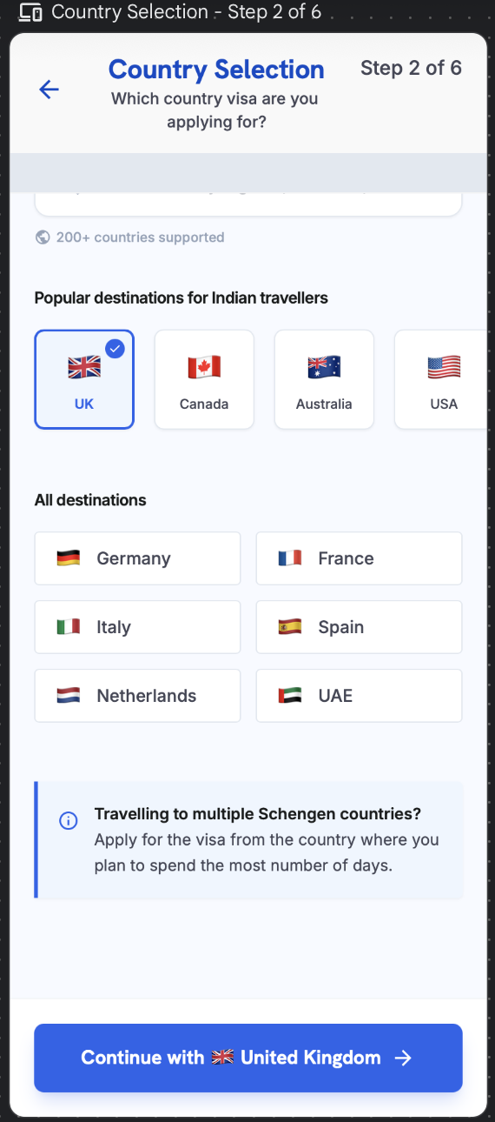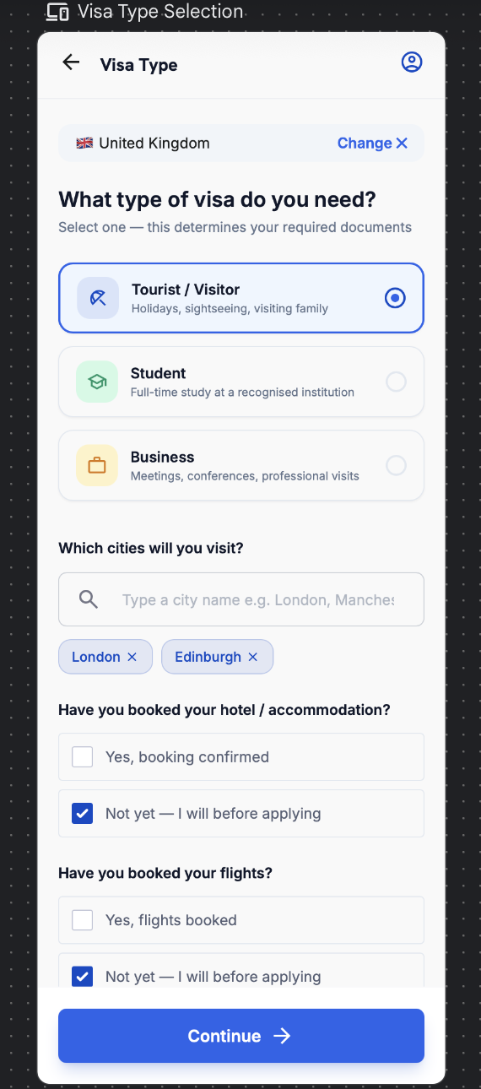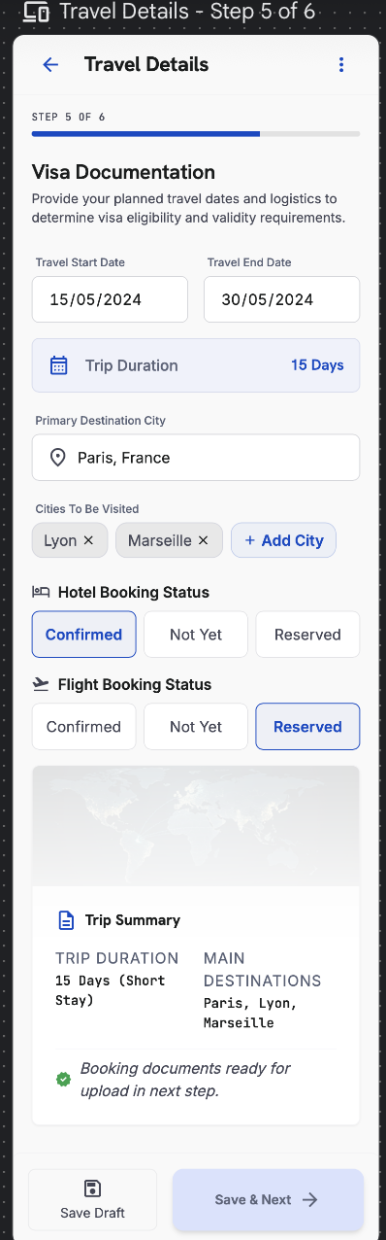

4.9 Applicant Details — Application Step 3
09 | Applicant Details

Purpose — Captures personal, employment and education details. The flow adapts to the selected user type and destination.

3a — Personal Details
- Two models on this surface: Details fetched from passport and Current details. A “Same as passport” checkbox auto-copies passport values into the current set.
- Every field available from the passport auto-fills via OCR; the user completes only what the passport does not contain.

Field | Type | M/O | Validation
First name | Text | M | Letters/spaces/hyphen; OCR-prefilled
Last name | Text | O | Letters/spaces/hyphen
Date of birth | Date | M | Valid; age ≥ 18 (else guardian flow)
Gender | Dropdown | M | From list
Marital status | Dropdown | M | Single / Married / Divorced / Widowed
Nationality | Dropdown | M | From list; OCR-prefilled
Same as passport | Checkbox | O | Copies passport values to current details
Current City of Residence | Dropdown | M | Options update by destination
State | Dropdown | M | From list
PIN / postal code | Numeric | M | 6 digits
Email | Email | M | Valid format (prefilled from account)
Mobile | Phone | M | Country code + 10 digits

3b — User Type
Options: Salaried · Self-Employed · Business Owner · Student · Retired · Unemployed · Homemaker · Freelancer.
The choice determines the next screen (3c) and the document checklist (4.14).

3c — Profile Details by User Type
Salaried
Field | Type | M/O | Validation
Company name | Text | M | ≥ 2 chars
Employer type | Dropdown | M | Private / Government / PSU / MNC / Professional
Designation | Text | M | ≥ 2 chars
Monthly earning | Range dropdown | M | Configured ranges
Annual income | Range dropdown | M | Configured ranges
Years in current role | Numeric | M | 0–50
Total work experience | Numeric / band | M | ≥ years in role
Second income | Yes/No + range | O | Range required if Yes

Self-Employed / Business Owner
Field | Type | M/O | Validation
Business name | Text | M | ≥ 2 chars
Industry / business practice | Dropdown | M | Includes ‘Other’ (free-text if chosen)
GST number | Alphanumeric | O | 15-char GSTIN format if entered
Annual turnover | Range dropdown | M | Configured ranges
Years in business | Numeric | M | 0–60
Ownership / role | Dropdown | M | Proprietor / Partner / Director

Student
Field | Type | M/O | Validation
Institution | Text | M | ≥ 2 chars
Course / programme | Text | M | ≥ 2 chars
Current year / level | Dropdown | M | From list
Expected graduation | Date / year | M | Future date
Sponsor | Dropdown | M | Self / Parent / Other (with relation)

Retired
Field | Type | M/O | Validation
Previous occupation | Text | M | ≥ 2 chars
Year of retirement | Year | M | ≤ current year
Pension / annuity | Yes/No + range | M | Range required if Yes
Other income (rent, interest, investments) | Yes/No + range | O | Range required if Yes
Primary funding source for trip | Dropdown | M | Self / Pension / Family / Savings

Unemployed
Field | Type | M/O | Validation
Currently employed | Yes/No | M | Locked to No for this type
Last employment (if any) | Text | O | —
Source of funds for trip | Dropdown | M | Self-savings / Sponsor / Family
Sponsor name & relation | Text | C | Required if sponsored
Sponsor monthly income | Range dropdown | C | Required if sponsored

Homemaker
Field | Type | M/O | Validation
Spouse / family occupation | Text | M | ≥ 2 chars
Sponsor name & relation | Text | M | Spouse / Parent / Child / Other
Sponsor monthly income | Range dropdown | M | Configured ranges
Sponsor employment proof available | Yes/No | M | Drives document checklist
Own income (if any) | Yes/No + range | O | Range required if Yes

Freelancer
Field | Type | M/O | Validation
Profession / field | Text | M | ≥ 2 chars
Primary platform / clients | Text | O | —
GST number | Alphanumeric | O | 15-char GSTIN if entered
Average monthly income | Range dropdown | M | Configured ranges
Years freelancing | Numeric | M | 0–50
ITR filed | Yes/No | M | Drives document checklist

3d — Education (all user types)
Field | Type | M/O | Validation
Highest qualification | Dropdown | M | From list
Institution | Text | O | —
Year of completion | Year | O | ≤ current year

Next-Screen Routing
User Type | Next Screen
Student | Student profile + education
Business / Self-Employed / Business Owner | Business practice details
Salaried | Employment details
Retired | Retired profile (pension / funding)
Unemployed | Unemployed profile (source of funds / sponsor)
Homemaker | Homemaker profile (sponsor details)
Freelancer | Freelancer profile (income / ITR)

⚠ Client Input Required — Confirm dropdown value sets (employer types, industry, qualifications, city lists) and any destination-specific applicant fields.

Element Detail — 4.9 Applicant Details — Application Step 3
Step 3 — Base (all applicants)
Element Type | Element ID | Label | Type | M/O/C | Auto-Populate Source | Visible When | Enabled When | Validation / Precondition | On Click / On Change | Next / Result | Source (config) | Editable By | Error / Fallback | Dev Notes
Checkbox | ad_same | Same as passport | Checkbox | O | Passport OCR (Step 1) | Always | Always | Copies passport name/DOB/nationality into details | On tick prefill from passport | — | User | User | — | Big time-saver; prefills base identity
Date | ad_dob | Date of birth | Date | M | Passport OCR / Profile 4.6.4 | Always | Always | Valid; age ≥ 18 else guardian flow | On change | — | OCR / User | User | Under-18 → guardian flow | Single DOB source
Dropdown | ad_gender | Gender | Dropdown | M | Profile 4.6.4 | Always | Always | From list | On change | — | Admin — Field Sets | User | Required error | —
Dropdown | ad_marital | Marital status | Dropdown | M | Profile 4.6.4 | Always | Always | From list | On change | — | Admin — Field Sets | User | Required error | Feeds Personal Profile score
Dropdown | ad_nat | Nationality | Dropdown | M | Passport OCR | Always | Always | From list | On change | — | Admin — Field Sets | User | Required error | —
Dropdown | ad_city | Current city of residence | Dropdown | M | Profile 4.6.6 (address) | Always | Always | Updates by destination; PIN 6 digits | On change | — | Admin — Field Sets | User | PIN format error | Prefill from saved address
Dropdown | ad_qual | Highest qualification | Dropdown | M | — | Always | Always | From list | On change | — | Admin — Field Sets | User | Required error | Feeds Personal Profile
Dropdown | ad_usertype | User type | Dropdown | M | — | Always | Always | 9 options incl. Homemaker, Freelancer | On change reveal matching path sub-form | Path sub-form below | Admin — Field Sets | User | Required error | Determines which sub-table below shows

Step 3 — Salaried / Employee path
Element Type | Element ID | Label | Type | M/O/C | Auto-Populate Source | Visible When | Enabled When | Validation / Precondition | On Click / On Change | Next / Result | Source (config) | Editable By | Error / Fallback | Dev Notes
Dropdown | ad_s_emp | Employer type | Dropdown | C | — | User type = Salaried | After user type | From list | On change | — | Admin — Field Sets | User | Required error | Visible only for Salaried
Text | ad_s_desig | Designation | Text | C | — | User type = Salaried | After user type | Non-empty | On change | — | User | User | Required error | —
Range | ad_s_income | Monthly earning | Range dropdown | M | — | User type = Salaried | After user type | Configured ranges | On change feed Financial score | — | Admin — Field Sets (AD-26) | User | Required error | Range bands from Admin
Numeric | ad_s_exp | Years in current role | Numeric/Band | M | — | User type = Salaried | After user type | ≥ 0; banded | On change feed Employment score | — | User | User | Negative error | —
Numeric | ad_s_totexp | Total work experience | Numeric/Band | M | — | User type = Salaried | After user type | ≥ 0; banded | On change | — | User | User | Negative error | —

Step 3 — Self-Employed / Business path
Element Type | Element ID | Label | Type | M/O/C | Auto-Populate Source | Visible When | Enabled When | Validation / Precondition | On Click / On Change | Next / Result | Source (config) | Editable By | Error / Fallback | Dev Notes
Text | ad_b_name | Business name | Text | C | — | User type = Business | After user type | Non-empty | On change | — | User | User | Required error | —
Dropdown | ad_b_ind | Industry | Dropdown | C | — | User type = Business | After user type | From list; ‘Other’ allowed | On change | — | Admin — Field Sets | User | — | —
Alphanumeric | ad_b_gst | GST number | Alphanumeric | O | — | User type = Business | After user type | 15-char GSTIN if provided | On change validate | — | User | User | Format error if present | Optional
Range | ad_b_turnover | Annual turnover | Range dropdown | M | — | User type = Business | After user type | Configured ranges | On change feed Financial score | — | Admin — Field Sets | User | Required error | —
Numeric | ad_b_years | Years in business | Numeric/Band | M | — | User type = Business | After user type | ≥ 0; banded | On change feed Employment score | — | User | User | Negative error | —

Step 3 — Student path
Element Type | Element ID | Label | Type | M/O/C | Auto-Populate Source | Visible When | Enabled When | Validation / Precondition | On Click / On Change | Next / Result | Source (config) | Editable By | Error / Fallback | Dev Notes
Text | ad_st_inst | Institution | Text | C | — | User type = Student | After user type | Non-empty | On change | — | User | User | Required error | —
Text | ad_st_course | Course | Text | C | — | User type = Student | After user type | Non-empty | On change | — | User | User | Required error | —
Numeric | ad_st_grad | Graduation year | Numeric | C | — | User type = Student | After user type | 4-digit year ≥ current | On change | — | User | User | Invalid year | —

Step 3 — Other user types (Retired / Unemployed / Homemaker / Freelancer)
Element Type | Element ID | Label | Type | M/O/C | Auto-Populate Source | Visible When | Enabled When | Validation / Precondition | On Click / On Change | Next / Result | Source (config) | Editable By | Error / Fallback | Dev Notes
Mixed | ad_o_fields | Type-specific fields | Mixed | C | — | User type = one of these | After user type | Fields configured per type in Admin | On change | — | Admin — Field Sets (AD-26) | User | Required per config | Field set driven by Admin per user type
Range | ad_o_income | Income / support source | Range dropdown | C | — | As configured | After user type | Configured ranges | On change feed Financial score | — | Admin — Field Sets | User | Required if configured | —

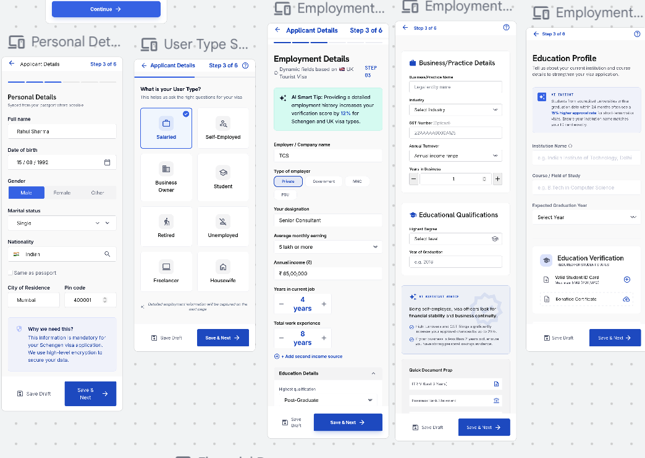

4.10 Financial Profile — Application Step 4
10 | Financial Profile

Purpose — Captures financial strength using range-based inputs for speed and consistency.

- Average bank balance (range); existing account closing balance (range).
- Fixed deposits — Yes / No + range; mutual funds / investments — Yes / No + range.
- ITR filed for the last two years — Yes / No.
- After the ITR Yes/No, a Yearly Gross Income / Last ITR Filed Amount field collected as a range dropdown (ranges configured by Super Admin).
⚠ Client Input Required — Definitions for each income, balance and turnover range.

Element Detail — 4.10 Financial Profile — Application Step 4
Element Type | Element ID | Label | Type | M/O/C | Auto-Populate Source | Visible When | Enabled When | Validation / Precondition | On Click / On Change | Next / Result | Source (config) | Editable By | Error / Fallback | Dev Notes
Range | fin_avgbal | Average bank balance | Range dropdown | M | — | Always | Always | Configured ranges | On change feed Financial score | — | Admin — Field Sets (AD-26) | User | Required error | 3–6 mo avg; feeds fund checks
Range | fin_closing | Existing closing balance | Range dropdown | M | — | Always | Always | Configured ranges | On change | — | Admin — Field Sets | User | Required error | —
Yes/No+Range | fin_fd | Fixed deposits | Yes/No + range | C | — | Always | Always | Range required if Yes | On change reveal range | — | User | User | Range required if Yes | —
Yes/No+Range | fin_mf | Mutual funds / investments | Yes/No + range | C | — | Always | Always | Range required if Yes | On change reveal range | — | User | User | Range required if Yes | —
Yes/No | fin_itr | ITR last 2 years | Yes/No | M | — | Always | Always | — | On change; No → risk flag potential | — | User | User | Required error | Missing ITR feeds risk penalty
Range | fin_gross | Yearly gross / last ITR amount | Range dropdown | M | Step 3 income (indicative) | Always | Always | Configured ranges | On change feed Financial score | — | Admin — Field Sets | User | Required error | Cross-checked vs credits for fund-parking

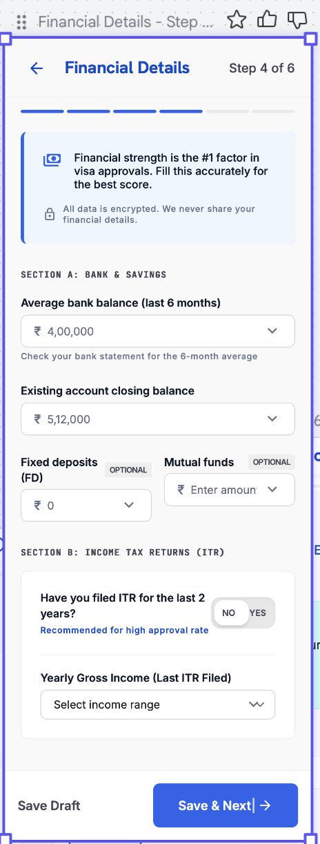

4.11 Travel History — Application Step 5
11 | Travel History

Purpose — Establishes travel record and compliance.

- Visas previously held and countries visited — searchable, multi-select.
- Countries visited is an explicit multiple-country selection; the count and tier of countries directly feed Travel-History scoring.
- After ‘Countries visited in the last 5 years’: “Do you already hold a valid visa for any country?” — dropdown to pick the country whose visa is held, plus its expiry date.
- For all previously visa-stamped countries, the answer defaults to ‘No.’
- Compliance: visa violation / overstay / immigration violation — Yes / No.
- Values already provided (passport OCR or earlier entry) auto-populate into Travel Details and Home Ties.

Country-Visited Scoring Tiers
Tier | Countries (more visited → more points)
Maximum points | Europe (Schengen) · USA · UK · Australia
Mid points | Japan · Korea · Singapore
Minimum points | Thailand · Malaysia · Indonesia

Note — The tier list is configurable in the Admin Portal. More high-tier countries visited increases the Travel-History dimension score.

Element Detail — 4.11 Travel History — Application Step 5
Element Type | Element ID | Label | Type | M/O/C | Auto-Populate Source | Visible When | Enabled When | Validation / Precondition | On Click / On Change | Next / Result | Source (config) | Editable By | Error / Fallback | Dev Notes
Multi-select | th_held | Visas previously held | Multi-select | O | — | Always | Always | From country list | On change | — | Admin — Countries | User | — | Schengen/UK/USA toggles
Multi-select | th_visited | Countries visited (last 5 yrs) | Multi-select | M | Profile travel history (if stored) | Always | Always | ≥ 1; tiered max/mid/min for scoring | On change feed Travel-History score | — | Admin — Country Weightage (AD-39) | User | Required error (≥ 1) | Tier drives Travel score
Yes/No+Country+Date | th_validvisa | Existing valid visa (hold now?) | Yes/No + country + expiry | C | Defaults No for stamped countries | Always | Always | Country & expiry required if Yes | On change reveal country + expiry | — | User | User | Country/expiry required if Yes | Separate from ‘previously held’
Yes/No | th_refusal | Previous visa refusal | Yes/No | M | — | Always | Always | Required | On change run risk penalty (−10 to −25) | — | User | User | Required error | Feeds risk layer
Yes/No | th_overstay | Overstay | Yes/No | M | — | Always | Always | Required | On change run risk penalty (−30 to −50) | — | User | User | Required error | Heaviest penalty
Yes/No | th_violation | Immigration violation / deportation | Yes/No | M | — | Always | Always | Required | On change run risk penalty | — | User | User | Required error | —

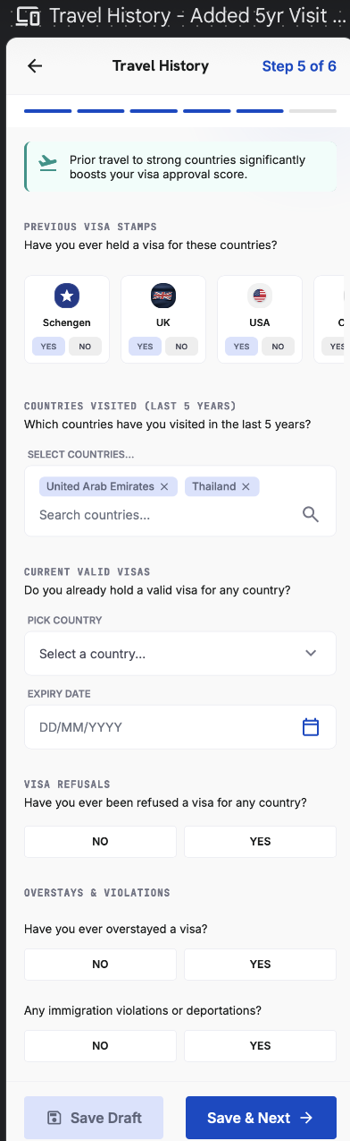

4.12 Home Ties — Application Step 6
12 | Home Ties

Purpose — Assesses the strength of ties to the home country.

- Family: marital status; children in home country (Yes/No + number); dependent parents (Yes/No).
- “My current commitments in India are …” — multiple selections allowed.
- Stability: employment stability; years in current city; property ownership (Yes/No + city).
- Declaration: ‘I confirm I intend to return upon completion of my trip’ — required to proceed.

Element Detail — 4.12 Home Ties — Application Step 6
Element Type | Element ID | Label | Type | M/O/C | Auto-Populate Source | Visible When | Enabled When | Validation / Precondition | On Click / On Change | Next / Result | Source (config) | Editable By | Error / Fallback | Dev Notes
Yes/No+Num | ht_children | Children in home country | Yes/No + number | C | — | Always | Always | Number required if Yes | On change reveal number | — | User | User | Number required if Yes | Feeds Personal Profile
Yes/No | ht_parents | Dependent parents | Yes/No | M | — | Always | Always | Required | On change | — | User | User | Required error | —
Multi-select | ht_commit | Current commitments | Multi-select | M | — | Always | Always | ≥ 1 | On change | — | Admin — Field Sets | User | Required error | Job/loan/property etc.
Numeric | ht_years | Years in current city | Numeric | M | Profile 4.6.6 (if stored) | Always | Always | ≥ 0 | On change | — | User | User | Negative error | Stable residence signal
Yes/No+City | ht_property | Property ownership | Yes/No + city | C | — | Always | Always | City required if Yes | On change reveal city | — | User | User | City required if Yes | Property/assets score
Checkbox | ht_return | Return declaration | Checkbox | M | — | Always | Always | Required to proceed | On tick enable continue | Agency Code / VisaScore Lite | User | User | Blocked until ticked | Gate to Lite score

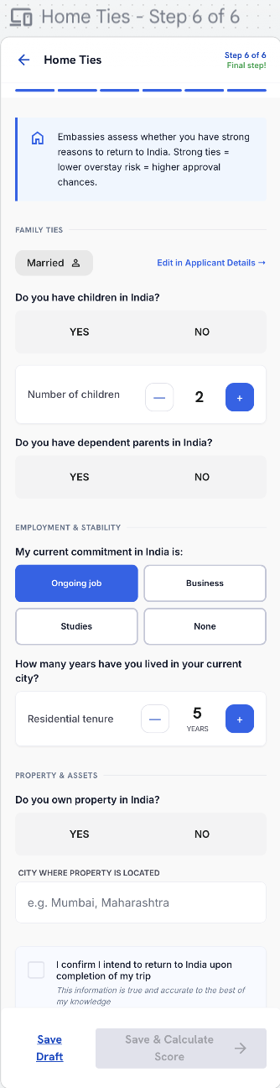

4.13 Agency Code & VisaScore™ Lite (Indicative)
13 | Agency Code & VisaScore™ Lite

Purpose — Optionally links the application to an agent, then reveals the indicative readiness score.

Agency Code
- ‘Do you have an agency code?’ — Yes / No. If yes, a code field appears (a code unlocks added benefits). If no, the user skips without penalty.
- When the applicant enters a valid agency code — at this step or while filling any earlier form step — the whole application (including anything already filled) maps to that agency and appears as a booking lead in the agency's dashboard. Details already entered populate the agency's view of the same shared record; the agent does not re-key them. And to super admin

Lead Routing
Scenario | Where the lead goes
No agency code entered | The applicant’s details populate in the Super Admin Portal as an unassigned lead. The Admin can transfer the lead to an agency (transfer is a Phase-2 capability).
Agency code entered | The lead is shown to both the agency (in its dashboard) and the Super Admin (with the agency name attached).
ACCOUNT LINKING
When an agent creates or fills an application before the customer has an account, the application is keyed to the customer’s mobile number and email. When the customer later signs up or signs in with the same mobile or email, the agent-created application is automatically linked to their account and appears in My Applications. Until then, the agent manages it from the Agency Dashboard.

VisaScore™ Lite
- Renamed from ‘Preliminary Score’ to VisaScore™ Lite — Indicative Score.
- Lite is computed from five parameters only: Financial Strength, Travel History, Employment Stability, Trip Details, Personal Profile (see 5.3) will show detail breakdown to user with progress bar like how progress is there .
- Output shows Low / Medium / High chance only — no risk levels and no flags at this stage.
- A disclaimer and a self-declaration statement appear at the bottom of the score page.
- Footnote:after the original score, one regeneration is free; from the second regeneration onward it is paid / token-consumed (see 5.3). A profile edit is required to regenerate..

Disclaimer & Self-Declaration
All data provided is self-declared and forms the basis of scoring. Any misrepresentation can cause the VisaScore to vary. VisaReady does not predict, influence or guarantee visa approval — final decisions rest solely with the relevant Embassy / Consulate / Immigration Authority.

Element Detail — 4.13 Agency Code & VisaScore™ Lite (Indicative)
Agency Code
Element Type | Element ID | Label | Type | M/O/C | Auto-Populate Source | Visible When | Enabled When | Validation / Precondition | On Click / On Change | Next / Result | Source (config) | Editable By | Error / Fallback | Dev Notes
Yes/No | ac_have | Have agency code? | Yes/No | M | — | Always | Always | — | On change reveal code field | — | User | User | — | —
Numeric | ac_code | Agency code | Numeric | C | WhatsApp referral link (pre-filled) | Have code = Yes | When Yes | Exactly 6 digits; validated vs active agencies | On blur validate; on valid map whole application to agency | VisaScore Lite | Admin — Agency Registry | User | Invalid/inactive code error | Pre-filled if arrived via referral link; maps at any step

VisaScore Lite (Indicative) — result & rules
Element Type | Element ID | Label | Type | M/O/C | Auto-Populate Source | Visible When | Enabled When | Validation / Precondition | On Click / On Change | Next / Result | Source (config) | Editable By | Error / Fallback | Dev Notes
Result | ac_lite | VisaScore Lite | Score band | — | Auto from Steps 2–6 inputs | After form complete | — | 5-parameter model (Financial, Travel, Employment, Trip, Personal); output Low/Med/High; NO flags, NO numeric risk | Generate on view | Lite result screen | Scoring engine — Lite mode (AD-28) | — | — | Lite excludes Document Readiness & Others; no penalties
Breakdown | ac_lite_params | Lite parameter contributions | Display | — | Auto from scoring engine | After Lite generated | — | Shows the 5 contributing parameters (indicative only) | — | — | Scoring engine | — | — | No exact numbers/flags exposed in Lite
CTA | ac_lite_cta | Continue to full score | Button | M | — | After Lite | Always | — | On click → Document Checklist / Payment | Document Checklist (4.14) | App | — | — | Lite → Final funnel
Rule | ac_regen | Regeneration rule | Business rule | — | Regeneration counter (system) | After Lite/Final score | — | After original score: 1 regeneration FREE; 2nd onward PAID/token; profile edit required to regenerate | On regenerate check counter | Free once, then paywall | Admin — Token Engine | — | Paywall on 2nd regeneration | 1 passport = 1 credit

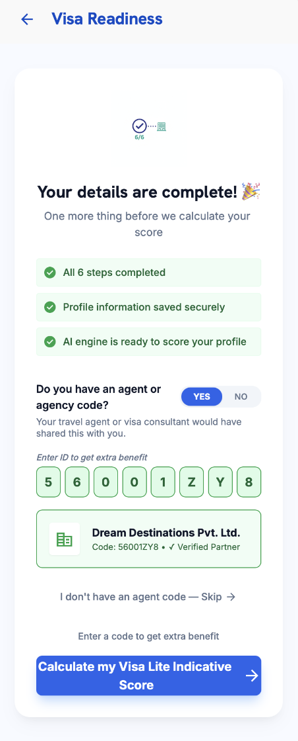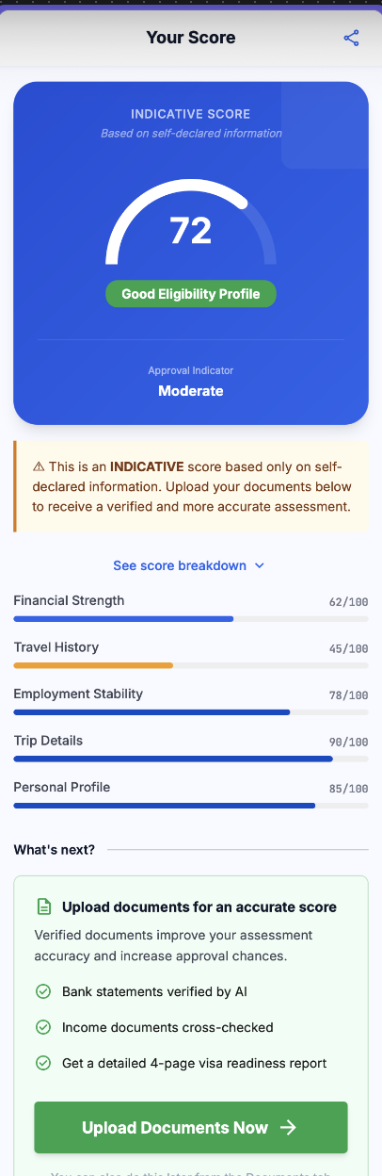

4.14 Document Checklist & Upload
14 | Document Checklist & Upload

Purpose — Collects supporting documents for the verified, paid assessment. The checklist is built from the applicant’s profile.

- For the paid version, passport scanning is mandatory; if the passport is not yet scanned, the OCR review screen is presented., same flow for co applicant if needed.
- Always required (every applicant): passport; passport-size photo; six-month bank statement (up to two accounts); confirmed/booked or draft travel itinerary.

Document Checklist by User Type
User Type | Type-Specific Documents
Salaried | Last 3 salary slips · 2 years ITR / Form-16 · employment / leave-approval letter · employer ID
Self-Employed / Business Owner | Business registration / incorporation · GST certificate · current-account statement (6 mo) · 2 years business ITR · ownership proof
Student | Student ID · enrolment / bonafide letter · latest marksheet / certificates · sponsor’s funds + sponsor letter (if sponsored)
Retired | Pension statement / order · retirement proof · investment / FD statements · funding-source proof
Unemployed | Sponsor letter + sponsor’s ID, bank statement & income proof · source-of-funds declaration
Homemaker | Sponsor (spouse/parent) letter, ID, employment proof & 6-mo bank statement · marriage/relationship proof
Freelancer | Client contracts / invoices · 2 years ITR · 6-mo bank statement · GST certificate (if registered)

- Document intelligence: the system auto-recognises the latest documents and organises them in the correct order.
- Auto-flagging: inconsistent or suspicious information is flagged (e.g. a recent very-high credit relative to balance).

Fund-Parking Flag
- Fund parking is a temporary deposit made shortly before applying to appear financially stronger than usual.
- Detection: the engine analyses 3–6 months of statements for sudden unexplained large credits, average balance, salary credits, ITR consistency and spending pattern. A sudden large credit (≥ 50% of the total transaction amount in one go by default) raises the flag and applies a −15 to −25 risk penalty.
- Legitimate large deposits are accepted when documented. The applicant can attach a source-of-funds proof — sale deed, FD maturity, bonus / incentive, business receipts, inheritance / gift, or a sanctioned education loan. With valid proof the penalty is waived.
- Flight and hotel booking documents are optional.
- Upload via camera, gallery / file picker, or drag-and-drop. PDF, JPG, PNG up to 10 MB each.

Element Detail — 4.14 Document Checklist & Upload
Element Type | Element ID | Label | Type | M/O/C | Auto-Populate Source | Visible When | Enabled When | Validation / Precondition | On Click / On Change | Next / Result | Source (config) | Editable By | Error / Fallback | Dev Notes
Checklist | doc_list | Dynamic checklist | Checklist | — | Auto from visa type + user type | Paid flow | — | Rebuilt from Admin checklist (AD-34) per visa & user type | Render required/optional items | — | Admin — Doc Checklist (AD-34) | Admin | — | Checklist adapts to Step 2 visa + Step 3 user type
File | doc_passport | Passport scan | File | M | Reuse Step 1 scan if present | Paid flow | Always | PDF/JPG/PNG ≤ 10 MB | On upload OCR + validate | — | User | User | Type/size error | Can reuse the Step 1 OCR file
File | doc_bank | 6-month bank statement | File | M | — | Paid flow | Always | Up to two accounts | On upload run fund-parking + balance checks | Fund-parking flag if triggered | User | User | Fund-parking flag | Feeds Financial score & risk layer
File | doc_salary | Salary slips / ITR | File | C | — | Salaried path | Always | Salaried path | On upload | — | User | User | — | Path-specific (from Step 3)
File | doc_bizstu | Business / student docs | File | C | — | By user type | Always | By user type | On upload | — | User | User | — | Path-specific
File | doc_sof | Source-of-funds proof | File | O | — | Fund-parking flag raised | Always | Clears fund-parking penalty (sale deed, FD maturity, bonus, business receipts, gift/inheritance, edu loan) | On upload clear flag | Penalty waived if valid | User | User | — | Only shown when flag present
File | doc_travel | Flight / hotel bookings | File | O | Step 2 booking status (hint) | Always | Always | — | On upload | Payment | User | User | — | Feeds Document Readiness

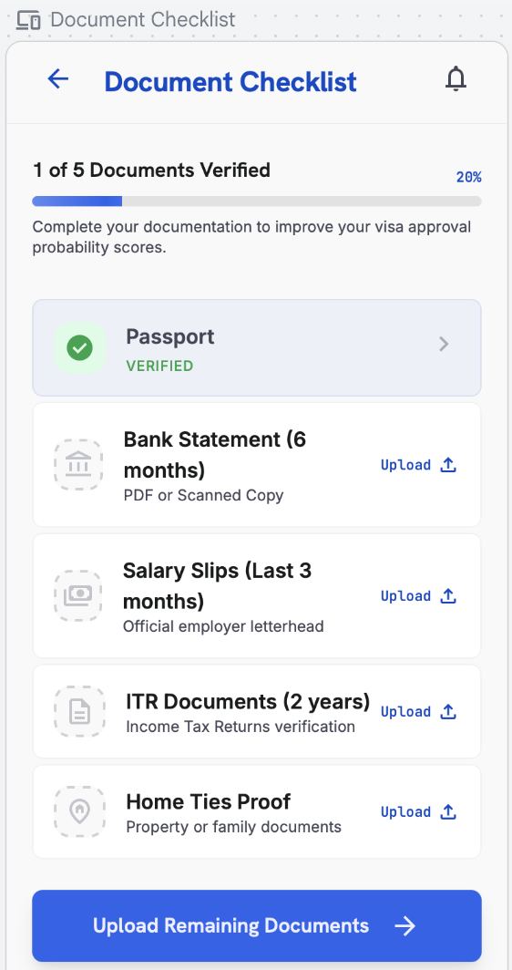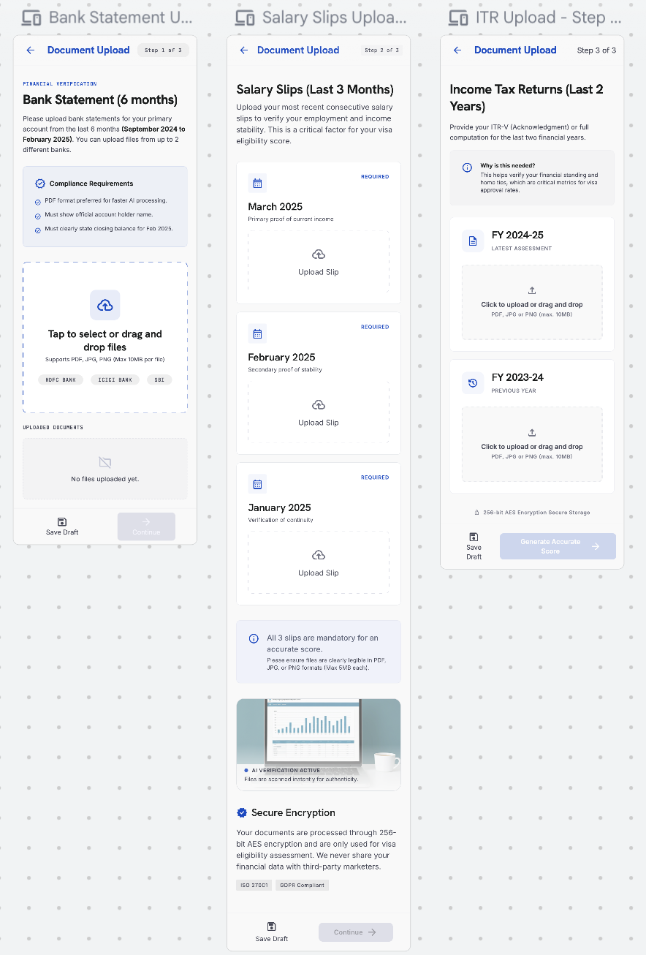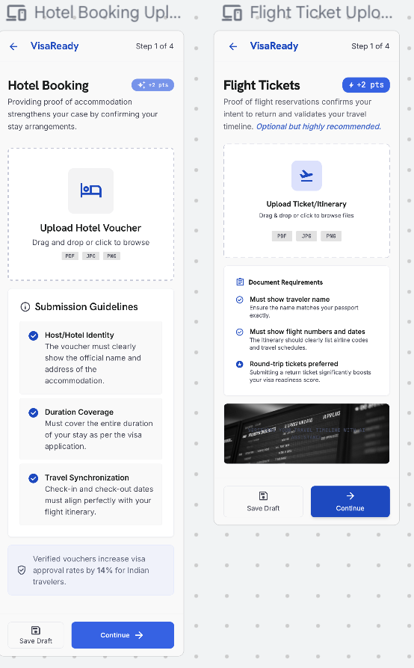

4.15 Payment
15 | Payment

Purpose — Lets the user choose and purchase a plan, then processes payment to unlock the verified score and full report.

Plan-Selection Modal
- When the user proceeds to pay, a plan modal prompts them to choose a plan before paying: Starter (VisaScore only) and Advance (VisaScore + VisaMatrix™ report), each showing price, what’s included, visa category and pack (single / couple / family).
- Promo Code. At payment, the user can enter a promo code shared by their agency. A promo code is generated by Super Admin, allocated to an agency, and emailed to the customer by that agency. On entering a valid code (exists, within validity, has remaining uses), the transaction fee is waived — that payment is free. Single-use codes work once; multi-use codes work until they expire or hit their usage cap. An invalid/expired/used code shows a clear error and the user proceeds to normal payment.
- Invoice. On every successful payment (or a fully promo-covered transaction), the app generates an invoice showing invoice number & date, applicant/payer name, plan and visa category, applicant count, line items (scoring fee, any processing fee), any promo code applied and amount waived, taxes, total paid, payment method and gateway reference. The invoice is viewable and downloadable as PDF from the Payment confirmation and from Profile › Plan › View Invoices (4.6.8). Invoices also appear in the Admin Portal transaction detail (AD-51).
- The user selects a plan and taps Purchase; the chosen plan, applicant count and computed price are shown before confirming.
- Shows the scoring fee (and any processing fee) for the selected plan; secure gateway with on-screen confirmation.
- Token consumption: one passport consumes one token; the score is calculated for the primary applicant only. Pricing varies by plan and visa category (see 5.3, 5.7).
- Co-applicants and tokens. Because the VisaScore is generated for the primary applicant only, processing an application consumes one token for the primary applicant. Co-applicant passports are captured for the application record but are not separately scored and do not each consume a scoring token. (Final treatment of co-applicant tokens is confirmed with the client.)
- Note — The customer pays per-use via plans/tokens (Lite / Starter / Advance) at Payment. This is separate from the agency credit/token system — customers are never charged from an agency's credit wallet, and the agency token model does not apply to direct (B2C) customers.
- Note — The customer pays per-use via plans/tokens (Lite / Starter / Advance) at Payment. This is separate from the agency credit/token system — customers are never charged from an agency's credit wallet, and the agency token model does not apply to direct (B2C) customers.
- When an agency/customer purchases a plan, the plan is auto-assigned to their account on successful payment. AD-09 (agency) / plan override (AD-16 for customer) is used only to manually change or override the auto-assigned plan.
Note — The same plan modal is reachable from Profile › Plan (4.6.8) for renew / upgrade.
⚠ Client Input Required — Plan modal contents (which plans appear, price within ranges, pack multipliers), and the payment gateway.

Element Detail — 4.15 Payment
Element Type | Element ID | Label | Type | M/O/C | Auto-Populate Source | Visible When | Enabled When | Validation / Precondition | On Click / On Change | Next / Result | Source (config) | Editable By | Error / Fallback | Dev Notes
Selection | pay_plan | Plan / token pack | Selection | M | Profile 4.6.8 current plan (hint) | Paid flow | Always | Lite/Starter/Advance; price by visa category & pack | On select compute price | — | Admin — Pricing Mgmt | User | Required error | Couple/family pack multipliers if configured
Input | pay_promo | Promo code | Text | O | — | Always | Always | Valid, within validity, has uses; must map to the agency code used on this application | On apply validate; if valid waive transaction fee | Free transaction if valid | Admin — Promo (AD-62) | User | Invalid/expired/used → normal payment | Single-use or multi-use per Admin
Gateway | pay_method | Payment method | Gateway | M | — | Not fully promo-covered | Always | Secure gateway; on-screen confirmation | On pay process transaction | Final Score & Report | Payment gateway (Razorpay assumed) | — | Gateway failure → retry | Skip if promo covers 100%
PDF | pay_invoice | Invoice | PDF output | — | Auto from transaction + promo | After success / promo-covered | — | Invoice no., date, payer, plan, visa cat, applicant count, line items, promo waived, tax, total, method, gateway ref | On view download PDF | Invoice (view/download) | Billing / System | — | — | Also in Profile 4.6.8 & Admin AD-51

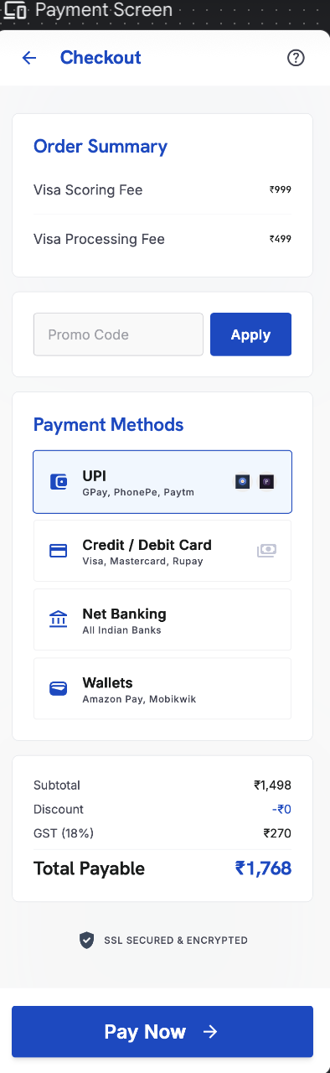

4.16 Final Score & VisaMatrix™ Report
16 | Final Score & Report

Purpose — Presents the verified result and the full readiness report.

- Verified score uses all seven weighted factors minus the risk-penalty layer (see 5.3); shows approval indicator, risk level, document-verification status and category breakdown.
- Final VisaScore™ bands: 80–100 Strong · 72–79 Good · 58–71 Moderate · Below 58 High Rejection Risk · Below 40 Do Not Apply. Thresholds and weights are configured in the Admin Portal.
- Report is the multi-page VisaMatrix™: executive summary & VisaScore, embassy checklist & red-flag analysis, recommendation engine & destination intelligence, and the intelligence layer (FraudShield™, Return Assurance Score™, EmbassyFit™, action plan).
- The VisaMatrix™ report carries a VisaReady logo background watermark on every page.
- Verifiable by report ID and QR code. Agency-referred reports carry ‘Powered by VisaReady’ alongside the agency’s branding.
- Share via WhatsApp · Email · Copy Link · Download PDF.
- every page of the VisaMatrix report shows a footnote with "VisaReady" and the applicant's passport number (dynamically inserted per report) for traceability.

Element Detail — 4.16 Final Score & VisaMatrix™ Report
Final Score — result
Element Type | Element ID | Label | Type | M/O/C | Auto-Populate Source | Visible When | Enabled When | Validation / Precondition | On Click / On Change | Next / Result | Source (config) | Editable By | Error / Fallback | Dev Notes
Result | fs_score | Final VisaScore (0–100) | Score | — | Auto: all 7 factors − risk penalties | After payment | — | Weighted 7 factors − risk penalty layer; primary applicant only | Generate on view | VisaMatrix report | Scoring engine (AD-27) | — | — | = Weighted Score − Risk Penalties
Band | fs_band | Readiness band | Band label | — | Auto from score | After score | — | 80–100 Strong · 72–79 Good · 58–71 Moderate · <58 High Risk · <40 Do Not Apply | — | — | Admin — Score Bands (AD-28) | Admin | — | Band thresholds editable in Admin
Breakdown | fs_factors | Factor-by-factor breakdown | Display | — | Auto from scoring engine | After score | — | Shows each of 7 factors with weight & contribution | On tap expand factor | — | Scoring engine | — | — | See companion Scoring Factor table below
Flags | fs_flags | Risk flags | Flags | — | Auto from risk layer / documents | Final only (never in Lite) | — | Fund parking, missing ITR, refusal, passport validity, missing doc, overstay, fraud | — | — | Scoring engine (AD-30/31/32) | Admin (rules) | — | See companion Risk-Penalty table below

VisaMatrix™ Report
Element Type | Element ID | Label | Type | M/O/C | Auto-Populate Source | Visible When | Enabled When | Validation / Precondition | On Click / On Change | Next / Result | Source (config) | Editable By | Error / Fallback | Dev Notes
Document | fs_report | VisaMatrix report | Document | — | Auto-generated | After score | — | Logo background watermark; sections & order per Admin (AD-65) | On view / share | Share via WhatsApp / Email; PDF | Admin — Report Template (AD-65) | Admin | — | Sections: exec summary, embassy checklist, red-flag analysis, recommendations, destination intelligence
Recommendations | fs_reco | AI recommendations | Text blocks | — | Auto from reason codes | After score | — | Human-readable reason codes with merge fields (AD-35) | — | — | Admin — Reason Codes (AD-35) | Admin | — | Explainability layer
Button | fs_share | Share / download | Button | O | — | Report exists | Always | — | On click share/download | Share sheet | System | — | — | Agency-referred reports co-branded
Element TypeElement IDLabelTypeM/O/CAuto-Populate SourceVisible WhenEnabled WhenValidation / PreconditionOn Click / On ChangeNext / ResultSource (config)Editable ByError / FallbackDev NotesFootnoterep_footnoteReport footnoteDisplay—Auto: "VisaReady" + applicant passport numberOn report—Passport number inserted dynamically per report—Rendered on every pageAdmin — Report Template (AD-65)Admin—Dynamic merge field {{passport_number}}; page footer
Companion — VisaScore™ Factor Weights & Scoring Rules (Final = all 7; Lite = 5 marked)
Factor | Weight | In Lite? | Sub-criteria & points (editable in Admin AD-27) | Contribution
Financial Strength | 25% | Yes | Stable 3–6 mo balance +25 · income supports trip cost +25 · ITR matches credits +20 · no funds parking +20 · clear savings/assets +10 | 0–100 → ×0.25
Travel History | 24% | Yes | Strong history +40 · prior developed-country visa +30 · no rejection/overstay +20 · pattern matches profile +10 | 0–100 → ×0.24
Document Readiness | 17% | No | Passport valid +15 · mandatory docs complete +35 · financial docs +20 · profile docs +20 · consistent formats +10 | 0–100 → ×0.17
Employment Stability | 14% | Yes | Stable employment +30 · income proof +25 · leave/business proof +20 · employer/CA docs +15 · return obligation +10 | 0–100 → ×0.14
Trip Details | 10% | Yes | Clear purpose +25 · realistic itinerary +25 · trip cost affordable +20 · correct consulate +20 · supporting bookings +10 | 0–100 → ×0.10
Personal Profile | 5% | Yes | Strong family ties +25 · property/assets +25 · dependents +20 · stable residence +15 · no adverse history +15 | 0–100 → ×0.05
Others | 5% | No | Reserved, configurable factor — aspect & sub-rules defined by client in Admin (AD-27) | 0–100 → ×0.05

Companion — Risk-Penalty Layer (applied AFTER weighted score; Final only)
Trigger | Penalty | Notes
Funds parking | −15 to −25 | Scaled by amount, timing, whether source explained; cleared by valid source-of-funds proof
Missing ITR | −10 to −20 | When ITR not provided / inconsistent
Previous visa rejection | −10 to −25 | Declared in Travel History (Step 5)
Passport validity issue | −20 | ≤ 6 months validity beyond travel
Missing major document | −10 to −20 | Mandatory checklist item absent
Previous overstay | −30 to −50 | Heaviest penalty band
Fake / tampered document | Hard reject flag | FraudShield™ — high risk / reject

Companion — Final Bands & Calculation
Band | Label | Meaning
80–100 | Strong Readiness | High approval probability
72–79 | Good Approval Probability | Minor gaps, overall strong
58–71 | Moderate Readiness | Fix gaps before applying
Below 58 | High Rejection Risk | Corrections strongly recommended
Below 40 | Do Not Apply | High chance of refusal
Final calculation: VisaScore™ = Weighted Score (Σ factor×weight) − Risk Penalties, clamped 0–100. Primary applicant only; 1 token per passport.

Companion — VisaScore™ Lite (Indicative) Model
Aspect | Detail
Parameters used | Financial Strength, Travel History, Employment Stability, Trip Details, Personal Profile (5 of 7)
Excluded from Lite | Document Readiness, Others factor, and the entire risk-penalty layer
Output | Low / Medium / High only — no numeric score, no flags, no risk levels exposed
Purpose | Fast indicative read before payment; upgrades to Final after document upload + payment
Regeneration | After original score: 1 regeneration free; 2nd onward paid/token; profile edit required

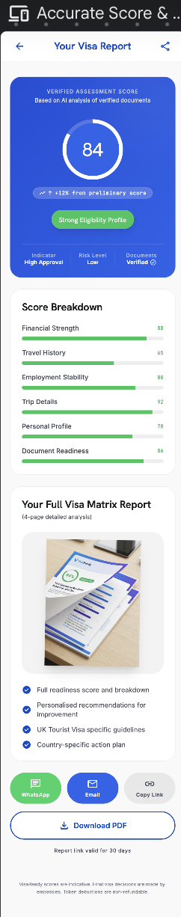
4.16a Score Improvement:
Purpose — Shown to a returning user after a score exists. It presents the current VisaScore, a plain-language readiness verdict, and a prioritised list of actions that would raise the score, each tagged with its estimated impact. It is the actionable bridge between the Final Score/VisaMatrix and regenerating an improved score.
The improvement recommendations and their impact estimates are driven by the reason-code catalogue configured in Admin (AD-35).
The improvement recommendations and their impact estimates are driven by the reason-code catalogue configured in the Admin Portal (AD-35). The same reason codes power the VisaMatrix report recommendations (4.16).
Entry points
- Home Dashboard → Improve Score button (on the Visa Readiness card).or from my application
- Final Score & VisaMatrix™ Report → "Improve your score" link.
Layout & elements
- Current score gauge — circular gauge showing the current score (e.g. 72%) with the readiness label beneath (e.g. "Good Chance"), colour-coded to the band.
- Verdict text — one or two lines summarising standing and that the recommendations below will maximise approval odds.
- Improvement Recommendations list — each card shows an icon, a title, a short detail line, and an impact tag(High / Medium / Low) with the estimated +X% uplift. Examples from config: Increase Bank Balance (Recommended: ₹5,00,000+) — High +8%; Upload Missing Documents (Income Tax Returns, 2 Years) — Medium +5%; Add Travel History (previous stamps/e-visas) — Low +3%; Provide Employment Proof (NOC from current employer) — Medium +5%.
- Target hint — informational line, e.g. "Improving your score to 85% or above significantly increases approval chances."
- Primary CTA — Generate New Score — regenerates the score using updated data (subject to the re-score rule: 1 regeneration free, 2nd onward paid).
- Secondary CTA — Upload Documents — jumps to Document Checklist & Upload (4.14) to supply the missing items.
Behaviour
- Recommendations, their thresholds and impact weights are driven by the scoring engine and Admin config (they mirror the factor weights and risk-penalty gaps that lowered the score).
- Recommendations are ordered by impact (High → Low).
- Completing an action (e.g. uploading ITR) and tapping Generate New Score recomputes the score; the regeneration counter and paywall from the re-score rule apply.
- The uplift figures are estimates for guidance, not guarantees.
▸ RULE — "Generate New Score" follows the re-score rule (5.3): after the original score, one regeneration is free; the second regeneration onward is paid / token-consumed. A profile or document change is required to regenerate.
Application-scoped. Score Improvement always operates on a single application. When opened from the Home Dashboard it uses the active/most-recent application; when opened from a My Applications card it uses that application. The gauge, recommendations, impact estimates and "Generate New Score" all read and write that one application's record.
⚠ Client Input Required — The recommendation catalogue (which actions surface per factor gap), the impact-weight mapping (how each action maps to a +% estimate), and the target-score threshold copy.

ELEMENT TABLE —
Element Type | Element ID | Label | Type | M/O/C | Auto-Populate Source | Visible When | Enabled When | Validation / Precondition | On Click / On Change | Next / Result | Source (config) | Editable By | Error / Fallback | Dev Notes
Context | si_appctx | Application context | Param | M | From entry point (Home = active app; My Apps = selected app) | Always | — | Valid applicationId; user owns the application | Loads that application's score & gaps | — | System | — | Invalid/missing ID → error state | Screen is a reusable component keyed by applicationId

Element Type | Element ID | Label | Type | M/O/C | Auto-Populate Source | Visible When | Enabled When | Validation / Precondition | On Click / On Change | Next / Result | Source (config) | Editable By | Error / Fallback | Dev Notes
Context | si_appctx | Application context | Param | M | From entry point (Home = active app; My Apps = selected app) | Always | — | Valid applicationId; user owns the application | Loads that application's score & gaps | — | System | — | Invalid/again missing ID → error state | Screen is a reusable component keyed by applicationId

Element Type | Element ID | Label | Type | M/O/C | Auto-Populate Source | Visible When | Enabled When | Validation / Precondition | On Click / On Change | Next / Result | Source (config) | Editable By | Error / Fallback | Dev Notes
Gauge | si_gauge | Current score gauge | Display | — | Scoring engine (last Final score) | Score exists | — | Shows current score + band label | — | — | Scoring engine (AD-27/28) | — | Hidden if no score yet | Colour by band (80+/72+/58+/<58/<40)
Text | si_verdict | Readiness verdict | Display | — | Auto from band | Score exists | — | One/two-line summary | — | — | Admin — Reason Codes (AD-35) | Admin | — | Band-driven copy
List | si_reco | Improvement recommendations | List | — | Scoring engine (factor gaps + risk layer) | Score exists | — | Ordered High→Low; each = icon, title, detail, impact tag, +X% | On tap card open related step | 4.14 / relevant step | Admin — Recommendation catalogue | Admin | Empty state if fully optimised | Maps factor/penalty gap → action + impact weight
Tag | si_impact | Impact tag (+X%) | Badge | — | Auto from impact-weight map | Per recommendation | — | High / Medium / Low + estimated % | — | — | Admin — Impact Weights | Admin | — | Estimate only; not a guarantee
Info | si_target | Target-score hint | Display | — | Admin config | Score exists | — | e.g. "85% or above increases approval chances" | — | — | Admin — Content (AD-33/36) | Admin | — | Threshold configurable
Button | si_generate | Generate New Score | Button | M | — | Score exists | Profile/docs changed | Re-score rule: 1 regen free, 2nd onward paid; change required | On click recompute score | Final Score & VisaMatrix (4.16) | Scoring + Token engine | User | Paywall on 2nd regen; "no change" notice | 1 passport = 1 credit
Button | si_upload | Upload Documents | Button | O | — | Score exists | Always | — | On click open Document Upload | Document Checklist & Upload (4.14) | App | User | — | Shortcut to supply missing items
Nav | si_back | Back | Button | M | — | Always | Always

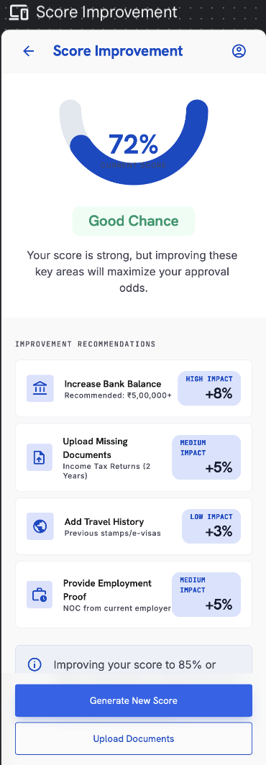
Element TypeElement IDLabelTypeM/O/CAuto-Populate SourceVisible WhenEnabled WhenValidation / PreconditionOn Click / On ChangeNext / ResultSource (config)Editable ByError / FallbackDev NotesContextsi_appctxApplication contextParamMFrom entry point (Home = active app; My Apps = selected app)Always—Valid applicationId; user owns the applicationLoads that application's score & gaps—System—Invalid/missing ID → error stateScreen is a reusable component keyed by applicationId

4.17 My Applications & Conclusion
17 | My Applications

Purpose — Find, resume and track every application across draft and submitted states.

- Grouped as Draft, In Progress and Submitted, with search; each card shows title, current step, last-updated date and ‘Continue’.
- Agency-assisted applications. An application created, continued or filled by an agent on the customer’s behalf appears in the customer’s My Applications list and updates in real time as the agent edits it. It is a single shared record — changes made by the agent or the customer are reflected on both sides, and either party can continue where the other left off.
- Per-application Score Improvement — each application card with an existing score shows an Improve Scoreaction that opens Score Improvement (4.16a) scoped to that application. The recommendations and the regenerated score apply to that application only.
- ▸ RULE — Score Improvement opened from an application card operates on that application's record. "Generate New Score" there regenerates that application's score and draws on that application's regeneration allowance (1 free, then paid). Other applications are unaffected.

Application Detail — Timeline
Header shows the visa type + country (e.g. ‘Tourist Visa — France’), a status pill (e.g. ‘Submitted’) and a reference number (e.g. REF: FR-49201-B). The timeline shows each stage with date & time, completed/active state, and stage-specific detail:

Timeline Stage | Detail Shown
Application Started | Date & time
Preliminary Score Generated | Date & time + the indicative score (e.g. 84/100) with a one-line summary
Documents Uploaded | Date & time + verification count (e.g. ‘8 of 8 mandatory documents verified’) + a ‘View Documents’ link
Submitted to Agent | Date & time (agency-routed applications)
Submitted to Embassy | Date & time + a ‘View Embassy Portal’ link
Embassy Review | Estimated working days (e.g. ‘5–7 working days’); shown as the active stage
Decision Pending | Upcoming stage (greyed until reached)

- ‘View Documents’ opens the per-application document list with details for each item (name, type, uploaded date, OCR/verification status).
- ‘View Embassy Portal’ opens the relevant embassy / official visa website in an in-app browser where the user enters their application reference and last name to track the official status.

Conclusion Step
Applied By | Behaviour
User only (self-applied) | User toggles Yes/No on whether the visa was received and may add an optional short reason if rejected.
Agency | Agency sets the status from its dashboard; the decision (Accepted / Rejected) is shown to the user with an image of the rejection/acceptance document.
⚠ Client Input Required — Per-country embassy / official tracking URLs to power the ‘View Embassy Portal’ link.

Element Detail — 4.17 My Applications & Conclusion
Element Type | Element ID | Label | Type | M/O/C | Auto-Populate Source | Visible When | Enabled When | Validation / Precondition | On Click / On Change | Next / Result | Source (config) | Editable By | Error / Fallback | Dev Notes
List | ma_list | My applications | List | O | User applications | Has applications | — | — | On tap open timeline | Conclusion / timeline | User data | — | Empty state if none | —
Timeline | ma_timeline | Status timeline | Timeline | — | Agency/system status updates | Per application | — | Statuses set by agency/system | — | — | Agency / Admin | — | — | Submitted→Under review→Doc requested→Embassy→Granted/Rejected
Result | ma_decision | Visa decision | Accepted/Rejected | C | Agency-uploaded decision | Decision uploaded | — | Shown with decision document image | On tap view document | Decision document | Agency (upload) | — | Pending state if none | Self-applied users set own

Element Type | Element ID | Label | Type | M/O/C | Auto-Populate Source | Visible When | Enabled When | Validation / Precondition | On Click / On Change | Next / Result | Source (config) | Editable By | Error / Fallback | Dev Notes
Button | ma_improve | Improve Score (per application) | Button | O | Scoring engine (this application's score) | Application has a score | Always | Passes application ID to Score Improvement | On click → Score Improvement scoped to this application | Score Improvement (4.16a) | App | User | Hidden if application has no score yet | Reuses 4.16a with applicationIdcontext
Detail table for timeline
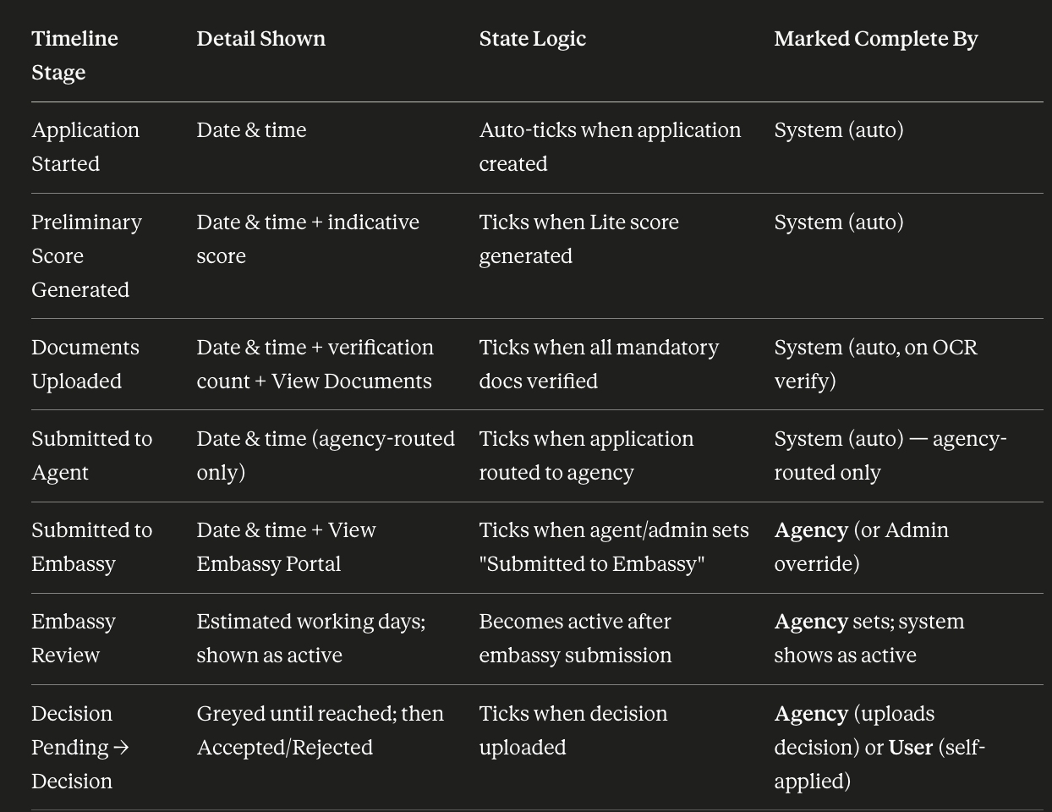
Timeline tick logic — Early stages (Started, Preliminary Score, Documents Uploaded) auto-complete from system events. Later stages (Submitted to Embassy, Embassy Review, Decision) are marked by the agency from its dashboard (or admin override); for self-applied users, the user sets the final decision at the Conclusion step. A stage shows as completed (tick), active (current), or pending (greyed) — the next stage stays pending until the current one is marked done.
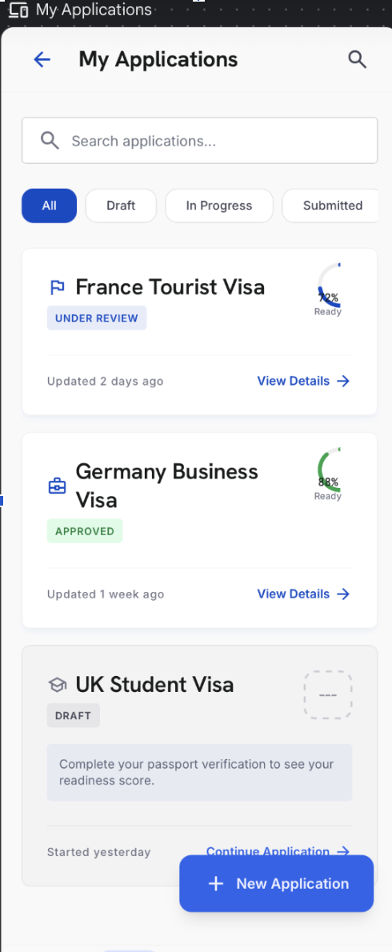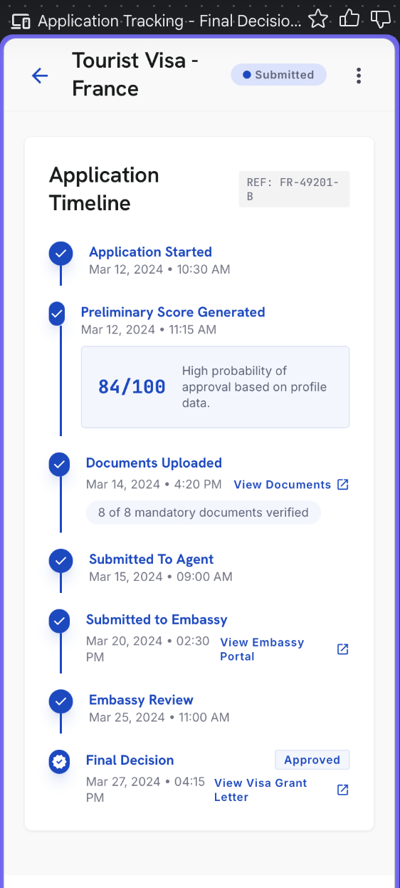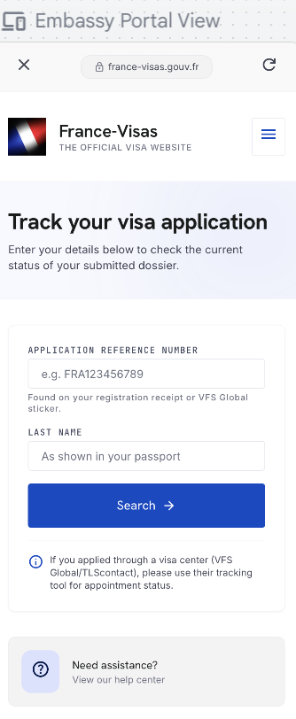

4.18 Reports
18 | Reports

Purpose — A library of all generated readiness reports.

- Recent reports and ‘View All’ history; view, email, download PDF, share by WhatsApp, copy link, verify by QR code.

Element Detail — 4.18 Reports
Element Type | Element ID | Label | Type | M/O/C | Auto-Populate Source | Visible When | Enabled When | Validation / Precondition | On Click / On Change | Next / Result | Source (config) | Editable By | Error / Fallback | Dev Notes
List | rep_list | Report list | List | O | Generated reports | Reports exist | — | — | On tap open report | VisaMatrix report | User data | — | Empty state | —
Button | rep_share | Share / download | Button | O | — | Report exists | Always | — | On click share/download PDF | Share sheet | System | — | — | —

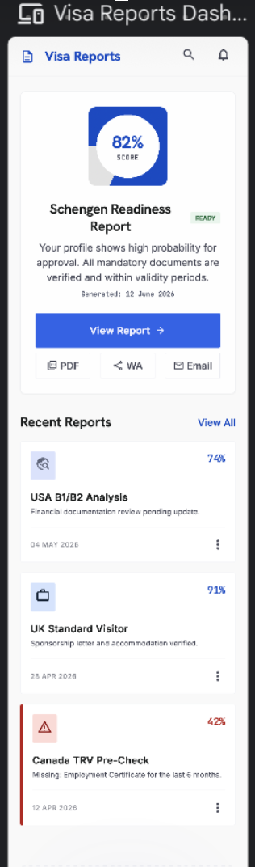

4.19 Library
19 | Library

Purpose — A new bottom-navigation destination that helps applicants understand each country’s visa process.

- A dropdown of countries; tapping a country opens readable guidance about that country’s visa process.
- Content is maintained by Super Admin (per-country) and updated centrally.
⚠ Client Input Required — Per-country Library content (visa-process guidance) and the country list for the Library.

Element Detail — 4.19 Library
Element Type | Element ID | Label | Type | M/O/C | Auto-Populate Source | Visible When | Enabled When | Validation / Precondition | On Click / On Change | Next / Result | Source (config) | Editable By | Error / Fallback | Dev Notes
Dropdown | lib_country | Country selector | Dropdown | M | Profile preferred destinations (hint) | Always | Always | From configured Library list | On change load content | — | Admin — Library CMS (AD-63) | Admin | — | Order & list controlled by Admin
Rich text | lib_body | Visa-process guidance | Rich text | — | Auto from selected country | Country chosen | — | Published content only | — | — | Admin — Library CMS | Admin | Empty state if unpublished | Read-only guidance

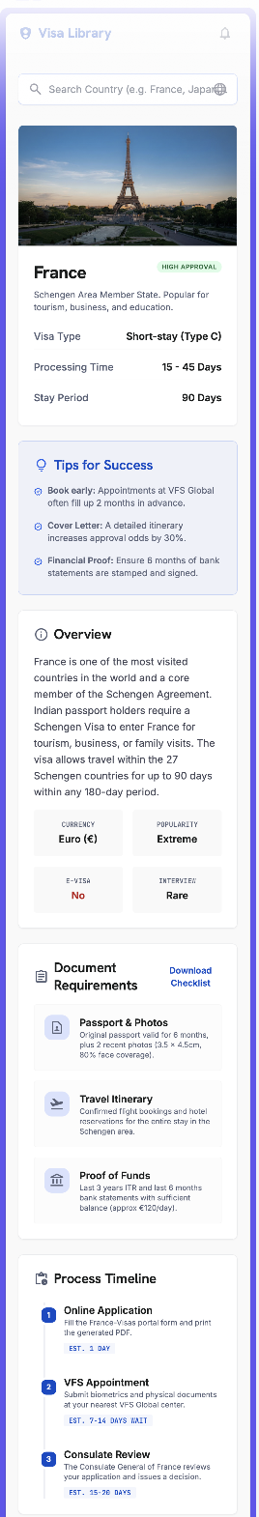

4.20 Automatic Flags & Warnings

The app surfaces the following advisory flags to the applicant:

Flag | Trigger
Passport expiry | Six months or less of validity remaining
Travel-date risk | Gap between travel date and passport expiry falls within six months
Salary mismatch nudge | Stated current salary does not match the uploaded payslip

Note — Customer-facing flags are advisory and do not block progress. Red-flag scoring appears only in the Final score / VisaMatrix™ report (see 5.3).

Element Detail — 4.20 Automatic Flags & Warnings
Element Type | Element ID | Label | Type | M/O/C | Auto-Populate Source | Visible When | Enabled When | Validation / Precondition | On Click / On Change | Next / Result | Source (config) | Editable By | Error / Fallback | Dev Notes
Process | flg_engine | Auto flags & warnings | Process | — | Auto during scoring/upload | During scoring / upload | — | Per risk & document rules (AD-30/31/32) | Raise flag on trigger | Flag on score/report | Scoring / Doc engine | Admin (rules) | — | Runs server-side
Warning | flg_passport | Passport expiry warning | Warning | — | Auto from passport expiry vs travel | Expiry < 6 mo beyond travel | — | Passport-expiry rule | Show warning | — | Scoring engine | — | — | Advisory + −20 penalty
Flag | flg_fraud | FraudShield hard flag | Flag | — | Auto from document intelligence | Tampered/fake doc detected | — | Fake/tampered document | Hard reject flag | — | Scoring engine | Admin | — | Highest severity

4.21 Field Validation
- Field-level validation is applied on every input — mandatory/optional rules, format checks (email, mobile, passport number, dates), range limits, date logic (e.g. expiry after issue; travel end after start), and file type/size on uploads.
- The detailed rule per field is defined in 5.6 and in the per-screen Element Detail tables under each screen.

Element Detail — 4.21 Field Validation
Element Type | Element ID | Label | Type | M/O/C | Auto-Populate Source | Visible When | Enabled When | Validation / Precondition | On Click / On Change | Next / Result | Source (config) | Editable By | Error / Fallback | Dev Notes
Reference | fv_ref | Field validation summary | Reference | — | — | — | — | Consolidated rules per 5.6 + the per-screen Element Detail tables above | — | — | Admin — Field Sets (AD-26) | Admin | — | Per-field rules live in each screen table

5. Business Rules

5.1 Authentication & Access
- OTP-based sign-in only (email or mobile), with Google as an alternative.
- Suspended or blacklisted accounts are blocked at the platform level.

5.2 Data Handling
- Auto-save as the user types; resume any application from where it was left.

5.3 VisaScore™ Scoring Engine
VisaScore™ = Financial Strength 25% + Travel History 24% + Document Readiness 17% + Employment Stability 14% + Trip Details 10% + Personal Profile 5% + Others 5%. Each dimension is scored 0–100, then weighted to a final 0–100. Risk penalties are applied after the weighted score.

- VisaScore™ Lite (Indicative) — five parameters (Financial Strength, Travel History, Employment Stability, Trip Details, Personal Profile). Output: Low / Medium / High. No risk levels, no flags.
- Final VisaScore™ — all seven factors plus the risk-penalty layer.
- The score is calculated for the primary applicant only; co-applicants are captured but not individually scored, and one scoring token is consumed for the primary applicant.
- Scoring is calculated for the primary applicant only. Co-applicants are captured for the application record and are not individually scored.

Dimension Scoring Rules
Dimension (Weight) | Sub-Criteria & Scoring Rules | In Lite?
Financial Strength (25%) | Bank-balance consistency, income vs trip cost, ITR match, no sudden large deposits, sponsor strength. Stable 3–6 mo balance +25 · income supports trip cost +25 · ITR matches credits +20 · no funds parking +20 · clear savings/assets +10. | Yes
Travel History (24%) | Previous international travel, prior Schengen/US/UK/Canada/Australia visa, no overstays, regular return. Strong history +40 · prior developed-country visa +30 · no rejection/overstay +20 · pattern matches profile +10. | Yes
Document Readiness (17%) | Passport validity, complete checklist, cover letter, insurance, hotel/flight reservations, profile-specific docs. Passport valid +15 · mandatory docs complete +35 · financial docs +20 · profile docs +20 · consistent formats +10. | No
Employment Stability (14%) | Job/business stability, tenure, income proof, leave/business proof, employer or CA verification. Stable employment +30 · income proof +25 · leave/business proof +20 · employer/CA docs +15 · strong return obligation +10. | Yes
Trip Details (10%) | Clear purpose, logical itinerary, stay matches profile, hotel & transport plan, budget vs capacity. Clear purpose +25 · realistic itinerary +25 · trip cost affordable +20 · correct consulate +20 · supporting bookings +10. | Yes
Personal Profile (5%) | Family ties, property/assets, dependents in India, age/profile risk, prior compliance. Strong family ties +25 · property/assets +25 · dependents +20 · stable residence +15 · no adverse history +15. | Yes
Others (5%) | Reserved, configurable factor — aspect and sub-rules to be defined by the client. Editable in Admin. | No

Risk-Penalty Layer
Trigger | Penalty | Notes
Funds parking | −15 to −25 | Scaled by amount, timing and whether the source is explained
Missing ITR | −10 to −20
Previous visa rejection | −10 to −25
Passport validity issue | −20 | ≤ 6 months validity
Missing major document | −10 to −20
Previous overstay | −30 to −50
Fake / tampered document | High risk / reject flag | FraudShield™ hard flag

Final VisaScore™ Bands
Band | Label | Meaning
80–100 | Strong Readiness | High approval probability
72–79 | Good Approval Probability | Minor gaps, overall strong
58–71 | Moderate Readiness | Fix gaps before applying
Below 58 | High Rejection Risk | Corrections strongly recommended
Below 40 | Do Not Apply | High chance of refusal

Final calculation: Weighted Score − Risk Penalties = VisaScore™ (0–100).

Re-score / credit logic: after the original score, the user or agent may edit the profile and regenerate one time free; from the second regeneration onward it is paid / token-consumed per plan. One passport = one credit. A profile edit is required to regenerate.
Country Weightage & Bands
- Country visited tiers: maximum — Europe/USA/UK/Australia; mid — Japan/Korea/Singapore; minimum — Thailand/Malaysia/Indonesia.
- Destination difficulty: higher — US, UK, Australia, EU/Schengen, Canada; medium — Japan, Korea, Singapore, Dubai.
- Experience bands: <2 yrs (lowest) · 2–5 · 8–10 · 10+ (highest). Salary bands: ≤₹50k · ₹50k–₹1.5L · ₹1.5L–₹2.5L · ₹3.5L+.
- Boosters: graduate, married, property. Funds benchmark ≈ €100 per person per day.

5.4 Reporting
- Multi-page VisaMatrix™ report; shareable & verifiable by WhatsApp, email, link or PDF with report-ID / QR verification.
- Agency-referred reports show ‘Powered by VisaReady’ with the agency’s branding; direct (B2C) reports show VisaReady branding only.

5.5 Readiness Positioning
- Assessment, not a guarantee — VisaReady measures preparedness; final decisions rest solely with the relevant embassy or authority. Stated on every report.

5.6 Field Validation Rules
Field Group | Validation
First / Last name | First name mandatory (letters, spaces, hyphen); last name optional
Email / mobile | Format + OTP verification; mobile with country code
Passport number / dates | Alphanumeric format; expiry after issue; expiry-vs-travel flag
Income / balance / turnover | Selected from configured range dropdowns; no free text
Travel dates | End date after start date; trip within passport validity
Existing visa expiry | Valid date; future or flagged if expired
Uploads | PDF / JPG / PNG; max 10 MB each; mandatory items enforced before submit
⚠ Client Input Required — Confirmation of the complete per-field validation matrix and any country-specific rules.

5.7 Pricing
Plan | Price | What You Get
VisaReady Lite | Free | Mobile app / WhatsApp Connect / Web Portal. A few Q&A to get the indicative VisaScore as a tentative probability.
Starter | ₹299 – ₹499 / token | VisaScore only, generated from detailed data + OCR documentation, validated with data. Cost by visa category (tourist / business / student) and pack (single / couple / family).
Advance | ₹499 – ₹799 / token | VisaScore + full VisaMatrix™ report, from detailed data + OCR. Cost by visa category and pack (single / couple / family).

B2B (SaaS user licence): Standard ₹2,500/mo (25 tokens, no carry-forward) · Growth ₹5,000/mo (75 tokens, carry-forward) · Professional ₹50,000/yr (1,000 tokens). Alternate B2B model: pay-as-you-use revenue share of the B2C plan by volume.
⚠ Client Input Required — Exact per-token price within each range and the precise couple / family pack multipliers.

6. Integrations & Compliance

6.1 Integrations
- WhatsApp Business API — conversational bot and report delivery.
- Document verification — OCR extraction with document-integrity checks.
- Payment gateway for scoring and processing fees; platform services (scoring, country, content) sourced from the Admin Portal.

6.2 Data, Security & Compliance
- Encryption — all personal and financial data is encrypted. Financial details are never shared with third parties.
- Document integrity — OCR and verification checks on every uploaded document.
- Regulatory — compliant with applicable data-protection requirements (e.g. DPDPA) and data-residency rules.

7. Client Inputs Required & Open Questions
The following inputs and decisions are needed to finalise configuration and begin development.

7.1 Content
- Final Terms of Use, Privacy Policy and Disclaimer copy (v5.0 draft provided in 4.4).
- WhatsApp bot conversation script (the full question set).
- Schengen / country-selection footnote final wording (beyond the Schengen rules already drafted).
- Per-country Library content (visa-process guidance) and the Library country list.
- Support assistant Q&A set; client philosophy text and any user-facing footnotes.

7.2 Configuration
- Supported countries and display order; full ‘all destinations’ list; popular-list confirmation.
- Visa types and form fields per destination; city-dropdown value sets.
- Income, balance, turnover and gross-income / ITR range definitions.
- Final scoring weights and the country / salary / experience / booster bands; risk-flag logic.
- Destination-intelligence content per country (embassy rules, insurance, financial benchmark, processing time, biometrics, multi-entry).

7.3 Commercial
- Exact B2C per-token pricing within ₹299–₹799; family/couple pack definitions; scoring vs processing fee; payment gateway.

7.4 Integrations & Branding
- WhatsApp Business API, document-verification and email service credentials.
- Logo (PNG), icon, colour palette and report branding assets; ‘Powered by Tech2Go’ lockup.

7.5 Open Questions
# | Remaining Question | Impacts
1 | Exact B2C per-token price within ₹299–₹799 and the couple / family pack multipliers (notes suggested ≈ ₹99 per additional passport). | 5.7
2 | Confirm regeneration counter reset behaviour after a paid regeneration (2 free, 3rd paid is confirmed). | 4.13, 5.3
3 | Where does the Library tab sit in the 5-item bottom navigation, and does it replace any existing tab? | 4.5, 4.19
4 | Confirm exact thresholds for bank-statement flags (sudden-parking % default 50, low-balance, large-credit). | 4.14
5 | Confirm which next screen each of Homemaker, Freelancer, Retired and Unemployed routes to. | 4.9
6 | Sign-off the per-screen Element Detail tables and any country-specific overrides. | Per-screen tables
7 | Provide final Terms of Use / Privacy / Disclaimer copy (the draft is in 4.4). | 4.4

Appendix B — Admin Portal & Agency Portal Dependencies
This appendix maps every point in the Customer Application where data, configuration, or actions originate from the Super Admin Portal or the Agency Dashboard. Developers and QA must ensure these integrations are in place before the relevant customer screen can function. References in brackets (e.g. AD-27) correspond to feature IDs in the respective PRDs.

B.1 Super Admin Portal — What the Customer App Receives
The Super Admin Portal is the single source of truth for all platform configuration. Nothing listed below is hard-coded in the customer app — it is fetched from the Admin backend at runtime.

B.1.1 Country & Destination Configuration
What the Customer App Uses | Where It Is Configured (Admin) | Customer Screen(s)
Supported country list and display order | Admin — Country Management | 4.8 Country Selection
Popular destinations list (UK, Canada, Schengen, Australia, Japan, Korea …) | Admin — Country Management — Popular Flag | 4.8 Country Selection
Full ‘all destinations’ searchable list | Admin — Country Management | 4.8 Country Selection
Per-destination city dropdown values | Admin — City Management per Country | 4.8 Trip Details
Schengen jurisdiction footnote text | Admin — Content / Footnotes | 4.8 Country Selection
Country-visited scoring tiers (max / mid / min) | Admin — Country Weightage (AD-39) | 4.11 Travel History, 5.3 Scoring
Destination difficulty bands (higher / medium) | Admin — Country Weightage (AD-39) | 5.3 Scoring Engine
Per-country embassy / official tracking URL | Admin — Destination Intelligence | 4.17 View Embassy Portal
Per-country Library visa-process guidance content | Admin — Library Content Management | 4.19 Library

B.1.2 Scoring Engine Configuration
What the Customer App Uses | Where It Is Configured (Admin) | Customer Screen(s)
All 7 dimension weights (Financial 25%, Travel History 24%, etc.) | Admin — Scoring Engine — Dimension Weights (AD-27) | 4.16 Final Score, 5.3
Per-dimension sub-rules and point allocations | Admin — Scoring Engine — Rule Base (AD-27) | 5.3 Scoring Engine
‘Others’ 5% factor — aspect and sub-rules | Admin — Scoring Engine — Others Slot (AD-27) | 5.3 Scoring Engine
Risk-penalty values (fund parking, missing ITR, overstay, etc.) | Admin — Risk Penalty Configuration (AD-32) | 4.14 Documents, 4.16 Final Score
Fund-parking detection threshold (default ≥ 50% in one credit) | Admin — Risk Penalty Configuration (AD-32) | 4.14 Documents
Final VisaScore™ band thresholds (80–100 Strong, 72–79 Good …) | Admin — Score Bands Configuration | 4.16 Final Score
VisaScore™ Lite — 5-parameter set used for indicative scoring | Admin — Lite Scoring Toggle | 4.13 VisaScore Lite
Salary bands for scoring (≤₹50k, ₹50k–₹1.5L …) | Admin — Country Weightage (AD-39) | 5.3 Scoring Engine
Experience bands (<2 yrs, 2–5, 8–10, 10+) | Admin — Country Weightage (AD-39) | 5.3 Scoring Engine
Booster factors (graduate, married, property) | Admin — Country Weightage (AD-39) | 5.3 Scoring Engine
Funds benchmark per person per day (≈ €100) | Admin — Destination Intelligence | 5.3 Scoring Engine

B.1.3 Dropdown Values & Range Definitions
What the Customer App Uses | Where It Is Configured (Admin) | Customer Screen(s)
Monthly earning range options | Admin — Field Value Sets (AD-26) | 4.9 Applicant Details
Annual income range options | Admin — Field Value Sets (AD-26) | 4.9 Applicant Details
Annual turnover range options | Admin — Field Value Sets (AD-26) | 4.9 Applicant Details
Average monthly income range options (freelancer) | Admin — Field Value Sets (AD-26) | 4.9 Applicant Details
Average bank balance range options | Admin — Field Value Sets (AD-26) | 4.10 Financial Profile
Existing closing balance range options | Admin — Field Value Sets (AD-26) | 4.10 Financial Profile
Fixed deposit range options | Admin — Field Value Sets (AD-26) | 4.10 Financial Profile
Mutual funds / investments range options | Admin — Field Value Sets (AD-26) | 4.10 Financial Profile
Yearly gross income / last ITR filed amount ranges | Admin — Field Value Sets (AD-26) | 4.10 Financial Profile
Sponsor monthly income range options | Admin — Field Value Sets (AD-26) | 4.9 Applicant Details
Gender, marital status, nationality dropdown values | Admin — Field Value Sets (AD-26) | 4.9 Applicant Details
Highest qualification dropdown values | Admin — Field Value Sets (AD-26) | 4.9 Applicant Details
Employer type dropdown values | Admin — Field Value Sets (AD-26) | 4.9 Applicant Details
Industry / business practice dropdown values | Admin — Field Value Sets (AD-26) | 4.9 Applicant Details

B.1.4 Pricing & Plan Configuration
What the Customer App Uses | Where It Is Configured (Admin) | Customer Screen(s)
B2C plan names, prices and inclusions (Lite / Starter / Advance) | Admin — Pricing Management | 4.15 Payment, 4.6.8 Plan
Visa category multipliers (tourist / business / student) | Admin — Pricing Management | 4.15 Payment
Pack multipliers (single / couple / family) | Admin — Pricing Management | 4.15 Payment
B2B plan definitions (Standard / Growth / Professional) | Admin — B2B Plan Management | 4.6.8 Plan
Token consumption rules (1 passport = 1 token) | Admin — Token Engine | 4.15 Payment, 5.3
Re-score credit logic (2 free, 3rd paid) | Admin — Token Engine | 4.13 VisaScore Lite, 5.3

B.1.5 Content & Platform Settings
What the Customer App Uses | Where It Is Configured (Admin) | Customer Screen(s)
Terms of Use, Privacy Policy and Disclaimer copy | Admin — Legal Content Management | 4.4 Terms of Use
VisaMatrix™ report watermark and branding assets | Admin — Branding Management | 4.16 Final Score & Report
FraudShield™, Return Assurance Score™, EmbassyFit™ intelligence layers | Admin — Report Intelligence Config | 4.16 Final Score & Report
Notification categories and channel options | Admin — Notification Configuration | 4.6.2 Notification Settings
Support WhatsApp number | Admin — Platform Settings | 4.6.9 Support
OCR confidence thresholds and field-extraction rules | Admin — OCR / Document Engine Config | 4.7 Passport, 4.14 Documents
Document auto-flagging rules and organisation logic | Admin — Document Intelligence (AD-32) | 4.14 Documents

B.1.6 Lead Management
What the Customer App Uses | Where It Is Configured / Managed (Admin) | Customer Screen(s)
Unassigned leads (no agency code) visible to Super Admin | Admin — Lead Management (AD-08) | 4.13 Agency Code
Lead transfer from Admin to an agency (Phase 2) | Admin — Lead Management (AD-08) | 4.13 Agency Code
Agency code validation (6-digit, active agencies only) | Admin — Agency Registry | 4.13 Agency Code

B.2 Agency Dashboard — What the Customer App Receives or Triggers
The Agency Dashboard is operated by travel agents and consultants. The actions agents take in their dashboard have direct visible effects inside the customer app, as listed below.

B.2.1 WhatsApp Referral & Agency Code
What the Customer Sees / Experiences | What the Agent Does in the Agency Dashboard | Customer Screen(s)
Agency code pre-filled at the Agency Code step | Agent generates and shares a unique WhatsApp referral link from their dashboard | 4.13 Agency Code, 3. WhatsApp Flow
WhatsApp bot initiates and guides the assessment | Agent enters the client’s WhatsApp number; system generates the link | 3. WhatsApp Referral Flow
Score and application attributed to the referring agent | Agent’s dashboard shows the application under their client list | 4.13, 4.16, 4.17
Agency code field accepts 6-digit code (validated against active agencies) | Admin activates agency accounts; agency codes are registered in the system | 4.13 Agency Code

B.2.2 Application Conclusion & Decision
What the Customer Sees / Experiences | What the Agent Does in the Agency Dashboard | Customer Screen(s)
Visa decision shown as Accepted / Rejected with a document image | Agent uploads the acceptance or rejection document and sets the decision status | 4.17 Conclusion Step
Application status ‘Submitted to Agent’ shown in timeline | Agent receives the application and can view it in their dashboard | 4.17 My Applications Timeline
VisaMatrix™ report carries ‘Powered by VisaReady’ + agency branding | Agent’s logo and branding are configured in their Agency Dashboard profile | 4.16 Final Score & Report

B.2.3 Lead Visibility
What the Customer Sees / Experiences | What the Agent Sees in the Agency Dashboard | Customer Screen(s)
No visible change to the customer when agency code is entered | Lead appears in the agency’s Leads section with the customer’s application details and agency name attached to the Super Admin view | 4.13 Agency Code
Customer receives no credits display; token logic is B2B-only | Agent’s token balance is deducted per passport scored; visible in agency dashboard | 4.15 Payment, 5.3

B.3 Quick-Reference Summary
A one-page summary of which portal is responsible for each category of data flowing into the customer app.

Category | Super Admin Portal | Agency Dashboard
Country & city lists | ✓ Configured here | —
Scoring engine weights & rules | ✓ Configured here (AD-27) | —
Risk penalty values | ✓ Configured here (AD-32) | —
Score band thresholds | ✓ Configured here | —
All dropdown & range values | ✓ Configured here (AD-26) | —
Pricing & plan definitions | ✓ Configured here | —
Token & re-score logic | ✓ Configured here | —
Legal content (T&C, Privacy, Disclaimer) | ✓ Configured here | —
Library content (per country) | ✓ Configured here | —
Embassy tracking URLs | ✓ Configured here | —
OCR & document intelligence rules | ✓ Configured here (AD-32) | —
Notification categories & channels | ✓ Configured here | —
Support WhatsApp number | ✓ Configured here | —
Agency code generation & sharing | — | ✓ Agent generates link
WhatsApp referral link | — | ✓ Agent sends to client
Lead visibility (with agency code) | ✓ Also visible to Admin | ✓ Primary owner
Lead management (no agency code) | ✓ Unassigned — Admin assigns | —
Lead transfer between agencies | ✓ Admin action (Phase 2) | —
Visa decision upload (Accepted / Rejected) | — | ✓ Agent uploads document
Report branding (agency logo) | — | ✓ Set in agency profile
Token balance (B2B) | ✔ Token engine managed by Admin | ✓ Agent’s balance visible here

Note — All items marked ✓ in the Super Admin Portal column must be configured and published before the corresponding customer screen can render correctly. Items in the Agency Dashboard column depend on the agent having an active, verified account with the correct permissions.

Client Input

7.1 terms : *VisaReady Terms Of Use*
1. *Accurate Information*
Users must provide accurate, complete, and truthful information. VisaReady relies on submitted details to generate reliable AI-powered visa readiness assessments and recommendations.
2. *Service Disclaimer*
VisaReady provides predictive guidance, document assistance, and preparedness insights only. We do not offer legal advice or guarantee visa approvals, appointments, or outcomes.
3. *User Responsibilities*
Users must review all recommendations before submission. Fraudulent documents, false information, or misuse of the platform may result in account suspension or termination.
4. *Acceptance of Terms*
By accessing or using VisaReady, you confirm acceptance of these Terms of Use, our Privacy Policy, and all applicable platform policies.
User Consent Checkbox
✅ I have read and agree to the Terms of Use, Privacy Policy, and Disclaimer. I understand that VisaReady provides predictive guidance only and does not guarantee visa approval.
7.1 3rd point
Schengen / country-selection footnote final wording For travel to the Schengen Area, the visa application follows well-established jurisdiction rules. The decision is based on your itinerary—not your preferred embassy.
Rule 1: Main Destination (Primary Rule)
Apply to the country where you will spend the most nights.
Example:
* France – 5 nights
* Italy – 3 nights
* Switzerland – 2 nights
✅ Apply to France.
Rule 2: Equal Stay
If you will spend the same number of nights in multiple Schengen countries, apply to the country where you will first enter the Schengen Area.
Example:
* Italy – 3 nights
* France – 3 nights
* Flight: Delhi → Rome
✅ Apply to Italy.
Rule 3: Single Country Visit
If you visit only one Schengen country:
✅ Apply to that country’s embassy or visa center.
7.1 of 4th point
Per-country Library content (visa-process guidance) and the Library country list.
https://drive.google.com/drive/folders/1qU7BO5kq_sYI2wvXyltPmW74emsdCW1s?usp=sharing
7.2 of 1sr point country option of all country and priority country in Shenanigan option place country in alphabetical also all country alphabetical
Which country or region are you planning to visit?
Please select one:
1.⁠ ⁠🇦🇺 Australia
2.⁠ ⁠🇨🇦 Canada
3.⁠ ⁠🇪🇺 Europe (Schengen Area)
4.⁠ ⁠🇯🇵 Japan
5.⁠ ⁠🇳🇿 New Zealand
6.⁠ ⁠🇸🇬 Singapore
7.⁠ ⁠🇦🇪 United Arab Emirates (UAE)
8.⁠ ⁠🇬🇧 United Kingdom (UK)
20 popular Schengen tourist countries in alphabetical order:
🇦🇹 Austria
🇧🇪 Belgium
🇨🇿 Czech Republic
🇩🇰 Denmark
🇫🇮 Finland
🇫🇷 France
🇩🇪 Germany
🇬🇷 Greece
🇭🇺 Hungary
🇮🇸 Iceland
🇮🇹 Italy
🇱🇺 Luxembourg
🇲🇹 Malta
🇳🇱 Netherlands
🇳🇴 Norway
🇵🇱 Poland
🇵🇹 Portugal
🇪🇸 Spain
🇸🇪 Sweden
🇨🇭 Switzerland
In master login super admin keep option to add more country to populate in front end for visa applicant to get more country VisaScore option
7.2 of 2nd point Visa types and form fields per destination

Purpose
Why are you travelling?
•⁠ ⁠Tourism (Tourist)
•⁠ ⁠Business
•⁠ ⁠Family Visit
•⁠ ⁠Student
•⁠ ⁠Transit
•⁠ ⁠Conference
•⁠ ⁠Cruise
7.2 of 3rd point
Income, balance, turnover and gross-income / ITR range
Below is a finalized VisaReady™️ Financial Scoring Matrix.

A. Monthly Income Range
Level Monthly Income Range Score
Poor Below ₹50,000 25
Moderate ₹50,000 – ₹99,999 50
Good ₹1,00,000 – ₹2,49,999 75
Very Good ₹2,50,000+ 100
B. Bank Balance Range
Formula:
Minimum Trip Fund = Daily Amount × Number of Tour Days
Good Bank Balance = Minimum Trip Fund × 4
Destination Daily Amount
Europe / Schengen €100 per day
United Kingdom £100 per day
Australia AU$100 per day
USA US$100 per day
Japan US$50 per day
Korea US$50 per day
Bank Balance Scoring
Level Balance Compared to Minimum Trip Fund Score
Poor Less than 1× 25
Moderate 1× to below 2× 50
Good 2× to below 4× 75
Very Good 4× or above 100
C. Business Annual Turnover
Level Annual Business Turnover Score
Poor Below ₹25 lakh 25
Moderate ₹25 lakh – ₹99 lakh 50
Good ₹1 crore – ₹5 crore 75
Very Good Above ₹5 crore 100
D. Gross Annual Income by ITR
Level Gross Annual Income as per ITR Score
Poor Below ₹6 lakh 25
Moderate ₹6 lakh – ₹12 lakh 50
Good ₹12 lakh – ₹30 lakh 75
Very Good Above ₹30 lakh 100
Example
For a 10-day Europe trip:
Minimum Trip Fund = €100 × 10 = €1,000
Very Good Balance = €1,000 × 4 = €4,000
Final bot message:
“For your 10-day Europe trip, your minimum trip fund should be €1,000. To score Very Good in VisaReady™️, your bank balance should ideally be €4,000 or above.”
Keep option in super admin panel to change the logic of poor / moderate / good / very good as per visiting country of each financial aspect
7.2 of 4th point
Final scoring weights and the country / salary / experience /booster bands & risk-flag logic.
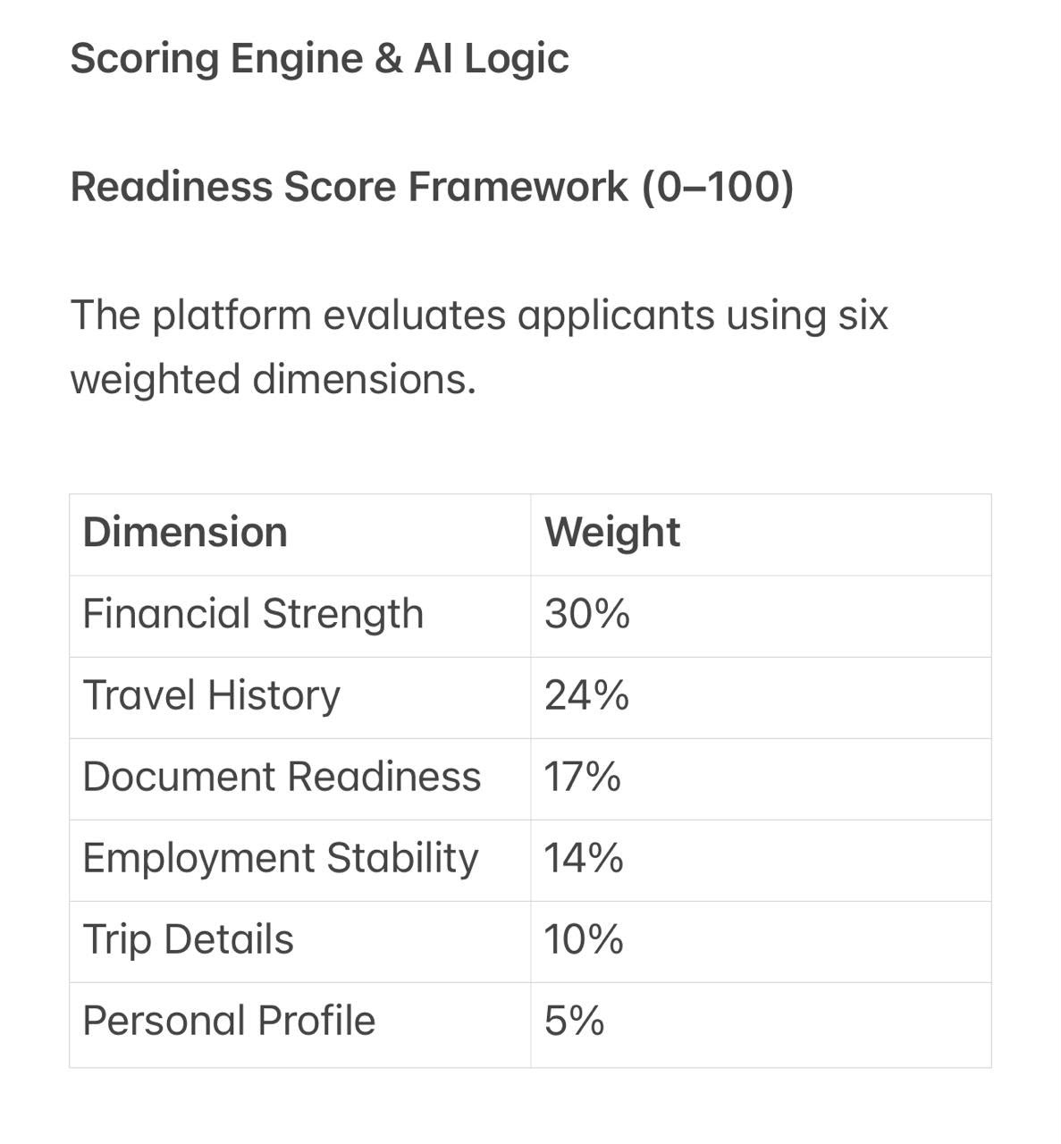

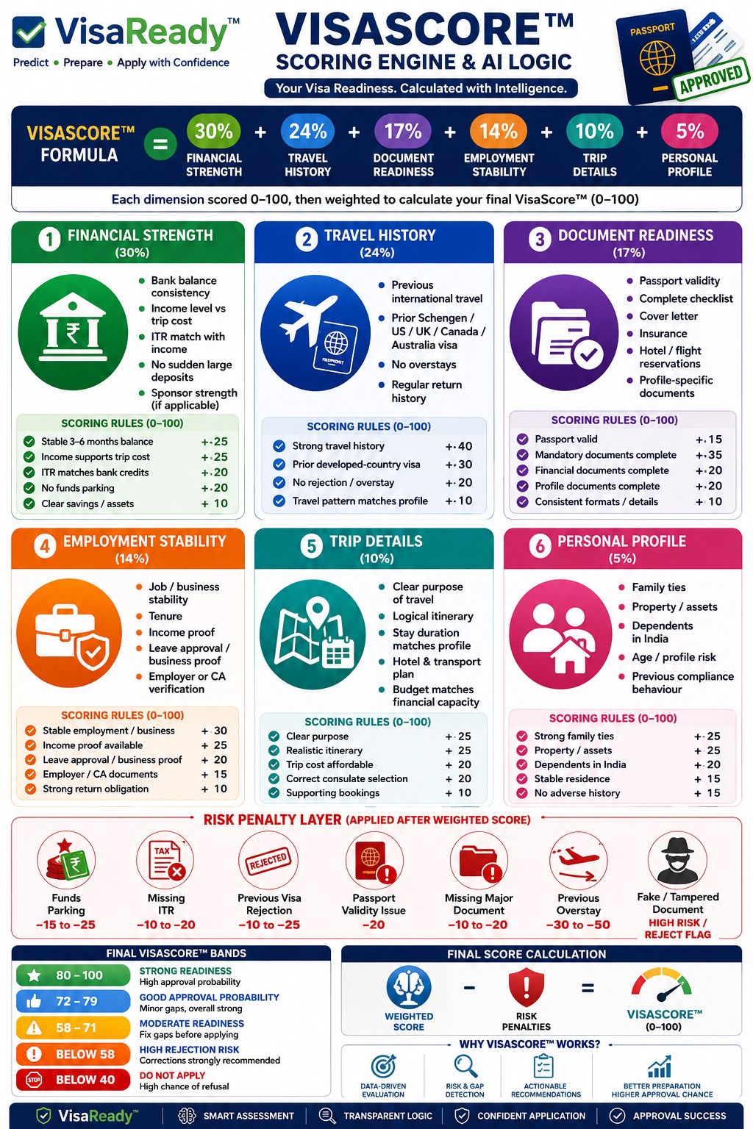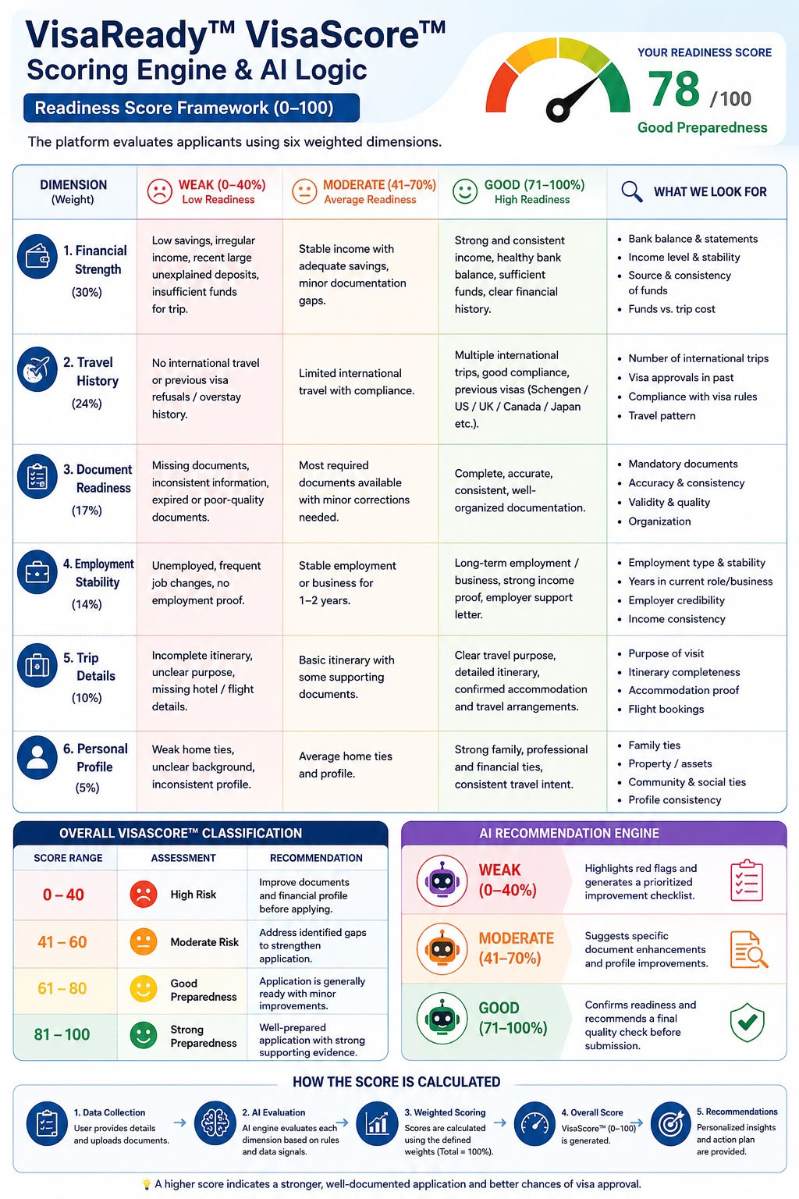

7.2 of 5th point
Destination-intelligence content per country (embassy rules, insurance, financial benchmark
SAME AS ABOVE AS ON DATE ONCE GO TO MARKET WILL CHANGE AS PER AGENCY / EMBASSY/ VFS guidelines
7.3 of 1st point
Pricing:
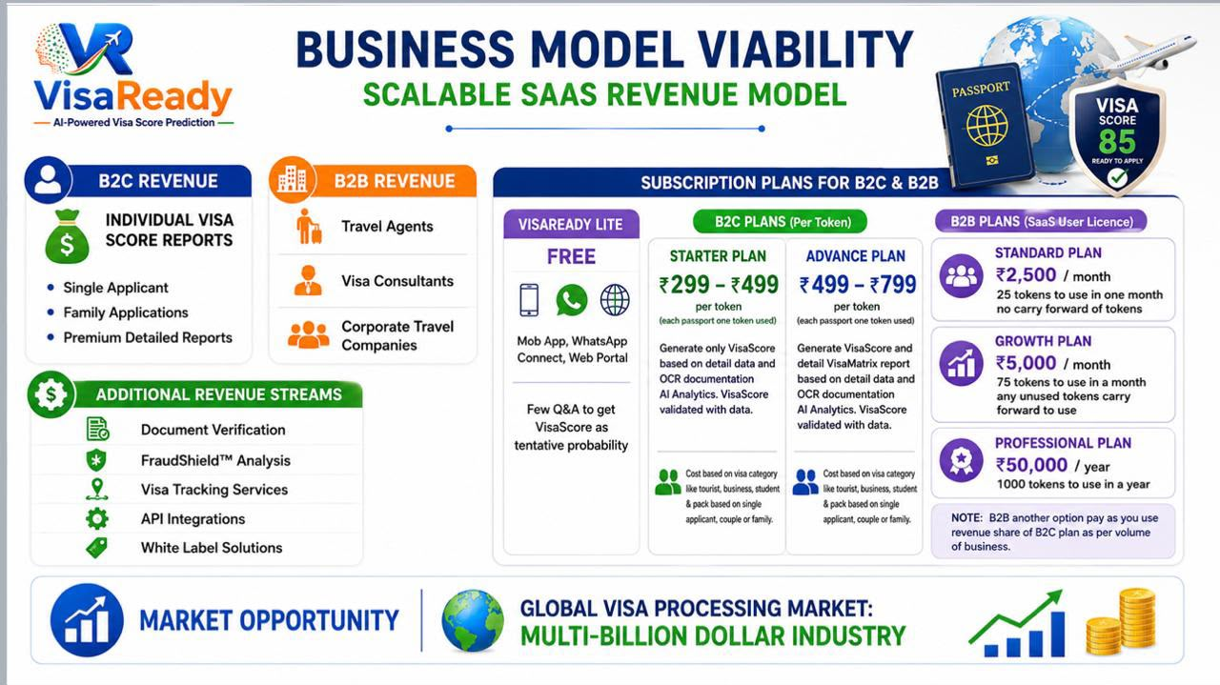
VisaScore- Lite is free where no documentation upload except passport that also optional can enter passport detail of own
Paid :Option -1: VisaScore as per upload document with AI analysis of all doc to generate score for one passport one token of any primary applicant upload his or her spouse or family but need VisaScore only of primary applicant so one token used for B2C price Rs 299 but need visa score of spouse also of uploaded documents then combo up to 1+3 passport use use 1 token but charges @ Rd 499 for B2C Option - 2: Generate VisaScoreand VisaMatrix report both of one passport one token @ Rs 499 of combo of up to 1+3 charges @ Rs 799 will get separate score & report if uploaded each person documentation as per flow
For B2B simple one passport one token one case no will get both score and report with red flag option

7.2 of 5th point red flag in VisaMatrix report to raise concerns few May be missing will add during field trial when populate data:
https://drive.google.com/drive/folders/1qIIJhWe4nw53gvUxssjvYTAGyBD9OaeM?usp=share_link
Integrations & Branding:
WhatsApp Business API, document-verification and email service credentials.
ADVISE WHAT YOU NEED FROM US FOR WHATSAPP BUSINESS API TO GET
EMAIL TO USE INFO@VISAREADY.GLOBAL ALREDY WORKING IF YOU NEED ACCESS CAN SHARE DETAIL
Logo (PNG), icon, colour palette and report branding assets; ‘Powered by Tech2Go’ lockup.
SENDING CREATIVE OF MOCK-UP FOR OPENING SCREEN FYI REFERENCE SENDING PNG LOGO BELOW
https://drive.google.com/drive/folders/1zs-uCrlll90IOnvmlNoUrvsF0NBCSmz2?usp=share_link
FAQ for latter phases :
https://drive.google.com/drive/folders/1MdgqfgvKd_rXy_RtIS21updpDBuCznZf?usp=sharing
Additional info shared by Client plus doc for whatsapp:
Agency WhatsApp trigger flow take a note when agency send trigger the country to apply visa and visa type to select is optional reason in few cases agency which do not know apply from which country since not aware of client travel plan once visa applicant fill data it will be captured and agency have option to change any applicant who came to dashboard can change which country visa and visa type if required May be client filled wring as per rule not followed
https://drive.google.com/drive/folders/1T_lNRLOnBacI0ZPhrAND2pTVeANgGDVm?usp=share_link
7.5 point 2
Confirm regeneration counter reset behaviour after a paid
regeneration (2 free, 3rd paid is confirmed).
ONLY ALLOW ONE MORE TIME MEANS TOTAL 2 TIMES ONLY NOT MORE
7.5 point 3
Where does the Library tab sit in the 5-item bottom navigation,
and does it replace any existing tab? If it is a challenge to position bottom give any tab insted of library term it Knowledge Base i hope given option at bottom of FAQ it is important
7.5 point 4
Confirm exact thresholds for bank-statement flags
(sudden-parking % default 50, low-balance, large-credit).
Sudden parking trigger logic 50% of correct balance or more deposit in last 45 days if that kind of amount deposit every month +/- 10% of that amount then is not a sudden deposit
7.5 point 7
Provide final Terms of Use / Privacy / Disclaimer & Terms of VisaReady platform use copy (the v4.0
draft is in 4.4).
As below
*VisaReady Terms & Disclaimer Of Use*
1. *Accurate Information*
Users must provide accurate, complete, and truthful information. VisaReady relies on submitted details to generate reliable AI-powered visa readiness assessments and recommendations.
2. *Service Disclaimer*
VisaReady provides predictive guidance, document assistance, and preparedness insights only. We do not offer legal advice or guarantee visa approvals, appointments, or outcomes.
3. *User Responsibilities*
Users must review all recommendations before submission. Fraudulent documents, false information, or misuse of the platform may result in account suspension or termination.
4. *Acceptance of Terms*
By accessing or using VisaReady, you confirm acceptance of these Terms of Use, our Privacy Policy, and all applicable platform policies.
User Consent Checkbox
✅ I have read and agree to the Terms of Use, Privacy Policy, and Disclaimer. I understand that VisaReady provides predictive guidance only and does not guarantee visa approval.
7. Client Inputs Required & Open Questions
Resolved 28 June: B2B token allotments are confirmed as 25 / 75 / 1,000 (Standard / Growth /
Professional). The earlier slide-vs-notes discrepancy is closed.

YES FOLLOW THIS

7.1 Onboarding & Verification
•
Exact list of mandatory onboarding documents; GST + PAN validation rules (format + any live
verification).

NO LIVE VERIFICATION REQUIRED GST & PAN IS OK

7.2 Credits & Pricing
•
Confirm credit deduction counter reset (2 free, 3rd paid is confirmed).

YES

•
Credit pack definitions; scoring vs processing fee per country/visa type; low-credit threshold

TRIGGER WHEN LAST 5 TOKEN LEFT OF STANDARD PLAN AND 15 LEFT FOR GROWTH PLAN AND 50 LEFT FOR PROFESSIONAL PLAN TO SHOW IN AGENCY DASHBOARD COLOUR CHANGE TO BRING ATTENTION
and
removal policy.
Whether the agency can self-switch Credit-Based vs Pay-Per-Use, or it is platform-set; payment
gateway for recharge.
AGENCY SEND REQUEST FROM DASHBOARD TO SUPER ADMIN TO REFILL IF ON PAYMENT SUPER ADMIN WILL SEND PAYMENT LINK ONCE PAID TOKEN WILL CREDIT IN AGENCY DASHBOARD. Reson of it in B2B business need payment flexibility including price advantage and credit
7.3 Promo Codes & Leads
Promo-code allocation model (count per agency, validity, reuse) and the delivery email template.
Whether agencies are notified of new leads (email/WhatsApp) and the lead SLA before it returns to
the Admin pool.
PROMO CODE NEED LOGIC TO MAP IT NEED TO MATCH WITH AGENCY CODE TO GET PROMO CODE ADVANTAGE ACTIVATED OTHERWISE IN MARKET PROMO CODE WILL BE MISUSED
7.4 Users, Integrations & Branding
•Granular sub-user permission list and default template; WhatsApp Business API credentials and link
format; ‘Powered by VisaReady’ lockup; logo constraints.
IN CASE OF WHATSAPP TRIGGER FROM AGENCY DASHBOARD ALREDY GIVEN PDF DOC
IN TEMPLATE CAN USE POWERED BY VISAREADY
7.5 Open Questions for the Client
# Question Impacts
1 Are the 25 free credits one-time on approval only, or repeated
on each renewal? Screen 2, §4
ONE TIME ONBOARDING IF TO ADD MORE FREE CREDIT SUPER ADMIN CAN
2 Confirm the regeneration counter reset behaviour (2 free, 3rd
paid is confirmed). §4.1
ONLY 2 TIME
3 Promo-code allocation: how many codes per agency, validity,
and reuse rules? §4.4
SINGLE PROMO CODE MAP WITH AGENCY CODE TO ACTIVATE PROMO CODE

4 Passport-data export: which recipients are permitted, and
what consent/audit is required? Screen 14
NO NEED OF CONSENT NOW WILL PLAN IN PHASE 2 NOW PLAN EXPORT DATE FROM DASHBOARD SELECTING CASE NO TO SEND ANOTHER DASHBOARD BY AGENCY CODE TO POPULATE IN ANOTHER AGENCY DASHBOARD CAN SEND EXCEL SHEET IN E MAIL WITH SUBJECT LINE TO WRITE FOR DASHBOARD TEMPLATE
5 Lead notifications and SLA before an unworked lead returns to
the Admin pool. Screen 16, §6# Question Impacts
SUPER ADMIN WILL SEND LEAD TO ANY AGENCY BY AGENCY CODE TO TRANSFER TO OTHER AGRNCY DASHBOARD TO SHOW
6 Does the 6-digit code allow enough capacity for projected
agency volume? Screen 1, §5
YES - 6-digit numeric code (100000–999999, no leading zero): 900,000 unique codes
Client ans in capital
.21. Client Inputs Required & Open Questions:
The following require client confirmation before development on the affected screens.
Resolved 28 June: the scoring model is the confirmed editable rule base — 7 factors (Financial 25%,
Travel 24%, Document 17%, Employment 14%, Trip 10%, Personal 5%, Others 5%) — and B2B tokens are
25 / 75 / 1,000. The earlier 6-vs-7 and slide-vs-notes items are closed.
# Open item Blocking screen(s)
1 Range bands and dropdown value sets for every
configurable customer-form field AD-26
2 Aspect and sub-rules for the new ‘Others’ factor
(currently a 5% placeholder) AD-27
3 Confirm Lite/Final parameter split and Lite
Low/Med/High thresholds AD-27, AD-28
4
Country-visited & destination-difficulty tiers,
experience/salary bands, booster values, funds
benchmark
AD-39
5 Risk triggers + penalty points (passport-expiry,
travel-date already drafted) AD-30, AD-31
6
Bank-statement flag thresholds (sudden-parking %
default 50, low balance, large credit) + accepted proof
types
AD-32
7 Country requirement content + any other
source-of-information (SOI) AD-33
8 Document checklists per visa type for all destinations AD-34
9 Cover-letter copy (UK / Canada / Australia) and any
itineraries beyond the Schengen seed AD-41
10 Per-country Library content and country list AD-63
11 Final Terms of Use / Privacy / Disclaimer copy AD-64
12 Report branding asset (logo for watermark) and
VisaMatrix section order AD-65
13 Lead-assignment policy: SLA before an unworked
agency lead returns to the unassigned pool AD-08
14 Exact pricing within the confirmed B2C ranges and
couple/family pack multipliers
AD-42
15 Promo-code allocation model and delivery emailz
template
AD-62# Open item 16 Payment gateway (Razorpay assumed): API keys +
webhook config 17 Notification events + preferred channel per event 18 DPDPA retention period and erasure-job SLA 19 Final list of destination countries at MVP launch 20 Per-country embassy / official tracking URLs (for the
app’s ‘View Embassy Portal’ link)
*THESE POINTS ON THURSDAY DISCUSSION WILL TRY TO CLOSE NEED TO UNDERSTAND THE QUERY WELL TO FRAME ANSWER*

