VisaReady™ Customer application doc

VisaReady™
Customer Application
Predict. Prepare. Travel with Confidence.

Product Requirements Document

Platform | iOS, Android & WhatsApp
Phase | MVP
Version | v5.0
Status | Final — For Client Approval
Audience | Customer Application
Powered by | Tech2Go
Date | 29 June 2026

Contents
1. Product Overview
2. User Types & Journeys
3. WhatsApp Referral Flow
4. Screen Specifications
4.1 Splash
4.2 Onboarding
4.3 Login & Sign Up
4.4 Terms of Use & Consent
4.5 Home Dashboard
4.6 Profile
4.6.1 Edit Profile
4.6.2 Notification Settings
4.6.3 Privacy Settings
4.6.4 Personal Information
4.6.5 Passport Information
4.6.6 Address Information
4.6.7 Travel Preferences
4.6.8 Plan
4.6.9 Support
4.6.10 Logout
4.7 Passport (Application Step 1)
4.7a Co-Applicant / Family Management
4.8 Country, Visa & Trip Details (Step 2)
4.9 Applicant Details (Step 3)
4.10 Financial Profile (Step 4)
4.11 Travel History (Step 5)
4.12 Home Ties (Step 6)
4.13 Agency Code & VisaScore™ Lite
4.14 Document Checklist & Upload
4.15 Payment
4.16 Final Score & VisaMatrix™ Report
4.16a Score Improvement
4.17 My Applications & Conclusion
4.18 Reports
4.19 Library
4.20 Automatic Flags & Warnings
4.21 Field Validation
5. Business Rules
6. Integrations & Compliance
7. Client Inputs Required & Open Questions
Appendix B — Admin Portal & Agency Portal Dependencies

1. Product Overview
VisaReady is an AI-powered visa readiness platform that helps travellers understand and improve their visa eligibility before they apply. The customer application guides each user through a structured assessment, produces an indicative readiness score (VisaScore™ Lite), supports document upload and verification, and delivers a comprehensive readiness report (VisaMatrix™) with clear, personalised recommendations.

1.1 The Experience
- Assess — A guided self-declaration covering passport, destination, profile, finances, travel history and home ties.
- Score — An instant VisaScore™ Lite indicative result showing Low / Medium / High likelihood.
- Verify — Document upload with OCR and integrity checks for a verified, decision-grade assessment.
- Report — A multi-page VisaMatrix™ readiness report, shareable by WhatsApp, email, link or PDF.
- Refer — Agents can onboard clients through a WhatsApp link; every application maps back to the agent.

1.2 Platform Context
Product | Audience | Role
Customer Application | Travellers / applicants | This document — the mobile app, WhatsApp experience, and the customer web app (full parallel web application with the same features as the mobile app).
Agency Dashboard | Travel agencies & consultants | Manage clients, credits and reports.
Super Admin Portal | VisaReady platform team | Configure scoring, countries, pricing and content.

2. User Types & Journeys

2.1 User Types
- New User — First-time visitor with no prior application.
- Returning User — Has saved or completed applications; resuming or starting fresh.
- Agency-Referred User — Arrived through an agent's WhatsApp link or agency code.
- Direct (B2C) User — Self-registered without an agency code.

2.2 End-to-End Journey
Step | Stage
1 | Splash — routes to onboarding or login based on session
2 | Onboarding — three slides; one is a “How VisaReady Works” flowchart (first-time users only)
3 | Login / Sign Up — First & Last name, then email or mobile OTP, or Google
4 | Terms & Conditions + Privacy Policy — accept after reading
5 | Home Dashboard — begin from ‘Start New Application’
6 | Step 1 — Passport (OCR; co-applicant scan + form when multi)
7 | Step 2 — Country & Visa (multi-select; Schengen footnote)
8 | Step 3 — Applicant Details (passport auto-fill; user-type routing)
9 | Step 4 — Financial Profile (incl. gross income / ITR range)
10 | Step 5 — Travel History (existing-visa capture)
11 | Step 6 — Home Ties (multi-select commitments)
12 | Agency Code (optional) → VisaScore™ Lite (Indicative)
13 | Document Checklist & Upload (intelligent organisation + flags)
14 | Payment (token consumption per plan)
15 | Final VisaScore™ & VisaMatrix™ Report
16 | Application tracking → Conclusion (outcome capture)

Note — After the indicative score, the applicant uploads documents and completes payment to unlock the verified score and full report. Two regenerations are free; the third onward is paid.

3. WhatsApp Referral Flow
Agents can invite clients to begin entirely within WhatsApp. The VisaReady bot guides the client through the assessment conversationally, then hands off to the web application for the score, documents and report. Every application is automatically attributed to the referring agent.

Step | Actor | Action
1 | Agent | In the Agency Dashboard, enters the client’s WhatsApp number; the system generates a unique link.
2 | Agent | Shares the link with the client over WhatsApp.
3 | Client | Taps the link; a chat opens with the VisaReady bot.
4 | Bot | Guides the client through the steps, confirming each answer and showing progress.
5 | Bot | On completion sends a deep link: ‘Tap to see your VisaScore™ Lite.’
6 | Client | Opens the web application (not asked to download the app); the agency code is pre-filled and the indicative score is shown and details mapped to the customer portal which he fills .
7 | System | Maps all captured detail to the agency, the application and Super Admin wherever needed; notifies the agent.

After the WhatsApp flow the user is redirected to the customer web application and can view the score there; they are not prompted to install the mobile app.

⚠ Client Input Required — WhatsApp Business API credentials and the bot conversation script (question set and replies).

4. Screen Specifications
All screens in this section apply to both the mobile app and the customer web app; the web app is a full parallel application with the same features.

4.1 Splash
01 | Splash

Purpose — First screen on launch; routes the user by session state.

Layout
- Brand logo (PNG) positioned at the top of the screen.
- Enlarged shield icon with a tick mark, reinforcing trust and readiness.
- Tagline ‘AI-Powered Visa Readiness Platform’ beneath the shield.
- ‘Powered by Tech2Go’ footnote at the bottom.
- Slim loading indicator.

Behaviour
- Valid session → Home Dashboard. No session → Onboarding (first-time) or Login (returning).
- On first run, applicant details are populated from the passport via OCR — no manual key-in of passport fields.

Element Detail — 4.1 Splash
Element Type | Element ID | Label | Type | M/O/C | Auto-Populate Source | Visible When | Enabled When | Validation / Precondition | On Click / On Change | Next / Result | Source (config) | Editable By | Error / Fallback | Dev Notes
Image | spl_logo | VisaReady logo | Image | — | — | Always | — | — | Auto-advance after asset load + session check | Home (valid session) / Onboarding (first) / Login | App asset | — | Retry on asset load failure | Max splash 2.5s; then route
Process | spl_session | Session check | Process | — | — | On launch | — | Valid JWT & not expired | Evaluate token, route | Home / Onboarding / Login | Auth service | — | No/expired session → Login/Onboarding | Check secure storage token; refresh if near expiry

Mockups (just ui reference may need to add element mention in req , or remove extra applied for all screens

4.2 Onboarding
02 | Onboarding Carousel

Purpose — Introduces the value of VisaReady to first-time users only.

Slides (three total)
- Know Your Chances — readiness scoring.
- How VisaReady Works — a simple flowchart slide (Fill Steps → Score → Upload Docs → Verified Report).
- Submit Smarter, Travel More — confident applications.

Navigation
- Dot indicators; ‘Next’ on the first two slides, ‘Get Started’ on the last. ‘Skip’ goes straight to Login.

Element Detail — 4.2 Onboarding
Element Type | Element ID | Label | Type | M/O/C | Auto-Populate Source | Visible When | Enabled When | Validation / Precondition | On Click / On Change | Next / Result | Source (config) | Editable By | Error / Fallback | Dev Notes
Carousel | onb_slides | Feature slides | Carousel | O | — | First launch only | — | — | Swipe / Next | Next slide → Login | Admin content | Admin (content) | Skip → Login | 3–4 slides; store 'seen' flag so shown once
Button | onb_skip | Skip / Get Started | Button | M | — | Always | Always | — | On click → Login | Login & Sign Up | App | — | — | Persist onboarding-complete flag

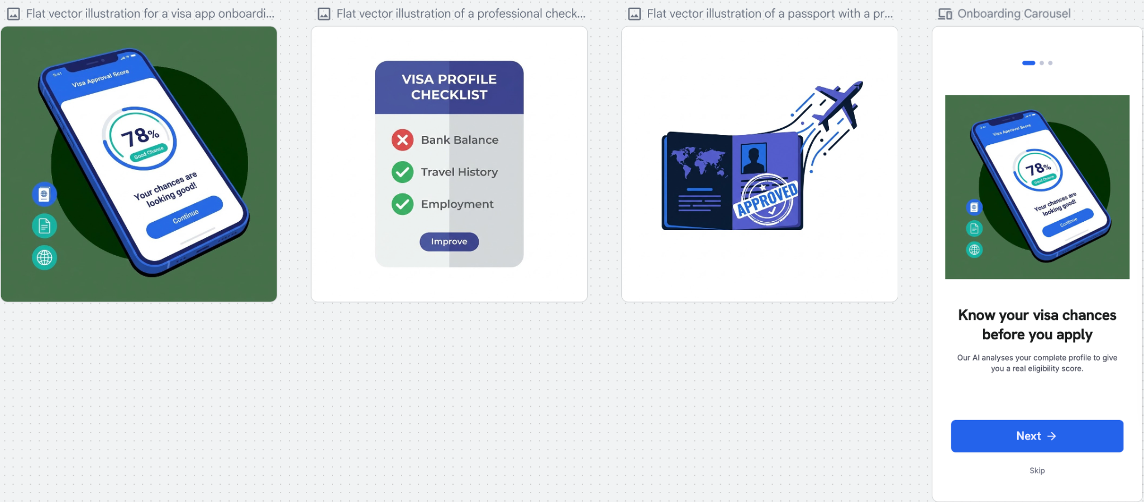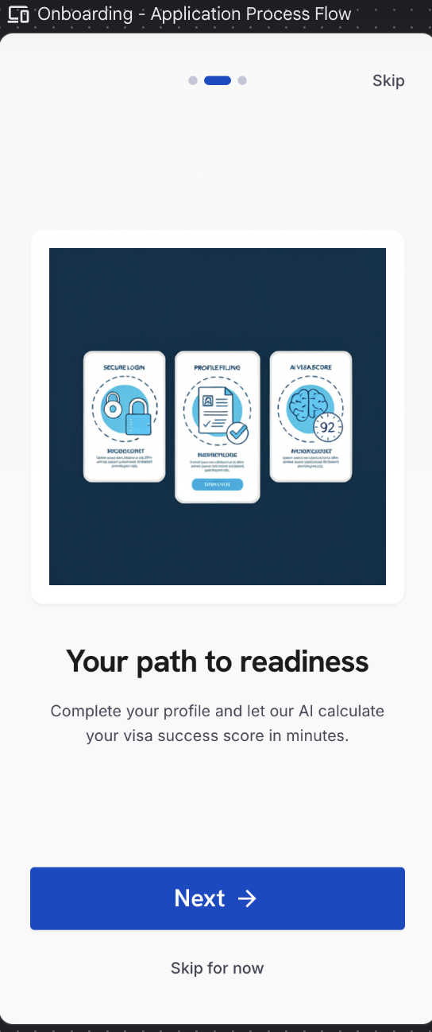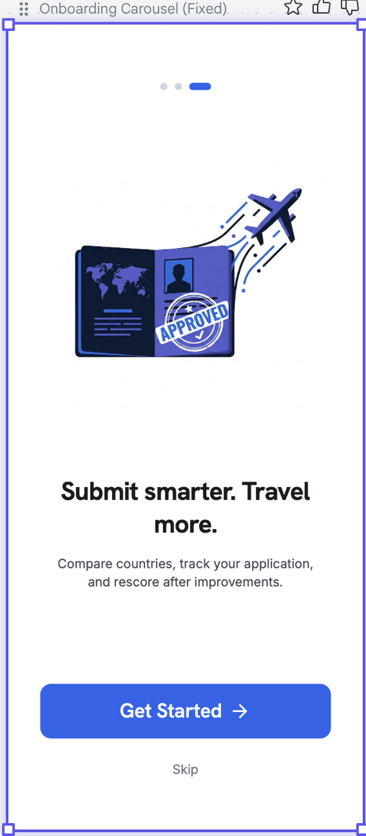

4.3 Login & Sign Up
03 | Login & Sign Up

Purpose — Authenticates users through OTP — no passwords.

Sign-In Options
- Email + 4-digit OTP (primary)
- Mobile number + 4-digit OTP
- Google Sign-In

Sign-Up Fields
- First Name (mandatory) and Last Name (optional).

Behaviour
- OTP screen: four digit fields, 30-second resend timer, up to three attempts, then account verification.
- On first sign-up, the user accepts the Terms of Use, Privacy Policy and Disclaimer via a single consent checkbox (see 4.4) before proceeding.

Element Detail — 4.3 Login & Sign Up
Element Type | Element ID | Label | Type | M/O/C | Auto-Populate Source | Visible When | Enabled When | Validation / Precondition | On Click / On Change | Next / Result | Source (config) | Editable By | Error / Fallback | Dev Notes
Input | log_email | Email | Email | C | From Google profile if Google path | Email path chosen | Always | Valid email; unique; OTP-verified | On submit send 4-digit OTP | OTP entry | User | User | Invalid format inline error | Rate-limit OTP sends
Input | log_mobile | Mobile number | Phone | C | — | Mobile path chosen | Always | Country code + 10 digits; OTP-verified | On submit send OTP | OTP entry | User | User | Invalid number inline error | E.164 storage
Button | log_google | Google Sign-In | OAuth | O | — | Always | Always | Google account auth | Launch Google OAuth | Home / Terms (first time) | Google | — | OAuth fail → retry | Pull name+email to prefill sign-up
Input | log_first | First name | Text | M | Google profile / passport OCR (later) | Sign-up | Always | Letters/spaces/hyphen; ≥ 2 chars | On change validate | — | User / Google | User | Required error if empty | Prefill from Google given_name
Input | log_last | Last name | Text | O | Google profile | Sign-up | Always | Letters/spaces/hyphen | On change validate | — | User / Google | User | — | Prefill from Google family_name
Input | log_otp | OTP | Numeric | M | — | After OTP sent | After send | 4 digits; 30s resend; max 3 attempts then verify block | Verify OTP | Terms (first) / Home | Auth service | — | Wrong OTP → attempts remaining; lock after 3 | Server-side OTP validation & attempt counter

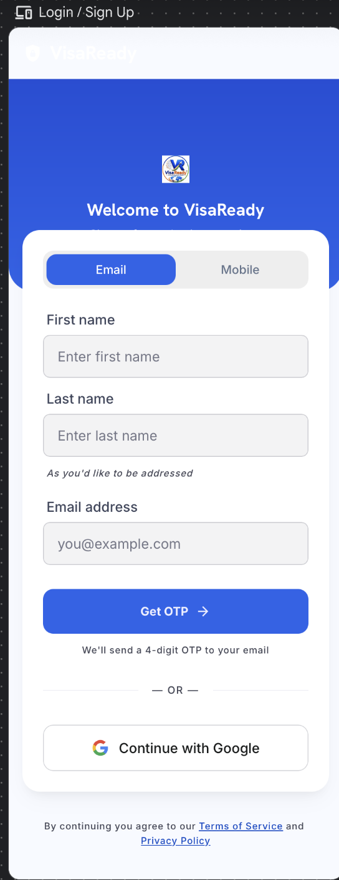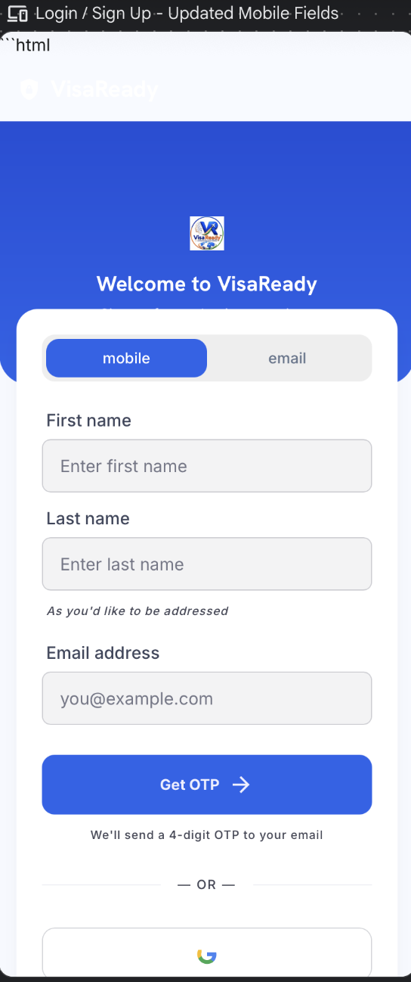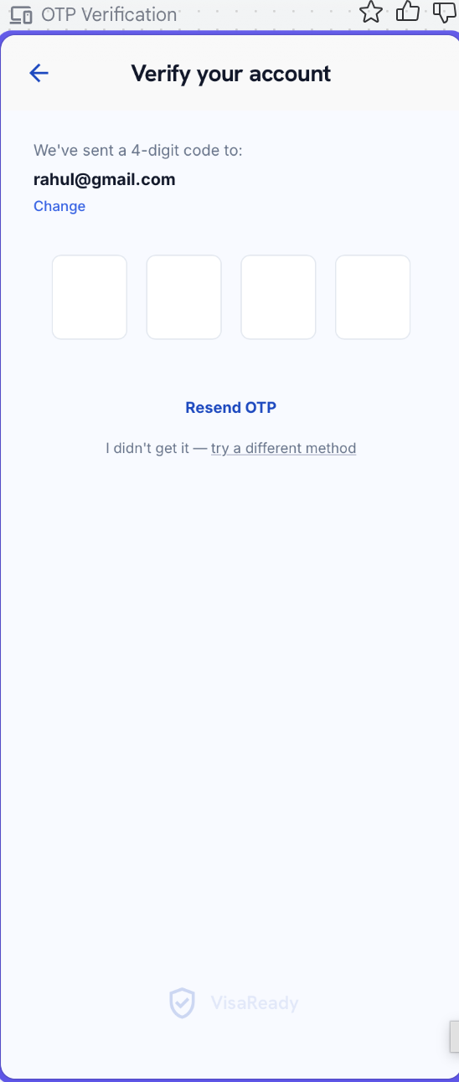

4.4 Terms of Use, Consent & Disclaimer
04 | Terms of Use & Consent

Purpose — Captures informed consent before any data is processed. Presented after sign-up and linked from Profile › Privacy.

Terms of Use (confirmed copy)
- Accurate Information — Users must provide accurate, complete and truthful information. VisaReady relies on submitted details to generate reliable AI-powered visa readiness assessments and recommendations.
- Service Disclaimer — VisaReady provides predictive guidance, document assistance and preparedness insights only. It does not offer legal advice or guarantee visa approvals, appointments or outcomes.
- User Responsibilities — Users must review all recommendations before submission. Fraudulent documents, false information or misuse of the platform may result in account suspension or termination.
- Acceptance of Terms — By accessing or using VisaReady, the user confirms acceptance of these Terms of Use, the Privacy Policy and all applicable platform policies.

Consent Checkbox (required to proceed)
☑ CONSENT — “I have read and agree to the Terms of Use, Privacy Policy and Disclaimer. I understand that VisaReady provides predictive guidance only and does not guarantee visa approval.”

Behaviour & Validation
- The full policy is scrollable; ‘Accept & Continue’ activates only after the user scrolls to the end and ticks the consent checkbox. Permissions (camera, storage, notifications) are requested in context.
- Acceptance is timestamped and stored against the user record (consent log) for compliance (DPDPA).

⚠ Client Input Required — Final Terms of Use, Privacy Policy and Disclaimer copy (the wording above is the client-approved draft).

Element Detail — 4.4 Terms of Use, Consent & Disclaimer
Element Type | Element ID | Label | Type | M/O/C | Auto-Populate Source | Visible When | Enabled When | Validation / Precondition | On Click / On Change | Next / Result | Source (config) | Editable By | Error / Fallback | Dev Notes
Rich text | tou_policy | Terms / Privacy / Disclaimer | Rich text | — | — | After sign-up; Profile › Privacy | — | Scroll-to-end tracked before enabling Accept | Track scroll position | — | Admin — Legal CMS (AD-64) | Admin | — | Version each doc; store version accepted
Checkbox | tou_consent | Consent checkbox | Checkbox | M | — | Always | After full scroll | Must be ticked | On tick enable Accept | — | User | User | Cannot proceed until ticked | —
Button | tou_accept | Accept & Continue | Button | M | — | Always | After scroll + tick | Writes consent log (user, version, timestamp) — DPDPA | On click store consent | Home Dashboard | App | — | Blocked until enabled | Re-prompt if legal version changes
Prompt | tou_perm | Runtime permissions | System prompt | C | — | In context (camera/storage/notif) | — | OS-level permission | Request when feature used | — | OS | — | Denied → feature-specific fallback | Ask at point-of-use, not upfront

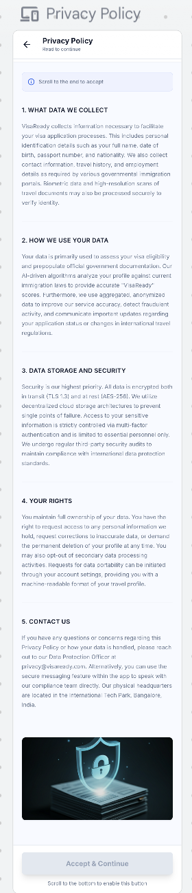

4.5 Home Dashboard
05 | Home Dashboard

Purpose — The user’s home base for starting and resuming applications.

Header
- VisaReady branding on the left; notification bell and profile icon on the right.
- The score is shown consistently across screens on the 0–100 scale. The Home Dashboard "Preliminary Eligibility Score" is the indicative (Lite) read; Score Improvement operates on the application's fuller score. Display format (with "%") is standardised across both.

New User
- Greeting ‘Hi [First Name]’; application overview showing the steps; primary action ‘Start New Application’.
- Trust line reads ‘Protected — your data is encrypted.’

Returning User
- Active application cards with ‘Continue’ and current step; quick actions(start application view reports); current score with ‘View Improvement Score’.,Visa Readiness card — shows the preliminary eligibility score with a readiness label (e.g. "Needs Improvement") and an Improve Score button that opens Score Improvement (4.16a).

Bottom Navigation
- Home · My Applications · Reports · Library · Profile

Co-Applicant
- When the user selects multi-applicant / co-applicant, they can scan each co-applicant’s passport and complete a separate form for each — opened after the primary applicant’s form is done.
- Scoring is calculated for the primary applicant only. An ⓘ info icon next to the score notifies the user of this. Tapping reveals: ‘The VisaScore reflects the primary applicant’s profile. Co-applicants are captured for the application record but are not individually scored.’

Element Detail — 4.5 Home Dashboard
Element Type | Element ID | Label | Type | M/O/C | Auto-Populate Source | Visible When | Enabled When | Validation / Precondition | On Click / On Change | Next / Result | Source (config) | Editable By | Error / Fallback | Dev Notes
Button | hom_new | Start New Application | Button | M | — | Always | Always | — | On click → Passport Step 1 | Passport (Step 1) | App | — | — | Primary CTA
List | hom_apps | Applications summary | List | O | User applications | Has applications | — | — | On tap open case | My Applications | User data | — | Empty state if none | Show latest status per case
Card | hom_score | Latest VisaScore card | Card | O | Scoring engine (last score) | Score exists | — | — | On tap open report | Final Score & Report | Scoring engine | — | Hidden if no score | Show band + date
Tab bar | hom_nav | Bottom navigation | Tabs | M | — | Always | Always | — | On tap switch tab | Home/Reports/Library/Profile | App | — | — | Persist last tab

Element Type | Element ID | Label | Type | M/O/C | Auto-Populate Source | Visible When | Enabled When | Validation | On Click/Change | Next / Result | Source | Editable By | Error/Fallback | Dev Notes
Button | hom_improve | Improve Score | Button | O | Scoring engine (last score) | Score exists | Always | — | On click → Score Improvement | Score Improvement (4.16a) | App | — | Hidden if no score | On the Visa Readiness card

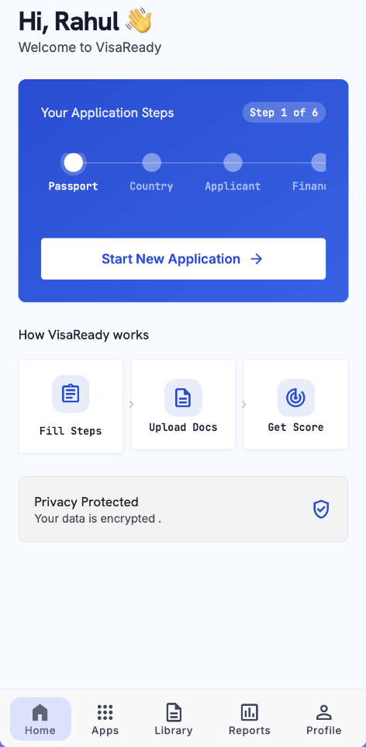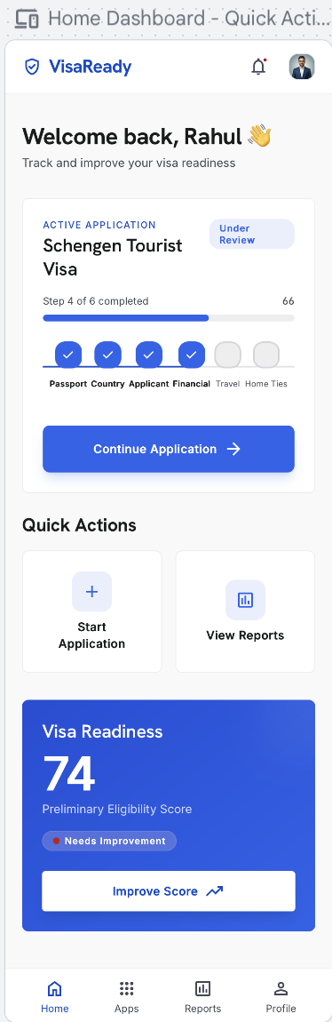

4.6 Profile
06 | Profile

Purpose — Account management hub reached from the profile icon. Displays the user’s photo, name and email at the top, with a menu of sub-sections below.

4.6.1 Edit Profile
- The user can edit their profile photo, first name, last name, email address and mobile number directly — no OTP re-verification required.
- Photo upload supports camera capture or gallery selection.
- Changes are saved immediately on confirmation.

4.6.2 Notification Settings
- Allows the user to manage which notifications they receive and through which channels.
- Notification categories include: Application status updates, VisaScore result alerts, Document verification status, Promotional offers and plan renewals.
- Channels available per category: In-App, WhatsApp, Email.
- Each category can be toggled on or off per channel independently.
- Master toggle at the top to enable or disable all notifications at once.

4.6.3 Privacy Settings
- Data-sharing consent toggle — controls whether the user’s anonymised data may be used for platform improvement.
- View Terms of Use — opens the full Terms of Use text (same as 4.4).
- View Privacy Policy — opens the full Privacy Policy.
- View Disclaimer — opens the platform disclaimer.
- Request Data Export — user can request a download of all their stored data (DPDPA compliance).
- Request Account Deletion — user can initiate a deletion request; a confirmation prompt and a 7-day cooling-off window are shown before the account is permanently removed.

4.6.4 Personal Information
- Displays and allows editing of: First Name, Last Name, Date of Birth, Gender, Marital Status, Nationality, Mobile Number, Email Address.
- Fields pre-populated from the sign-up and passport OCR data.
- Editable directly; changes saved on ‘Save’.

4.6.5 Passport Information
- Displays passport details captured via OCR at Step 1: Passport Number, Place of Issue, Date of Issue, Date of Expiry.
- The user can update these fields if details have changed (e.g., passport renewed).
- An advisory banner is shown if the passport is within six months of expiry.

4.6.6 Address Information
- Current residential address: Address Line 1, Address Line 2 (optional), City / Town, State, PIN / Postal Code, Country.
- All address fields are editable and saved for reuse across future applications.

4.6.7 Travel Preferences
- Preferred destinations (multi-select from the active country list).
- Preferred visa type (Tourist / Business / Student).
- Typical travel party size (Solo / Couple / Family).
4.6.8 Plan
- Displays the user’s current plan: Lite / Starter / Advance.
- Shows plan status (Active / Expired), validity period, renewal date, tokens or scores remaining, and purchase history.
- Actions available: Renew (current plan), Upgrade / Change Plan (opens the plan-purchase modal — see 4.15), View Invoices.

4.6.9 Support
- A single ‘Chat with us on WhatsApp’ button that opens WhatsApp directly with the VisaReady support number pre-loaded.
- No in-app FAQ or other contact options in this phase; these are deferred to a later release.

4.6.10 Logout
- Signs the user out of the application immediately.
- A confirmation prompt is shown: ‘Are you sure you want to log out?’ with Confirm and Cancel actions.
- After logout, the next launch returns to the Login screen.

⚠ Client Input Required — Final list of editable profile fields, the support WhatsApp number, and the plan-status fields (validity, renewal, usage) to display.

Element Detail — 4.6 Profile
Profile — Header & Menu
Element Type | Element ID | Label | Type | M/O/C | Auto-Populate Source | Visible When | Enabled When | Validation / Precondition | On Click / On Change | Next / Result | Source (config) | Editable By | Error / Fallback | Dev Notes
Header | pf_header | Photo / Name / Email | Display | — | Sign-up + Edit Profile | Always | — | — | — | — | User record | — | — | Header shows across sub-screens
Menu | pf_menu | Sub-section menu | Nav list | M | — | Always | Always | — | On tap open sub-screen | 4.6.1–4.6.10 | App | — | — | Deep-link each sub-screen

4.6.1 Edit Profile
Element Type | Element ID | Label | Type | M/O/C | Auto-Populate Source | Visible When | Enabled When | Validation / Precondition | On Click / On Change | Next / Result | Source (config) | Editable By | Error / Fallback | Dev Notes
Image | pf_photo | Profile photo | Image upload | O | — | Always | Edit mode | Camera or gallery; image type/size limits | On save persist | — | User | User | Upload error → retry | No OTP re-verify needed
Input | pf_first | First name | Text | M | Sign-up / OCR | Always | Edit mode | ≥ 2 chars | On save persist | — | User | User | Required error | —
Input | pf_last | Last name | Text | O | Sign-up / OCR | Always | Edit mode | Letters/spaces | On save persist | — | User | User | — | —
Input | pf_email | Email | Email | M | Sign-up | Always | Edit mode | Valid email; no OTP re-verify | On save persist | — | User | User | Invalid format | —
Input | pf_mobile | Mobile | Phone | M | Sign-up | Always | Edit mode | Country code + 10 digits; no OTP re-verify | On save persist | — | User | User | Invalid number | —

4.6.2 Notification Settings
Element Type | Element ID | Label | Type | M/O/C | Auto-Populate Source | Visible When | Enabled When | Validation / Precondition | On Click / On Change | Next / Result | Source (config) | Editable By | Error / Fallback | Dev Notes
Toggle | pf_notif_master | Master notifications | Toggle | O | — | Always | Always | — | On change cascade to all | — | App | User | — | Off disables all channels
Matrix | pf_notif_matrix | Category × Channel toggles | Toggle grid | O | — | Always | Master on | Per category per channel (In-App/WhatsApp/Email) | On change persist | — | Admin (categories) | User | — | Categories: App status, Score alerts, Doc status, Promo, Renewals

4.6.3 Privacy Settings
Element Type | Element ID | Label | Type | M/O/C | Auto-Populate Source | Visible When | Enabled When | Validation / Precondition | On Click / On Change | Next / Result | Source (config) | Editable By | Error / Fallback | Dev Notes
Toggle | pf_data_consent | Data-sharing consent | Toggle | O | — | Always | Always | Controls anonymised data use | On change persist to consent log | — | User | User | — | DPDPA log
Link | pf_view_legal | View Terms / Privacy / Disclaimer | Link | O | — | Always | Always | — | On tap open 4.4 content | Terms & Consent | Admin — Legal CMS | Admin | — | Same source as 4.4
Action | pf_export | Request data export | Action | O | — | Always | Always | DPDPA export job | On tap raise export request | Confirmation | Backend | — | Job failure → retry | Async; notify when ready
Action | pf_delete | Request account deletion | Action | O | — | Always | Always | DPDPA deletion request; confirmation required | On tap start deletion flow | Confirmation | Backend | — | — | Irreversible; grace period per policy

4.6.4 Personal Information
Element Type | Element ID | Label | Type | M/O/C | Auto-Populate Source | Visible When | Enabled When | Validation / Precondition | On Click / On Change | Next / Result | Source (config) | Editable By | Error / Fallback | Dev Notes
Input | pf_pi_first | First / Last name | Text | M | Sign-up + passport OCR | Always | Edit mode | ≥ 2 chars | On save persist | — | User / OCR | User | Required error | Pre-populated from sign-up & OCR
Date | pf_pi_dob | Date of birth | Date | M | Passport OCR | Always | Edit mode | Valid; age check | On save persist | — | User / OCR | User | Invalid date | Reused in Step 3
Dropdown | pf_pi_gmn | Gender / Marital / Nationality | Dropdown | M | Passport OCR (nationality) | Always | Edit mode | From configured lists | On save persist | — | Admin — Field Sets | User | Required error | Reused in Step 3
Input | pf_pi_contact | Mobile / Email | Mixed | M | Sign-up | Always | Edit mode | Format validation | On save persist | — | User | User | Invalid format | —

4.6.5 Passport Information
Element Type | Element ID | Label | Type | M/O/C | Auto-Populate Source | Visible When | Enabled When | Validation / Precondition | On Click / On Change | Next / Result | Source (config) | Editable By | Error / Fallback | Dev Notes
Input | pf_pp_num | Passport number | Alphanumeric | M | Passport OCR (Step 1) | Always | Edit mode | 8–9 chars uppercase | On save persist | — | OCR / User | User | Format error | Reused across applications
Text | pf_pp_issue | Place / Date of issue | Mixed | M | Passport OCR | Always | Edit mode | Issue ≤ today | On save persist | — | OCR / User | User | Future date error | —
Date | pf_pp_expiry | Date of expiry | Date | M | Passport OCR | Always | Edit mode | > issue | On save persist; recheck expiry advisory | Advisory banner if < 6 mo | OCR / User | User | — | Advisory banner when within 6 months

4.6.6 Address Information
Element Type | Element ID | Label | Type | M/O/C | Auto-Populate Source | Visible When | Enabled When | Validation / Precondition | On Click / On Change | Next / Result | Source (config) | Editable By | Error / Fallback | Dev Notes
Input | pf_addr1 | Address line 1 | Text | M | Prior application | Always | Edit mode | Non-empty | On save persist | — | User | User | Required error | Saved for reuse across applications
Input | pf_addr2 | Address line 2 | Text | O | Prior application | Always | Edit mode | — | On save persist | — | User | User | — | —
Mixed | pf_addr_city | City / State / PIN / Country | Mixed | M | Prior application | Always | Edit mode | PIN 6 digits | On save persist | — | User / Admin (lists) | User | PIN format error | Reused in Step 3 residence

4.6.7 Travel Preferences
Element Type | Element ID | Label | Type | M/O/C | Auto-Populate Source | Visible When | Enabled When | Validation / Precondition | On Click / On Change | Next / Result | Source (config) | Editable By | Error / Fallback | Dev Notes
Multi-select | pf_tp_dest | Preferred destinations | Multi-select | O | — | Always | Edit mode | From active country list | On save persist | — | Admin — Countries | User | — | Prefills Step 2 destination
Dropdown | pf_tp_visa | Preferred visa type | Dropdown | O | — | Always | Edit mode | Tourist/Business/Student | On save persist | — | Admin — Visa Types | User | — | Prefills Step 2 visa type
Choice | pf_tp_party | Typical party size | Choice | O | — | Always | Edit mode | Solo/Couple/Family | On save persist | — | App | User | — | Hints multi-applicant default

4.6.8 Plan
Element Type | Element ID | Label | Type | M/O/C | Auto-Populate Source | Visible When | Enabled When | Validation / Precondition | On Click / On Change | Next / Result | Source (config) | Editable By | Error / Fallback | Dev Notes
Display | pf_plan_cur | Current plan | Display | — | Billing record | Always | — | — | — | — | Billing | — | — | Lite/Starter/Advance + status/validity/renewal/usage
Button | pf_plan_renew | Renew | Button | O | — | Plan active/expired | Always | — | On click open purchase modal | Payment (4.15) | Billing | User | — | —
Button | pf_plan_upgrade | Upgrade / Change plan | Button | O | — | Always | Always | — | On click open plan modal | Payment (4.15) | Admin — Pricing | User | — | —
Link | pf_plan_inv | View invoices | Link | O | Billing record | Has invoices | Always | — | On tap open invoice list | Invoice (view/download PDF) | Billing | — | Empty state if none | Same invoice as 4.15

4.6.9 Support
Element Type | Element ID | Label | Type | M/O/C | Auto-Populate Source | Visible When | Enabled When | Validation / Precondition | On Click / On Change | Next / Result | Source (config) | Editable By | Error / Fallback | Dev Notes
Button | pf_support_wa | Chat on WhatsApp | Button | O | — | Always | Always | Opens WhatsApp with support number pre-loaded | On click open WhatsApp deep link | WhatsApp | Admin — Platform Settings | — | WhatsApp not installed → fallback link | No in-app FAQ this phase

4.6.10 Logout
Element Type | Element ID | Label | Type | M/O/C | Auto-Populate Source | Visible When | Enabled When | Validation / Precondition | On Click / On Change | Next / Result | Source (config) | Editable By | Error / Fallback | Dev Notes
Button | pf_logout | Logout | Button | M | — | Always | Always | Confirmation prompt (Confirm/Cancel) | On confirm clear session | Login screen | App | — | — | Clear secure token; next launch → Login

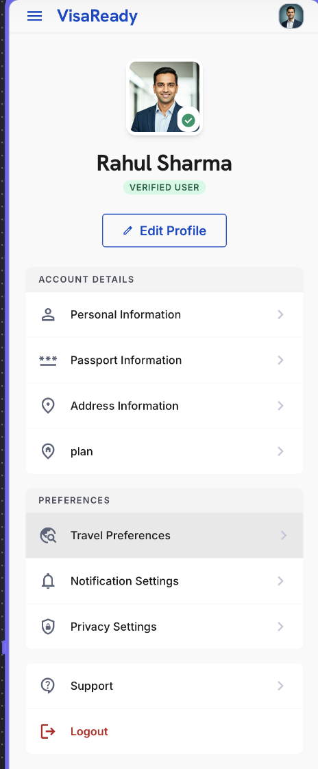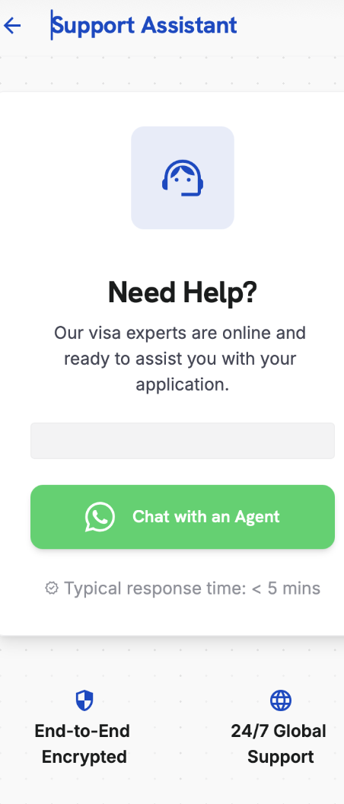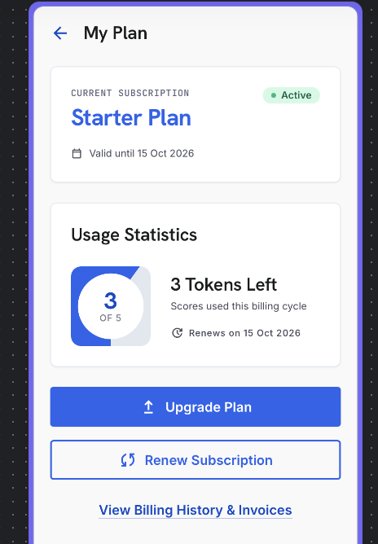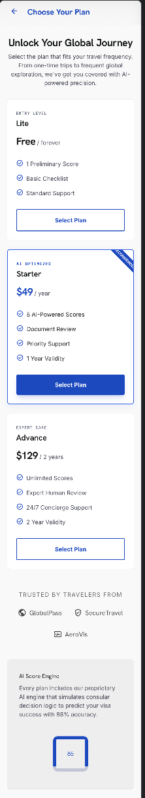(only for ui reference)

4.7 Passport — Application Step 1
07 | Passport

Purpose — Captures passport details and sets single- or multi-applicant mode.

Applicant Mode
- Single — one primary applicant.
- Multi — reveals the co-applicant capture flow. Up to five applicants can be added; each co-applicant’s passport is scanned and a separate form completed. The VisaScore is calculated for the primary applicant only.

Capture
- ‘Scan Now’ auto-fills fields using OCR; manual entry remains available. Scanning tips shown below the button.

Fields
- Passport number, place of issue, date of issue, date of expiry.
- Previous passport — declaration only (Yes / No).

OCR Review & Co-Applicant
- After a scan, an OCR Review screen lets the applicant confirm or correct extracted data (confidence indicator shown per field).
- In Multi mode, each co-applicant is scanned and reviewed, then a separate form is completed per co-applicant (‘Add Co-Applicant’, up to five).
Note — Passport validity is checked against the travel end date; the user is warned if validity is under six months beyond return (advisory; see 4.20).
Element Detail — 4.7 Passport — Application Step 1
Element Type | Element ID | Label | Type | M/O/C | Auto-Populate Source | Visible When | Enabled When | Validation / Precondition | On Click / On Change | Next / Result | Source (config) | Editable By | Error / Fallback | Dev Notes
Toggle | pp_mode | Applicant mode | Toggle | M | Profile › Travel Preferences (party size hint) | Always | Always | Single / Multi (default Single) | On change reveal co-applicant flow | Co-applicant mgmt (4.7a) if Multi | User | User | — | Party-size pref can hint default
Camera/File | pp_ocr | Passport scan (OCR) | Camera/File | O | — | Always | Always | OCR confidence threshold per Admin | On scan prefill fields | Populates fields below | OCR engine | User | Low confidence → manual entry | Prefills name, number, dates, nationality
Input | pp_number | Passport number | Alphanumeric | M | Passport OCR → also fills Profile 4.6.5 | Always | Always | 8–9 chars uppercase | On change validate | — | OCR / User | User | Format error inline | Write-back to profile passport info
Input | pp_issue_place | Place of issue | Text | M | Passport OCR | Always | Always | Non-empty | On change | — | OCR / User | User | Required error | —
Date | pp_issue_date | Date of issue | Date | M | Passport OCR | Always | Always | ≤ today | On change | — | OCR / User | User | Future date error | —
Date | pp_expiry | Date of expiry | Date | M | Passport OCR | Always | Always | > issue; flag if < 6 mo beyond travel end | On change run passport-expiry risk check | Risk flag if triggered | OCR / User | User | Expiry-risk flag/advisory | Feeds Document Readiness + risk layer
Text | pp_name | Name (as in passport) | Text | M | Passport OCR → prefills Step 3 & Profile | Always | Always | Matches passport MRZ where available | On change | — | OCR / User | User | Required error | Single source for applicant name
Dropdown | pp_nationality | Nationality | Dropdown | M | Passport OCR → prefills Step 3 | Always | Always | From list | On change | — | OCR / User | User | Required error | —
Yes/No | pp_prev | Previous passport held | Yes/No | O | — | Always | Always | Declaration | On change | — | User | User | — | —
Group | pp_coapp | Co-applicant passport | Group | C | Per co-applicant OCR | Multi mode | Multi mode | Same rules; up to 5 co-applicants | Add/edit co-applicant | Co-applicant mgmt (4.7a) | User | User | Max 5 enforced | Each co-applicant is own OCR

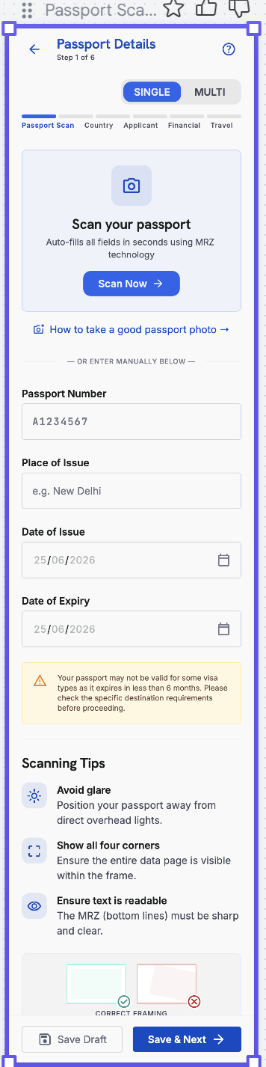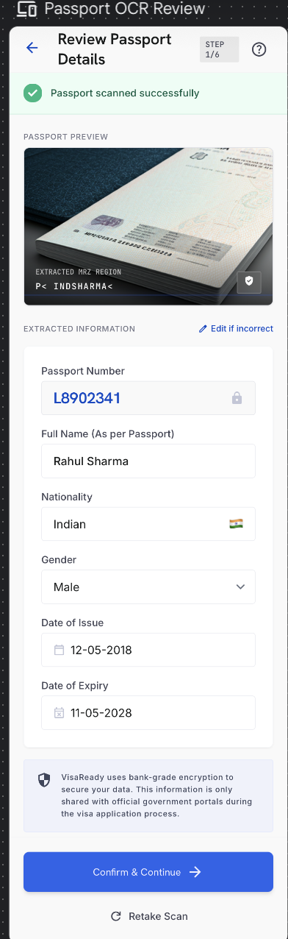

4.7a Co-Applicant / Family Management (Multi-Applicant)
07a | Co-Applicant / Family Management

Purpose — A hub to add and manage every person travelling on one application — the primary applicant plus co-applicants. It appears when the user chooses Multi-applicant at Step 1 and can be reopened any time before Payment.

WHERE IT FITS IN THE FLOW
- Opens immediately after the primary applicant’s passport scan (Step 1) when Multi-applicant is selected; the user can return to it at any point before Payment (4.15) to add or complete applicants.
- Each applicant’s own six-step form (Passport to Home Ties) is launched from this hub; on completion the user returns here.
SCREEN LAYOUT (per the family-management UI)
- Primary Applicant card — name, ’Passport Verified’, a READY badge and the VisaScore (e.g. 84%). Only the primary applicant shows an actual VisaScore.
- Co-Applicant cards — each shows name, relationship (Spouse / Child / Parent / Other), passport status (Passport Added / Passport Pending), a profile-completion ring (e.g. 79%), a warning icon when something is missing, and an action button: ’Complete Profile’ (passport added, details pending) or ’Add Passport’ (passport pending).
- Add Co-Applicant tiles — Add Spouse, Add Child, Add Parent, Add Other.
- Footer — a progress bar with ’X of 5 seats filled’ and the note ’Maximum 5 co-applicants allowed.’
Note — The percentage shown on a co-applicant card is profile completeness, not a VisaScore. Only the primary applicant is scored (see 4.5, 5.3); co-applicants are captured for the application record and are not individually scored.

ADDING A CO-APPLICANT
- Selecting a tile (Spouse / Child / Parent / Other) sets the relationship and opens that co-applicant’s form. The passport scan (OCR) is captured first, then the type-specific details below.
- A co-applicant can be removed, which frees a seat. The primary applicant cannot be removed.
Common fields — all co-applicant types
Field | Type | M/O/C | Validation
Passport scan (OCR) | Capture | M | OCR-prefilled: number, place, issue & expiry
First / Last name | Text | M / O | OCR-prefilled; first name mandatory
Date of birth | Date | M | Valid; drives minor logic for Child
Gender | Dropdown | M | From list
Nationality | Dropdown | M | From list
Relationship to primary | Auto | M | Set by the selected tile
Passport photo | Image | M | JPG / PNG up to 5 MB

Add Spouse
Field | Type | M/O/C | Validation
Marriage / relationship proof | File | M | Marriage certificate
Occupation / user type | Dropdown | M | Salaried / Self-employed / etc.
Monthly income | Range dropdown | O | For documentation only (not scored)
Shares finances with primary | Yes/No | O | —

Add Child
Field | Type | M/O/C | Validation
Minor (under 18) | Auto | — | Derived from date of birth
Birth certificate (relationship proof) | File | M | —
School / institution | Text | C | If of school age
Guardian / parent on application | Dropdown | M | Link to primary or a co-applicant
Parental consent / NOC | File | C | Required if travelling without a parent

Add Parent
Field | Type | M/O/C | Validation
Relationship proof | File | M | Document linking to the primary applicant
Dependency status | Dropdown | M | Dependent / Independent
Pension / income | Yes/No + range | O | For documentation
Funding source for trip | Dropdown | M | Self / Sponsored by primary

Add Other
Field | Type | M/O/C | Validation
Relationship description | Text | M | Free text (e.g. sibling, relative, friend)
Relationship / association proof | File | M | Supporting document
Funding source for trip | Dropdown | M | Self / Sponsored

Rule — Each co-applicant must have a passport added and the mandatory fields completed before the application can proceed to Payment. Co-applicants do not each consume a scoring token; one token is consumed for the primary applicant (see 4.15, 5.3).

⚠ Client Input Required — Confirm the maximum number of co-applicants (the UI shows up to 5 co-applicants in addition to the primary), the relationship-proof document required per type, and which co-applicant fields are mandatory versus optional.
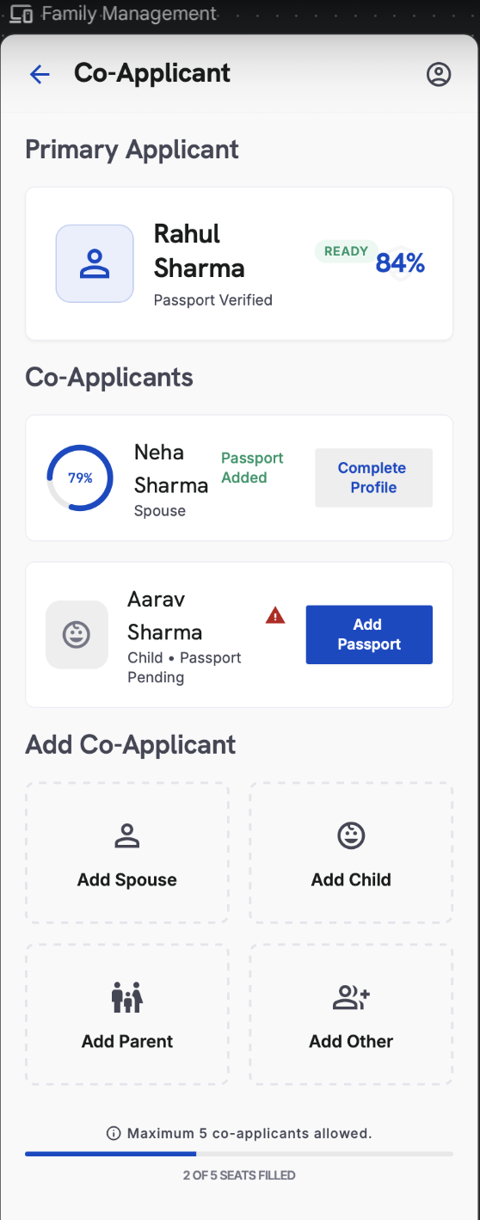

Element Type | Element ID | Label | Type | M/O/C | Auto-Populate Source | Visible When | Enabled When | Validation / Precondition | On Click / On Change | Next / Result | Source (config) | Editable By | Error / Fallback | Dev Notes
Card | ca_primary | Primary applicant card | Display | — | Step 1 passport + primary score | Multi-applicant mode | — | Shows name, 'Passport Verified', READY badge, VisaScore (e.g. 84%) | On tap open primary form | Primary six-step form | Shared record | User | — | Only the primary shows an actual VisaScore
Card | ca_coapp | Co-applicant card | Display | — | Co-applicant OCR + completion state | Co-applicant exists | — | Shows name, relationship, passport status, profile-completion ring, warning icon | On tap open action | Complete Profile / Add Passport | Shared record | User | — | Ring % = profile completeness, NOT a VisaScore
Tile | ca_add | Add Co-Applicant tiles | Action | O | — | Seats remaining | < 5 co-applicants | Add Spouse / Child / Parent / Other; sets relationship | On tap open co-applicant form (OCR first) | Co-applicant form | App | User | Blocked at 5 seats | Tile choice sets relationship
Capture | ca_ocr | Passport scan (OCR) | Camera/File | M | — | Adding co-applicant | Always | OCR-prefills number, place, issue, expiry | On scan prefill fields | — | OCR engine | User | Low OCR → manual entry | Per co-applicant
Input | ca_name | First / Last name | Text | M/O | Passport OCR | Adding co-applicant | Always | First name mandatory; letters/spaces | On change | — | OCR / User | User | Required error | —
Date | ca_dob | Date of birth | Date | M | Passport OCR | Adding co-applicant | Always | Valid; drives minor logic for Child | On change | — | OCR / User | User | Invalid date | —
Dropdown | ca_gender | Gender | Dropdown | M | Passport OCR | Adding co-applicant | Always | From list | On change | — | Admin — Field Sets | User | Required error | —
Dropdown | ca_nat | Nationality | Dropdown | M | Passport OCR | Adding co-applicant | Always | From list | On change | — | Admin — Field Sets | User | Required error | —
Auto | ca_rel | Relationship to primary | Auto | M | Set by selected tile | Adding co-applicant | — | Spouse / Child / Parent / Other | — | — | System | — | — | Determines type-specific fields below
Image | ca_photo | Passport photo | Image | M | — | Adding co-applicant | Always | JPG/PNG ≤ 5 MB | On upload | — | User | User | Type/size error | —
Group | ca_typefields | Type-specific fields | Group | C | — | Per relationship | After relationship set | Spouse/Child/Parent/Other fields (relationship proof, occupation, guardian, funding source, etc.) | On save | — | Admin — Field Sets | User | Required per type | See per-type field lists in 4.7a prose
Action | ca_remove | Remove co-applicant | Action | O | — | Co-applicant exists | Not primary | Frees a seat; primary cannot be removed | On click confirm remove | Seat freed | App | User | Primary block message | —
Progress | ca_seats | Seats-filled progress | Display | — | Auto from co-applicants added | Always | — | 'X of 5 seats filled'; max 5 | — | — | System | — | — | Footer progress bar
Gate | ca_gate | Proceed-to-Payment gate | Rule | — | Auto from completion | Always | All applicants complete | Each co-applicant needs passport + mandatory fields before Payment | On proceed validate all | Payment (4.15) | System | — | Blocks if any incomplete | Co-applicants don't each consume a token; 1 token = primary

4.8 Country, Visa & Trip Details — Application Step 2
08 | Country & Visa Selection

Purpose — Selects the destination(s) and visa type; drives the dynamic form that follows.

2a — Country Selection
- Screen heading: “Where do you want to apply for a visa? Select the country.”
- Popular destinations include UK, Canada, Europe (Schengen), Australia, Japan and Korea; full list configured by Super Admin where all destinations will be displayed.
- Multiple countries can be selected; a selected country can be changed via ‘Change’.
- Schengen jurisdiction footnote shown on this screen (see below).

Schengen Jurisdiction Footnote
Decision is based on your itinerary, not your preferred embassy. (1) Main destination: apply to the country of most nights. (2) Equal stay: apply to the country of first entry. (3) Single country: apply to that country’s embassy / visa centre.

2b — Visa Type
Heading: ‘What type of visa do you need?’ with the helper line ‘Select one — this determines your required documents.’ The selected destination is shown at top with a ‘Change’ action.
- Visa type (single-select, mandatory): Tourist / Visitor · Student · Business.
- Each option shows an icon and a one-line descriptor (e.g. Tourist — ‘Holidays, sightseeing, visiting family’; Student — ‘Full-time study at a recognised institution’; Business — ‘Meetings, conferences, professional visits’).
Note — Work / Employment visa type is not offered in this version.

2c — Trip / Travel Details
Heading: ‘Provide your planned travel dates and logistics to determine visa eligibility and validity requirements.’

Field | Type | M/O | Validation
Travel start date | Date | M | ≥ today; before end date
Travel end date | Date | M | After start; trip within passport validity
Trip duration | Auto (read-only) | — | Computed from dates (e.g. ‘15 Days’)
Primary destination city | Dropdown | M | From destination’s city list
Cities to be visited | Multi-select + Add City | O | From destination; de-duplicated
Hotel booking status | Confirmed / Not yet / Reserved | M | Single-select; ‘Not yet’ allowed
Flight booking status | Confirmed / Not yet / Reserved | M | Single-select; ‘Not yet’ allowed

Note — A Trip Summary card shows trip duration, main destinations, and a ‘booking documents ready for upload in next step’ note. ‘Save Draft’ and ‘Save & Next’ actions available.
⚠ Client Input Required — Full supported-country list and display order, the all-destinations list, the per-destination city lists, and confirmation of the three booking-status options.

Element Detail — 4.8 Country, Visa & Trip Details — Application Step 2
Step 2a — Destination Country
Element Type | Element ID | Label | Type | M/O/C | Auto-Populate Source | Visible When | Enabled When | Validation / Precondition | On Click / On Change | Next / Result | Source (config) | Editable By | Error / Fallback | Dev Notes
Multi-select | cv_dest | Destination country | Multi-select | M | Profile › Travel Preferences (preferred dest) | Always | Always | ≥ 1 from active list; Schengen footnote | On change load city list + adjust checklist | Enables city + visa | Admin — Countries (AD-20/21) | User | Required error | Prefill from saved preferences

Step 2b — Visa Type
Element Type | Element ID | Label | Type | M/O/C | Auto-Populate Source | Visible When | Enabled When | Validation / Precondition | On Click / On Change | Next / Result | Source (config) | Editable By | Error / Fallback | Dev Notes
Single-select | cv_visa | Visa type | Single-select | M | Profile › Travel Preferences (preferred visa) | Destination chosen | After destination | Tourist / Student / Business | On change rebuild document checklist | Applicant Details path | Admin — Visa Types (AD-22/23) | User | Required error | Drives checklist (AD-34) & path

Step 2c — Trip Details
Element Type | Element ID | Label | Type | M/O/C | Auto-Populate Source | Visible When | Enabled When | Validation / Precondition | On Click / On Change | Next / Result | Source (config) | Editable By | Error / Fallback | Dev Notes
Multi-select | cv_cities | Cities to be visited | Multi-select | O | Destination selection | Destination chosen | After destination | From destination's city list | On change update Trip Summary | — | Admin — Countries | User | — | City list keyed to destination
Date | cv_start | Travel start date | Date | M | — | Trip Details | Always | Valid; ≤ end date | On change compute duration | — | User | User | Start > end error | —
Date | cv_end | Travel end date | Date | M | — | Trip Details | Always | ≥ start date | On change compute duration | — | User | User | End < start error | —
Computed | cv_duration | Trip duration | Computed | — | Auto from start/end dates | After dates | — | Derived (end − start) | Recompute on change | Trip Summary | System | — | — | Feeds Trip Details scoring
Choice | cv_hotel | Hotel booking status | Choice | O | — | Trip Details | Always | Confirmed/Not yet/Reserved | On change update summary | — | User | User | — | Feeds Document Readiness
Choice | cv_flight | Flight booking status | Choice | O | — | Trip Details | Always | Confirmed/Not yet/Reserved | On change update summary | — | User | User | — | Feeds Document Readiness
Card | cv_summary | Trip summary | Card | — | Auto from all Step 2 inputs | After trip details | — | — | — | Applicant Details (Step 3) | System | — | — | Read-only recap; ‘docs ready in next step’

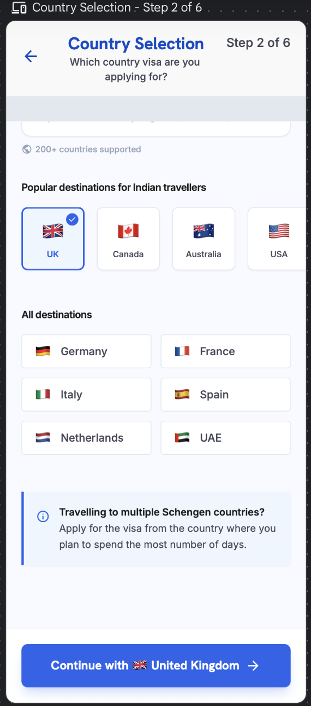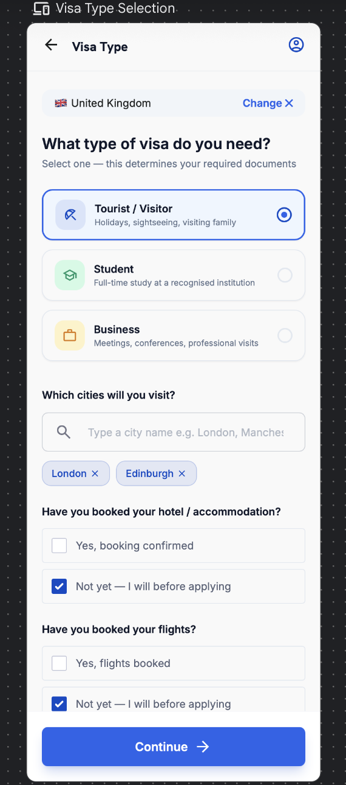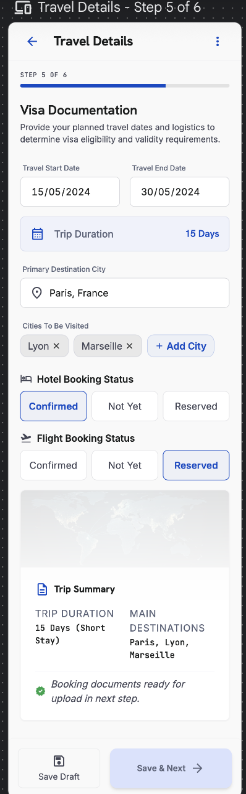

4.9 Applicant Details — Application Step 3
09 | Applicant Details

Purpose — Captures personal, employment and education details. The flow adapts to the selected user type and destination.

3a — Personal Details
- Two models on this surface: Details fetched from passport and Current details. A “Same as passport” checkbox auto-copies passport values into the current set.
- Every field available from the passport auto-fills via OCR; the user completes only what the passport does not contain.

Field | Type | M/O | Validation
First name | Text | M | Letters/spaces/hyphen; OCR-prefilled
Last name | Text | O | Letters/spaces/hyphen
Date of birth | Date | M | Valid; age ≥ 18 (else guardian flow)
Gender | Dropdown | M | From list
Marital status | Dropdown | M | Single / Married / Divorced / Widowed
Nationality | Dropdown | M | From list; OCR-prefilled
Same as passport | Checkbox | O | Copies passport values to current details
Current City of Residence | Dropdown | M | Options update by destination
State | Dropdown | M | From list
PIN / postal code | Numeric | M | 6 digits
Email | Email | M | Valid format (prefilled from account)
Mobile | Phone | M | Country code + 10 digits

3b — User Type
Options: Salaried · Self-Employed · Business Owner · Student · Retired · Unemployed · Homemaker · Freelancer.
The choice determines the next screen (3c) and the document checklist (4.14).

3c — Profile Details by User Type
Salaried
Field | Type | M/O | Validation
Company name | Text | M | ≥ 2 chars
Employer type | Dropdown | M | Private / Government / PSU / MNC / Professional
Designation | Text | M | ≥ 2 chars
Monthly earning | Range dropdown | M | Configured ranges
Annual income | Range dropdown | M | Configured ranges
Years in current role | Numeric | M | 0–50
Total work experience | Numeric / band | M | ≥ years in role
Second income | Yes/No + range | O | Range required if Yes

Self-Employed / Business Owner
Field | Type | M/O | Validation
Business name | Text | M | ≥ 2 chars
Industry / business practice | Dropdown | M | Includes ‘Other’ (free-text if chosen)
GST number | Alphanumeric | O | 15-char GSTIN format if entered
Annual turnover | Range dropdown | M | Configured ranges
Years in business | Numeric | M | 0–60
Ownership / role | Dropdown | M | Proprietor / Partner / Director

Student
Field | Type | M/O | Validation
Institution | Text | M | ≥ 2 chars
Course / programme | Text | M | ≥ 2 chars
Current year / level | Dropdown | M | From list
Expected graduation | Date / year | M | Future date
Sponsor | Dropdown | M | Self / Parent / Other (with relation)

Retired
Field | Type | M/O | Validation
Previous occupation | Text | M | ≥ 2 chars
Year of retirement | Year | M | ≤ current year
Pension / annuity | Yes/No + range | M | Range required if Yes
Other income (rent, interest, investments) | Yes/No + range | O | Range required if Yes
Primary funding source for trip | Dropdown | M | Self / Pension / Family / Savings

Unemployed
Field | Type | M/O | Validation
Currently employed | Yes/No | M | Locked to No for this type
Last employment (if any) | Text | O | —
Source of funds for trip | Dropdown | M | Self-savings / Sponsor / Family
Sponsor name & relation | Text | C | Required if sponsored
Sponsor monthly income | Range dropdown | C | Required if sponsored

Homemaker
Field | Type | M/O | Validation
Spouse / family occupation | Text | M | ≥ 2 chars
Sponsor name & relation | Text | M | Spouse / Parent / Child / Other
Sponsor monthly income | Range dropdown | M | Configured ranges
Sponsor employment proof available | Yes/No | M | Drives document checklist
Own income (if any) | Yes/No + range | O | Range required if Yes

Freelancer
Field | Type | M/O | Validation
Profession / field | Text | M | ≥ 2 chars
Primary platform / clients | Text | O | —
GST number | Alphanumeric | O | 15-char GSTIN if entered
Average monthly income | Range dropdown | M | Configured ranges
Years freelancing | Numeric | M | 0–50
ITR filed | Yes/No | M | Drives document checklist

3d — Education (all user types)
Field | Type | M/O | Validation
Highest qualification | Dropdown | M | From list
Institution | Text | O | —
Year of completion | Year | O | ≤ current year

Next-Screen Routing
User Type | Next Screen
Student | Student profile + education
Business / Self-Employed / Business Owner | Business practice details
Salaried | Employment details
Retired | Retired profile (pension / funding)
Unemployed | Unemployed profile (source of funds / sponsor)
Homemaker | Homemaker profile (sponsor details)
Freelancer | Freelancer profile (income / ITR)

⚠ Client Input Required — Confirm dropdown value sets (employer types, industry, qualifications, city lists) and any destination-specific applicant fields.

Element Detail — 4.9 Applicant Details — Application Step 3
Step 3 — Base (all applicants)
Element Type | Element ID | Label | Type | M/O/C | Auto-Populate Source | Visible When | Enabled When | Validation / Precondition | On Click / On Change | Next / Result | Source (config) | Editable By | Error / Fallback | Dev Notes
Checkbox | ad_same | Same as passport | Checkbox | O | Passport OCR (Step 1) | Always | Always | Copies passport name/DOB/nationality into details | On tick prefill from passport | — | User | User | — | Big time-saver; prefills base identity
Date | ad_dob | Date of birth | Date | M | Passport OCR / Profile 4.6.4 | Always | Always | Valid; age ≥ 18 else guardian flow | On change | — | OCR / User | User | Under-18 → guardian flow | Single DOB source
Dropdown | ad_gender | Gender | Dropdown | M | Profile 4.6.4 | Always | Always | From list | On change | — | Admin — Field Sets | User | Required error | —
Dropdown | ad_marital | Marital status | Dropdown | M | Profile 4.6.4 | Always | Always | From list | On change | — | Admin — Field Sets | User | Required error | Feeds Personal Profile score
Dropdown | ad_nat | Nationality | Dropdown | M | Passport OCR | Always | Always | From list | On change | — | Admin — Field Sets | User | Required error | —
Dropdown | ad_city | Current city of residence | Dropdown | M | Profile 4.6.6 (address) | Always | Always | Updates by destination; PIN 6 digits | On change | — | Admin — Field Sets | User | PIN format error | Prefill from saved address
Dropdown | ad_qual | Highest qualification | Dropdown | M | — | Always | Always | From list | On change | — | Admin — Field Sets | User | Required error | Feeds Personal Profile
Dropdown | ad_usertype | User type | Dropdown | M | — | Always | Always | 9 options incl. Homemaker, Freelancer | On change reveal matching path sub-form | Path sub-form below | Admin — Field Sets | User | Required error | Determines which sub-table below shows

Step 3 — Salaried / Employee path
Element Type | Element ID | Label | Type | M/O/C | Auto-Populate Source | Visible When | Enabled When | Validation / Precondition | On Click / On Change | Next / Result | Source (config) | Editable By | Error / Fallback | Dev Notes
Dropdown | ad_s_emp | Employer type | Dropdown | C | — | User type = Salaried | After user type | From list | On change | — | Admin — Field Sets | User | Required error | Visible only for Salaried
Text | ad_s_desig | Designation | Text | C | — | User type = Salaried | After user type | Non-empty | On change | — | User | User | Required error | —
Range | ad_s_income | Monthly earning | Range dropdown | M | — | User type = Salaried | After user type | Configured ranges | On change feed Financial score | — | Admin — Field Sets (AD-26) | User | Required error | Range bands from Admin
Numeric | ad_s_exp | Years in current role | Numeric/Band | M | — | User type = Salaried | After user type | ≥ 0; banded | On change feed Employment score | — | User | User | Negative error | —
Numeric | ad_s_totexp | Total work experience | Numeric/Band | M | — | User type = Salaried | After user type | ≥ 0; banded | On change | — | User | User | Negative error | —

Step 3 — Self-Employed / Business path
Element Type | Element ID | Label | Type | M/O/C | Auto-Populate Source | Visible When | Enabled When | Validation / Precondition | On Click / On Change | Next / Result | Source (config) | Editable By | Error / Fallback | Dev Notes
Text | ad_b_name | Business name | Text | C | — | User type = Business | After user type | Non-empty | On change | — | User | User | Required error | —
Dropdown | ad_b_ind | Industry | Dropdown | C | — | User type = Business | After user type | From list; ‘Other’ allowed | On change | — | Admin — Field Sets | User | — | —
Alphanumeric | ad_b_gst | GST number | Alphanumeric | O | — | User type = Business | After user type | 15-char GSTIN if provided | On change validate | — | User | User | Format error if present | Optional
Range | ad_b_turnover | Annual turnover | Range dropdown | M | — | User type = Business | After user type | Configured ranges | On change feed Financial score | — | Admin — Field Sets | User | Required error | —
Numeric | ad_b_years | Years in business | Numeric/Band | M | — | User type = Business | After user type | ≥ 0; banded | On change feed Employment score | — | User | User | Negative error | —

Step 3 — Student path
Element Type | Element ID | Label | Type | M/O/C | Auto-Populate Source | Visible When | Enabled When | Validation / Precondition | On Click / On Change | Next / Result | Source (config) | Editable By | Error / Fallback | Dev Notes
Text | ad_st_inst | Institution | Text | C | — | User type = Student | After user type | Non-empty | On change | — | User | User | Required error | —
Text | ad_st_course | Course | Text | C | — | User type = Student | After user type | Non-empty | On change | — | User | User | Required error | —
Numeric | ad_st_grad | Graduation year | Numeric | C | — | User type = Student | After user type | 4-digit year ≥ current | On change | — | User | User | Invalid year | —

Step 3 — Other user types (Retired / Unemployed / Homemaker / Freelancer)
Element Type | Element ID | Label | Type | M/O/C | Auto-Populate Source | Visible When | Enabled When | Validation / Precondition | On Click / On Change | Next / Result | Source (config) | Editable By | Error / Fallback | Dev Notes
Mixed | ad_o_fields | Type-specific fields | Mixed | C | — | User type = one of these | After user type | Fields configured per type in Admin | On change | — | Admin — Field Sets (AD-26) | User | Required per config | Field set driven by Admin per user type
Range | ad_o_income | Income / support source | Range dropdown | C | — | As configured | After user type | Configured ranges | On change feed Financial score | — | Admin — Field Sets | User | Required if configured | —

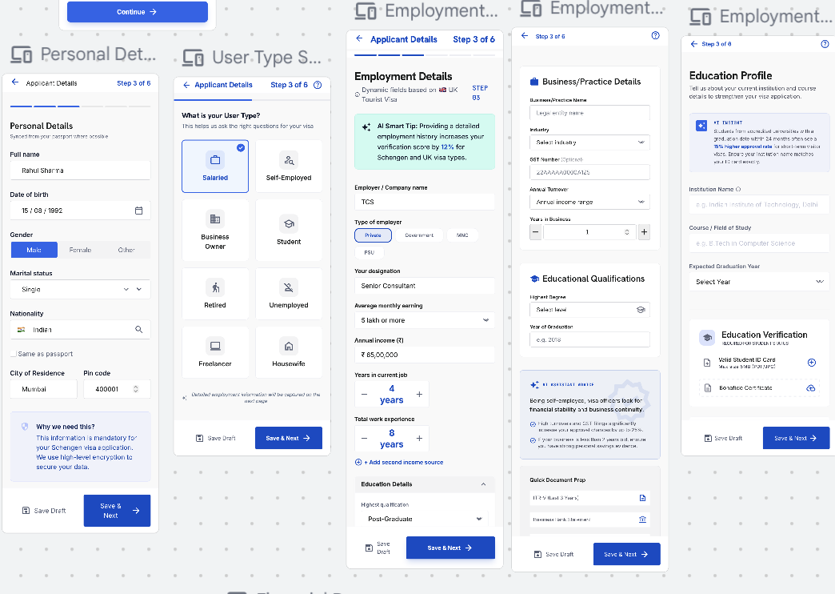

4.10 Financial Profile — Application Step 4
10 | Financial Profile

Purpose — Captures financial strength using range-based inputs for speed and consistency.

- Average bank balance (range); existing account closing balance (range).
- Fixed deposits — Yes / No + range; mutual funds / investments — Yes / No + range.
- ITR filed for the last two years — Yes / No.
- After the ITR Yes/No, a Yearly Gross Income / Last ITR Filed Amount field collected as a range dropdown (ranges configured by Super Admin).
⚠ Client Input Required — Definitions for each income, balance and turnover range.

Element Detail — 4.10 Financial Profile — Application Step 4
Element Type | Element ID | Label | Type | M/O/C | Auto-Populate Source | Visible When | Enabled When | Validation / Precondition | On Click / On Change | Next / Result | Source (config) | Editable By | Error / Fallback | Dev Notes
Range | fin_avgbal | Average bank balance | Range dropdown | M | — | Always | Always | Configured ranges | On change feed Financial score | — | Admin — Field Sets (AD-26) | User | Required error | 3–6 mo avg; feeds fund checks
Range | fin_closing | Existing closing balance | Range dropdown | M | — | Always | Always | Configured ranges | On change | — | Admin — Field Sets | User | Required error | —
Yes/No+Range | fin_fd | Fixed deposits | Yes/No + range | C | — | Always | Always | Range required if Yes | On change reveal range | — | User | User | Range required if Yes | —
Yes/No+Range | fin_mf | Mutual funds / investments | Yes/No + range | C | — | Always | Always | Range required if Yes | On change reveal range | — | User | User | Range required if Yes | —
Yes/No | fin_itr | ITR last 2 years | Yes/No | M | — | Always | Always | — | On change; No → risk flag potential | — | User | User | Required error | Missing ITR feeds risk penalty
Range | fin_gross | Yearly gross / last ITR amount | Range dropdown | M | Step 3 income (indicative) | Always | Always | Configured ranges | On change feed Financial score | — | Admin — Field Sets | User | Required error | Cross-checked vs credits for fund-parking

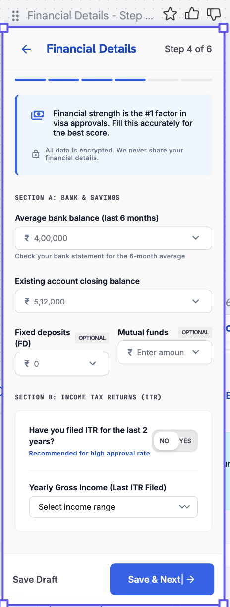

4.11 Travel History — Application Step 5
11 | Travel History

Purpose — Establishes travel record and compliance.

- Visas previously held and countries visited — searchable, multi-select.
- Countries visited is an explicit multiple-country selection; the count and tier of countries directly feed Travel-History scoring.
- After ‘Countries visited in the last 5 years’: “Do you already hold a valid visa for any country?” — dropdown to pick the country whose visa is held, plus its expiry date.
- For all previously visa-stamped countries, the answer defaults to ‘No.’
- Compliance: visa violation / overstay / immigration violation — Yes / No.
- Values already provided (passport OCR or earlier entry) auto-populate into Travel Details and Home Ties.

Country-Visited Scoring Tiers
Tier | Countries (more visited → more points)
Maximum points | Europe (Schengen) · USA · UK · Australia
Mid points | Japan · Korea · Singapore
Minimum points | Thailand · Malaysia · Indonesia

Note — The tier list is configurable in the Admin Portal. More high-tier countries visited increases the Travel-History dimension score.

Element Detail — 4.11 Travel History — Application Step 5
Element Type | Element ID | Label | Type | M/O/C | Auto-Populate Source | Visible When | Enabled When | Validation / Precondition | On Click / On Change | Next / Result | Source (config) | Editable By | Error / Fallback | Dev Notes
Multi-select | th_held | Visas previously held | Multi-select | O | — | Always | Always | From country list | On change | — | Admin — Countries | User | — | Schengen/UK/USA toggles
Multi-select | th_visited | Countries visited (last 5 yrs) | Multi-select | M | Profile travel history (if stored) | Always | Always | ≥ 1; tiered max/mid/min for scoring | On change feed Travel-History score | — | Admin — Country Weightage (AD-39) | User | Required error (≥ 1) | Tier drives Travel score
Yes/No+Country+Date | th_validvisa | Existing valid visa (hold now?) | Yes/No + country + expiry | C | Defaults No for stamped countries | Always | Always | Country & expiry required if Yes | On change reveal country + expiry | — | User | User | Country/expiry required if Yes | Separate from ‘previously held’
Yes/No | th_refusal | Previous visa refusal | Yes/No | M | — | Always | Always | Required | On change run risk penalty (−10 to −25) | — | User | User | Required error | Feeds risk layer
Yes/No | th_overstay | Overstay | Yes/No | M | — | Always | Always | Required | On change run risk penalty (−30 to −50) | — | User | User | Required error | Heaviest penalty
Yes/No | th_violation | Immigration violation / deportation | Yes/No | M | — | Always | Always | Required | On change run risk penalty | — | User | User | Required error | —

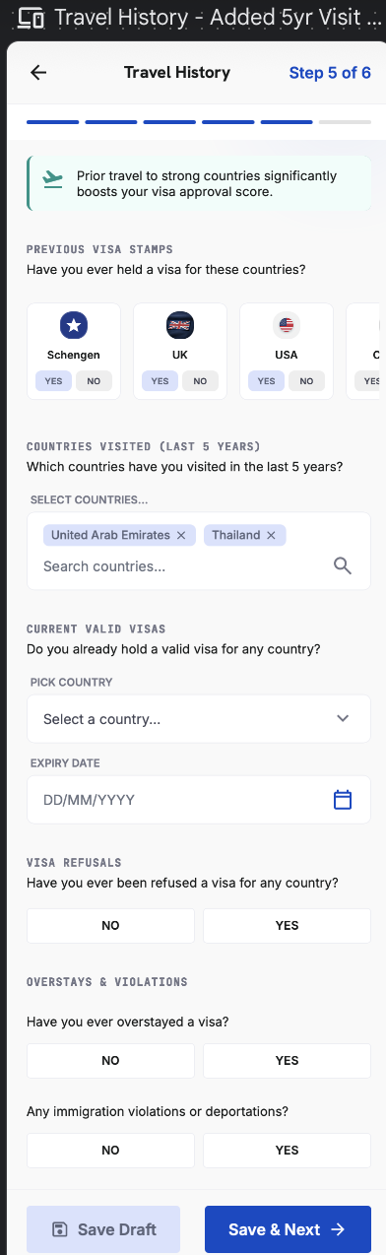

4.12 Home Ties — Application Step 6
12 | Home Ties

Purpose — Assesses the strength of ties to the home country.

- Family: marital status; children in home country (Yes/No + number); dependent parents (Yes/No).
- “My current commitments in India are …” — multiple selections allowed.
- Stability: employment stability; years in current city; property ownership (Yes/No + city).
- Declaration: ‘I confirm I intend to return upon completion of my trip’ — required to proceed.

Element Detail — 4.12 Home Ties — Application Step 6
Element Type | Element ID | Label | Type | M/O/C | Auto-Populate Source | Visible When | Enabled When | Validation / Precondition | On Click / On Change | Next / Result | Source (config) | Editable By | Error / Fallback | Dev Notes
Yes/No+Num | ht_children | Children in home country | Yes/No + number | C | — | Always | Always | Number required if Yes | On change reveal number | — | User | User | Number required if Yes | Feeds Personal Profile
Yes/No | ht_parents | Dependent parents | Yes/No | M | — | Always | Always | Required | On change | — | User | User | Required error | —
Multi-select | ht_commit | Current commitments | Multi-select | M | — | Always | Always | ≥ 1 | On change | — | Admin — Field Sets | User | Required error | Job/loan/property etc.
Numeric | ht_years | Years in current city | Numeric | M | Profile 4.6.6 (if stored) | Always | Always | ≥ 0 | On change | — | User | User | Negative error | Stable residence signal
Yes/No+City | ht_property | Property ownership | Yes/No + city | C | — | Always | Always | City required if Yes | On change reveal city | — | User | User | City required if Yes | Property/assets score
Checkbox | ht_return | Return declaration | Checkbox | M | — | Always | Always | Required to proceed | On tick enable continue | Agency Code / VisaScore Lite | User | User | Blocked until ticked | Gate to Lite score

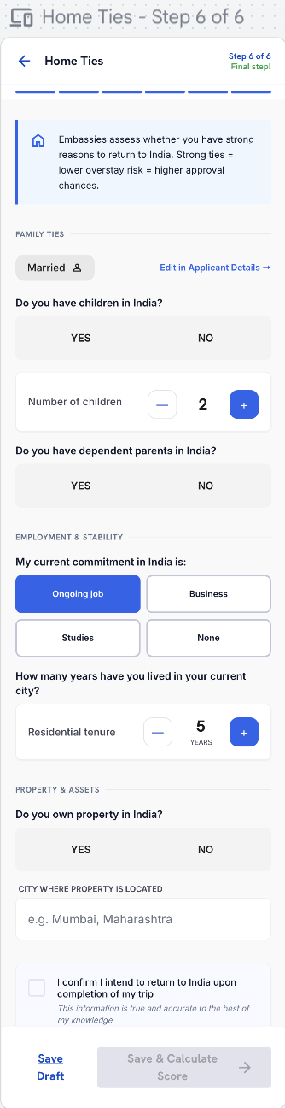

4.13 Agency Code & VisaScore™ Lite (Indicative)
13 | Agency Code & VisaScore™ Lite

Purpose — Optionally links the application to an agent, then reveals the indicative readiness score.

Agency Code
- ‘Do you have an agency code?’ — Yes / No. If yes, a code field appears (a code unlocks added benefits). If no, the user skips without penalty.
- When the applicant enters a valid agency code — at this step or while filling any earlier form step — the whole application (including anything already filled) maps to that agency and appears as a booking lead in the agency's dashboard. Details already entered populate the agency's view of the same shared record; the agent does not re-key them. And to super admin

Lead Routing
Scenario | Where the lead goes
No agency code entered | The applicant’s details populate in the Super Admin Portal as an unassigned lead. The Admin can transfer the lead to an agency (transfer is a Phase-2 capability).
Agency code entered | The lead is shown to both the agency (in its dashboard) and the Super Admin (with the agency name attached).
ACCOUNT LINKING
When an agent creates or fills an application before the customer has an account, the application is keyed to the customer’s mobile number and email. When the customer later signs up or signs in with the same mobile or email, the agent-created application is automatically linked to their account and appears in My Applications. Until then, the agent manages it from the Agency Dashboard.

VisaScore™ Lite
- Renamed from ‘Preliminary Score’ to VisaScore™ Lite — Indicative Score.
- Lite is computed from five parameters only: Financial Strength, Travel History, Employment Stability, Trip Details, Personal Profile (see 5.3) will show detail breakdown to user with progress bar like how progress is there .
- Output shows Low / Medium / High chance only — no risk levels and no flags at this stage.
- A disclaimer and a self-declaration statement appear at the bottom of the score page.
- Footnote:after the original score, one regeneration is free; from the second regeneration onward it is paid / token-consumed (see 5.3). A profile edit is required to regenerate..

Disclaimer & Self-Declaration
All data provided is self-declared and forms the basis of scoring. Any misrepresentation can cause the VisaScore to vary. VisaReady does not predict, influence or guarantee visa approval — final decisions rest solely with the relevant Embassy / Consulate / Immigration Authority.

Element Detail — 4.13 Agency Code & VisaScore™ Lite (Indicative)
Agency Code
Element Type | Element ID | Label | Type | M/O/C | Auto-Populate Source | Visible When | Enabled When | Validation / Precondition | On Click / On Change | Next / Result | Source (config) | Editable By | Error / Fallback | Dev Notes
Yes/No | ac_have | Have agency code? | Yes/No | M | — | Always | Always | — | On change reveal code field | — | User | User | — | —
Numeric | ac_code | Agency code | Numeric | C | WhatsApp referral link (pre-filled) | Have code = Yes | When Yes | Exactly 6 digits; validated vs active agencies | On blur validate; on valid map whole application to agency | VisaScore Lite | Admin — Agency Registry | User | Invalid/inactive code error | Pre-filled if arrived via referral link; maps at any step

VisaScore Lite (Indicative) — result & rules
Element Type | Element ID | Label | Type | M/O/C | Auto-Populate Source | Visible When | Enabled When | Validation / Precondition | On Click / On Change | Next / Result | Source (config) | Editable By | Error / Fallback | Dev Notes
Result | ac_lite | VisaScore Lite | Score band | — | Auto from Steps 2–6 inputs | After form complete | — | 5-parameter model (Financial, Travel, Employment, Trip, Personal); output Low/Med/High; NO flags, NO numeric risk | Generate on view | Lite result screen | Scoring engine — Lite mode (AD-28) | — | — | Lite excludes Document Readiness & Others; no penalties
Breakdown | ac_lite_params | Lite parameter contributions | Display | — | Auto from scoring engine | After Lite generated | — | Shows the 5 contributing parameters (indicative only) | — | — | Scoring engine | — | — | No exact numbers/flags exposed in Lite
CTA | ac_lite_cta | Continue to full score | Button | M | — | After Lite | Always | — | On click → Document Checklist / Payment | Document Checklist (4.14) | App | — | — | Lite → Final funnel
Rule | ac_regen | Regeneration rule | Business rule | — | Regeneration counter (system) | After Lite/Final score | — | After original score: 1 regeneration FREE; 2nd onward PAID/token; profile edit required to regenerate | On regenerate check counter | Free once, then paywall | Admin — Token Engine | — | Paywall on 2nd regeneration | 1 passport = 1 credit

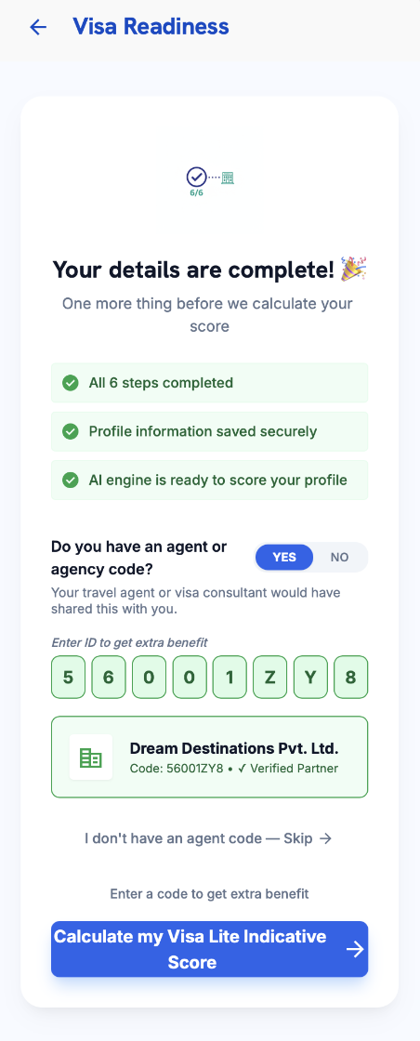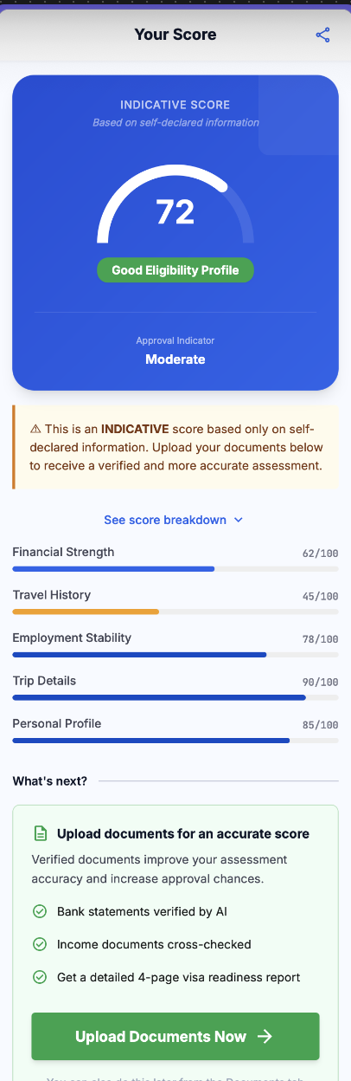

4.14 Document Checklist & Upload
14 | Document Checklist & Upload

Purpose — Collects supporting documents for the verified, paid assessment. The checklist is built from the applicant’s profile.

- For the paid version, passport scanning is mandatory; if the passport is not yet scanned, the OCR review screen is presented., same flow for co applicant if needed.
- Always required (every applicant): passport; passport-size photo; six-month bank statement (up to two accounts); confirmed/booked or draft travel itinerary.

Document Checklist by User Type
User Type | Type-Specific Documents
Salaried | Last 3 salary slips · 2 years ITR / Form-16 · employment / leave-approval letter · employer ID
Self-Employed / Business Owner | Business registration / incorporation · GST certificate · current-account statement (6 mo) · 2 years business ITR · ownership proof
Student | Student ID · enrolment / bonafide letter · latest marksheet / certificates · sponsor’s funds + sponsor letter (if sponsored)
Retired | Pension statement / order · retirement proof · investment / FD statements · funding-source proof
Unemployed | Sponsor letter + sponsor’s ID, bank statement & income proof · source-of-funds declaration
Homemaker | Sponsor (spouse/parent) letter, ID, employment proof & 6-mo bank statement · marriage/relationship proof
Freelancer | Client contracts / invoices · 2 years ITR · 6-mo bank statement · GST certificate (if registered)

- Document intelligence: the system auto-recognises the latest documents and organises them in the correct order.
- Auto-flagging: inconsistent or suspicious information is flagged (e.g. a recent very-high credit relative to balance).

Fund-Parking Flag
- Fund parking is a temporary deposit made shortly before applying to appear financially stronger than usual.
- Detection: the engine analyses 3–6 months of statements for sudden unexplained large credits, average balance, salary credits, ITR consistency and spending pattern. A sudden large credit (≥ 50% of the total transaction amount in one go by default) raises the flag and applies a −15 to −25 risk penalty.
- Legitimate large deposits are accepted when documented. The applicant can attach a source-of-funds proof — sale deed, FD maturity, bonus / incentive, business receipts, inheritance / gift, or a sanctioned education loan. With valid proof the penalty is waived.
- Flight and hotel booking documents are optional.
- Upload via camera, gallery / file picker, or drag-and-drop. PDF, JPG, PNG up to 10 MB each.

Element Detail — 4.14 Document Checklist & Upload
Element Type | Element ID | Label | Type | M/O/C | Auto-Populate Source | Visible When | Enabled When | Validation / Precondition | On Click / On Change | Next / Result | Source (config) | Editable By | Error / Fallback | Dev Notes
Checklist | doc_list | Dynamic checklist | Checklist | — | Auto from visa type + user type | Paid flow | — | Rebuilt from Admin checklist (AD-34) per visa & user type | Render required/optional items | — | Admin — Doc Checklist (AD-34) | Admin | — | Checklist adapts to Step 2 visa + Step 3 user type
File | doc_passport | Passport scan | File | M | Reuse Step 1 scan if present | Paid flow | Always | PDF/JPG/PNG ≤ 10 MB | On upload OCR + validate | — | User | User | Type/size error | Can reuse the Step 1 OCR file
File | doc_bank | 6-month bank statement | File | M | — | Paid flow | Always | Up to two accounts | On upload run fund-parking + balance checks | Fund-parking flag if triggered | User | User | Fund-parking flag | Feeds Financial score & risk layer
File | doc_salary | Salary slips / ITR | File | C | — | Salaried path | Always | Salaried path | On upload | — | User | User | — | Path-specific (from Step 3)
File | doc_bizstu | Business / student docs | File | C | — | By user type | Always | By user type | On upload | — | User | User | — | Path-specific
File | doc_sof | Source-of-funds proof | File | O | — | Fund-parking flag raised | Always | Clears fund-parking penalty (sale deed, FD maturity, bonus, business receipts, gift/inheritance, edu loan) | On upload clear flag | Penalty waived if valid | User | User | — | Only shown when flag present
File | doc_travel | Flight / hotel bookings | File | O | Step 2 booking status (hint) | Always | Always | — | On upload | Payment | User | User | — | Feeds Document Readiness

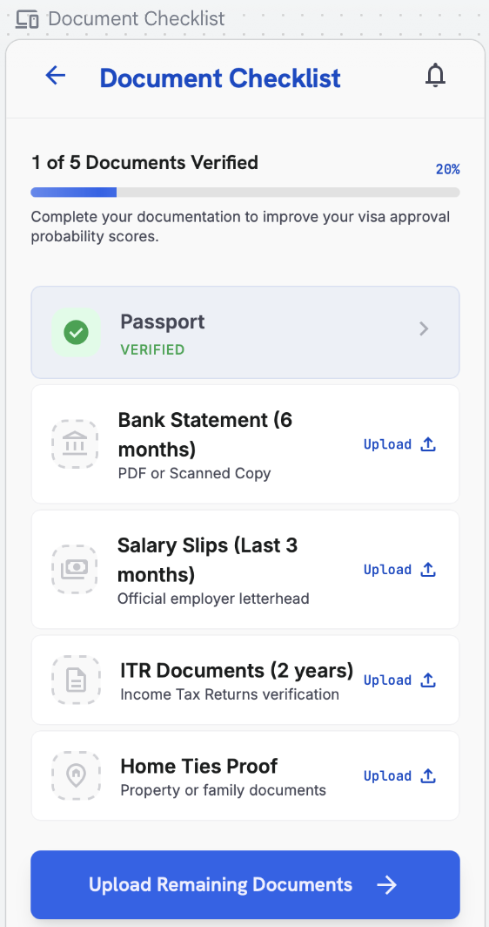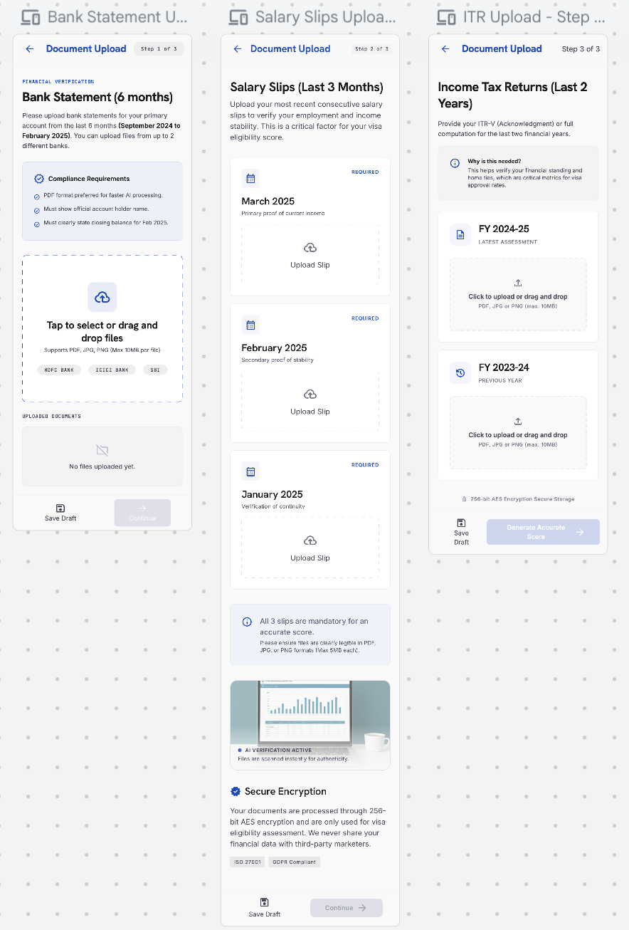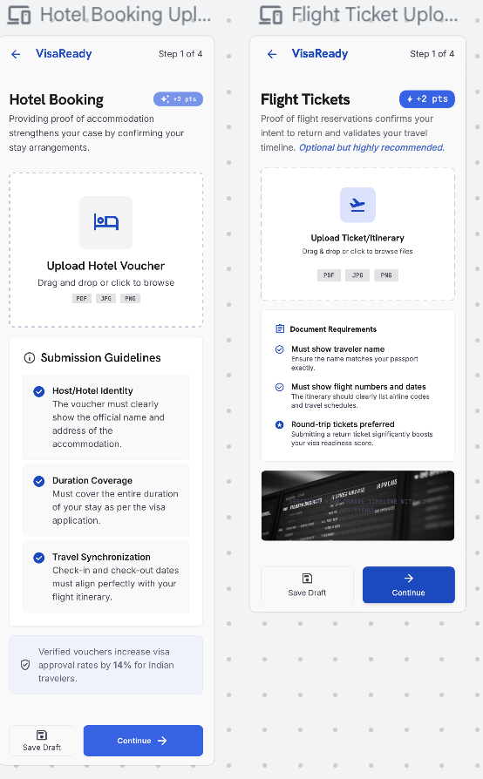

4.15 Payment
15 | Payment

Purpose — Lets the user choose and purchase a plan, then processes payment to unlock the verified score and full report.

Plan-Selection Modal
- When the user proceeds to pay, a plan modal prompts them to choose a plan before paying: Starter (VisaScore only) and Advance (VisaScore + VisaMatrix™ report), each showing price, what’s included, visa category and pack (single / couple / family).
- Promo Code. At payment, the user can enter a promo code shared by their agency. A promo code is generated by Super Admin, allocated to an agency, and emailed to the customer by that agency. On entering a valid code (exists, within validity, has remaining uses), the transaction fee is waived — that payment is free. Single-use codes work once; multi-use codes work until they expire or hit their usage cap. An invalid/expired/used code shows a clear error and the user proceeds to normal payment.
- Invoice. On every successful payment (or a fully promo-covered transaction), the app generates an invoice showing invoice number & date, applicant/payer name, plan and visa category, applicant count, line items (scoring fee, any processing fee), any promo code applied and amount waived, taxes, total paid, payment method and gateway reference. The invoice is viewable and downloadable as PDF from the Payment confirmation and from Profile › Plan › View Invoices (4.6.8). Invoices also appear in the Admin Portal transaction detail (AD-51).
- The user selects a plan and taps Purchase; the chosen plan, applicant count and computed price are shown before confirming.
- Shows the scoring fee (and any processing fee) for the selected plan; secure gateway with on-screen confirmation.
- Token consumption: one passport consumes one token; the score is calculated for the primary applicant only. Pricing varies by plan and visa category (see 5.3, 5.7).
- Co-applicants and tokens. Because the VisaScore is generated for the primary applicant only, processing an application consumes one token for the primary applicant. Co-applicant passports are captured for the application record but are not separately scored and do not each consume a scoring token. (Final treatment of co-applicant tokens is confirmed with the client.)
Note — The same plan modal is reachable from Profile › Plan (4.6.8) for renew / upgrade.
⚠ Client Input Required — Plan modal contents (which plans appear, price within ranges, pack multipliers), and the payment gateway.

Element Detail — 4.15 Payment
Element Type | Element ID | Label | Type | M/O/C | Auto-Populate Source | Visible When | Enabled When | Validation / Precondition | On Click / On Change | Next / Result | Source (config) | Editable By | Error / Fallback | Dev Notes
Selection | pay_plan | Plan / token pack | Selection | M | Profile 4.6.8 current plan (hint) | Paid flow | Always | Lite/Starter/Advance; price by visa category & pack | On select compute price | — | Admin — Pricing Mgmt | User | Required error | Couple/family pack multipliers if configured
Input | pay_promo | Promo code | Text | O | — | Always | Always | Valid, within validity, has uses; must map to the agency code used on this application | On apply validate; if valid waive transaction fee | Free transaction if valid | Admin — Promo (AD-62) | User | Invalid/expired/used → normal payment | Single-use or multi-use per Admin
Gateway | pay_method | Payment method | Gateway | M | — | Not fully promo-covered | Always | Secure gateway; on-screen confirmation | On pay process transaction | Final Score & Report | Payment gateway (Razorpay assumed) | — | Gateway failure → retry | Skip if promo covers 100%
PDF | pay_invoice | Invoice | PDF output | — | Auto from transaction + promo | After success / promo-covered | — | Invoice no., date, payer, plan, visa cat, applicant count, line items, promo waived, tax, total, method, gateway ref | On view download PDF | Invoice (view/download) | Billing / System | — | — | Also in Profile 4.6.8 & Admin AD-51

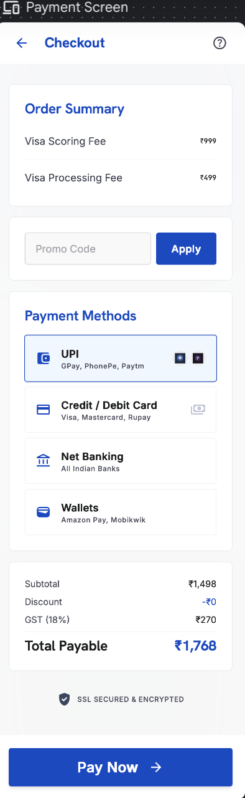

4.16 Final Score & VisaMatrix™ Report
16 | Final Score & Report

Purpose — Presents the verified result and the full readiness report.

- Verified score uses all seven weighted factors minus the risk-penalty layer (see 5.3); shows approval indicator, risk level, document-verification status and category breakdown.
- Final VisaScore™ bands: 80–100 Strong · 72–79 Good · 58–71 Moderate · Below 58 High Rejection Risk · Below 40 Do Not Apply. Thresholds and weights are configured in the Admin Portal.
- Report is the multi-page VisaMatrix™: executive summary & VisaScore, embassy checklist & red-flag analysis, recommendation engine & destination intelligence, and the intelligence layer (FraudShield™, Return Assurance Score™, EmbassyFit™, action plan).
- The VisaMatrix™ report carries a VisaReady logo background watermark on every page.
- Verifiable by report ID and QR code. Agency-referred reports carry ‘Powered by VisaReady’ alongside the agency’s branding.
- Share via WhatsApp · Email · Copy Link · Download PDF.

Element Detail — 4.16 Final Score & VisaMatrix™ Report
Final Score — result
Element Type | Element ID | Label | Type | M/O/C | Auto-Populate Source | Visible When | Enabled When | Validation / Precondition | On Click / On Change | Next / Result | Source (config) | Editable By | Error / Fallback | Dev Notes
Result | fs_score | Final VisaScore (0–100) | Score | — | Auto: all 7 factors − risk penalties | After payment | — | Weighted 7 factors − risk penalty layer; primary applicant only | Generate on view | VisaMatrix report | Scoring engine (AD-27) | — | — | = Weighted Score − Risk Penalties
Band | fs_band | Readiness band | Band label | — | Auto from score | After score | — | 80–100 Strong · 72–79 Good · 58–71 Moderate · <58 High Risk · <40 Do Not Apply | — | — | Admin — Score Bands (AD-28) | Admin | — | Band thresholds editable in Admin
Breakdown | fs_factors | Factor-by-factor breakdown | Display | — | Auto from scoring engine | After score | — | Shows each of 7 factors with weight & contribution | On tap expand factor | — | Scoring engine | — | — | See companion Scoring Factor table below
Flags | fs_flags | Risk flags | Flags | — | Auto from risk layer / documents | Final only (never in Lite) | — | Fund parking, missing ITR, refusal, passport validity, missing doc, overstay, fraud | — | — | Scoring engine (AD-30/31/32) | Admin (rules) | — | See companion Risk-Penalty table below

VisaMatrix™ Report
Element Type | Element ID | Label | Type | M/O/C | Auto-Populate Source | Visible When | Enabled When | Validation / Precondition | On Click / On Change | Next / Result | Source (config) | Editable By | Error / Fallback | Dev Notes
Document | fs_report | VisaMatrix report | Document | — | Auto-generated | After score | — | Logo background watermark; sections & order per Admin (AD-65) | On view / share | Share via WhatsApp / Email; PDF | Admin — Report Template (AD-65) | Admin | — | Sections: exec summary, embassy checklist, red-flag analysis, recommendations, destination intelligence
Recommendations | fs_reco | AI recommendations | Text blocks | — | Auto from reason codes | After score | — | Human-readable reason codes with merge fields (AD-35) | — | — | Admin — Reason Codes (AD-35) | Admin | — | Explainability layer
Button | fs_share | Share / download | Button | O | — | Report exists | Always | — | On click share/download | Share sheet | System | — | — | Agency-referred reports co-branded

Companion — VisaScore™ Factor Weights & Scoring Rules (Final = all 7; Lite = 5 marked)
Factor | Weight | In Lite? | Sub-criteria & points (editable in Admin AD-27) | Contribution
Financial Strength | 25% | Yes | Stable 3–6 mo balance +25 · income supports trip cost +25 · ITR matches credits +20 · no funds parking +20 · clear savings/assets +10 | 0–100 → ×0.25
Travel History | 24% | Yes | Strong history +40 · prior developed-country visa +30 · no rejection/overstay +20 · pattern matches profile +10 | 0–100 → ×0.24
Document Readiness | 17% | No | Passport valid +15 · mandatory docs complete +35 · financial docs +20 · profile docs +20 · consistent formats +10 | 0–100 → ×0.17
Employment Stability | 14% | Yes | Stable employment +30 · income proof +25 · leave/business proof +20 · employer/CA docs +15 · return obligation +10 | 0–100 → ×0.14
Trip Details | 10% | Yes | Clear purpose +25 · realistic itinerary +25 · trip cost affordable +20 · correct consulate +20 · supporting bookings +10 | 0–100 → ×0.10
Personal Profile | 5% | Yes | Strong family ties +25 · property/assets +25 · dependents +20 · stable residence +15 · no adverse history +15 | 0–100 → ×0.05
Others | 5% | No | Reserved, configurable factor — aspect & sub-rules defined by client in Admin (AD-27) | 0–100 → ×0.05

Companion — Risk-Penalty Layer (applied AFTER weighted score; Final only)
Trigger | Penalty | Notes
Funds parking | −15 to −25 | Scaled by amount, timing, whether source explained; cleared by valid source-of-funds proof
Missing ITR | −10 to −20 | When ITR not provided / inconsistent
Previous visa rejection | −10 to −25 | Declared in Travel History (Step 5)
Passport validity issue | −20 | ≤ 6 months validity beyond travel
Missing major document | −10 to −20 | Mandatory checklist item absent
Previous overstay | −30 to −50 | Heaviest penalty band
Fake / tampered document | Hard reject flag | FraudShield™ — high risk / reject

Companion — Final Bands & Calculation
Band | Label | Meaning
80–100 | Strong Readiness | High approval probability
72–79 | Good Approval Probability | Minor gaps, overall strong
58–71 | Moderate Readiness | Fix gaps before applying
Below 58 | High Rejection Risk | Corrections strongly recommended
Below 40 | Do Not Apply | High chance of refusal
Final calculation: VisaScore™ = Weighted Score (Σ factor×weight) − Risk Penalties, clamped 0–100. Primary applicant only; 1 token per passport.

Companion — VisaScore™ Lite (Indicative) Model
Aspect | Detail
Parameters used | Financial Strength, Travel History, Employment Stability, Trip Details, Personal Profile (5 of 7)
Excluded from Lite | Document Readiness, Others factor, and the entire risk-penalty layer
Output | Low / Medium / High only — no numeric score, no flags, no risk levels exposed
Purpose | Fast indicative read before payment; upgrades to Final after document upload + payment
Regeneration | After original score: 1 regeneration free; 2nd onward paid/token; profile edit required

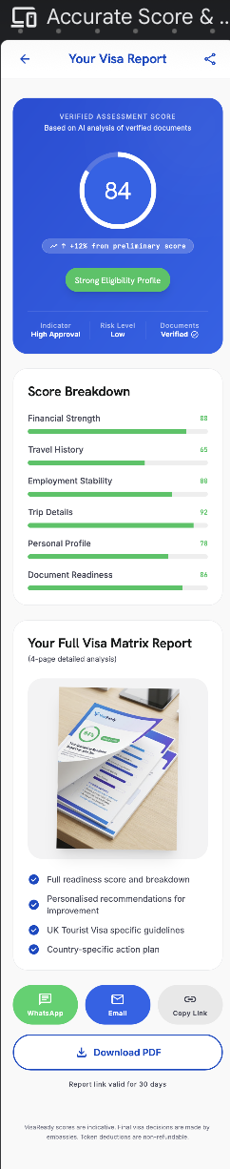
4.16a Score Improvement:
Purpose — Shown to a returning user after a score exists. It presents the current VisaScore, a plain-language readiness verdict, and a prioritised list of actions that would raise the score, each tagged with its estimated impact. It is the actionable bridge between the Final Score/VisaMatrix and regenerating an improved score.
Entry points
- Home Dashboard → Improve Score button (on the Visa Readiness card).or from my application
- Final Score & VisaMatrix™ Report → "Improve your score" link.
Layout & elements
- Current score gauge — circular gauge showing the current score (e.g. 72%) with the readiness label beneath (e.g. "Good Chance"), colour-coded to the band.
- Verdict text — one or two lines summarising standing and that the recommendations below will maximise approval odds.
- Improvement Recommendations list — each card shows an icon, a title, a short detail line, and an impact tag(High / Medium / Low) with the estimated +X% uplift. Examples from config: Increase Bank Balance (Recommended: ₹5,00,000+) — High +8%; Upload Missing Documents (Income Tax Returns, 2 Years) — Medium +5%; Add Travel History (previous stamps/e-visas) — Low +3%; Provide Employment Proof (NOC from current employer) — Medium +5%.
- Target hint — informational line, e.g. "Improving your score to 85% or above significantly increases approval chances."
- Primary CTA — Generate New Score — regenerates the score using updated data (subject to the re-score rule: 1 regeneration free, 2nd onward paid).
- Secondary CTA — Upload Documents — jumps to Document Checklist & Upload (4.14) to supply the missing items.
Behaviour
- Recommendations, their thresholds and impact weights are driven by the scoring engine and Admin config (they mirror the factor weights and risk-penalty gaps that lowered the score).
- Recommendations are ordered by impact (High → Low).
- Completing an action (e.g. uploading ITR) and tapping Generate New Score recomputes the score; the regeneration counter and paywall from the re-score rule apply.
- The uplift figures are estimates for guidance, not guarantees.
▸ RULE — "Generate New Score" follows the re-score rule (5.3): after the original score, one regeneration is free; the second regeneration onward is paid / token-consumed. A profile or document change is required to regenerate.
Application-scoped. Score Improvement always operates on a single application. When opened from the Home Dashboard it uses the active/most-recent application; when opened from a My Applications card it uses that application. The gauge, recommendations, impact estimates and "Generate New Score" all read and write that one application's record.
⚠ Client Input Required — The recommendation catalogue (which actions surface per factor gap), the impact-weight mapping (how each action maps to a +% estimate), and the target-score threshold copy.

ELEMENT TABLE —
Element Type | Element ID | Label | Type | M/O/C | Auto-Populate Source | Visible When | Enabled When | Validation / Precondition | On Click / On Change | Next / Result | Source (config) | Editable By | Error / Fallback | Dev Notes
Context | si_appctx | Application context | Param | M | From entry point (Home = active app; My Apps = selected app) | Always | — | Valid applicationId; user owns the application | Loads that application's score & gaps | — | System | — | Invalid/missing ID → error state | Screen is a reusable component keyed by applicationId

Element Type | Element ID | Label | Type | M/O/C | Auto-Populate Source | Visible When | Enabled When | Validation / Precondition | On Click / On Change | Next / Result | Source (config) | Editable By | Error / Fallback | Dev Notes
Context | si_appctx | Application context | Param | M | From entry point (Home = active app; My Apps = selected app) | Always | — | Valid applicationId; user owns the application | Loads that application's score & gaps | — | System | — | Invalid/again missing ID → error state | Screen is a reusable component keyed by applicationId

Element Type | Element ID | Label | Type | M/O/C | Auto-Populate Source | Visible When | Enabled When | Validation / Precondition | On Click / On Change | Next / Result | Source (config) | Editable By | Error / Fallback | Dev Notes
Gauge | si_gauge | Current score gauge | Display | — | Scoring engine (last Final score) | Score exists | — | Shows current score + band label | — | — | Scoring engine (AD-27/28) | — | Hidden if no score yet | Colour by band (80+/72+/58+/<58/<40)
Text | si_verdict | Readiness verdict | Display | — | Auto from band | Score exists | — | One/two-line summary | — | — | Admin — Reason Codes (AD-35) | Admin | — | Band-driven copy
List | si_reco | Improvement recommendations | List | — | Scoring engine (factor gaps + risk layer) | Score exists | — | Ordered High→Low; each = icon, title, detail, impact tag, +X% | On tap card open related step | 4.14 / relevant step | Admin — Recommendation catalogue | Admin | Empty state if fully optimised | Maps factor/penalty gap → action + impact weight
Tag | si_impact | Impact tag (+X%) | Badge | — | Auto from impact-weight map | Per recommendation | — | High / Medium / Low + estimated % | — | — | Admin — Impact Weights | Admin | — | Estimate only; not a guarantee
Info | si_target | Target-score hint | Display | — | Admin config | Score exists | — | e.g. "85% or above increases approval chances" | — | — | Admin — Content (AD-33/36) | Admin | — | Threshold configurable
Button | si_generate | Generate New Score | Button | M | — | Score exists | Profile/docs changed | Re-score rule: 1 regen free, 2nd onward paid; change required | On click recompute score | Final Score & VisaMatrix (4.16) | Scoring + Token engine | User | Paywall on 2nd regen; "no change" notice | 1 passport = 1 credit
Button | si_upload | Upload Documents | Button | O | — | Score exists | Always | — | On click open Document Upload | Document Checklist & Upload (4.14) | App | User | — | Shortcut to supply missing items
Nav | si_back | Back | Button | M | — | Always | Always

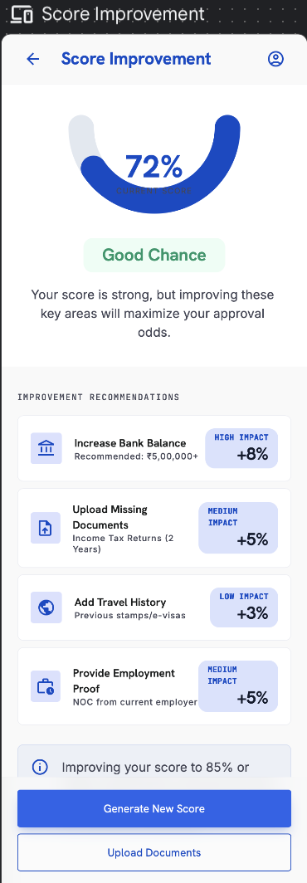

4.17 My Applications & Conclusion
17 | My Applications

Purpose — Find, resume and track every application across draft and submitted states.

- Grouped as Draft, In Progress and Submitted, with search; each card shows title, current step, last-updated date and ‘Continue’.
- Agency-assisted applications. An application created, continued or filled by an agent on the customer’s behalf appears in the customer’s My Applications list and updates in real time as the agent edits it. It is a single shared record — changes made by the agent or the customer are reflected on both sides, and either party can continue where the other left off.
- Per-application Score Improvement — each application card with an existing score shows an Improve Scoreaction that opens Score Improvement (4.16a) scoped to that application. The recommendations and the regenerated score apply to that application only.
- ▸ RULE — Score Improvement opened from an application card operates on that application's record. "Generate New Score" there regenerates that application's score and draws on that application's regeneration allowance (1 free, then paid). Other applications are unaffected.

Application Detail — Timeline
Header shows the visa type + country (e.g. ‘Tourist Visa — France’), a status pill (e.g. ‘Submitted’) and a reference number (e.g. REF: FR-49201-B). The timeline shows each stage with date & time, completed/active state, and stage-specific detail:

Timeline Stage | Detail Shown
Application Started | Date & time
Preliminary Score Generated | Date & time + the indicative score (e.g. 84/100) with a one-line summary
Documents Uploaded | Date & time + verification count (e.g. ‘8 of 8 mandatory documents verified’) + a ‘View Documents’ link
Submitted to Agent | Date & time (agency-routed applications)
Submitted to Embassy | Date & time + a ‘View Embassy Portal’ link
Embassy Review | Estimated working days (e.g. ‘5–7 working days’); shown as the active stage
Decision Pending | Upcoming stage (greyed until reached)

- ‘View Documents’ opens the per-application document list with details for each item (name, type, uploaded date, OCR/verification status).
- ‘View Embassy Portal’ opens the relevant embassy / official visa website in an in-app browser where the user enters their application reference and last name to track the official status.

Conclusion Step
Applied By | Behaviour
User only (self-applied) | User toggles Yes/No on whether the visa was received and may add an optional short reason if rejected.
Agency | Agency sets the status from its dashboard; the decision (Accepted / Rejected) is shown to the user with an image of the rejection/acceptance document.
⚠ Client Input Required — Per-country embassy / official tracking URLs to power the ‘View Embassy Portal’ link.

Element Detail — 4.17 My Applications & Conclusion
Element Type | Element ID | Label | Type | M/O/C | Auto-Populate Source | Visible When | Enabled When | Validation / Precondition | On Click / On Change | Next / Result | Source (config) | Editable By | Error / Fallback | Dev Notes
List | ma_list | My applications | List | O | User applications | Has applications | — | — | On tap open timeline | Conclusion / timeline | User data | — | Empty state if none | —
Timeline | ma_timeline | Status timeline | Timeline | — | Agency/system status updates | Per application | — | Statuses set by agency/system | — | — | Agency / Admin | — | — | Submitted→Under review→Doc requested→Embassy→Granted/Rejected
Result | ma_decision | Visa decision | Accepted/Rejected | C | Agency-uploaded decision | Decision uploaded | — | Shown with decision document image | On tap view document | Decision document | Agency (upload) | — | Pending state if none | Self-applied users set own

Element Type | Element ID | Label | Type | M/O/C | Auto-Populate Source | Visible When | Enabled When | Validation / Precondition | On Click / On Change | Next / Result | Source (config) | Editable By | Error / Fallback | Dev Notes
Button | ma_improve | Improve Score (per application) | Button | O | Scoring engine (this application's score) | Application has a score | Always | Passes application ID to Score Improvement | On click → Score Improvement scoped to this application | Score Improvement (4.16a) | App | User | Hidden if application has no score yet | Reuses 4.16a with applicationIdcontext

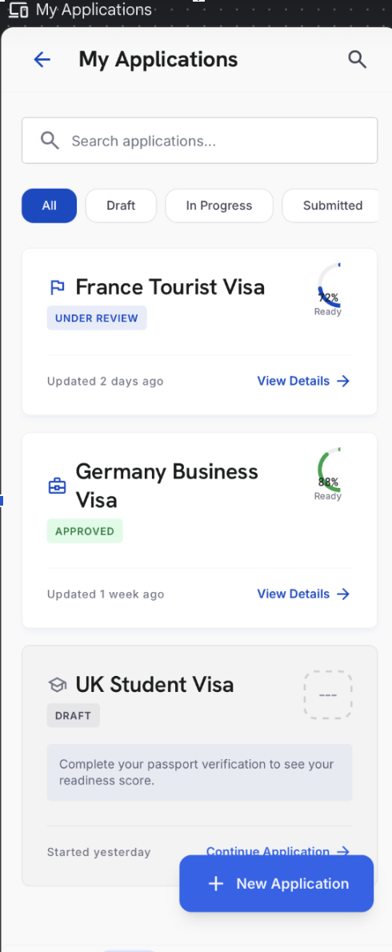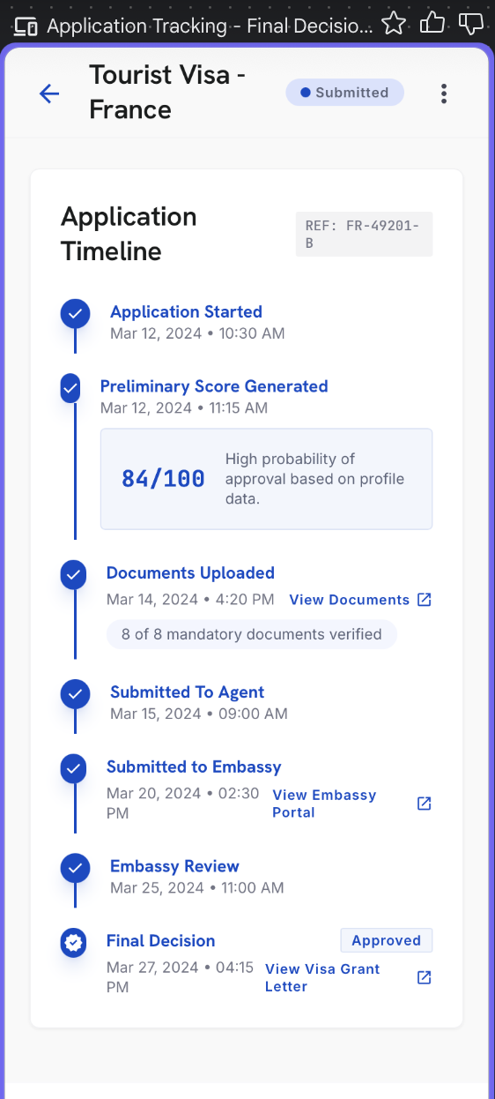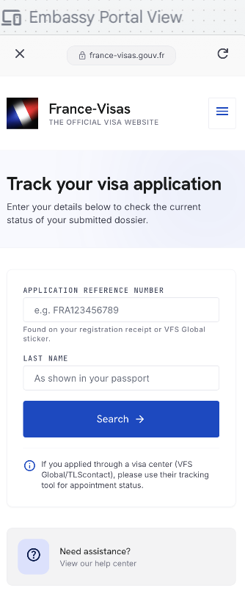

4.18 Reports
18 | Reports

Purpose — A library of all generated readiness reports.

- Recent reports and ‘View All’ history; view, email, download PDF, share by WhatsApp, copy link, verify by QR code.

Element Detail — 4.18 Reports
Element Type | Element ID | Label | Type | M/O/C | Auto-Populate Source | Visible When | Enabled When | Validation / Precondition | On Click / On Change | Next / Result | Source (config) | Editable By | Error / Fallback | Dev Notes
List | rep_list | Report list | List | O | Generated reports | Reports exist | — | — | On tap open report | VisaMatrix report | User data | — | Empty state | —
Button | rep_share | Share / download | Button | O | — | Report exists | Always | — | On click share/download PDF | Share sheet | System | — | — | —

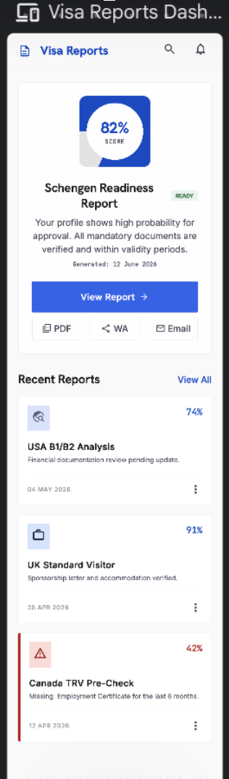

4.19 Library
19 | Library

Purpose — A new bottom-navigation destination that helps applicants understand each country’s visa process.

- A dropdown of countries; tapping a country opens readable guidance about that country’s visa process.
- Content is maintained by Super Admin (per-country) and updated centrally.
⚠ Client Input Required — Per-country Library content (visa-process guidance) and the country list for the Library.

Element Detail — 4.19 Library
Element Type | Element ID | Label | Type | M/O/C | Auto-Populate Source | Visible When | Enabled When | Validation / Precondition | On Click / On Change | Next / Result | Source (config) | Editable By | Error / Fallback | Dev Notes
Dropdown | lib_country | Country selector | Dropdown | M | Profile preferred destinations (hint) | Always | Always | From configured Library list | On change load content | — | Admin — Library CMS (AD-63) | Admin | — | Order & list controlled by Admin
Rich text | lib_body | Visa-process guidance | Rich text | — | Auto from selected country | Country chosen | — | Published content only | — | — | Admin — Library CMS | Admin | Empty state if unpublished | Read-only guidance



4.20 Automatic Flags & Warnings

The app surfaces the following advisory flags to the applicant:

Flag | Trigger
Passport expiry | Six months or less of validity remaining
Travel-date risk | Gap between travel date and passport expiry falls within six months
Salary mismatch nudge | Stated current salary does not match the uploaded payslip

Note — Customer-facing flags are advisory and do not block progress. Red-flag scoring appears only in the Final score / VisaMatrix™ report (see 5.3).

Element Detail — 4.20 Automatic Flags & Warnings
Element Type | Element ID | Label | Type | M/O/C | Auto-Populate Source | Visible When | Enabled When | Validation / Precondition | On Click / On Change | Next / Result | Source (config) | Editable By | Error / Fallback | Dev Notes
Process | flg_engine | Auto flags & warnings | Process | — | Auto during scoring/upload | During scoring / upload | — | Per risk & document rules (AD-30/31/32) | Raise flag on trigger | Flag on score/report | Scoring / Doc engine | Admin (rules) | — | Runs server-side
Warning | flg_passport | Passport expiry warning | Warning | — | Auto from passport expiry vs travel | Expiry < 6 mo beyond travel | — | Passport-expiry rule | Show warning | — | Scoring engine | — | — | Advisory + −20 penalty
Flag | flg_fraud | FraudShield hard flag | Flag | — | Auto from document intelligence | Tampered/fake doc detected | — | Fake/tampered document | Hard reject flag | — | Scoring engine | Admin | — | Highest severity

4.21 Field Validation
- Field-level validation is applied on every input — mandatory/optional rules, format checks (email, mobile, passport number, dates), range limits, date logic (e.g. expiry after issue; travel end after start), and file type/size on uploads.
- The detailed rule per field is defined in 5.6 and in the per-screen Element Detail tables under each screen.

Element Detail — 4.21 Field Validation
Element Type | Element ID | Label | Type | M/O/C | Auto-Populate Source | Visible When | Enabled When | Validation / Precondition | On Click / On Change | Next / Result | Source (config) | Editable By | Error / Fallback | Dev Notes
Reference | fv_ref | Field validation summary | Reference | — | — | — | — | Consolidated rules per 5.6 + the per-screen Element Detail tables above | — | — | Admin — Field Sets (AD-26) | Admin | — | Per-field rules live in each screen table

5. Business Rules

5.1 Authentication & Access
- OTP-based sign-in only (email or mobile), with Google as an alternative.
- Suspended or blacklisted accounts are blocked at the platform level.

5.2 Data Handling
- Auto-save as the user types; resume any application from where it was left.

5.3 VisaScore™ Scoring Engine
VisaScore™ = Financial Strength 25% + Travel History 24% + Document Readiness 17% + Employment Stability 14% + Trip Details 10% + Personal Profile 5% + Others 5%. Each dimension is scored 0–100, then weighted to a final 0–100. Risk penalties are applied after the weighted score.

- VisaScore™ Lite (Indicative) — five parameters (Financial Strength, Travel History, Employment Stability, Trip Details, Personal Profile). Output: Low / Medium / High. No risk levels, no flags.
- Final VisaScore™ — all seven factors plus the risk-penalty layer.
- The score is calculated for the primary applicant only; co-applicants are captured but not individually scored, and one scoring token is consumed for the primary applicant.
- Scoring is calculated for the primary applicant only. Co-applicants are captured for the application record and are not individually scored.

Dimension Scoring Rules
Dimension (Weight) | Sub-Criteria & Scoring Rules | In Lite?
Financial Strength (25%) | Bank-balance consistency, income vs trip cost, ITR match, no sudden large deposits, sponsor strength. Stable 3–6 mo balance +25 · income supports trip cost +25 · ITR matches credits +20 · no funds parking +20 · clear savings/assets +10. | Yes
Travel History (24%) | Previous international travel, prior Schengen/US/UK/Canada/Australia visa, no overstays, regular return. Strong history +40 · prior developed-country visa +30 · no rejection/overstay +20 · pattern matches profile +10. | Yes
Document Readiness (17%) | Passport validity, complete checklist, cover letter, insurance, hotel/flight reservations, profile-specific docs. Passport valid +15 · mandatory docs complete +35 · financial docs +20 · profile docs +20 · consistent formats +10. | No
Employment Stability (14%) | Job/business stability, tenure, income proof, leave/business proof, employer or CA verification. Stable employment +30 · income proof +25 · leave/business proof +20 · employer/CA docs +15 · strong return obligation +10. | Yes
Trip Details (10%) | Clear purpose, logical itinerary, stay matches profile, hotel & transport plan, budget vs capacity. Clear purpose +25 · realistic itinerary +25 · trip cost affordable +20 · correct consulate +20 · supporting bookings +10. | Yes
Personal Profile (5%) | Family ties, property/assets, dependents in India, age/profile risk, prior compliance. Strong family ties +25 · property/assets +25 · dependents +20 · stable residence +15 · no adverse history +15. | Yes
Others (5%) | Reserved, configurable factor — aspect and sub-rules to be defined by the client. Editable in Admin. | No

Risk-Penalty Layer
Trigger | Penalty | Notes
Funds parking | −15 to −25 | Scaled by amount, timing and whether the source is explained
Missing ITR | −10 to −20
Previous visa rejection | −10 to −25
Passport validity issue | −20 | ≤ 6 months validity
Missing major document | −10 to −20
Previous overstay | −30 to −50
Fake / tampered document | High risk / reject flag | FraudShield™ hard flag

Final VisaScore™ Bands
Band | Label | Meaning
80–100 | Strong Readiness | High approval probability
72–79 | Good Approval Probability | Minor gaps, overall strong
58–71 | Moderate Readiness | Fix gaps before applying
Below 58 | High Rejection Risk | Corrections strongly recommended
Below 40 | Do Not Apply | High chance of refusal

Final calculation: Weighted Score − Risk Penalties = VisaScore™ (0–100).

Re-score / credit logic: after the original score, the user or agent may edit the profile and regenerate one time free; from the second regeneration onward it is paid / token-consumed per plan. One passport = one credit. A profile edit is required to regenerate.
Country Weightage & Bands
- Country visited tiers: maximum — Europe/USA/UK/Australia; mid — Japan/Korea/Singapore; minimum — Thailand/Malaysia/Indonesia.
- Destination difficulty: higher — US, UK, Australia, EU/Schengen, Canada; medium — Japan, Korea, Singapore, Dubai.
- Experience bands: <2 yrs (lowest) · 2–5 · 8–10 · 10+ (highest). Salary bands: ≤₹50k · ₹50k–₹1.5L · ₹1.5L–₹2.5L · ₹3.5L+.
- Boosters: graduate, married, property. Funds benchmark ≈ €100 per person per day.

5.4 Reporting
- Multi-page VisaMatrix™ report; shareable & verifiable by WhatsApp, email, link or PDF with report-ID / QR verification.
- Agency-referred reports show ‘Powered by VisaReady’ with the agency’s branding; direct (B2C) reports show VisaReady branding only.

5.5 Readiness Positioning
- Assessment, not a guarantee — VisaReady measures preparedness; final decisions rest solely with the relevant embassy or authority. Stated on every report.

5.6 Field Validation Rules
Field Group | Validation
First / Last name | First name mandatory (letters, spaces, hyphen); last name optional
Email / mobile | Format + OTP verification; mobile with country code
Passport number / dates | Alphanumeric format; expiry after issue; expiry-vs-travel flag
Income / balance / turnover | Selected from configured range dropdowns; no free text
Travel dates | End date after start date; trip within passport validity
Existing visa expiry | Valid date; future or flagged if expired
Uploads | PDF / JPG / PNG; max 10 MB each; mandatory items enforced before submit
⚠ Client Input Required — Confirmation of the complete per-field validation matrix and any country-specific rules.

5.7 Pricing
Plan | Price | What You Get
VisaReady Lite | Free | Mobile app / WhatsApp Connect / Web Portal. A few Q&A to get the indicative VisaScore as a tentative probability.
Starter | ₹299 – ₹499 / token | VisaScore only, generated from detailed data + OCR documentation, validated with data. Cost by visa category (tourist / business / student) and pack (single / couple / family).
Advance | ₹499 – ₹799 / token | VisaScore + full VisaMatrix™ report, from detailed data + OCR. Cost by visa category and pack (single / couple / family).

B2B (SaaS user licence): Standard ₹2,500/mo (25 tokens, no carry-forward) · Growth ₹5,000/mo (75 tokens, carry-forward) · Professional ₹50,000/yr (1,000 tokens). Alternate B2B model: pay-as-you-use revenue share of the B2C plan by volume.
⚠ Client Input Required — Exact per-token price within each range and the precise couple / family pack multipliers.

6. Integrations & Compliance

6.1 Integrations
- WhatsApp Business API — conversational bot and report delivery.
- Document verification — OCR extraction with document-integrity checks.
- Payment gateway for scoring and processing fees; platform services (scoring, country, content) sourced from the Admin Portal.

6.2 Data, Security & Compliance
- Encryption — all personal and financial data is encrypted. Financial details are never shared with third parties.
- Document integrity — OCR and verification checks on every uploaded document.
- Regulatory — compliant with applicable data-protection requirements (e.g. DPDPA) and data-residency rules.

7. Client Inputs Required & Open Questions
The following inputs and decisions are needed to finalise configuration and begin development.

7.1 Content
- Final Terms of Use, Privacy Policy and Disclaimer copy (v5.0 draft provided in 4.4).
- WhatsApp bot conversation script (the full question set).
- Schengen / country-selection footnote final wording (beyond the Schengen rules already drafted).
- Per-country Library content (visa-process guidance) and the Library country list.
- Support assistant Q&A set; client philosophy text and any user-facing footnotes.

7.2 Configuration
- Supported countries and display order; full ‘all destinations’ list; popular-list confirmation.
- Visa types and form fields per destination; city-dropdown value sets.
- Income, balance, turnover and gross-income / ITR range definitions.
- Final scoring weights and the country / salary / experience / booster bands; risk-flag logic.
- Destination-intelligence content per country (embassy rules, insurance, financial benchmark, processing time, biometrics, multi-entry).

7.3 Commercial
- Exact B2C per-token pricing within ₹299–₹799; family/couple pack definitions; scoring vs processing fee; payment gateway.

7.4 Integrations & Branding
- WhatsApp Business API, document-verification and email service credentials.
- Logo (PNG), icon, colour palette and report branding assets; ‘Powered by Tech2Go’ lockup.

7.5 Open Questions
# | Remaining Question | Impacts
1 | Exact B2C per-token price within ₹299–₹799 and the couple / family pack multipliers (notes suggested ≈ ₹99 per additional passport). | 5.7
2 | Confirm regeneration counter reset behaviour after a paid regeneration (2 free, 3rd paid is confirmed). | 4.13, 5.3
3 | Where does the Library tab sit in the 5-item bottom navigation, and does it replace any existing tab? | 4.5, 4.19
4 | Confirm exact thresholds for bank-statement flags (sudden-parking % default 50, low-balance, large-credit). | 4.14
5 | Confirm which next screen each of Homemaker, Freelancer, Retired and Unemployed routes to. | 4.9
6 | Sign-off the per-screen Element Detail tables and any country-specific overrides. | Per-screen tables
7 | Provide final Terms of Use / Privacy / Disclaimer copy (the draft is in 4.4). | 4.4

Appendix B — Admin Portal & Agency Portal Dependencies
This appendix maps every point in the Customer Application where data, configuration, or actions originate from the Super Admin Portal or the Agency Dashboard. Developers and QA must ensure these integrations are in place before the relevant customer screen can function. References in brackets (e.g. AD-27) correspond to feature IDs in the respective PRDs.

B.1 Super Admin Portal — What the Customer App Receives
The Super Admin Portal is the single source of truth for all platform configuration. Nothing listed below is hard-coded in the customer app — it is fetched from the Admin backend at runtime.

B.1.1 Country & Destination Configuration
What the Customer App Uses | Where It Is Configured (Admin) | Customer Screen(s)
Supported country list and display order | Admin — Country Management | 4.8 Country Selection
Popular destinations list (UK, Canada, Schengen, Australia, Japan, Korea …) | Admin — Country Management — Popular Flag | 4.8 Country Selection
Full ‘all destinations’ searchable list | Admin — Country Management | 4.8 Country Selection
Per-destination city dropdown values | Admin — City Management per Country | 4.8 Trip Details
Schengen jurisdiction footnote text | Admin — Content / Footnotes | 4.8 Country Selection
Country-visited scoring tiers (max / mid / min) | Admin — Country Weightage (AD-39) | 4.11 Travel History, 5.3 Scoring
Destination difficulty bands (higher / medium) | Admin — Country Weightage (AD-39) | 5.3 Scoring Engine
Per-country embassy / official tracking URL | Admin — Destination Intelligence | 4.17 View Embassy Portal
Per-country Library visa-process guidance content | Admin — Library Content Management | 4.19 Library

B.1.2 Scoring Engine Configuration
What the Customer App Uses | Where It Is Configured (Admin) | Customer Screen(s)
All 7 dimension weights (Financial 25%, Travel History 24%, etc.) | Admin — Scoring Engine — Dimension Weights (AD-27) | 4.16 Final Score, 5.3
Per-dimension sub-rules and point allocations | Admin — Scoring Engine — Rule Base (AD-27) | 5.3 Scoring Engine
‘Others’ 5% factor — aspect and sub-rules | Admin — Scoring Engine — Others Slot (AD-27) | 5.3 Scoring Engine
Risk-penalty values (fund parking, missing ITR, overstay, etc.) | Admin — Risk Penalty Configuration (AD-32) | 4.14 Documents, 4.16 Final Score
Fund-parking detection threshold (default ≥ 50% in one credit) | Admin — Risk Penalty Configuration (AD-32) | 4.14 Documents
Final VisaScore™ band thresholds (80–100 Strong, 72–79 Good …) | Admin — Score Bands Configuration | 4.16 Final Score
VisaScore™ Lite — 5-parameter set used for indicative scoring | Admin — Lite Scoring Toggle | 4.13 VisaScore Lite
Salary bands for scoring (≤₹50k, ₹50k–₹1.5L …) | Admin — Country Weightage (AD-39) | 5.3 Scoring Engine
Experience bands (<2 yrs, 2–5, 8–10, 10+) | Admin — Country Weightage (AD-39) | 5.3 Scoring Engine
Booster factors (graduate, married, property) | Admin — Country Weightage (AD-39) | 5.3 Scoring Engine
Funds benchmark per person per day (≈ €100) | Admin — Destination Intelligence | 5.3 Scoring Engine

B.1.3 Dropdown Values & Range Definitions
What the Customer App Uses | Where It Is Configured (Admin) | Customer Screen(s)
Monthly earning range options | Admin — Field Value Sets (AD-26) | 4.9 Applicant Details
Annual income range options | Admin — Field Value Sets (AD-26) | 4.9 Applicant Details
Annual turnover range options | Admin — Field Value Sets (AD-26) | 4.9 Applicant Details
Average monthly income range options (freelancer) | Admin — Field Value Sets (AD-26) | 4.9 Applicant Details
Average bank balance range options | Admin — Field Value Sets (AD-26) | 4.10 Financial Profile
Existing closing balance range options | Admin — Field Value Sets (AD-26) | 4.10 Financial Profile
Fixed deposit range options | Admin — Field Value Sets (AD-26) | 4.10 Financial Profile
Mutual funds / investments range options | Admin — Field Value Sets (AD-26) | 4.10 Financial Profile
Yearly gross income / last ITR filed amount ranges | Admin — Field Value Sets (AD-26) | 4.10 Financial Profile
Sponsor monthly income range options | Admin — Field Value Sets (AD-26) | 4.9 Applicant Details
Gender, marital status, nationality dropdown values | Admin — Field Value Sets (AD-26) | 4.9 Applicant Details
Highest qualification dropdown values | Admin — Field Value Sets (AD-26) | 4.9 Applicant Details
Employer type dropdown values | Admin — Field Value Sets (AD-26) | 4.9 Applicant Details
Industry / business practice dropdown values | Admin — Field Value Sets (AD-26) | 4.9 Applicant Details

B.1.4 Pricing & Plan Configuration
What the Customer App Uses | Where It Is Configured (Admin) | Customer Screen(s)
B2C plan names, prices and inclusions (Lite / Starter / Advance) | Admin — Pricing Management | 4.15 Payment, 4.6.8 Plan
Visa category multipliers (tourist / business / student) | Admin — Pricing Management | 4.15 Payment
Pack multipliers (single / couple / family) | Admin — Pricing Management | 4.15 Payment
B2B plan definitions (Standard / Growth / Professional) | Admin — B2B Plan Management | 4.6.8 Plan
Token consumption rules (1 passport = 1 token) | Admin — Token Engine | 4.15 Payment, 5.3
Re-score credit logic (2 free, 3rd paid) | Admin — Token Engine | 4.13 VisaScore Lite, 5.3

B.1.5 Content & Platform Settings
What the Customer App Uses | Where It Is Configured (Admin) | Customer Screen(s)
Terms of Use, Privacy Policy and Disclaimer copy | Admin — Legal Content Management | 4.4 Terms of Use
VisaMatrix™ report watermark and branding assets | Admin — Branding Management | 4.16 Final Score & Report
FraudShield™, Return Assurance Score™, EmbassyFit™ intelligence layers | Admin — Report Intelligence Config | 4.16 Final Score & Report
Notification categories and channel options | Admin — Notification Configuration | 4.6.2 Notification Settings
Support WhatsApp number | Admin — Platform Settings | 4.6.9 Support
OCR confidence thresholds and field-extraction rules | Admin — OCR / Document Engine Config | 4.7 Passport, 4.14 Documents
Document auto-flagging rules and organisation logic | Admin — Document Intelligence (AD-32) | 4.14 Documents

B.1.6 Lead Management
What the Customer App Uses | Where It Is Configured / Managed (Admin) | Customer Screen(s)
Unassigned leads (no agency code) visible to Super Admin | Admin — Lead Management (AD-08) | 4.13 Agency Code
Lead transfer from Admin to an agency (Phase 2) | Admin — Lead Management (AD-08) | 4.13 Agency Code
Agency code validation (6-digit, active agencies only) | Admin — Agency Registry | 4.13 Agency Code

B.2 Agency Dashboard — What the Customer App Receives or Triggers
The Agency Dashboard is operated by travel agents and consultants. The actions agents take in their dashboard have direct visible effects inside the customer app, as listed below.

B.2.1 WhatsApp Referral & Agency Code
What the Customer Sees / Experiences | What the Agent Does in the Agency Dashboard | Customer Screen(s)
Agency code pre-filled at the Agency Code step | Agent generates and shares a unique WhatsApp referral link from their dashboard | 4.13 Agency Code, 3. WhatsApp Flow
WhatsApp bot initiates and guides the assessment | Agent enters the client’s WhatsApp number; system generates the link | 3. WhatsApp Referral Flow
Score and application attributed to the referring agent | Agent’s dashboard shows the application under their client list | 4.13, 4.16, 4.17
Agency code field accepts 6-digit code (validated against active agencies) | Admin activates agency accounts; agency codes are registered in the system | 4.13 Agency Code

B.2.2 Application Conclusion & Decision
What the Customer Sees / Experiences | What the Agent Does in the Agency Dashboard | Customer Screen(s)
Visa decision shown as Accepted / Rejected with a document image | Agent uploads the acceptance or rejection document and sets the decision status | 4.17 Conclusion Step
Application status ‘Submitted to Agent’ shown in timeline | Agent receives the application and can view it in their dashboard | 4.17 My Applications Timeline
VisaMatrix™ report carries ‘Powered by VisaReady’ + agency branding | Agent’s logo and branding are configured in their Agency Dashboard profile | 4.16 Final Score & Report

B.2.3 Lead Visibility
What the Customer Sees / Experiences | What the Agent Sees in the Agency Dashboard | Customer Screen(s)
No visible change to the customer when agency code is entered | Lead appears in the agency’s Leads section with the customer’s application details and agency name attached to the Super Admin view | 4.13 Agency Code
Customer receives no credits display; token logic is B2B-only | Agent’s token balance is deducted per passport scored; visible in agency dashboard | 4.15 Payment, 5.3

B.3 Quick-Reference Summary
A one-page summary of which portal is responsible for each category of data flowing into the customer app.

Category | Super Admin Portal | Agency Dashboard
Country & city lists | ✓ Configured here | —
Scoring engine weights & rules | ✓ Configured here (AD-27) | —
Risk penalty values | ✓ Configured here (AD-32) | —
Score band thresholds | ✓ Configured here | —
All dropdown & range values | ✓ Configured here (AD-26) | —
Pricing & plan definitions | ✓ Configured here | —
Token & re-score logic | ✓ Configured here | —
Legal content (T&C, Privacy, Disclaimer) | ✓ Configured here | —
Library content (per country) | ✓ Configured here | —
Embassy tracking URLs | ✓ Configured here | —
OCR & document intelligence rules | ✓ Configured here (AD-32) | —
Notification categories & channels | ✓ Configured here | —
Support WhatsApp number | ✓ Configured here | —
Agency code generation & sharing | — | ✓ Agent generates link
WhatsApp referral link | — | ✓ Agent sends to client
Lead visibility (with agency code) | ✓ Also visible to Admin | ✓ Primary owner
Lead management (no agency code) | ✓ Unassigned — Admin assigns | —
Lead transfer between agencies | ✓ Admin action (Phase 2) | —
Visa decision upload (Accepted / Rejected) | — | ✓ Agent uploads document
Report branding (agency logo) | — | ✓ Set in agency profile
Token balance (B2B) | ✔ Token engine managed by Admin | ✓ Agent’s balance visible here

Note — All items marked ✓ in the Super Admin Portal column must be configured and published before the corresponding customer screen can render correctly. Items in the Agency Dashboard column depend on the agent having an active, verified account with the correct permissions.

Client Input

7.1 terms : *VisaReady Terms Of Use*
1. *Accurate Information*
Users must provide accurate, complete, and truthful information. VisaReady relies on submitted details to generate reliable AI-powered visa readiness assessments and recommendations.
2. *Service Disclaimer*
VisaReady provides predictive guidance, document assistance, and preparedness insights only. We do not offer legal advice or guarantee visa approvals, appointments, or outcomes.
3. *User Responsibilities*
Users must review all recommendations before submission. Fraudulent documents, false information, or misuse of the platform may result in account suspension or termination.
4. *Acceptance of Terms*
By accessing or using VisaReady, you confirm acceptance of these Terms of Use, our Privacy Policy, and all applicable platform policies.
User Consent Checkbox
✅ I have read and agree to the Terms of Use, Privacy Policy, and Disclaimer. I understand that VisaReady provides predictive guidance only and does not guarantee visa approval.
7.1 3rd point
Schengen / country-selection footnote final wording For travel to the Schengen Area, the visa application follows well-established jurisdiction rules. The decision is based on your itinerary—not your preferred embassy.
Rule 1: Main Destination (Primary Rule)
Apply to the country where you will spend the most nights.
Example:
* France – 5 nights
* Italy – 3 nights
* Switzerland – 2 nights
✅ Apply to France.
Rule 2: Equal Stay
If you will spend the same number of nights in multiple Schengen countries, apply to the country where you will first enter the Schengen Area.
Example:
* Italy – 3 nights
* France – 3 nights
* Flight: Delhi → Rome
✅ Apply to Italy.
Rule 3: Single Country Visit
If you visit only one Schengen country:
✅ Apply to that country’s embassy or visa center.
7.1 of 4th point
Per-country Library content (visa-process guidance) and the Library country list.
https://drive.google.com/drive/folders/1qU7BO5kq_sYI2wvXyltPmW74emsdCW1s?usp=sharing
7.2 of 1sr point country option of all country and priority country in Shenanigan option place country in alphabetical also all country alphabetical
Which country or region are you planning to visit?
Please select one:
1.⁠ ⁠🇦🇺 Australia
2.⁠ ⁠🇨🇦 Canada
3.⁠ ⁠🇪🇺 Europe (Schengen Area)
4.⁠ ⁠🇯🇵 Japan
5.⁠ ⁠🇳🇿 New Zealand
6.⁠ ⁠🇸🇬 Singapore
7.⁠ ⁠🇦🇪 United Arab Emirates (UAE)
8.⁠ ⁠🇬🇧 United Kingdom (UK)
20 popular Schengen tourist countries in alphabetical order:
🇦🇹 Austria
🇧🇪 Belgium
🇨🇿 Czech Republic
🇩🇰 Denmark
🇫🇮 Finland
🇫🇷 France
🇩🇪 Germany
🇬🇷 Greece
🇭🇺 Hungary
🇮🇸 Iceland
🇮🇹 Italy
🇱🇺 Luxembourg
🇲🇹 Malta
🇳🇱 Netherlands
🇳🇴 Norway
🇵🇱 Poland
🇵🇹 Portugal
🇪🇸 Spain
🇸🇪 Sweden
🇨🇭 Switzerland
In master login super admin keep option to add more country to populate in front end for visa applicant to get more country VisaScore option
7.2 of 2nd point Visa types and form fields per destination

Purpose
Why are you travelling?
•⁠ ⁠Tourism (Tourist)
•⁠ ⁠Business
•⁠ ⁠Family Visit
•⁠ ⁠Student
•⁠ ⁠Transit
•⁠ ⁠Conference
•⁠ ⁠Cruise
7.2 of 3rd point
Income, balance, turnover and gross-income / ITR range
Below is a finalized VisaReady™️ Financial Scoring Matrix.

A. Monthly Income Range
Level Monthly Income Range Score
Poor Below ₹50,000 25
Moderate ₹50,000 – ₹99,999 50
Good ₹1,00,000 – ₹2,49,999 75
Very Good ₹2,50,000+ 100
B. Bank Balance Range
Formula:
Minimum Trip Fund = Daily Amount × Number of Tour Days
Good Bank Balance = Minimum Trip Fund × 4
Destination Daily Amount
Europe / Schengen €100 per day
United Kingdom £100 per day
Australia AU$100 per day
USA US$100 per day
Japan US$50 per day
Korea US$50 per day
Bank Balance Scoring
Level Balance Compared to Minimum Trip Fund Score
Poor Less than 1× 25
Moderate 1× to below 2× 50
Good 2× to below 4× 75
Very Good 4× or above 100
C. Business Annual Turnover
Level Annual Business Turnover Score
Poor Below ₹25 lakh 25
Moderate ₹25 lakh – ₹99 lakh 50
Good ₹1 crore – ₹5 crore 75
Very Good Above ₹5 crore 100
D. Gross Annual Income by ITR
Level Gross Annual Income as per ITR Score
Poor Below ₹6 lakh 25
Moderate ₹6 lakh – ₹12 lakh 50
Good ₹12 lakh – ₹30 lakh 75
Very Good Above ₹30 lakh 100
Example
For a 10-day Europe trip:
Minimum Trip Fund = €100 × 10 = €1,000
Very Good Balance = €1,000 × 4 = €4,000
Final bot message:
“For your 10-day Europe trip, your minimum trip fund should be €1,000. To score Very Good in VisaReady™️, your bank balance should ideally be €4,000 or above.”
Keep option in super admin panel to change the logic of poor / moderate / good / very good as per visiting country of each financial aspect
7.2 of 4th point
Final scoring weights and the country / salary / experience /booster bands & risk-flag logic.
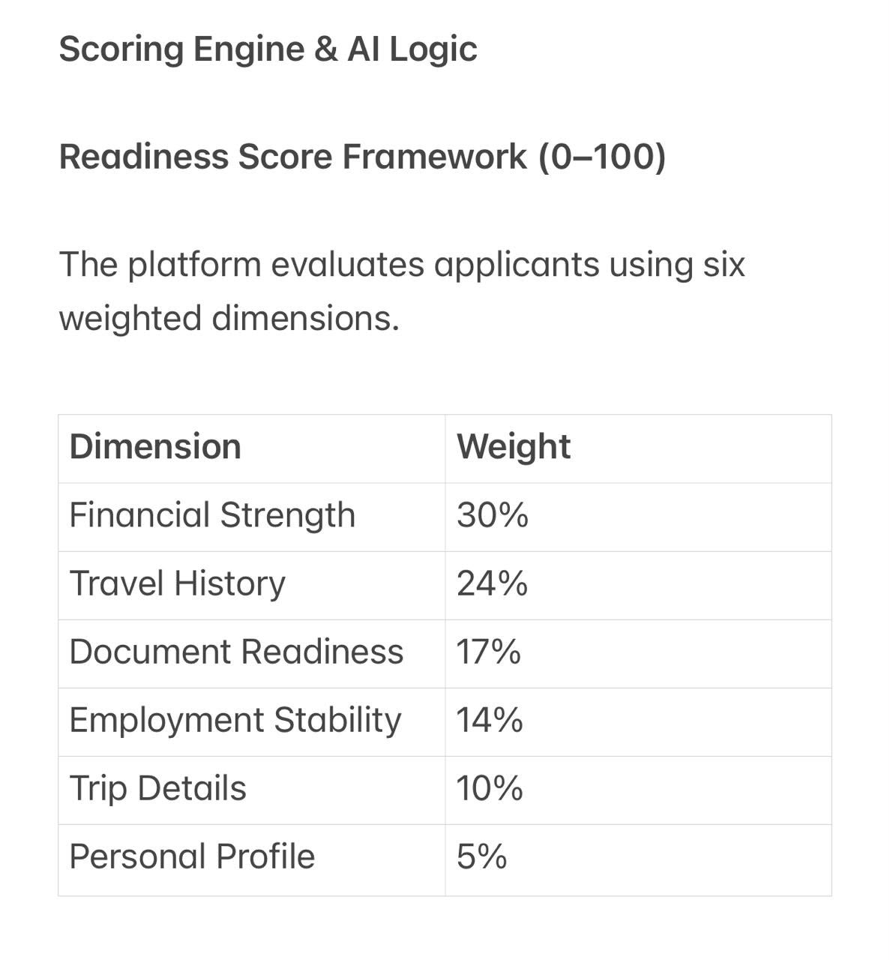

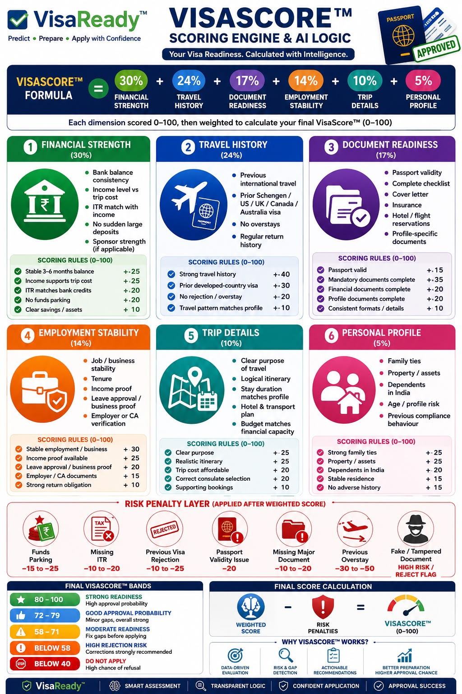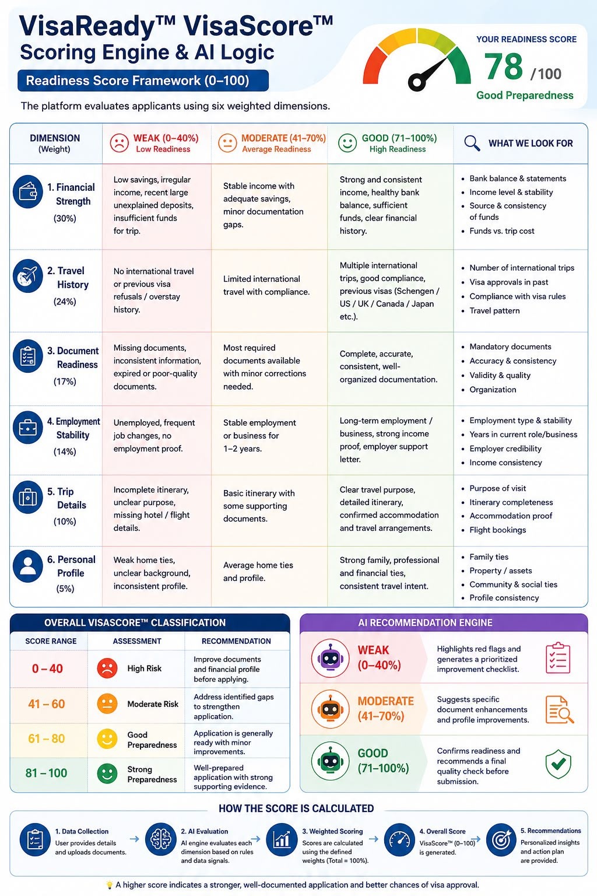

7.2 of 5th point
Destination-intelligence content per country (embassy rules, insurance, financial benchmark
SAME AS ABOVE AS ON DATE ONCE GO TO MARKET WILL CHANGE AS PER AGENCY / EMBASSY/ VFS guidelines
7.3 of 1st point
Pricing:
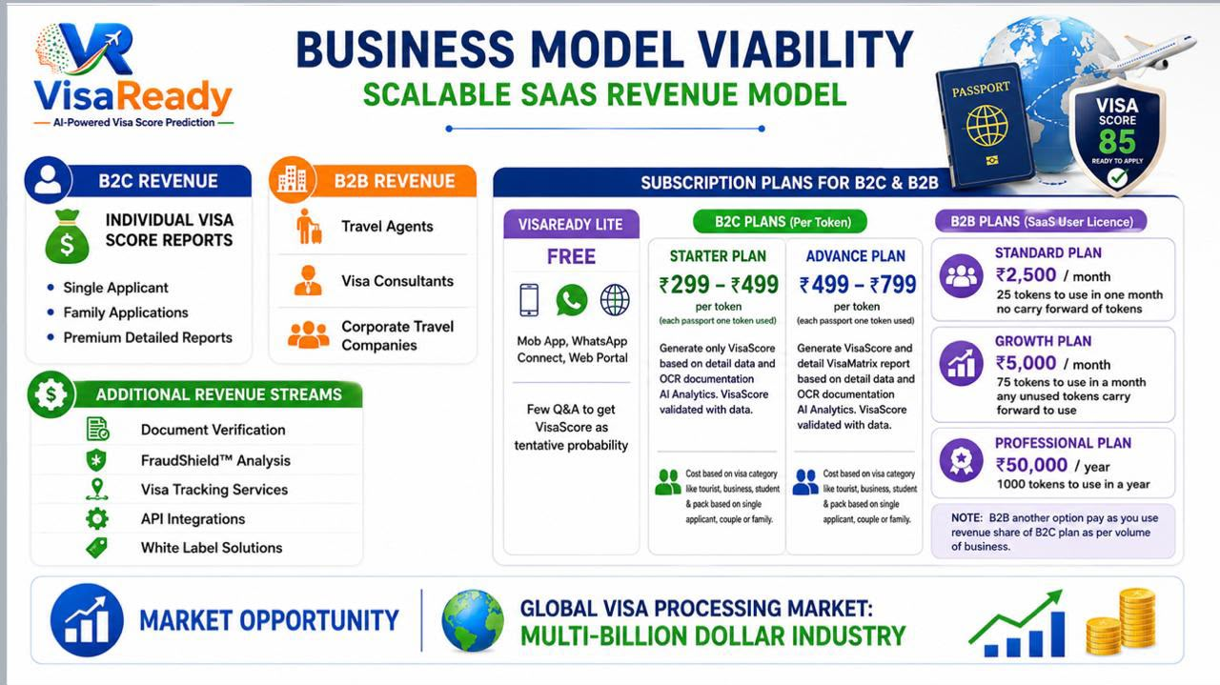
VisaScore- Lite is free where no documentation upload except passport that also optional can enter passport detail of own
Paid :Option -1: VisaScore as per upload document with AI analysis of all doc to generate score for one passport one token of any primary applicant upload his or her spouse or family but need VisaScore only of primary applicant so one token used for B2C price Rs 299 but need visa score of spouse also of uploaded documents then combo up to 1+3 passport use use 1 token but charges @ Rd 499 for B2C Option - 2: Generate VisaScoreand VisaMatrix report both of one passport one token @ Rs 499 of combo of up to 1+3 charges @ Rs 799 will get separate score & report if uploaded each person documentation as per flow
For B2B simple one passport one token one case no will get both score and report with red flag option

7.2 of 5th point red flag in VisaMatrix report to raise concerns few May be missing will add during field trial when populate data:
https://drive.google.com/drive/folders/1qIIJhWe4nw53gvUxssjvYTAGyBD9OaeM?usp=share_link
Integrations & Branding:
WhatsApp Business API, document-verification and email service credentials.
ADVISE WHAT YOU NEED FROM US FOR WHATSAPP BUSINESS API TO GET
EMAIL TO USE INFO@VISAREADY.GLOBAL ALREDY WORKING IF YOU NEED ACCESS CAN SHARE DETAIL
Logo (PNG), icon, colour palette and report branding assets; ‘Powered by Tech2Go’ lockup.
SENDING CREATIVE OF MOCK-UP FOR OPENING SCREEN FYI REFERENCE SENDING PNG LOGO BELOW
https://drive.google.com/drive/folders/1zs-uCrlll90IOnvmlNoUrvsF0NBCSmz2?usp=share_link
FAQ for latter phases :
https://drive.google.com/drive/folders/1MdgqfgvKd_rXy_RtIS21updpDBuCznZf?usp=sharing
Additional info shared by Client plus doc for whatsapp:
Agency WhatsApp trigger flow take a note when agency send trigger the country to apply visa and visa type to select is optional reason in few cases agency which do not know apply from which country since not aware of client travel plan once visa applicant fill data it will be captured and agency have option to change any applicant who came to dashboard can change which country visa and visa type if required May be client filled wring as per rule not followed
https://drive.google.com/drive/folders/1T_lNRLOnBacI0ZPhrAND2pTVeANgGDVm?usp=share_link
7.5 point 2
Confirm regeneration counter reset behaviour after a paid
regeneration (2 free, 3rd paid is confirmed).
ONLY ALLOW ONE MORE TIME MEANS TOTAL 2 TIMES ONLY NOT MORE
7.5 point 3
Where does the Library tab sit in the 5-item bottom navigation,
and does it replace any existing tab? If it is a challenge to position bottom give any tab insted of library term it Knowledge Base i hope given option at bottom of FAQ it is important
7.5 point 4
Confirm exact thresholds for bank-statement flags
(sudden-parking % default 50, low-balance, large-credit).
Sudden parking trigger logic 50% of correct balance or more deposit in last 45 days if that kind of amount deposit every month +/- 10% of that amount then is not a sudden deposit
7.5 point 7
Provide final Terms of Use / Privacy / Disclaimer & Terms of VisaReady platform use copy (the v4.0
draft is in 4.4).
As below
*VisaReady Terms & Disclaimer Of Use*
1. *Accurate Information*
Users must provide accurate, complete, and truthful information. VisaReady relies on submitted details to generate reliable AI-powered visa readiness assessments and recommendations.
2. *Service Disclaimer*
VisaReady provides predictive guidance, document assistance, and preparedness insights only. We do not offer legal advice or guarantee visa approvals, appointments, or outcomes.
3. *User Responsibilities*
Users must review all recommendations before submission. Fraudulent documents, false information, or misuse of the platform may result in account suspension or termination.
4. *Acceptance of Terms*
By accessing or using VisaReady, you confirm acceptance of these Terms of Use, our Privacy Policy, and all applicable platform policies.
User Consent Checkbox
✅ I have read and agree to the Terms of Use, Privacy Policy, and Disclaimer. I understand that VisaReady provides predictive guidance only and does not guarantee visa approval.
7. Client Inputs Required & Open Questions
Resolved 28 June: B2B token allotments are confirmed as 25 / 75 / 1,000 (Standard / Growth /
Professional). The earlier slide-vs-notes discrepancy is closed.

YES FOLLOW THIS

7.1 Onboarding & Verification
•
Exact list of mandatory onboarding documents; GST + PAN validation rules (format + any live
verification).

NO LIVE VERIFICATION REQUIRED GST & PAN IS OK

7.2 Credits & Pricing
•
Confirm credit deduction counter reset (2 free, 3rd paid is confirmed).

YES

•
Credit pack definitions; scoring vs processing fee per country/visa type; low-credit threshold

TRIGGER WHEN LAST 5 TOKEN LEFT OF STANDARD PLAN AND 15 LEFT FOR GROWTH PLAN AND 50 LEFT FOR PROFESSIONAL PLAN TO SHOW IN AGENCY DASHBOARD COLOUR CHANGE TO BRING ATTENTION
and
removal policy.
Whether the agency can self-switch Credit-Based vs Pay-Per-Use, or it is platform-set; payment
gateway for recharge.
AGENCY SEND REQUEST FROM DASHBOARD TO SUPER ADMIN TO REFILL IF ON PAYMENT SUPER ADMIN WILL SEND PAYMENT LINK ONCE PAID TOKEN WILL CREDIT IN AGENCY DASHBOARD. Reson of it in B2B business need payment flexibility including price advantage and credit
7.3 Promo Codes & Leads
Promo-code allocation model (count per agency, validity, reuse) and the delivery email template.
Whether agencies are notified of new leads (email/WhatsApp) and the lead SLA before it returns to
the Admin pool.
PROMO CODE NEED LOGIC TO MAP IT NEED TO MATCH WITH AGENCY CODE TO GET PROMO CODE ADVANTAGE ACTIVATED OTHERWISE IN MARKET PROMO CODE WILL BE MISUSED
7.4 Users, Integrations & Branding
•Granular sub-user permission list and default template; WhatsApp Business API credentials and link
format; ‘Powered by VisaReady’ lockup; logo constraints.
IN CASE OF WHATSAPP TRIGGER FROM AGENCY DASHBOARD ALREDY GIVEN PDF DOC
IN TEMPLATE CAN USE POWERED BY VISAREADY
7.5 Open Questions for the Client
# Question Impacts
1 Are the 25 free credits one-time on approval only, or repeated
on each renewal? Screen 2, §4
ONE TIME ONBOARDING IF TO ADD MORE FREE CREDIT SUPER ADMIN CAN
2 Confirm the regeneration counter reset behaviour (2 free, 3rd
paid is confirmed). §4.1
ONLY 2 TIME
3 Promo-code allocation: how many codes per agency, validity,
and reuse rules? §4.4
SINGLE PROMO CODE MAP WITH AGENCY CODE TO ACTIVATE PROMO CODE

4 Passport-data export: which recipients are permitted, and
what consent/audit is required? Screen 14
NO NEED OF CONSENT NOW WILL PLAN IN PHASE 2 NOW PLAN EXPORT DATE FROM DASHBOARD SELECTING CASE NO TO SEND ANOTHER DASHBOARD BY AGENCY CODE TO POPULATE IN ANOTHER AGENCY DASHBOARD CAN SEND EXCEL SHEET IN E MAIL WITH SUBJECT LINE TO WRITE FOR DASHBOARD TEMPLATE
5 Lead notifications and SLA before an unworked lead returns to
the Admin pool. Screen 16, §6# Question Impacts
SUPER ADMIN WILL SEND LEAD TO ANY AGENCY BY AGENCY CODE TO TRANSFER TO OTHER AGRNCY DASHBOARD TO SHOW
6 Does the 6-digit code allow enough capacity for projected
agency volume? Screen 1, §5
YES - 6-digit numeric code (100000–999999, no leading zero): 900,000 unique codes
Client ans in capital
.21. Client Inputs Required & Open Questions:
The following require client confirmation before development on the affected screens.
Resolved 28 June: the scoring model is the confirmed editable rule base — 7 factors (Financial 25%,
Travel 24%, Document 17%, Employment 14%, Trip 10%, Personal 5%, Others 5%) — and B2B tokens are
25 / 75 / 1,000. The earlier 6-vs-7 and slide-vs-notes items are closed.
# Open item Blocking screen(s)
1 Range bands and dropdown value sets for every
configurable customer-form field AD-26
2 Aspect and sub-rules for the new ‘Others’ factor
(currently a 5% placeholder) AD-27
3 Confirm Lite/Final parameter split and Lite
Low/Med/High thresholds AD-27, AD-28
4
Country-visited & destination-difficulty tiers,
experience/salary bands, booster values, funds
benchmark
AD-39
5 Risk triggers + penalty points (passport-expiry,
travel-date already drafted) AD-30, AD-31
6
Bank-statement flag thresholds (sudden-parking %
default 50, low balance, large credit) + accepted proof
types
AD-32
7 Country requirement content + any other
source-of-information (SOI) AD-33
8 Document checklists per visa type for all destinations AD-34
9 Cover-letter copy (UK / Canada / Australia) and any
itineraries beyond the Schengen seed AD-41
10 Per-country Library content and country list AD-63
11 Final Terms of Use / Privacy / Disclaimer copy AD-64
12 Report branding asset (logo for watermark) and
VisaMatrix section order AD-65
13 Lead-assignment policy: SLA before an unworked
agency lead returns to the unassigned pool AD-08
14 Exact pricing within the confirmed B2C ranges and
couple/family pack multipliers
AD-42
15 Promo-code allocation model and delivery emailz
template
AD-62# Open item 16 Payment gateway (Razorpay assumed): API keys +
webhook config 17 Notification events + preferred channel per event 18 DPDPA retention period and erasure-job SLA 19 Final list of destination countries at MVP launch 20 Per-country embassy / official tracking URLs (for the
app’s ‘View Embassy Portal’ link)
*THESE POINTS ON THURSDAY DISCUSSION WILL TRY TO CLOSE NEED TO UNDERSTAND THE QUERY WELL TO FRAME ANSWER*

Customer Application ui

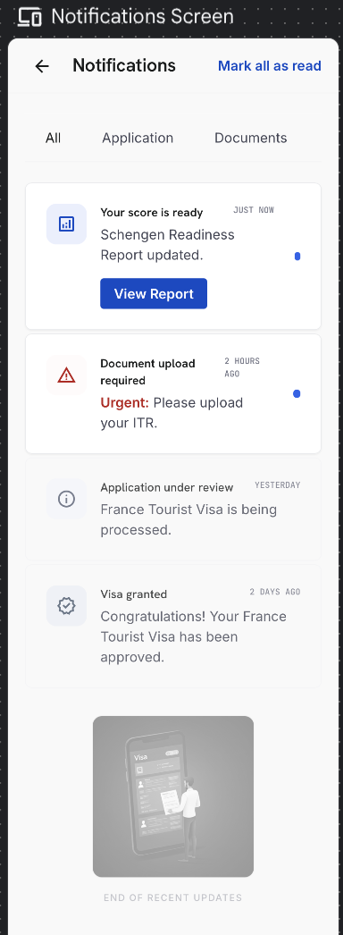
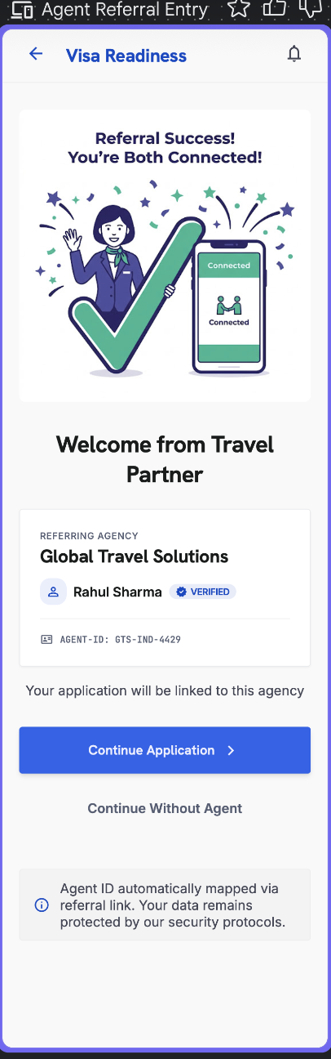

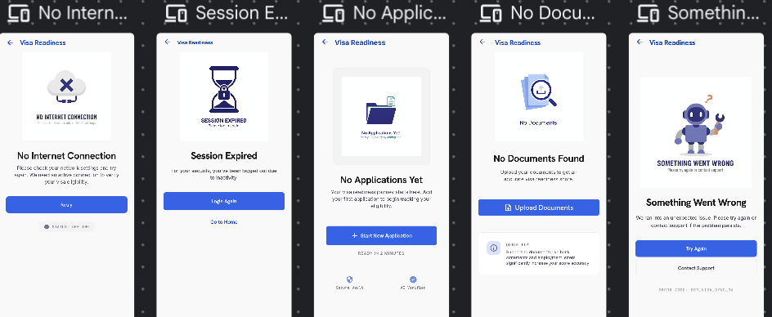
.These are just ui reference screen will be according to doc

Agency Website Doc
VisaReady™
Agency Dashboard
Manage clients, applications, credits and reports — Powered by VisaReady
Product Requirements Document
Attribute | Value
Platform | Web (responsive)
Phase | MVP
Version | 1.1 — Client Release (02 July 2026)
Status | For Client Review
Powered by | Tech2Go
Related | Customer Application PRD · Super Admin Portal PRD

Contents
1. Product Overview
2. User Roles, Access & Agency Lifecycle
2.4 Sub-User Creation & Powers (detailed)
3. Screen-by-Screen Requirements
Screens 1–4 — Registration, Approval, Login, Dashboard
Screens 5–7 — Clients, Application Detail, Add Client
Screens 8–10 — Credits, Recharge, Billing
Screens 11–16 — Users, Branding, Notifications, Profile, Support, Leads
4. Application Handling on Behalf of the Customer
5. Credit & Billing Logic
6. Promo Codes — End-to-End (detailed)
7. Branding & Top-Bar Rules
8. Agency Mapping & Lead Routing (Cross-Product)
9. Client Inputs Required & Open Questions
Appendix B — Field-Level Cross-Product Mapping (Admin ⇄ Agency ⇄ Customer)

1. Product Overview

1.1 Product Summary
The Agency Dashboard is the web workspace for travel agencies and consultants who use VisaReady to assess and prepare their clients' visa applications. From a single place, an agency onboards clients, runs or continues assessments on their behalf, manages co-applicants, generates the VisaScore™ and VisaMatrix™ report, tracks each application to its decision, and manages its credits, staff and branding.

1.2 Scope
- Agency registration, verification and lifecycle (pending, active, suspended, blacklisted), controlled by Super-Admin activate/deactivate toggles.
- Client and application management, including running, continuing or filling an assessment on a client's behalf and managing co-applicants.
- Credit wallet, recharge and billing; staff (sub-user) creation and permission management.
- Promo-code distribution: passing Super-Admin-generated codes to customers by email.
- Lead handling for customers who enter the agency code or are allocated by Super Admin.
- Branding, notifications, support, and report sharing.

1.3 Platform Context
Product | Audience | Role
Customer Application | Travellers / applicants | Mobile, WhatsApp & Web app; self-service assessment.
Agency Dashboard | Travel agencies & consultants | This document — manage clients, applications, credits and reports.
Super Admin Portal | VisaReady platform team | Configure scoring, countries, pricing, content; approve agencies; generate promo codes; manage leads.

Note — Every applicant created or referred by an agency is the same application record the customer sees in the Customer Application (mobile app and web app). Data entered on either side populates the same record, so an agency and its client always see a consistent view.

2. User Roles, Access & Agency Lifecycle

2.1 User Roles
Role | Description
Agency Admin | The primary account holder created on approval. Full access to clients, applications, credits, billing, staff (sub-users), branding and settings.
Sub-User (Agent / Staff) | A staff member created by the Agency Admin, with permissions granted per 2.2. Typically handles clients and applications but not billing.

2.2 Permission Control for Sub-Users
The Agency Admin grants each sub-user a set of granular permissions. Toggles control access to:
- Create / edit clients and applications; fill or continue an application on a client's behalf.
- Generate scores and reports; share reports with clients.
- View credits and usage; recharge credits (billing) — off by default.
- Manage leads; manage branding; manage other sub-users — off by default.
- Distribute promo codes to customers — off by default.

▸ RULE — Sub-users cannot access billing, recharge, promo-code distribution or sub-user management unless the Agency Admin explicitly grants it.

2.3 Agency Lifecycle & Activate / Deactivate Control
State | Behaviour | Controlled by
Pending Approval | Agency has registered and submitted documents; awaiting Super Admin review. Limited access; cannot process applications. | System (on registration)
Active | Approved by Super Admin; receives the initial credit allocation and full access per role and permissions. Agency code works. | Super Admin toggle (AD-07 KYC approve / AD-10 reinstate)
Suspended | Access blocked at platform level; the agency code stops working, active cases freeze and staff cannot sign in. Reversible. | Super Admin deactivate toggle (AD-10)
Blacklisted | Permanent block; a separate Super-Admin-only action. Code invalidated. | Super Admin only (AD-10)

▸ RULE — The agency's active/inactive state is driven entirely by the Super-Admin activate/deactivate toggle (see Super Admin PRD AD-10). When Super Admin deactivates an agency, the agency code stops validating on the customer side within the same action, every sub-user login is blocked, and the change is written to the Audit Trail. Re-activation restores access and the code immediately.

Note — On approval, the agency receives an initial allocation of free credits (see 5.1). Whether this allocation is one-time or recurs on renewal is confirmed with the client.

2.4 Sub-User Creation & Powers (Detailed)
Sub-users are created and governed entirely by the Agency Admin from Screen 11 (User Management). The Super Admin does not create agency sub-users; it only sees the agent list on the Agency Detail view (AD-07).

How to create a sub-user
- Step 1 — Agency Admin opens Screen 11 › ‘Add Sub-User’.
- Step 2 — Enters the sub-user's name, email and mobile (mobile OTP-verified on first login).
- Step 3 — Sets the permission toggles (2.2). Sensitive toggles (billing, recharge, promo distribution, manage sub-users) are OFF by default.
- Step 4 — Saves. The system emails the sub-user a one-time setup / invite link. The sub-user sets up access via email or mobile OTP.
- Step 5 — The sub-user appears in the user list with role, status (Invited / Active / Deactivated), last-active and assigned-client count.

Powers matrix — Agency Admin vs Sub-User
Capability | Agency Admin | Sub-User (default) | Sub-User (grantable)
Create / edit clients & applications | Yes | Yes | —
Fill / continue application on behalf | Yes | Yes | —
Generate & regenerate score, share report | Yes | Yes | —
View credits & usage ledger | Yes | Yes | —
Recharge credits / billing | Yes | No | Grantable
Distribute promo codes to customers | Yes | No | Grantable
Manage leads | Yes | No | Grantable
Manage branding | Yes | No | Grantable
Create / edit / deactivate sub-users | Yes | No | Grantable
Edit agency profile / GST / PAN | Yes | No | Not grantable

▸ RULE — The Agency Admin can deactivate a sub-user at any time; a deactivated sub-user is blocked from login but their historical actions and client assignments are retained. Only the Agency Admin (never a sub-user) can edit the agency profile, GST and PAN.

2.5 Navigation Map
Area | Screens
Home | Dashboard (Screen 4)
Clients | Clients / Applications List (5), Application Detail (6), Add New Client (7)
Leads | Leads (16)
Wallet | Credits & Wallet (8), Credit Recharge (9), Billing (10)
Agency | User Management (11), Branding (12), Notifications (13), Profile & Settings (14), Support (15)

3. Screen-by-Screen Requirements
01 | Agency Registration

Purpose — Lets a new agency apply to join VisaReady. Submission creates a Pending-Approval account for Super Admin review.
- Captures agency name, contact person, email, mobile, address, GST and PAN, and uploads of the required verification documents.
- A 6-digit Agency Code is issued by the system on approval and is unique to the agency.

Fields & Validation
Field | Type | M/O/C | Validation
Agency name | Text | M | ≥ 2 chars
Contact person | Text | M | Letters / spaces
Email | Email | M | Valid format; unique
Mobile | Phone | M | Country code + 10 digits; OTP-verified
Address | Text | M | Non-empty
GST number | Alphanumeric | M | 15-char GSTIN format
PAN | Alphanumeric | M | 10-char PAN format
Verification documents | File | M | PDF / JPG / PNG ≤ 10 MB each

⚠ CLIENT INPUT REQUIRED — Final list of mandatory onboarding documents and the GST + PAN validation rules (format, checksum, any live verification).

Element Detail — Screen 1 — Agency Registration
Element Type | Element ID | Label | Type | M/O/C | Auto-Populate Source | Visible When | Enabled When | Validation / Precondition | On Click / On Change | Next / Result | Source (config) | Editable By | Error / Fallback | Dev Notes / Cust-Agency Sync
Input | reg_name | Agency name | Text | M | — | Always | Always | ≥ 2 chars; unique | On submit validate | Approval status | User | Agency Admin | Duplicate/format error | Creates Pending-Approval account
Input | reg_contact | Contact person | Text | M | — | Always | Always | Letters/spaces | On change | — | User | Agency Admin | Required error | —
Input | reg_email | Email | Email | M | — | Always | Always | Valid; unique; OTP-verified | On submit send OTP | OTP verify | User | Agency Admin | Invalid/duplicate error | —
Input | reg_mobile | Mobile | Phone | M | — | Always | Always | Country code + 10 digits; OTP-verified | On submit send OTP | OTP verify | User | Agency Admin | Invalid number | —
Input | reg_addr | Address / City / State / PIN | Mixed | M | — | Always | Always | PIN 6 digits | On change | — | User | Agency Admin | PIN format error | —
Input | reg_gst | GST number | Alphanumeric | M | — | Always | Always | 15-char GSTIN format | On change validate | — | User | Agency Admin | GSTIN format error | Verified by Super Admin (AD-07)
Input | reg_pan | PAN | Alphanumeric | M | — | Always | Always | 10-char PAN format | On change validate | — | User | Agency Admin | PAN format error | Verified by Super Admin (AD-07)
File | reg_docs | Verification documents | File | M | — | Always | Always | PDF/JPG/PNG ≤ 10 MB each; ≥ 1 | On upload | Approval status | User | Agency Admin | Type/size error | Reviewed by Super Admin
System | reg_code | Agency code | System | — | Issued on approval | On approval | — | 6-digit; unique | — | Shown on approval | Admin — Agency Registry | — | — | Validates on customer entry (maps leads)

02 | Registration / Approval Status

Purpose — Shows the agency where its application stands after submission.
- Status banner — Pending / Approved / More Information Required / Rejected — with any reviewer note.
- On approval: the Agency Code, the initial credit allocation, and a link to sign in.

Element Detail — Screen 2 — Registration / Approval Status
Element Type | Element ID | Label | Type | M/O/C | Auto-Populate Source | Visible When | Enabled When | Validation / Precondition | On Click / On Change | Next / Result | Source (config) | Editable By | Error / Fallback | Dev Notes / Cust-Agency Sync
Display | apr_status | Status banner | Display | — | Super Admin review (AD-07) | Always | — | Pending / Approved / More Info / Rejected | — | — | Admin — KYC (AD-07) | — | — | Set by Super Admin approve/reject
Display | apr_note | Reviewer note | Display | — | Super Admin note | If provided | — | — | — | — | Admin | — | — | —
Display | apr_grant | Agency code / initial credits | Display | — | On approval (AD-07/AD-11) | On approval | — | — | On approval show code + credits + sign-in link | Login | Admin | — | — | Initial credit allocation per plan

03 | Login

Purpose — Authenticates agency staff.
- Email or mobile + OTP. Suspended or blacklisted agencies are blocked with a clear message.

Element Detail — Screen 3 — Login
Element Type | Element ID | Label | Type | M/O/C | Auto-Populate Source | Visible When | Enabled When | Validation / Precondition | On Click / On Change | Next / Result | Source (config) | Editable By | Error / Fallback | Dev Notes / Cust-Agency Sync
Input | log_id | Email or mobile | Text | M | — | Always | Always | Must match an active agency account | On submit send OTP | OTP verify | User | Agency staff | No/invalid account error | Suspended/blacklisted blocked
Input | log_otp | OTP | Numeric | M | — | After send | After send | Time-limited OTP | Verify OTP | Dashboard | Auth service | — | Wrong OTP; suspended-agency block | Deactivated agency → login blocked (AD-10)

04 | Dashboard (Home)

Purpose — An at-a-glance summary of the agency's activity.
- Key metrics: active applications, leads awaiting action, credits remaining, recent decisions.
- Quick actions: Add New Client, View Leads, Recharge Credits; recent-activity feed and low-credit warning.

Element Detail — Screen 4 — Dashboard (Home)
Element Type | Element ID | Label | Type | M/O/C | Auto-Populate Source | Visible When | Enabled When | Validation / Precondition | On Click / On Change | Next / Result | Source (config) | Editable By | Error / Fallback | Dev Notes / Cust-Agency Sync
Metric | dash_kpis | Key metrics | Display | — | Auto from agency data | Always | — | Active applications, leads awaiting, credits remaining, recent decisions | On tap drill in | Relevant screen | System | — | — | Live aggregates
Button | dash_add | Add New Client | Button | M | — | Always | Always | — | On click → Add New Client | Screen 7 | App | Agency staff | — | —
Button | dash_leads | View Leads | Button | M | — | Always | Always | — | On click → Leads | Screen 16 | App | Agency staff | — | —
Button | dash_recharge | Recharge Credits | Button | M | — | Always | Billing permission | — | On click → Recharge | Screen 9 | App | Admin / permitted sub-user | — | Sub-user needs billing permission
Feed | dash_activity | Recent activity + low-credit warning | Feed | — | Auto from ledger/events | Always | — | Low-credit warning below threshold | — | — | System | — | — | Threshold configurable (Admin)

05 | Clients / Applications List

Purpose — Central list of every applicant mapped to the agency, whether created in-dashboard, referred via the WhatsApp link / agency code, or allocated by Super Admin.
- Columns: Client · Destination · Visa type · VisaScore Lite · Status · Credits used · Last updated · Assigned sub-user.
- Search by name / mobile / application ID; filter by status, country, sub-user and date range.
- Row actions: open the application, review / continue / edit, update status, view or share the report.

Element Detail — Screen 5 — Clients / Applications List
Element Type | Element ID | Label | Type | M/O/C | Auto-Populate Source | Visible When | Enabled When | Validation / Precondition | On Click / On Change | Next / Result | Source (config) | Editable By | Error / Fallback | Dev Notes / Cust-Agency Sync
Table | cl_list | Clients / applications | Table | — | Auto: in-dashboard + referred + allocated | Always | — | Cols: Client · Destination · Visa · Lite score · Status · Credits used · Last updated · Assigned sub-user | On row action open case | Application Detail | User/System data | — | Empty state | Same shared records the customer sees
Search | cl_search | Search | Search | O | — | Always | Always | By name / mobile / application ID | On enter filter list | — | App | Agency staff | No results state | —
Filter | cl_filter | Filters | Filter | O | — | Always | Always | Status, country, sub-user, date range | On change filter | — | App | Agency staff | — | —
Action | cl_rowact | Row actions | Actions | — | — | Always | Per permission | Open / review / continue / edit / update status / view-share report | On click | Application Detail / Report | App | Agency staff | — | Edit syncs to customer app & web (⇄)

06 | Client / Application Detail

Purpose — Full view of a single applicant: profile, score, documents, report, and the controls to advance the application, manage co-applicants and communicate. The agent can review, continue or fill the application on the client's behalf (see Section 4).

Sections
- Applicant summary — personal, passport, destination, visa type, and co-applicants (up to five).
- Score — VisaScore™ Lite (indicative) and the final VisaScore™ with the full factor breakdown (Financial 25% · Travel 24% · Document 17% · Employment 14% · Trip 10% · Personal 5% · Others 5%). The score is for the primary applicant only. Final bands: 80–100 Strong · 72–79 Good · 58–71 Moderate · below 58 High Rejection Risk · below 40 Do Not Apply.
- Risk flags from the engine, including the fund-parking flag. The agent can request a source-of-funds proof from the client to clear it.
- Documents — uploaded files with OCR status. Report — the full VisaMatrix™ carrying a VisaReady logo background watermark, re-sendable by WhatsApp / Email.

Actions the agent can take
- Review the application; continue from where the client left off; edit any field on the client's behalf (data syncs to the customer app and web app).
- Add and manage co-applicant forms (up to five).
- Generate the VisaScore™ once the primary applicant's form and required documents are complete; regenerate per the re-score rule (5.1).
- Set the application status; communicate with the client; upload the visa decision.
- The agent can review the application, continue it from wherever the client left off mid-form, or fill it completely on the client's behalf. All three operate on the same shared record, so changes sync to the customer app and web app in real time.

Status values the agent can set
Status | Meaning / customer-facing message
Application Submitted | “Your application has been submitted. Your agent will get back to you.”
Under Review | Application is being processed.
Document Requested | Additional documents required from the client.
Submitted to Embassy | Application has been submitted to the embassy / visa centre.
Visa Granted — Passport Received | Visa approved; passport-received notification sent.
Visa Rejected | Application unsuccessful, with next steps.

▸ RULE — Status changes are pushed to the customer via WhatsApp, in-app notification and the customer web app. The platform shares no billing message with the end user; the agency bills its client directly.

Element Detail — Screen 6 — Client / Application Detail
Element Type | Element ID | Label | Type | M/O/C | Auto-Populate Source | Visible When | Enabled When | Validation / Precondition | On Click / On Change | Next / Result | Source (config) | Editable By | Error / Fallback | Dev Notes / Cust-Agency Sync
Section | det_summary | Applicant summary | Display | — | Shared application record (⇄) | Always | — | Personal, passport, destination, visa, co-applicants (up to 5) | — | — | Shared record | Agent (on behalf) | — | Mirrors customer app & web
Score | det_lite | VisaScore Lite (indicative) | Score | — | Scoring engine (Lite) | After Lite generated | — | 5-parameter indicative; Low/Med/High; no flags | — | — | Scoring engine (AD-28) | — | — | Primary applicant only
Score | det_final | Final VisaScore + breakdown | Score | — | Scoring engine (Final) | After Final generated | — | 7 factors weighted − risk; bands 80/72/58/<58/<40 | On tap expand factors | — | Scoring engine (AD-27) | — | — | Primary applicant only
Flags | det_flags | Risk flags | Flags | — | Risk engine (AD-30/31/32) | Final only | — | Incl. fund-parking flag | Request source-of-funds proof from client | Client doc request | Scoring engine | Agent | — | Cleared by valid proof upload
Docs | det_docs | Documents | List | — | Customer/agent uploads | Always | — | OCR status per file | On tap view | — | Shared record | Agent | — | Same files across app & web
Report | det_report | VisaMatrix report | Document | — | Auto after Final score | After Final | — | Logo watermark; re-sendable | On click share | WhatsApp / Email | Admin — Report Template (AD-65) | Agent | — | Agency-referred = co-branded
Editable | det_edit | Edit any field on behalf | Form | C | Prefilled from shared record | Always | Per permission | Same validation as customer form | On save sync | ⇄ Customer app & web | Shared record | Agent | Validation errors inline | Single source of truth per application
Group | det_coapp | Co-applicant forms | Group | C | Per co-applicant OCR | Always | Always | Up to 5; captured not separately scored | Add/edit | — | Shared record | Agent | Max 5 | Consistent with customer app
Action | det_generate | Generate / regenerate score | Action | M | — | Form + docs complete | Per permission | After original score: 1 regen free; 2nd onward paid/credit; profile edit required | On click score/regenerate | Score result | Scoring + Token engine | Agent | Paywall on 2nd regen | 1 passport = 1 credit
Dropdown | det_status | Application status | Dropdown | M | — | Always | Per permission | One of 6 statuses (below) | On change push notification | Customer notified | App | Agent | — | Pushed to customer WhatsApp/app/web
File | det_decision | Upload visa decision | File | C | — | Status = Granted/Rejected | Per permission | PDF/JPG/PNG ≤ 10 MB | On upload | Conclusion (customer) | App | Agent | Type/size error | Shown at customer Conclusion + audit trail
Text | det_remarks | Remarks | Text area | O | — | Always | Per permission | — | On save | — | App | Agent | — | Visible to Super Admin; NOT to customer

Element Type | Element ID | Label | Type | M/O/C | Auto-Populate Source | Visible When | Enabled When | Validation / Precondition | On Click / On Change | Next / Result | Source (config) | Editable By | Error / Fallback | Dev Notes / Cust-Agency Sync
Action | det_review | Review application | Action | O | Shared application record (⇄) | Always | Per permission | Opens read view of everything the client entered so far | On click open review | Application review view | Shared record | Agent | — | Read-only pass over current progress

Element Type | Element ID | Label | Type | M/O/C | Auto-Populate Source | Visible When | Enabled When | Validation / Precondition | On Click / On Change | Next / Result | Source (config) | Editable By | Error / Fallback | Dev Notes / Cust-Agency Sync
Action | det_continue | Continue application | Action | C | Shared record (last saved step) | Application is part-complete | Per permission | Resumes from the exact step the client left off; step progress preserved | On click open form at last step | Application form (at saved step) | Shared record | Agent | — | Agent picks up where the customer stopped mid-form; syncs ⇄ customer app & web

Element Type | Element ID | Label | Type | M/O/C | Auto-Populate Source | Visible When | Enabled When | Validation / Precondition | On Click / On Change | Next / Result | Source (config) | Editable By | Error / Fallback | Dev Notes / Cust-Agency Sync
Action | det_fill | Fill application on behalf | Action | C | Prefilled from shared record + OCR | Application incomplete | Per permission | Agent completes any/all steps (passport, country, visa & trip, applicant, financial, travel history, home ties) | On save each step syncs | ⇄ Customer app & web | Shared record | Agent | Validation errors inline | Agent can complete a fresh or partial application end-to-end

Element Type | Element ID | Label | Type | M/O/C | Auto-Populate Source | Visible When | Enabled When | Validation / Precondition | On Click / On Change | Next / Result | Source (config) | Editable By | Error / Fallback | Dev Notes / Cust-Agency Sync
Progress | det_progress | Application progress | Display | — | Auto from completed steps | Always | — | Shows steps completed vs total (e.g. "Step 4 of 6") | — | — | System | — | — | Signals where the customer left off; drives Continue

07 | Add New Client & WhatsApp Outreach

Purpose — Two ways to bring a client in, both mapping to this agency.(or auto map when user enter code while filling form or admin assign phase 2)
- Option A — Send WhatsApp link: the agent enters the client's number; the system generates a unique link embedded with the 6-digit agency code. The client completes the journey conversationally and is redirected to the customer web application for score and document upload. The application appears here, mapped to the agent.
- Option B — Process in-dashboard: the agent fills the applicant's details on the client's behalf. Captured detail populates the shared application record and the customer application (mobile & web) wherever fields overlap. A credit is consumed when the applicant is processed (a score is generated), not when a link is merely sent.

▸ RULE — A credit is deducted when a new applicant is processed (scored), not when a link is sent.

⚠ CLIENT INPUT REQUIRED — WhatsApp Business API credentials and confirmation of the outreach link format.

Element Detail — Screen 7 — Add New Client & WhatsApp Outreach
Element Type | Element ID | Label | Type | M/O/C | Auto-Populate Source | Visible When | Enabled When | Validation / Precondition | On Click / On Change | Next / Result | Source (config) | Editable By | Error / Fallback | Dev Notes / Cust-Agency Sync
Input | new_wa_num | Client mobile (Option A) | Phone | C | — | Option A | Always | Country code + 10 digits | On send generate link | WhatsApp link sent | App | Agency staff | Invalid number | Link embeds 6-digit agency code
System | new_wa_link | Generated WhatsApp link | System | — | Agency code auto-embedded | Option A | — | Unique; embeds agency code | On click by client → web app | Customer web app | App | — | — | Client redirected to customer web app; maps to agent
Form | new_indash | In-dashboard applicant form (Option B) | Form | C | OCR + shared record where overlapping | Option B | Always | Same fields/rules as customer application form | On save populate shared record | ⇄ Customer app & web | Shared record | Agent | Validation errors inline | Credit consumed when scored, not on link send
System | new_credit | Credit consumption | System | — | — | On processing (score) | — | 1 credit per applicant scored | On score deduct credit | Wallet updated | Token engine | — | Zero balance blocks | Not deducted on link send

08 | Credits & Wallet

Purpose — The agency's credit wallet: balance, usage ledger and recharge entry point.
- Balance display; low-credit warning; usage ledger (date, client, action, credits used, running balance); credit additions (recharges and Super-Admin allocations, including the initial allocation and any promotional token grants).

Element Detail — Screen 8 — Credits & Wallet
Element Type | Element ID | Label | Type | M/O/C | Auto-Populate Source | Visible When | Enabled When | Validation / Precondition | On Click / On Change | Next / Result | Source (config) | Editable By | Error / Fallback | Dev Notes / Cust-Agency Sync
Display | wal_balance | Balance | Display | — | Token engine | Always | — | — | — | — | Token engine | — | Low-credit warning | —
Ledger | wal_ledger | Usage ledger | Table | — | Auto from transactions | Always | — | Date, client, action, credits used, running balance | On tap view entry | — | Token engine | — | Empty state | Includes Super-Admin allocations & promo grants
Display | wal_additions | Credit additions | Display | — | Recharges + Admin allocations | Always | — | Initial allocation + recharges + promotional grants | — | — | Token engine | — | — | Initial allocation on approval (AD-07/AD-11)

09 | Credit Recharge

Purpose — Top up credits by purchasing a credit pack.
- List of credit packs (configured by Super Admin) with price and quantity; payment via the platform gateway; balance updates immediately on success.

⚠ CLIENT INPUT REQUIRED — Credit pack definitions (quantities, prices, validity) and the payment gateway.

Element Detail — Screen 9 — Credit Recharge
Element Type | Element ID | Label | Type | M/O/C | Auto-Populate Source | Visible When | Enabled When | Validation / Precondition | On Click / On Change | Next / Result | Source (config) | Editable By | Error / Fallback | Dev Notes / Cust-Agency Sync
Dropdown | rec_pack | Credit pack | Dropdown | M | Admin — Pricing (AD-42) | Always | Billing permission | From Super-Admin-configured packs | On select compute price | Payment | Admin — Pricing | Admin / permitted sub-user | Required error | Packs defined by Super Admin
Gateway | rec_pay | Payment | Gateway | M | — | Pack selected | Billing permission | Secure gateway | On pay process | Balance updated | Payment gateway | Admin / permitted sub-user | Gateway failure → retry | Balance updates immediately; logged in AD-50
PDF | rec_invoice | Recharge invoice | PDF output | — | Auto from recharge transaction | After success | — | Invoice no., date, agency, pack, credits, tax, total, gateway ref | On view download PDF | Invoice (view/download) | Billing / System | — | — | Agency's own invoice for the credit purchase (separate from customer billing; also in Admin AD-51)

10 | Billing

Purpose — Manages how the agency pays VisaReady and tracks its own records. The agency — not the platform — bills the end customer.
Model | How it works
Credit-Based (Advance) | The agency buys credits upfront; each applicant processed (scored) deducts credits. This is the MVP model.
Pay-Per-Use (Phase 2) | The agency is charged at the time of each use rather than pre-purchasing. Planned for a later release.

▸ RULE — The platform shares no billing message with the end user; customer billing is the agency's responsibility.

⚠ CLIENT INPUT REQUIRED — Scoring-fee vs processing-fee values per country / visa type, the low-credit threshold, and whether the agency can self-switch billing models or it is set by Super Admin.

Element Detail — Screen 10 — Billing
Element Type | Element ID | Label | Type | M/O/C | Auto-Populate Source | Visible When | Enabled When | Validation / Precondition | On Click / On Change | Next / Result | Source (config) | Editable By | Error / Fallback | Dev Notes / Cust-Agency Sync
Display | bil_model | Billing model | Display | — | Admin config | Always | — | Credit-Based (MVP) / Pay-Per-Use (Phase 2) | — | — | Admin | — | — | Self-switch is a client-input open question
Record | bil_records | Agency payment records | Table | — | Auto from transactions | Always | — | — | On tap view | — | Billing | — | Empty state | Agency bills its own customer separately

11 | User Management

Purpose — Where the Agency Admin creates and manages staff (sub-user) accounts and access. See 2.4 for the full creation flow and powers matrix.
- User list (role, status, last active, client count); ‘Add Sub-User’ (name, email / mobile, permission toggles per 2.2); edit / deactivate / re-invite.
- Each sub-user receives a one-time email invite and activates via email or mobile OTP.

▸ RULE — Sub-users cannot access billing, recharge, promo distribution or sub-user management unless the Admin explicitly grants it. Deactivating a sub-user blocks login but retains their history.

Element Detail — Screen 11 — User Management
Element Type | Element ID | Label | Type | M/O/C | Auto-Populate Source | Visible When | Enabled When | Validation / Precondition | On Click / On Change | Next / Result | Source (config) | Editable By | Error / Fallback | Dev Notes / Cust-Agency Sync
Table | um_list | Sub-user list | Table | — | Auto from agency users | Always | Manage-sub-users permission | Role, status, last active, client count | On row action edit/deactivate/re-invite | Add/Edit Sub-User | User data | Agency Admin | — | Sub-user actions retained on deactivate
Input | um_name | Sub-user name | Text | M | — | Add/Edit | Always | ≥ 2 chars | On save | — | User | Agency Admin | Required error | —
Input | um_email | Email | Email | M | — | Add/Edit | Always | Valid; unique within agency | On save send invite | Invite email | User | Agency Admin | Duplicate/format error | One-time setup link
Input | um_mobile | Mobile | Phone | M | — | Add/Edit | Always | Country code + 10 digits; OTP on first login | On save | — | User | Agency Admin | Invalid number | —
Toggles | um_perms | Permission toggles | Toggles | M | — | Add/Edit | Always | Sensitive toggles OFF by default (billing, recharge, promo distribution, manage sub-users) | On change persist | — | App | Agency Admin | — | Grantable per 2.2 powers matrix
System | um_status | Status | System | — | — | Always | — | Invited / Active / Deactivated | — | — | App | Agency Admin | — | Deactivate blocks login, retains history

12 | Branding

Purpose — Lets the agency present its own identity within platform rules.
- Upload agency logo; set display name; configure the support contact details surfaced to customers.

▸ RULE — The agency display name always appears with ‘Powered by VisaReady’; the 6-digit Agency Code is always visible in the top bar. Agency-referred reports carry the agency's logo alongside ‘Powered by VisaReady’.

Note — A public agency directory is a planned Phase-2 enhancement and is out of MVP scope.

Element Detail — Screen 12 — Branding
Element Type | Element ID | Label | Type | M/O/C | Auto-Populate Source | Visible When | Enabled When | Validation / Precondition | On Click / On Change | Next / Result | Source (config) | Editable By | Error / Fallback | Dev Notes / Cust-Agency Sync
File | br_logo | Agency logo | File | O | — | Always | Branding permission | PNG/JPG; transparent PNG recommended; size limit | On save persist | Referred reports | User | Admin / permitted sub-user | Upload error | Appears on agency-referred reports
Input | br_name | Display name | Text | M | — | Always | Branding permission | ≥ 2 chars | On save persist | — | User | Admin / permitted sub-user | Required error | Always shown with ‘Powered by VisaReady’
Input | br_support | Support contact (surfaced to customers) | Mixed | O | — | Always | Branding permission | Valid phone/email if provided | On save persist | — | User | Admin / permitted sub-user | Format error | Shown to that agency's customers

13 | Notifications

Purpose — A single feed of system notifications relevant to the agency.
- Account (approval, profile changes, suspension warnings); recharge (top-ups, failures); credit (low-credit, deductions, Super-Admin adjustments); client (new referred application, WhatsApp flow completed, new lead); promo-code allocated to the agency by email.

Element Detail — Screen 13 — Notifications
Element Type | Element ID | Label | Type | M/O/C | Auto-Populate Source | Visible When | Enabled When | Validation / Precondition | On Click / On Change | Next / Result | Source (config) | Editable By | Error / Fallback | Dev Notes / Cust-Agency Sync
Feed | not_feed | Notifications feed | Feed | — | System events | Always | — | Account, recharge, credit, client, promo-allocated | On tap open item | Relevant screen | System | — | Empty state | Promo-code allocation arrives here + email

14 | Agency Profile & Settings

Purpose — Manage agency profile details.
- View / edit agency name, address and contacts; view GST and PAN and submitted documents (re-upload if requested); view the 6-digit Agency Code (read-only).
- Passport-data export — passport details for a case can be shared / exported by email, subject to consent and audit.
- Profile section also has a logout functionality

⚠ CLIENT INPUT REQUIRED — Permitted recipients and format for passport-data export, and the consent / audit requirements.

Element Detail — Screen 14 — Agency Profile & Settings
Element Type | Element ID | Label | Type | M/O/C | Auto-Populate Source | Visible When | Enabled When | Validation / Precondition | On Click / On Change | Next / Result | Source (config) | Editable By | Error / Fallback | Dev Notes / Cust-Agency Sync
Input | prof_details | Agency name / address / contacts | Mixed | M | Registration | Always | Edit mode | Same rules as registration; Agency Admin only | On save persist | — | User | Agency Admin | Validation errors | Only Admin edits profile/GST/PAN
View | prof_gstpan | GST / PAN (view / re-upload) | Mixed | C | Registration | Always | Edit mode | Re-upload only if Super Admin requests | On upload | — | User | Agency Admin | Type/size error | —
System | prof_code | Agency code | System | — | Issued on approval | Always | — | Read-only; 6-digit | — | — | Admin — Agency Registry | — | — | —
Action | prof_export | Passport-data export (email) | Action | C | Case passport data | Always | Per policy | Subject to consent & audit; recipients/format per client policy | On export send email | Email export | Backend | Agency Admin | — | Consent + audit required (open item)

15 | Support

Purpose — A support channel for the agency, monitored by the Super Admin team. Agencies raise and track tickets here and reach the platform support team.

Raise a ticket
Field | Type | M/O/C | Validation
Category | Dropdown | M | Account / Credits & Billing / Application / Technical / Other
Subject | Text | M | ≥ 5 chars
Description | Text area | M | ≥ 20 chars
Priority | Dropdown | M | Low / Medium / High
Related Case ID | Text | O | Links the ticket to an application
Attachments | File | O | PDF / JPG / PNG ≤ 10 MB each

- Ticket list with ID, subject, category, priority, status, last-updated; search & filter by status.
- Statuses: Open · In Progress · Awaiting Agency Response · Resolved · Closed.
- Ticket detail shows a conversation thread with the Super Admin support team; reply and add attachments until closed.
- A ‘Chat on WhatsApp’ action, a support email, and a link to help resources / FAQs (maintained by Super Admin).

⚠ CLIENT INPUT REQUIRED — Support ticket categories, priority SLAs, the platform support WhatsApp number and email, and the help-resource content.

Element Detail — Screen 15 — Support
Element Type | Element ID | Label | Type | M/O/C | Auto-Populate Source | Visible When | Enabled When | Validation / Precondition | On Click / On Change | Next / Result | Source (config) | Editable By | Error / Fallback | Dev Notes / Cust-Agency Sync
Dropdown | sup_cat | Category | Dropdown | M | — | Raise ticket | Always | Account / Credits & Billing / Application / Technical / Other | On change | — | Admin (categories) | Agency staff | Required error | —
Input | sup_subj | Subject | Text | M | — | Raise ticket | Always | ≥ 5 chars | On change | — | User | Agency staff | Required error | —
Text | sup_desc | Description | Text area | M | — | Raise ticket | Always | ≥ 20 chars | On change | — | User | Agency staff | Required error | —
Dropdown | sup_prio | Priority | Dropdown | M | — | Raise ticket | Always | Low / Medium / High | On change | — | Admin (SLA) | Agency staff | Required error | SLA per priority (open item)
Input | sup_case | Related Case ID | Text | O | Case list | Raise ticket | Always | Links ticket to an application | On change | — | User | Agency staff | — | —
File | sup_attach | Attachments | File | O | — | Raise ticket | Always | PDF/JPG/PNG ≤ 10 MB each | On upload | — | User | Agency staff | Type/size error | —
Table | sup_list | Ticket list + thread | Table | — | Auto from tickets | Always | — | Statuses: Open / In Progress / Awaiting Agency Response / Resolved / Closed | On tap open thread | Ticket detail | Admin — Support | Agency staff | Empty state | Thread with Super Admin support team

16 | Leads

Purpose — Surfaces applicants who belong to this agency so it can act on them — both customers who entered the agency code and leads allocated by Super Admin.
- Code-mapped leads (normal booking): when a customer enters this agency's 6-digit code — in the app, web app, or while filling the application form (any step, including before or at the indicative-score step) — that application is mapped to this agency and appears here automatically. It is also visible to the Super Admin Portal with the agency name attached. This is the standard way a self-booking customer becomes this agency's lead.
- Admin-allocated leads: the Super Admin can allocate an unassigned lead (a customer who applied without an agency code) to this agency; allocated leads appear here for the agency to action.
- Each lead shows applicant name, destination, visa type, VisaScore™ Lite, source (app / web / WhatsApp / allocated), and a ‘Process’ action that opens the application so the agent can review, continue or fill it and generate the score (consuming a credit).

Note — The moment a customer enters the agency code while filling the form (whether at the dedicated Agency Code step or earlier), the whole application — including anything already filled — maps to this agency and surfaces here as a booking lead. Any details the customer already entered populate the agency's view of that shared application; the agent does not re-key them. See the mapping in Appendix B (‘Agency code entered by customer’).

⚠ CLIENT INPUT REQUIRED — Whether agencies are notified of new leads by email / WhatsApp, and the SLA before an unworked lead returns to the Super Admin pool.

Element Detail — Screen 16 — Leads
Element Type | Element ID | Label | Type | M/O/C | Auto-Populate Source | Visible When | Enabled When | Validation / Precondition | On Click / On Change | Next / Result | Source (config) | Editable By | Error / Fallback | Dev Notes / Cust-Agency Sync
Table | lead_list | Leads list | Table | — | Auto: code-mapped + allocated | Always | — | Name, destination, visa, Lite score, source (app/web/WhatsApp/allocated) | On Process open application | Application Detail | System data | Agency staff | Empty state | Code-mapped = normal booking self-serve customer
Lead | lead_code | Code-mapped lead (normal booking) | Auto | — | Customer enters agency code (any step) | When customer enters code | — | Whole application maps to this agency | On map appear here | This screen + Admin AD-08 | Admin — Agency Registry | — | — | Also visible to Super Admin with agency name; entered details populate agency view
Lead | lead_alloc | Admin-allocated lead | Auto | — | Super Admin allocation (AD-08) | When allocated | — | Unassigned lead allocated to this agency | On allocate appear here | This screen | Admin — Lead Mgmt (AD-08) | — | — | Customer applied without a code
Action | lead_process | Process | Action | — | — | Always | Per permission | Opens application to review/continue/fill & score | On click open case | Application Detail | App | Agency staff | — | Consumes a credit when scored

4. Application Handling on Behalf of the Customer
Agencies frequently complete the assessment for their clients. The dashboard supports this end to end while keeping a single, shared application record that both the agency and the customer see.

4.1 Review, Continue or Fill
- Review — the agent opens any mapped application (referred, code-mapped or allocated) and reviews everything the client has entered so far.
- Continue — the agent resumes a part-completed application from the exact step the client left off.
- Fill on behalf — the agent completes any or all steps for the client (passport, country, visa & trip, applicant details, financial profile, travel history, home ties). Field detail is in the Customer PRD application form.

▸ RULE — Data entered by the agent populates the same application record and is reflected in the customer application (mobile & web); data the customer enters is reflected in the agency dashboard. There is one source of truth per application.

4.2 Co-Applicant Management
- The agent can add and edit co-applicant forms (up to five), including scanning each co-applicant's passport and completing their details.
- The VisaScore™ is generated for the primary applicant only. Co-applicants are captured for the application record but are not individually scored — consistent with the customer application.

4.3 Generating the Score
- Once the primary applicant's form and required documents are complete, the agent generates the VisaScore™ Lite (indicative) and, after document upload, the final VisaScore™ and VisaMatrix™ report.
- Re-score: after the original score, one regeneration is free; from the second regeneration onward it consumes a credit / is paid. One passport scored = one credit. A profile edit is required to regenerate.

Note — Because scoring is primary-applicant-only, processing an application consumes one credit for the primary applicant; co-applicant capture does not generate a separate score. Final per-credit treatment for co-applicants is confirmed with the client (see Section 9).

5. Credit & Billing Logic

5.1 Deduction & Allocation Rules
- A credit is deducted when an applicant is processed (a score is generated), not when a WhatsApp link is sent or a lead is merely viewed.
- One passport scored consumes one credit; the score is for the primary applicant only.
- Regeneration: after the original score, one regeneration is free; from the second regeneration onward it is paid / credit-consumed (mirrors the Customer App).
- On approval, the agency receives an initial allocation of free credits; Super Admin can allocate additional credits at any time.

5.2 Scoring Fee vs Processing Fee
- The scoring fee (generating the VisaScore) and any processing fee are defined by Super Admin and may vary by country and visa type.

5.3 Low-Credit Handling
- A low-credit warning is shown on the dashboard and wallet below a configured threshold; processing is blocked at zero balance until the agency recharges.

5.4 Plans & Carry-Forward
Plan | Price | Tokens | Carry-forward
Standard | ₹2,500 / mo | 25 | No carry-forward
Growth | ₹5,000 / mo | 75 | Carry-forward
Professional | ₹50,000 / yr | 1,000 | Carry-forward

⚠ CLIENT INPUT REQUIRED — Whether the initial free-credit allocation is one-time or recurs on renewal, the credit-pack definitions, and the low-credit threshold.

6. Promo Codes — End-to-End (Detailed)
Promo codes let an agency give a customer a fully free transaction. A promo code is never generated by the agency — it is generated by Super Admin, allocated to the agency, and passed by the agency to the customer by email. When the customer redeems a valid code at payment, that transaction is free for the customer (the fee is waived).

6.1 Roles & Flow
Step | Who | Action
1. Generate | Super Admin | Creates the promo code (AD-62). Sets validity window and whether the code is single-use (one customer) or multi-use (many customers), then allocates it to a specific agency.
2. Receive | Agency | The allocated code (the code ID) arrives in the agency's Notifications (Screen 13) and by email. It also appears in the agency's promo area for reference.
3. Share | Agency | The agency shares the code with the eligible customer by email (agency-branded template). Only Agency Admin, or a sub-user granted the ‘Distribute promo codes’ permission, can do this.
4. Redeem | Customer | The customer enters the code at the Payment step in the customer app / web app. On validation, the transaction fee is waived — that payment is free.
5. Track | Super Admin | Redemption is tracked centrally (Active / Used / Expired) against the allocated agency.

▸ RULE — Agencies cannot generate promo codes; they only distribute Super-Admin-allocated codes. A single-use code becomes ‘Used’ after the first successful redemption; a multi-use code stays valid until it expires or its usage cap is reached.

6.2 What the agency sees & does
- Allocated codes list with code ID, type (single / multi-use), validity, remaining uses, and status.
- ‘Share by email’ action per code — enters the customer's email; the system sends the agency-branded promo email; the send is logged.
- A sub-user needs the ‘Distribute promo codes’ toggle (2.2) to use this; it is OFF by default.

6.3 Validation on redemption (customer side)
- Code exists, belongs to an allocated agency, is within its validity window, and has remaining uses.
- On success: the payment/transaction fee is waived for that transaction; a confirmation is shown; the code usage counter is decremented.
- On failure (expired / used-up / invalid): a clear error is shown and the customer proceeds to normal payment.

⚠ CLIENT INPUT REQUIRED — Promo-code allocation model (how many codes per agency, default validity, single- vs multi-use defaults, any per-customer cap) and the final delivery email template copy.

7. Branding & Top-Bar Rules
- The 6-digit Agency Code is always visible in the top bar.
- The agency display name always appears with ‘Powered by VisaReady’.
- Agency-referred VisaMatrix™ reports carry the agency's logo alongside ‘Powered by VisaReady’; direct (B2C) reports show VisaReady branding only.

8. Agency Mapping & Lead Routing (Cross-Product)
How customers connect to an agency, and where each lead is owned:
Path | Mapping & ownership
WhatsApp referral link | The agent generates a unique link (with the agency code). The client completes the assessment and is redirected to the customer web app. The application maps to the agent and appears in Clients.
Agency code entered by customer (normal booking) | The customer enters the 6-digit code in the app, web app, or while filling the application form. The whole application maps to this agency, appears in the agency's Leads (Screen 16), and is visible to Super Admin with the agency name attached; any details the customer already entered populate the agency's view of the shared record.
Allocated by Super Admin | An unassigned lead (customer applied with no code) is allocated by Super Admin to the agency and appears in the agency's Leads.
No code, not allocated | The lead remains unassigned in the Super Admin Portal. Transfer between agencies is a Phase-2 capability.

Note — This section mirrors the Customer Application PRD (4.13 Lead Routing) and Appendix B, so the agency and customer documents stay consistent.

9. Client Inputs Required & Open Questions

9.1 Onboarding & Verification
- Mandatory onboarding documents; GST + PAN validation rules.

9.2 Credits & Pricing
- Initial free-credit allocation (one-time vs recurring); credit-pack definitions; scoring vs processing fee; low-credit threshold; whether the agency can self-switch billing models.
- Per-credit treatment when an application includes co-applicants (primary-only scoring is confirmed).

9.3 Promo, Leads & Support
- Promo-code allocation model (count per agency, validity, single/multi-use defaults) and the delivery email template.
- Lead notification channel (email / WhatsApp) and the SLA before an unworked lead returns to the Admin pool.
- Support ticket categories, priority SLAs, the platform support WhatsApp number and email, and help-resource content.

9.4 Users, Integrations & Branding
- Granular sub-user permission list and the default permission template.
- WhatsApp Business API and payment-gateway credentials; the agency logo and branding assets.

9.5 Open Questions
# | Question | Impacts
1 | Is the initial free-credit allocation one-time on approval, or repeated on each renewal? | 2.3, 5.1
2 | When an application has co-applicants, how are credits treated (scoring is primary-only)? | 4.2, 5.1
3 | Can an agency self-switch between Credit-Based and Pay-Per-Use (Phase 2), or is it platform-set? | Screen 10
4 | Passport-data export: permitted recipients, format, and consent / audit required. | Screen 14
5 | Lead notifications and the SLA before an unworked lead returns to the Admin pool. | Screen 16, 8
6 | Promo-code allocation model: codes per agency, validity, single/multi-use defaults, per-customer cap. | Section 6
7 | Does the 6-digit agency code give enough capacity for projected agency volume? | Screen 1

Appendix B — Field-Level Cross-Product Mapping
This appendix makes the cross-product wiring explicit: for each field or action, it shows what changes in one product and the effect in the others. ‘⇄’ means the data is a single shared record. Read it as: a change in the source column produces the effect columns.

B.1 Admin change → Agency & Customer effect
Admin action / field (Super Admin) | Effect in Agency Dashboard | Effect in Customer App / Web
Approve agency KYC (AD-07) / Activate toggle | Agency becomes Active; 6-digit code works; initial credits allocated; staff can log in | Agency code now validates when a customer enters it
Deactivate / Suspend agency (AD-10) | Login blocked for all staff; active cases frozen; code stops working | Customer entering that agency code sees an invalid/inactive-code error
Agency plan / token allotment (AD-09, AD-11) | Wallet balance and plan tier update; carry-forward per tier | No direct change (agency-side only)
Scoring weights / rule base (AD-27) | VisaScore shown on Application Detail & reports recomputed | VisaScore Lite & Final recomputed on next generation
Risk rules & penalties (AD-30/31/32) | Fund-parking & other flags on Application Detail change | Flags/penalties on Final score & VisaMatrix change
Form fields & range bands (AD-26) | Fields shown when filling on behalf change | Application-form dropdowns & ranges change immediately
Document checklist (AD-34) | Checklist per applicant when agent uploads changes | Upload checklist rebuilt for the customer
Country / visa type add or set inactive (AD-20–23) | Country/visa options in Add Client change | Country/visa options in the app change; inactive ones hidden
Generate & allocate promo code (AD-62) | Code appears in agency Notifications & promo list to distribute | Customer can redeem the code at Payment for a free transaction
Allocate a lead to agency (AD-08) | Lead appears in agency Leads (Screen 16) | No direct change; customer already applied
Application status override (AD-19) | Status on Application Detail updates | Timeline & status update; customer notified
Content / Library / Legal (AD-33, 63, 64, 65) | Report template & help content the agency sees update | Library, requirement content, legal text & report template update

B.2 Agency change → Customer & Admin effect
Agency action / field | Effect in Customer App / Web | Effect in Admin Portal
Generate / share WhatsApp referral link | Agency code pre-filled at the customer's Agency Code step | Lead attributed to the agency in Lead Management (AD-08)
Fill / continue application on behalf | Same shared record updates in the customer app & web (⇄) | Case data & timeline visible in Application Detail (AD-18)
Generate the score (primary applicant) | VisaScore Lite / Final & VisaMatrix shown to the customer | Case moves to Scored; visible platform-wide (AD-17)
Regenerate score (1 free, then paid) | Updated score shown; regeneration counter reflected | Regeneration & credit deduction logged
Add / edit co-applicants (up to 5) | Co-applicants reflected on the shared record | Co-applicant data shown on the case
Set application status | Status & timeline update; customer notified | Status mirrored platform-wide
Upload visa decision (approve/reject doc) | Accepted / Rejected with document image at the Conclusion step | Decision & document mirrored; stored in audit trail
Add remarks | Not shown to the customer | Remarks visible to Super Admin
Distribute promo code by email | Customer receives the code; can redeem for a free transaction | Redemption tracked against the agency (AD-62)
Set agency branding (logo, display name) | Agency logo + ‘Powered by VisaReady’ on referred reports | Branding stored on the agency profile
Create / deactivate sub-user | No direct change | Agent list on Agency Detail (AD-07) updates
Recharge credits | No direct change | Transaction appears in Payment Monitoring (AD-50)

B.3 What the Agency Dashboard receives from Super Admin
Item | Used for
Agency approval, status & activate/deactivate toggle | Activates the account, code and credit allocation; suspends access
Scoring engine, weights, risk rules, bands | The VisaScore shown on Application Detail and reports
Pricing, credit packs, fees, promo codes | Wallet, recharge, billing and promo distribution
Country, city, visa-type and dropdown / range values | Application forms filled on a client's behalf
Document checklists (visa & user type) | Document collection per applicant
Lead allocation | Admin-allocated leads in Screen 16
Support responses | Ticket replies and status in Screen 15

Note — All scoring, pricing, content and configuration originate in the Super Admin Portal. The agency operates on that configuration; the customer sees the result. This mirrors the Customer Application PRD's Appendix B.

VisaReady™ · Agency Dashboard · Product Requirements Document · Client Release 1.1

Mockups (just ui reference may need to add element mention in req , or remove extra: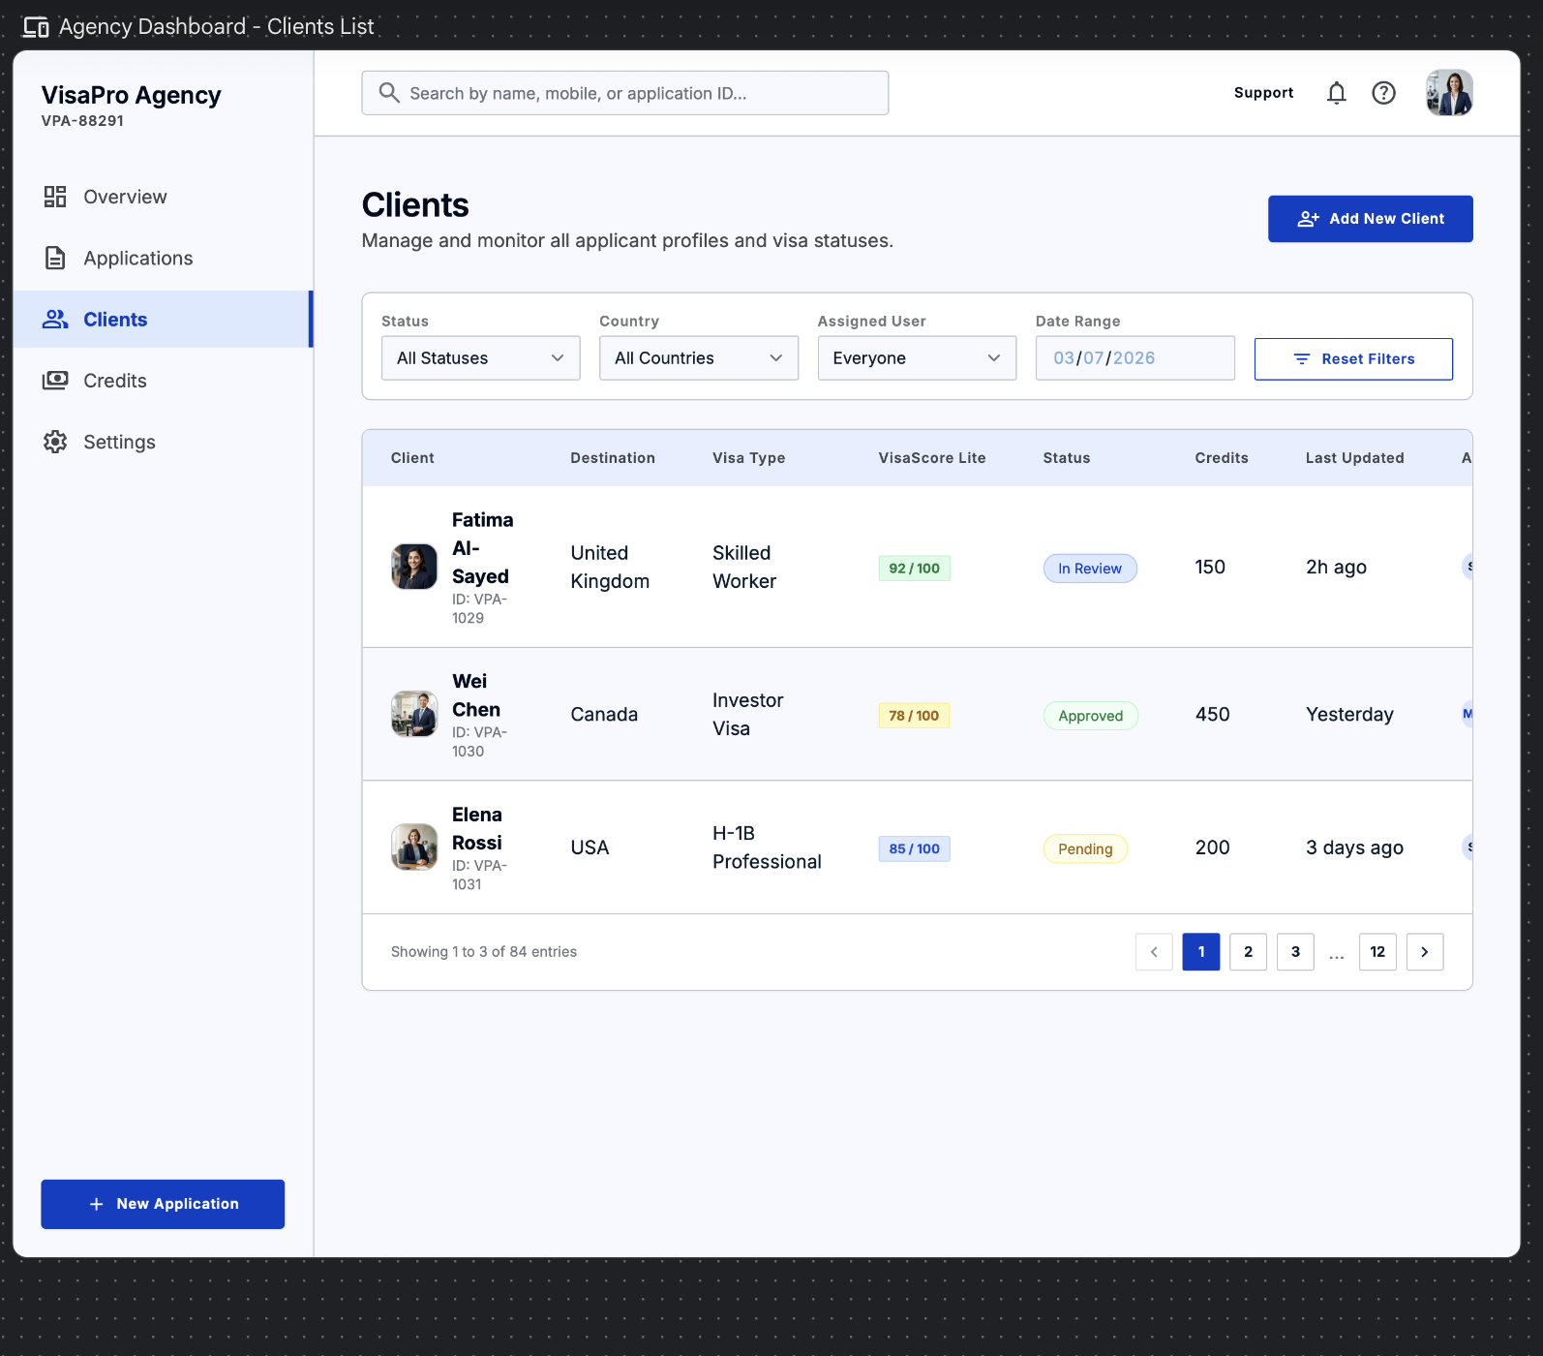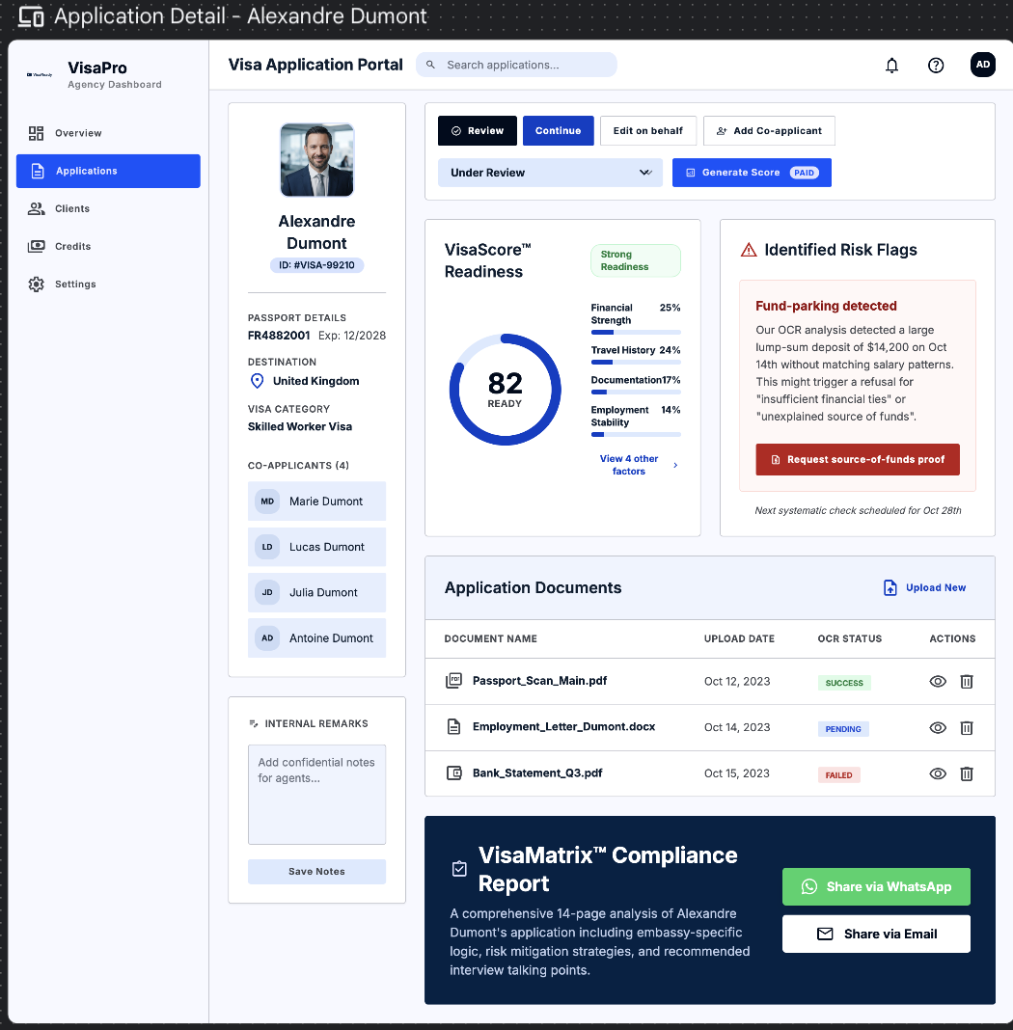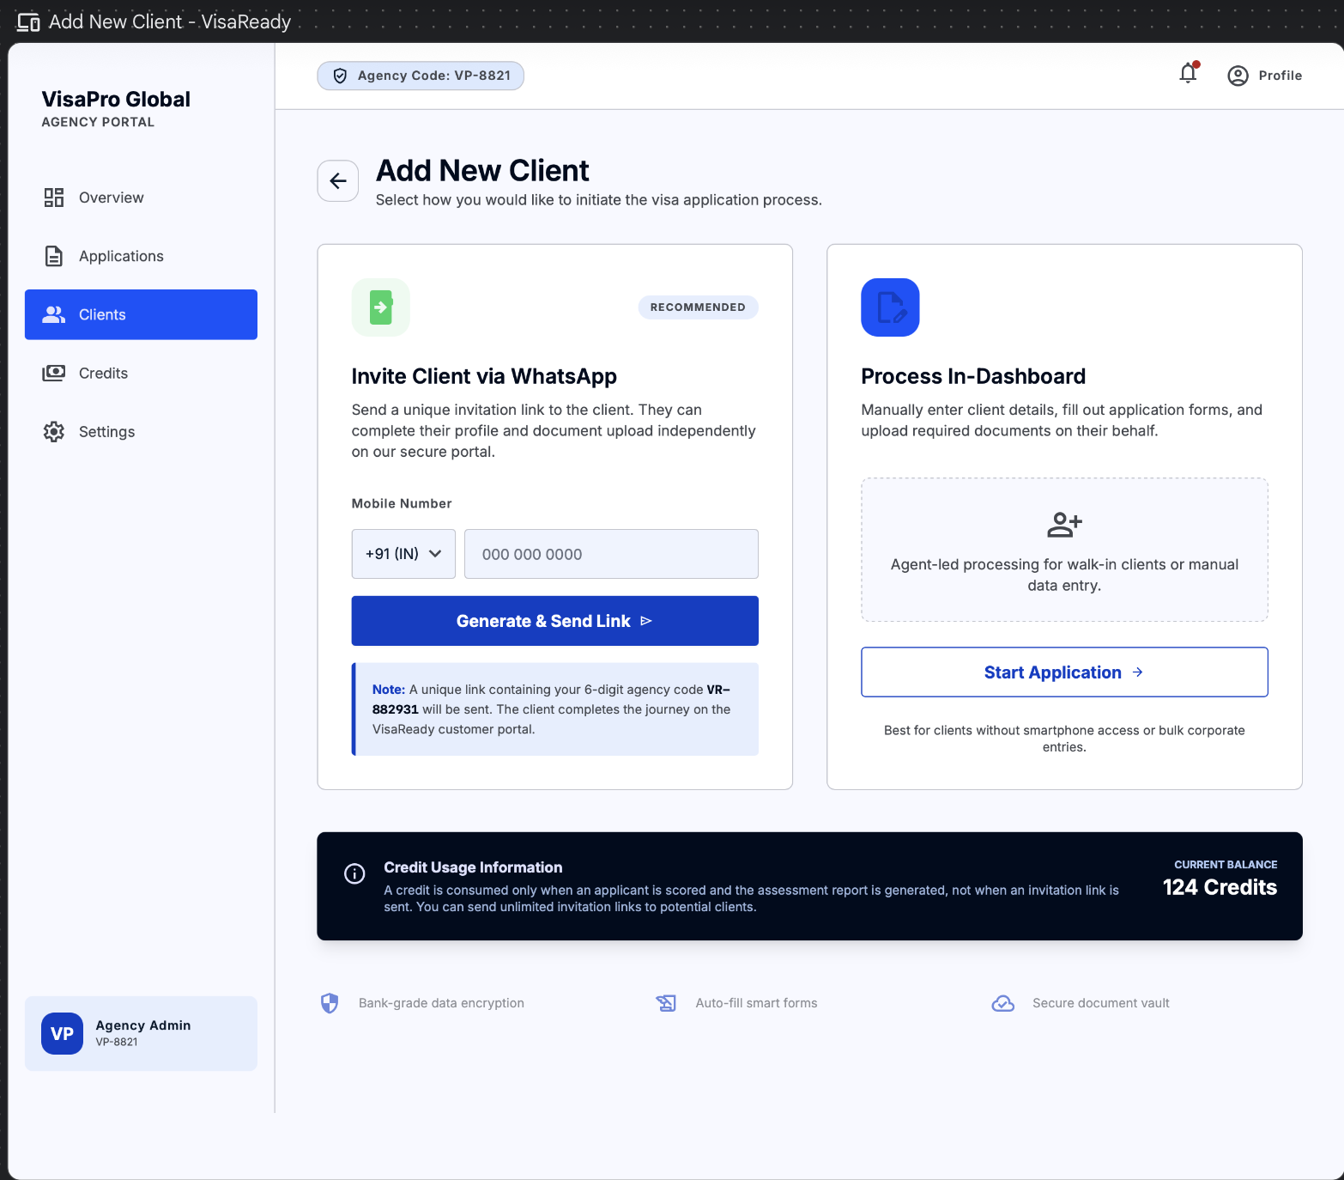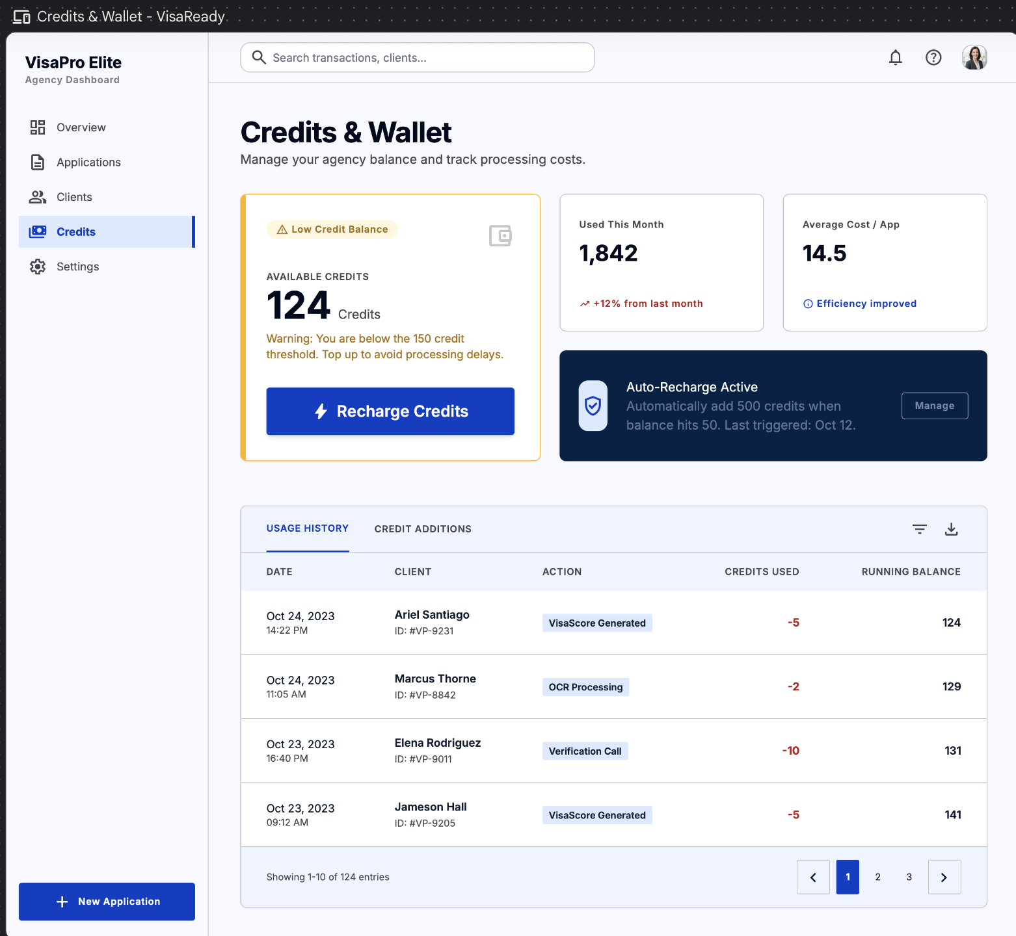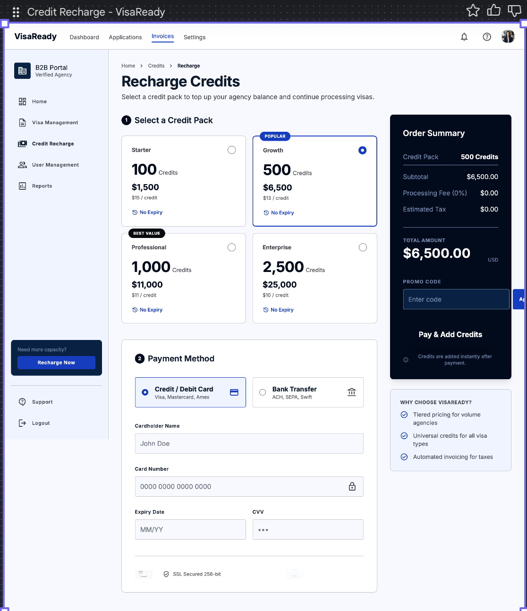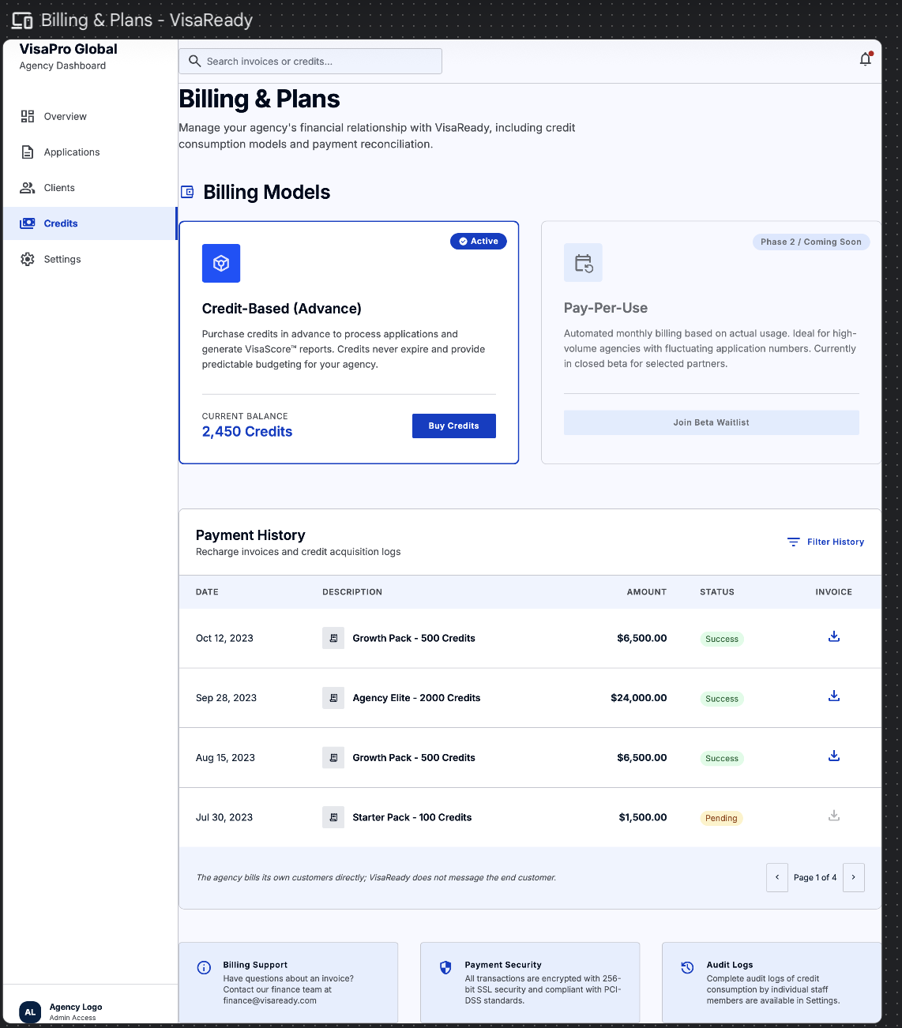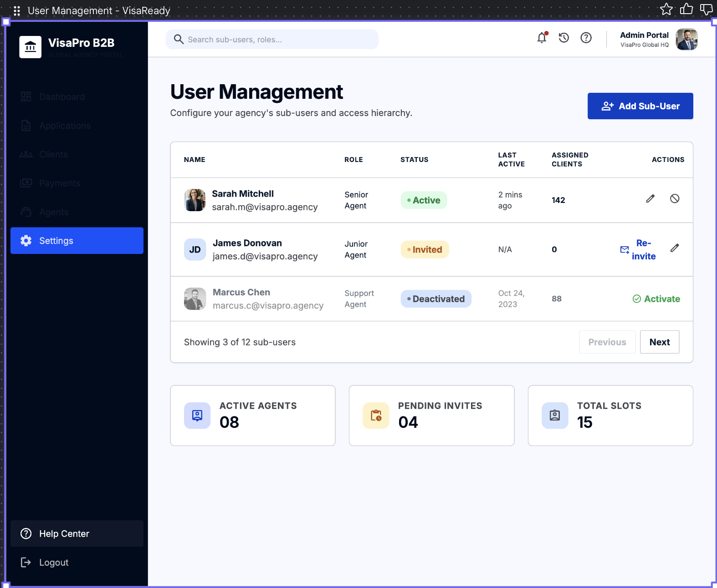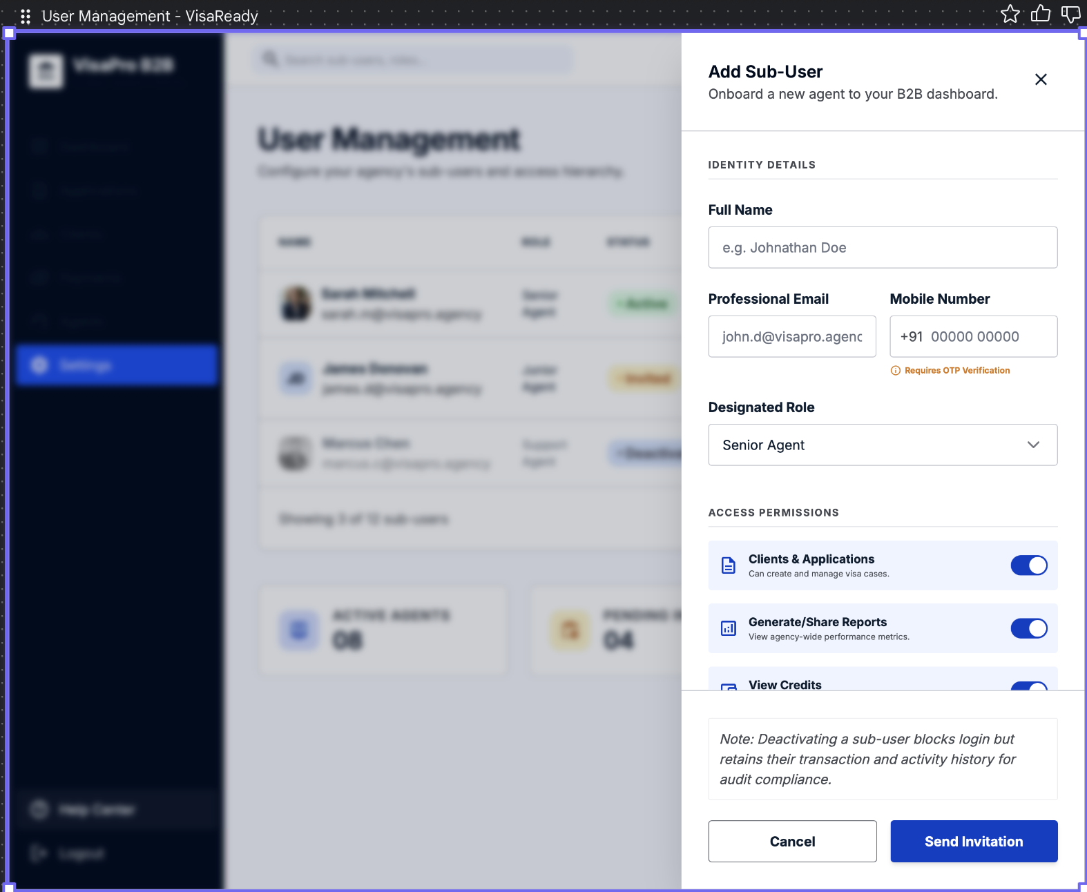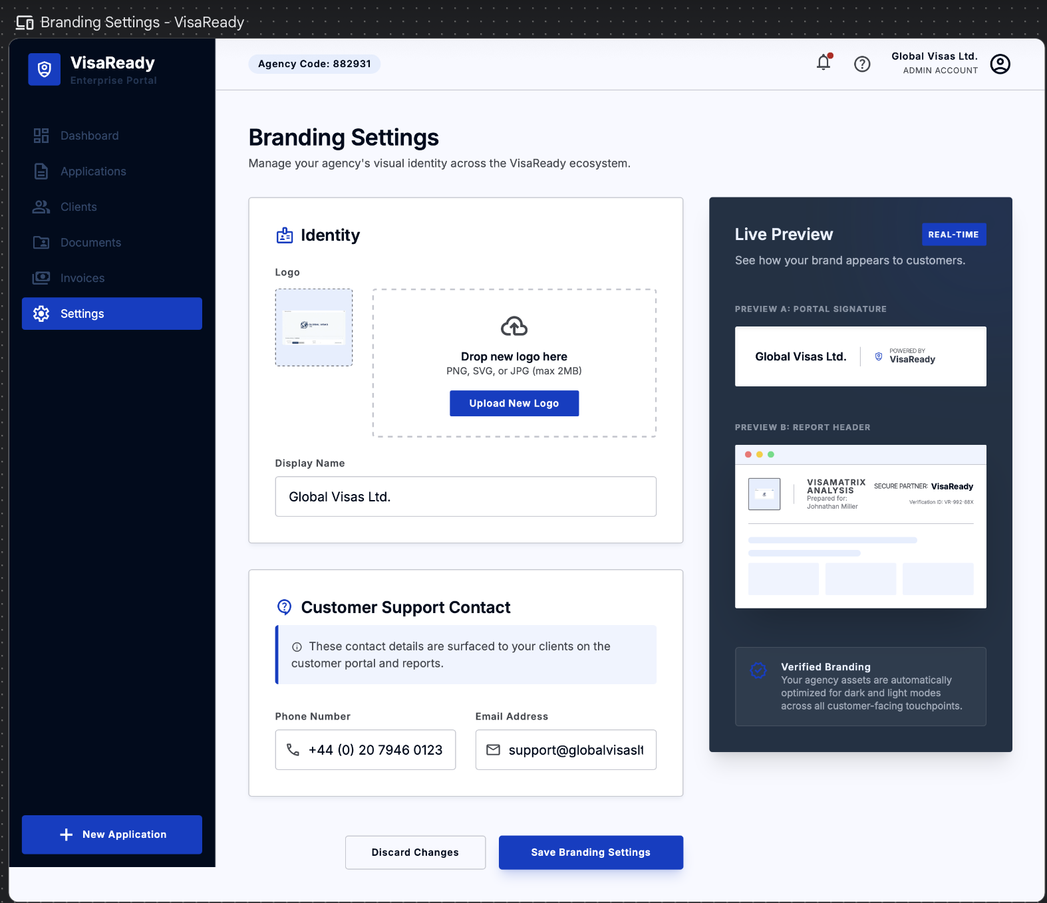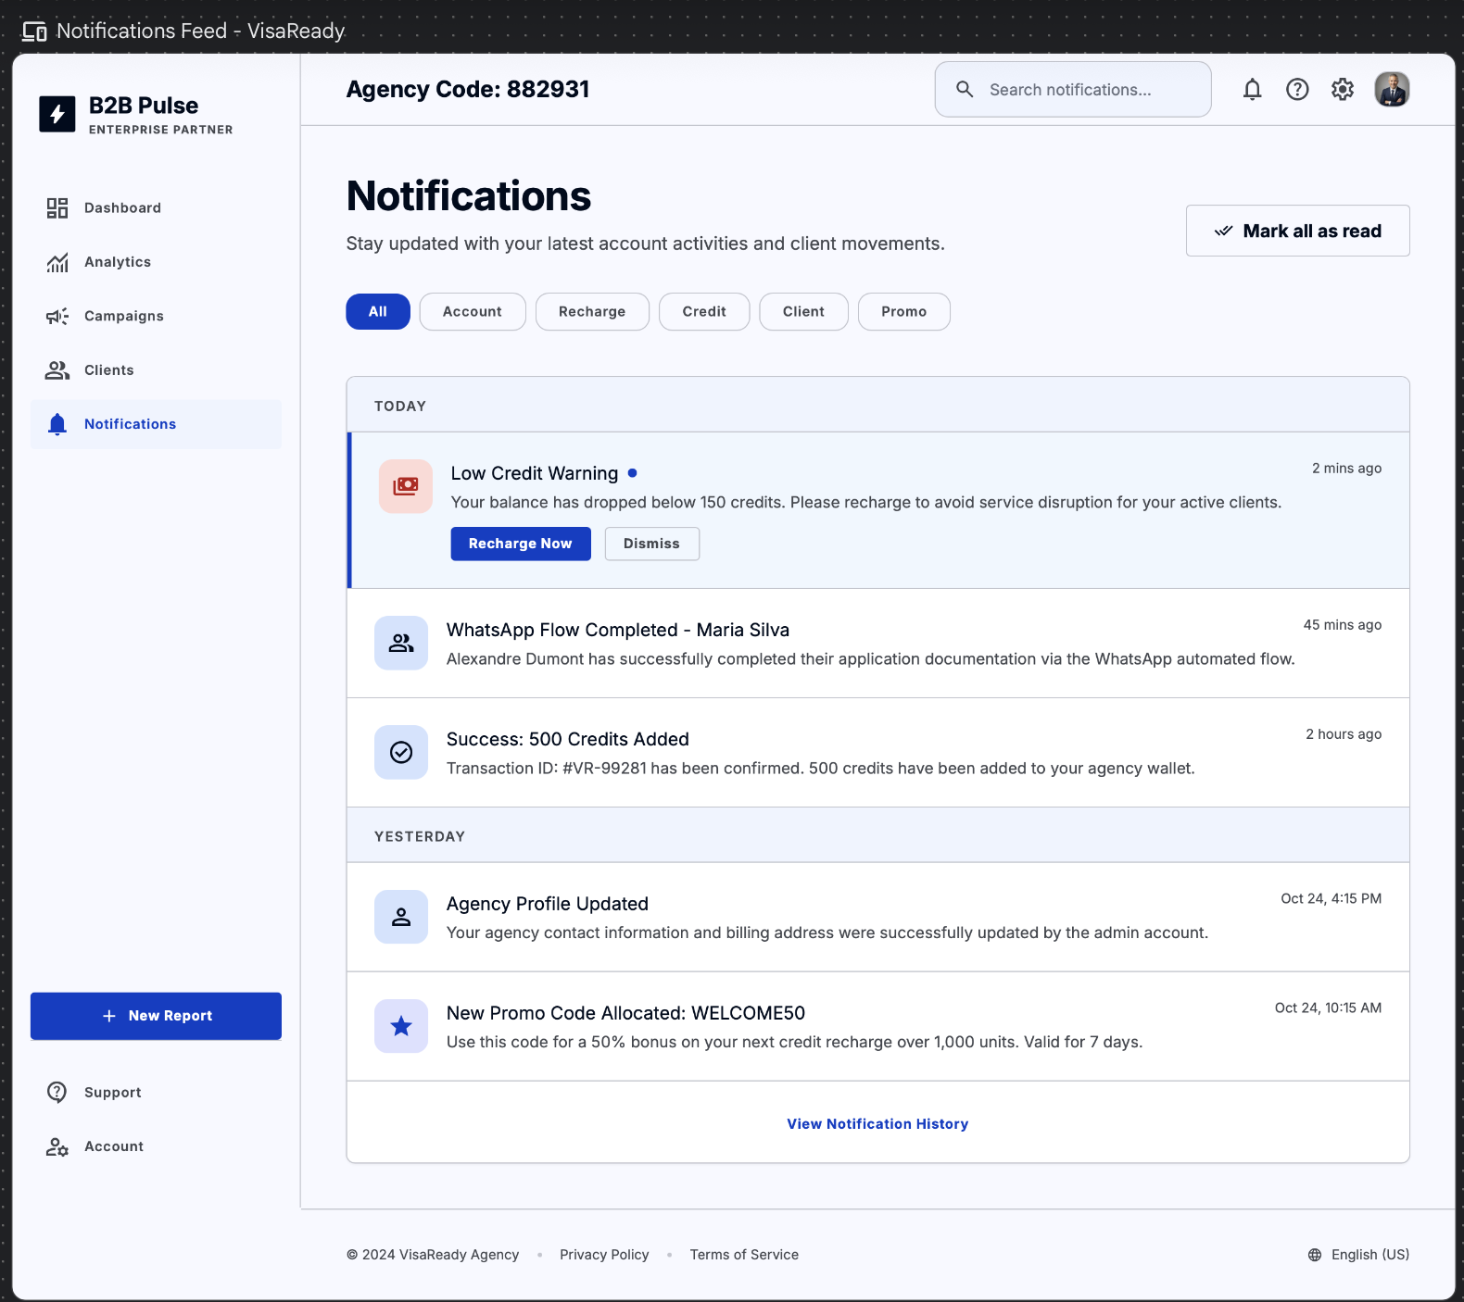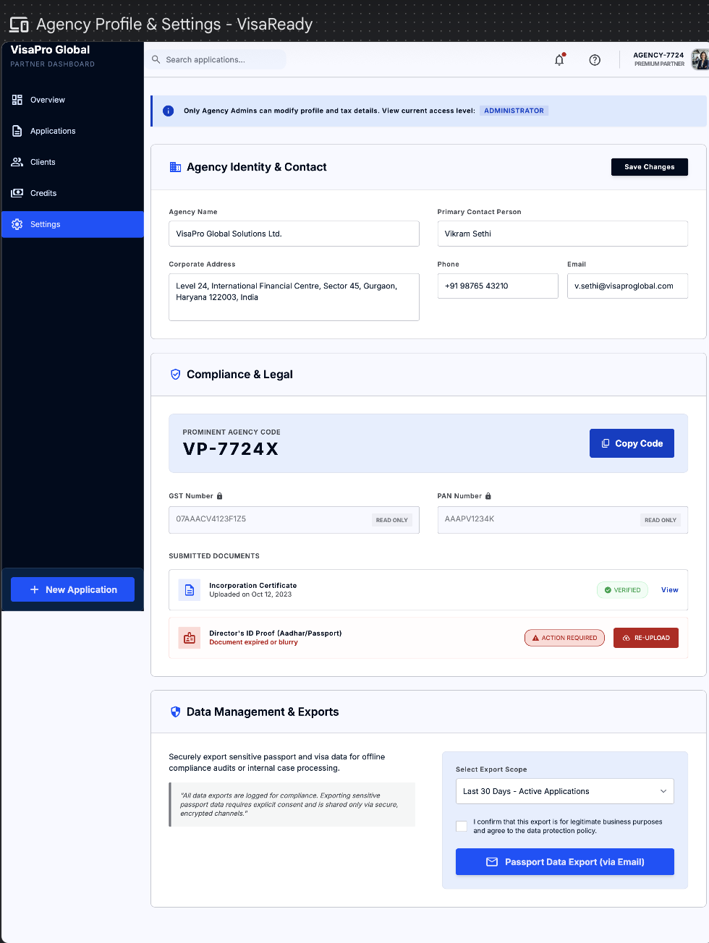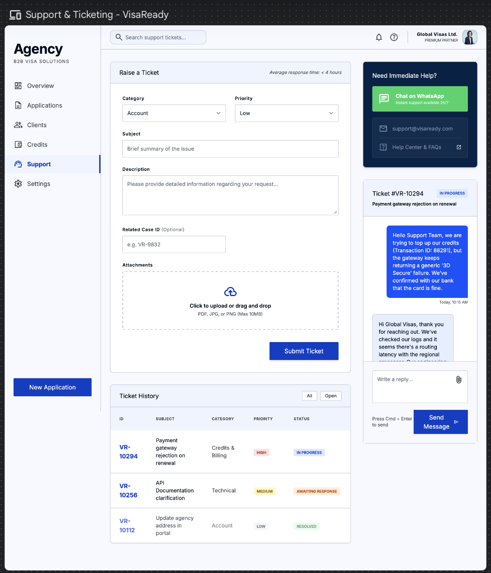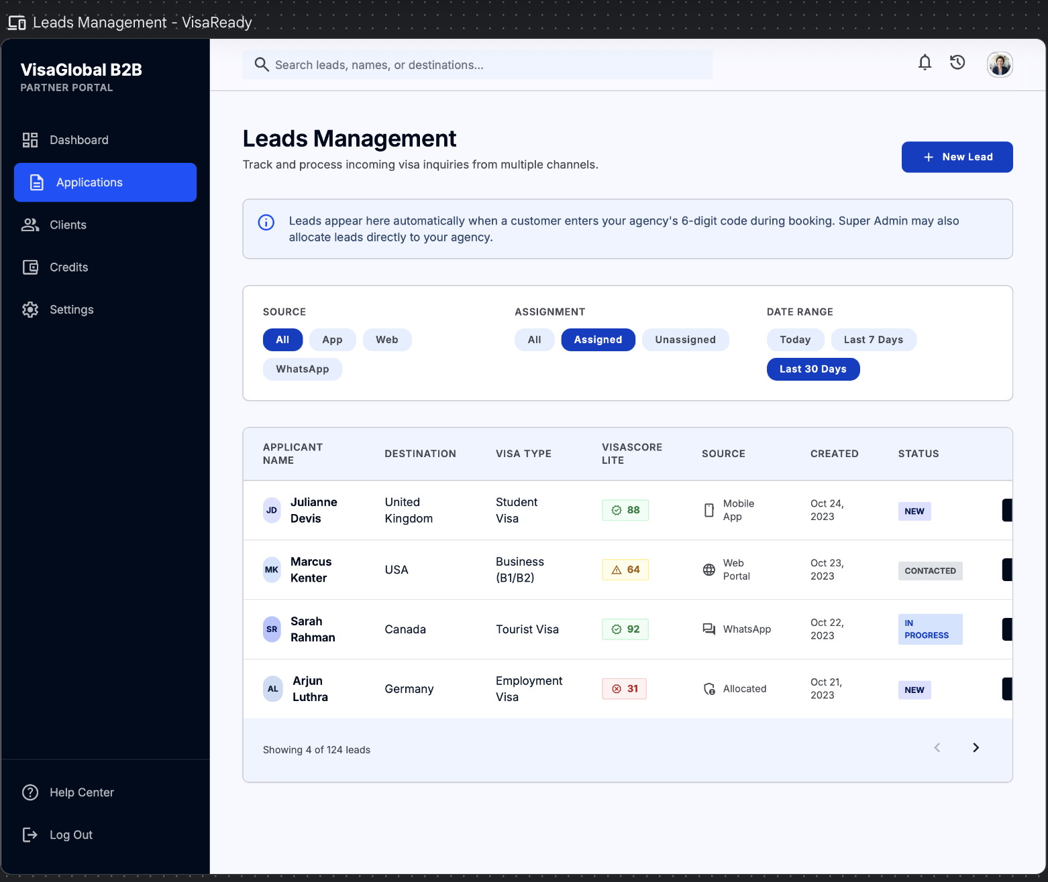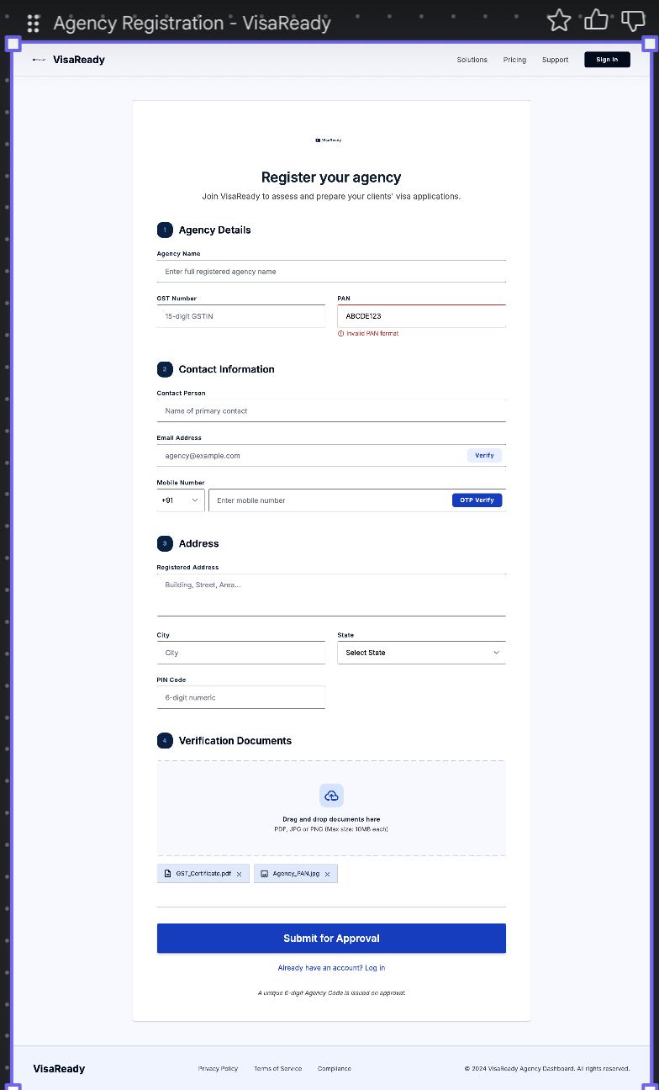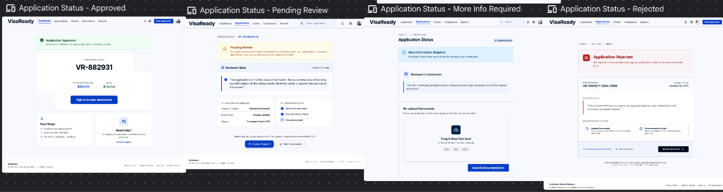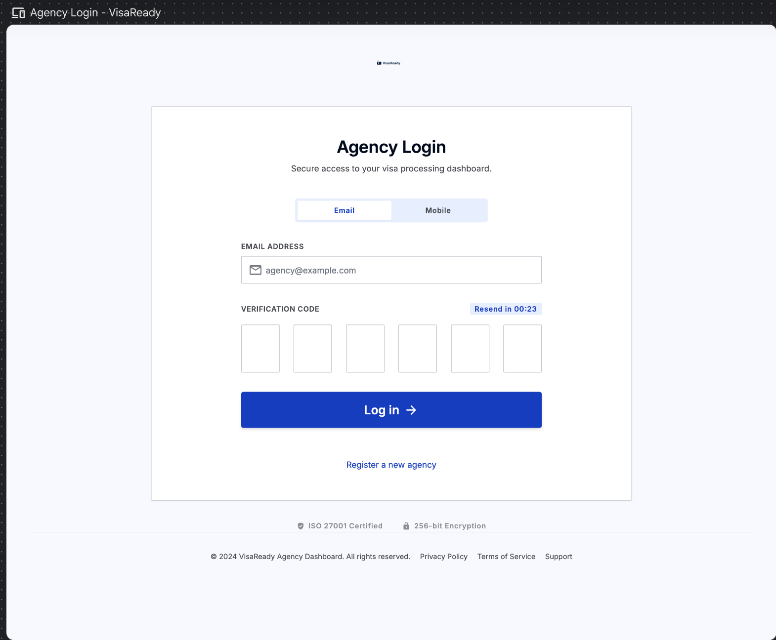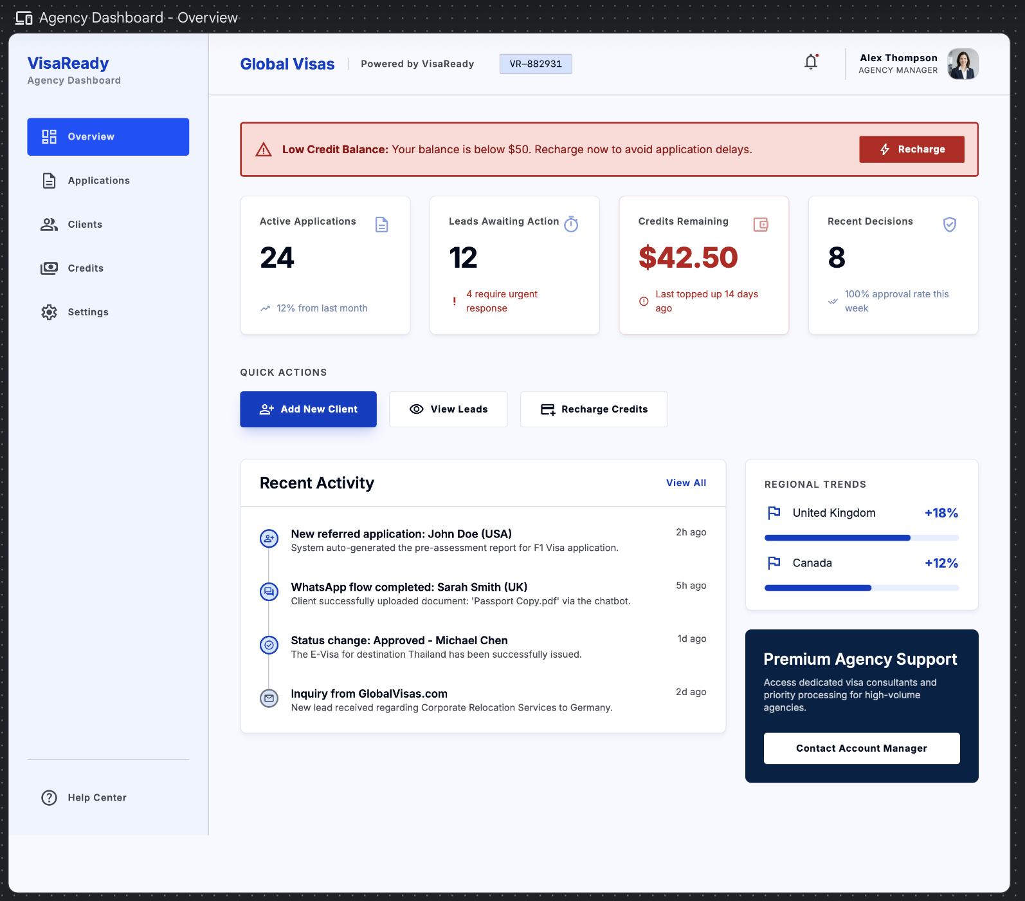

Admin Website Doc
VisaReady™
Super Admin Portal
VisaReady Internal Command Centre
Product Requirements Document
Attribute | Value
Platform | Responsive Web Portal (Desktop + Tablet)
Audience | VisaReady Internal Team (Super Admins)
Phase | MVP
Version | 1.1 — Client Release (02 July 2026)
Status | For Client Review
Powered by | Tech2Go
Related | Customer Application PRD · Agency Dashboard PRD

Contents
1. Document Overview
2. Admin User Roles & Access (incl. 2.3 Navigation Map)
3. Authentication & Security (AD-01, AD-03)
4. Platform Dashboard & Overview (AD-04–AD-05)
5. Agency Management (AD-06–AD-12) — incl. Activate / Deactivate toggles & Phase-2 lead powers (AD-08)
6. User Management (AD-13–AD-16)
7. Case & Application Management (AD-17–AD-19)
8. Country & Visa Type Management (AD-20–AD-23)
9. Form Field & Range Configuration (AD-26)
10. Scoring Engine & Editable Rule Base (AD-27–AD-29)
11. Risk Rules (AD-30–AD-32)
12. Content Management — Detailed (AD-33–AD-36, AD-41, AD-63–AD-65)
13. Country Rules & Weightage (AD-24, AD-25, AD-39)
14. Reports & Analytics (AD-37–AD-40)
15. Subscription & Billing (AD-42–AD-45)
16. Promo Codes — End-to-End Detailed (AD-62)
17. Notifications (AD-46–AD-49)
18. Payment Monitoring (AD-50–AD-53)
19. Admin Roles & Permissions (AD-54–AD-57)
20. Audit Trail & Logs (AD-58–AD-59)
21. System Health & Utility (AD-60, AD-69, AD-70)

22. Client Inputs Required & Open Questions
23. Non-Functional Requirements
Appendix B — Field-Level Cross-Product Mapping (Admin ⇄ Agency ⇄ Customer)
Appendix C — Customer App & Agency Dependencies

1. Document Overview
This document defines the VisaReady Super Admin Portal — the internal command centre operated by the VisaReady platform team. It mirrors the Customer Application and Agency Dashboard PRDs and integrates the latest client feedback.

1.1 Product Summary
VisaReady consists of three connected products: the Customer Application (mobile, WhatsApp & web app), the Agency Dashboard, and the Super Admin Portal (this document) — internal management of agency verification, activate/deactivate control, credit allocation, scoring and form configuration, content, promo codes, analytics and system health.

1.2 Scope
Note — This document covers the Super Admin Portal only. Customer- and agency-facing screens are specified in their own PRDs and referenced here only where Super Admin actions affect them. Per-screen fields are in the Element Detail table under each screen; the field-level effect of each Admin action is mapped in Appendix B.

2. Admin User Roles & Access

2.1 Admin Role Hierarchy (RBAC)
Role | Who they are | Key capabilities
Super Admin | Founders / senior ops | Full access incl. role management, system settings, maintenance mode, promo-code generation, agency blacklisting.
Admin | Operations managers | Agency, credit, user, content and form configuration; agency activate/deactivate — cannot manage admin users or roles.
Support | Customer support | Read-only on agency/user/case records; can initiate refunds and update case status.
Analyst | Data / business analysts | Read-only analytics, reporting and audit logs. No actions.

▸ RULE — RBAC is enforced on every API route; unauthorised access returns a 403 Access Denied screen (AD-69). Roles & permissions are flexible/configurable for licensed users (AD-54–AD-57).

2.2 Admin Lifecycle
Admin users are created by the Super Admin and receive an email invite with a one-time setup link. Authentication is email + OTP.

2.3 Navigation Map
The portal groups screens into modules in the left navigation. RBAC (2.1) determines which modules a given admin role can see.
Module | Screens
Overview | Platform Dashboard (AD-04), KPI Drill-Down (AD-05)
Agencies | Agencies List (AD-06), Agency Detail (AD-07), Plan Assignment (AD-09), Activate/Deactivate (AD-10), Token Adjustment (AD-11), Code Re-generation (AD-12), Lead Management (AD-08)
Users (B2C) | Users List (AD-13), User Detail (AD-14), Account Actions (AD-15), Plan Override (AD-16)
Cases | Applications List (AD-17), Application Detail (AD-18), Status Override (AD-19)
Configuration | Countries & Visa Types (AD-20–23), Form Fields & Ranges (AD-26), Scoring Engine (AD-27–29), Risk Rules (AD-30–32), Country Rules & Weightage (AD-24, 25, 39)
Content | Country Requirements (AD-33), Document Checklists (AD-34), Reason Codes (AD-35), Help/FAQ (AD-36), Cover Letters & Itineraries (AD-41), Library (AD-63), Legal (AD-64), Report Template (AD-65)
Reports & Analytics | Platform Analytics (AD-37), Approval Trends (AD-38), Revenue Analytics (AD-40)
Billing & Promo | Subscription Plans (AD-42), Subscribers (AD-43), Revenue Dashboard (AD-44), Manual Override (AD-45), Promo Codes (AD-62)
Notifications | Templates (AD-46, 47), Test Send (AD-48), Trigger Config (AD-49)
Payments | Transactions (AD-50), Transaction Detail (AD-51), Refunds (AD-52), Reconciliation (AD-53)
Access & Roles | Admin Users (AD-54, 55), Roles (AD-56, 57)
Audit & System | Audit Log (AD-58, 59), System Health (AD-60), Access Denied (AD-69), Maintenance Mode (AD-70)

3. Authentication & Security

AD-01 | Admin Login

Purpose — Secure entry to the portal; role is resolved from the account and RBAC applied immediately.
Key elements
- Email + OTP entry; role badge on the login card; JWT session issued; ‘Forgot Password’ link.
▸ RULE — Account locks after N failed attempts (configurable). Sessions are JWT-based with policy-driven expiry.

Element Detail — AD-01 — Admin Login
Element Type | Element ID | Label | Type | M/O/C | Auto-Populate Source | Visible When | Enabled When | Validation / Precondition | On Click / On Change | Next / Result | Source (config) | Editable By (role) | Error / Fallback | Dev Notes
Input | ad01_email | Email | Email | M | — | Always | Always | Must match an admin account | On submit send OTP | OTP verify | Auth | — | No account / invalid | RBAC resolved on login
Input | ad01_otp | OTP | Numeric | M | — | After send | After send | Locks after N failed attempts (configurable) | Verify → issue JWT | Platform Dashboard | Auth service | — | Lock after N fails | JWT policy-driven expiry
Badge | ad01_role | Role badge | Display | — | From account | Always | — | — | — | — | RBAC | — | — | Shows resolved role
Link | ad01_forgot | Forgot Password | Link | O | — | Always | Always | — | On click → AD-03 | Reset password | App | — | — | —

AD-03 | Admin Forgot / Reset Password

Purpose — Recover access via email OTP and password reset, consistent with the platform auth model.
Key elements
- Email input; OTP entry; new + confirm password fields.
▸ RULE — Account must exist; new password must meet the platform password policy.
Element Detail — AD-03 — Admin Forgot / Reset Password
Element Type | Element ID | Label | Type | M/O/C | Auto-Populate Source | Visible When | Enabled When | Validation / Precondition | On Click / On Change | Next / Result | Source (config) | Editable By (role) | Error / Fallback | Dev Notes
Input | ad03_email | Email | Email | M | — | Always | Always | Account must exist | On submit send OTP | OTP entry | Auth | — | No account | —
Input | ad03_otp | OTP | Numeric | M | — | After send | After send | Time-limited | Verify | New password | Auth | — | Wrong OTP | —
Input | ad03_pwd | New + confirm password | Password | M | — | After OTP | After verify | Meets password policy; both match | On save | Login | Auth | — | Policy/mismatch error | —

4. Platform Dashboard & Overview

AD-04 | Platform Dashboard

Purpose — Command centre with real-time KPIs, activity, alerts, and quick access to all modules.
Key elements
- KPI tiles: Total Applications | Active Agencies | B2C Users | Approval Rate | Rejection Rate | Avg Processing Days | Revenue | Active Subscriptions.
- Trend chart (30/60/90-day toggle); risk-level donut; recent applications table; live alerts strip (pending KYC, low-credit agencies, flagged cases, health).
▸ RULE — KPIs aggregate in real time. The alerts strip cannot be dismissed until the underlying condition is resolved.

Element Detail — AD-04 — Platform Dashboard
Element Type | Element ID | Label | Type | M/O/C | Auto-Populate Source | Visible When | Enabled When | Validation / Precondition | On Click / On Change | Next / Result | Source (config) | Editable By (role) | Error / Fallback | Dev Notes
Tiles | ad04_kpis | KPI tiles | Display | — | Real-time aggregates | Always | — | Total Apps, Active Agencies, B2C Users, Approval%, Rejection%, Avg Days, Revenue, Active Subs | On tap drill (AD-05) | KPI Drill-Down | System | — | — | Real-time
Chart | ad04_trend | Trend chart | Chart | — | Aggregates | Always | — | 30/60/90-day toggle | On toggle re-query | — | System | — | — | —
Chart | ad04_donut | Risk-level donut | Chart | — | Aggregates | Always | — | — | — | — | System | — | — | —
Table | ad04_recent | Recent applications | Table | — | Case data | Always | — | — | On tap open case | Application Detail | System | — | — | —
Strip | ad04_alerts | Live alerts strip | Alerts | — | System events | Always | — | Pending KYC, low-credit agencies, flagged cases, health | On tap open item | Relevant screen | System | — | Cannot dismiss until resolved | Persistent

AD-05 | KPI Drill-Down

Purpose — Deep-dive for any single KPI with filtering and chart-type switching.
Key elements
- Metric trend chart; breakdowns by country, visa type and plan; export (CSV).
Element Detail — AD-05 — KPI Drill-Down
Element Type | Element ID | Label | Type | M/O/C | Auto-Populate Source | Visible When | Enabled When | Validation / Precondition | On Click / On Change | Next / Result | Source (config) | Editable By (role) | Error / Fallback | Dev Notes
Chart | ad05_metric | Metric trend chart | Chart | — | Aggregates | Always | — | Chart-type switch | On change | — | System | — | — | —
Breakdown | ad05_break | Breakdowns | Display | — | Aggregates | Always | — | By country / visa type / plan | On filter | — | System | — | — | —
Button | ad05_export | Export CSV | Button | O | — | Always | Export permission | — | On click export | CSV file | System | Analyst+ | — | —

5. Agency Management

AD-06 | Agencies List

Purpose — All registered agencies across every lifecycle state.
Key elements
- Searchable table: Agency | Code | Plan | Status | Case Count | Token Balance | Revenue | KYC | Registered Date. Filters; bulk status change; CSV export.
▸ RULE — Status colour-coding: Active = green, Pending = amber, Suspended = red, Expired = grey.

Element Detail — AD-06 — Agencies List
Element Type | Element ID | Label | Type | M/O/C | Auto-Populate Source | Visible When | Enabled When | Validation / Precondition | On Click / On Change | Next / Result | Source (config) | Editable By (role) | Error / Fallback | Dev Notes
Table | ad06_list | Agencies table | Table | — | Agency registry | Always | — | Cols: Agency|Code|Plan|Status|Case Count|Token Balance|Revenue|KYC|Registered | On row open detail | Agency Detail | System | — | Empty state | Status colour-coded
Search | ad06_search | Search / filters | Filter | O | — | Always | Always | — | On change filter | — | App | Admin+ | — | —
Action | ad06_bulk | Bulk status change | Action | O | — | Rows selected | Manage permission | — | On apply update | Status updated | App | Admin+ | — | Logged to Audit Trail
Button | ad06_export | CSV export | Button | O | — | Always | Export permission | — | On click | CSV | System | Analyst+ | — | —

AD-07 | Agency Detail View

Purpose — 360° view of a single agency: profile, documents, plan, credits, agents (sub-users), cases, revenue, activity.
Key elements
- KYC documents now include GST and PAN; approve/reject controls.
- Profile (name, code, owner, contact, address); plan; token wallet; agent (sub-user) list; case summary; revenue; activity log (last 30).
▸ RULE — KYC approval activates the agency and allocates the initial free credits per the approved plan. Rejection requires a reason; all actions logged to the Audit Trail (AD-58).

Element Detail — AD-07 — Agency Detail View
Element Type | Element ID | Label | Type | M/O/C | Auto-Populate Source | Visible When | Enabled When | Validation / Precondition | On Click / On Change | Next / Result | Source (config) | Editable By (role) | Error / Fallback | Dev Notes
Section | ad07_profile | Profile | Display | — | Agency registration | Always | — | Name, code, owner, contact, address | — | — | Agency data | — | — | —
View | ad07_kyc | KYC documents (GST/PAN) | Display | — | Agency uploads | Always | — | GST 15-char, PAN 10-char | On review | — | Agency data | — | — | Verify before approve
Action | ad07_approve | Approve / Reject KYC | Action | M | — | Pending KYC | Manage permission | Reject requires reason | On approve activate + allocate credits | Agency Active | App | Admin+ | Reason required on reject | Activates agency + initial credits; logged AD-58
Display | ad07_wallet | Token wallet | Display | — | Token engine | Always | — | — | — | — | Token engine | — | — | —
List | ad07_agents | Agent (sub-user) list | List | — | Agency user mgmt | Always | — | — | On tap view | — | Agency data | — | — | Created by Agency Admin, shown here
Summary | ad07_cases | Case summary + revenue + activity | Display | — | Case/billing data | Always | — | Activity log last 30 | — | — | System | — | — | —

AD-10 | Agency Activate / Deactivate (Suspend / Reinstate) — Detailed

Purpose — The single place where Super Admin controls whether an agency is live. Every agency has an explicit active/inactive state driven by these toggles; suspension freezes active cases.
Toggle behaviour
Toggle / action | Effect on the agency | Effect on the customer side
Activate (on KYC approval or Reinstate) | Login enabled for all staff; agency code validates; credit allocation applied; cases resume | Customers can enter the agency code successfully; new leads map to the agency
Deactivate / Suspend | Login blocked for all staff (Admin + sub-users); active cases frozen; agency notified by email + WhatsApp | The agency code stops validating — a customer entering it sees an invalid/inactive-code message
Blacklist (Super Admin only) | Permanent block; code invalidated; separate from suspend | Code permanently rejected

- Reason selector + free text; effective date; confirmation dialog.
▸ RULE — Activate/Deactivate is written to the Audit Trail (AD-58) with reason, admin and timestamp. Deactivation and its effect on the agency code, staff login and frozen cases all take effect in the same action. Blacklisting is a separate Super-Admin-only action.

Element Detail — AD-10 — Agency Activate / Deactivate (Suspend / Reinstate / Blacklist)
Element Type | Element ID | Label | Type | M/O/C | Auto-Populate Source | Visible When | Enabled When | Validation / Precondition | On Click / On Change | Next / Result | Source (config) | Editable By (role) | Error / Fallback | Dev Notes
Toggle | ad10_action | Activate / Deactivate / Blacklist | Select | M | — | Always | Manage permission (blacklist=Super Admin) | Activate / Deactivate / Blacklist | On change apply state | Agency state changes | App | Admin+ / Super Admin | — | Deactivate: code stops validating, staff login blocked, cases frozen — same action
Select | ad10_reason | Reason | Dropdown+text | M | — | Always | Always | Mandatory; free text | On save | — | App | Admin+ | Required error | Written to Audit Trail (AD-58)
Date | ad10_eff | Effective date | Date | M | — | Always | Always | Today or future | On save | — | App | Admin+ | — | —
Dialog | ad10_confirm | Confirmation dialog | Dialog | M | — | On apply | Always | — | On confirm commit | Applied + agency notified | App | Admin+ | — | Agency notified email+WhatsApp

AD-09 | Agency Plan Assignment

Purpose — Assign or override an agency's plan tier with effective-date and proration handling.
Key elements
- Plan picker (Standard / Growth / Professional); effective date; proration summary.
▸ RULE — Plan change triggers token-allotment adjustment per the new tier.
⚠ CLIENT INPUT REQUIRED — Final plan tier names, token allotments per tier, carry-forward rules, and proration.

Element Detail — AD-09 — Agency Plan Assignment
Element Type | Element ID | Label | Type | M/O/C | Auto-Populate Source | Visible When | Enabled When | Validation / Precondition | On Click / On Change | Next / Result | Source (config) | Editable By (role) | Error / Fallback | Dev Notes
Dropdown | ad09_plan | Plan | Dropdown | M | — | Always | Manage permission | Standard / Growth / Professional | On change compute proration | — | Admin — Plans (AD-42) | Admin+ | Required error | Triggers token-allotment adjustment
Date | ad09_eff | Effective date | Date | M | — | Always | Always | Today or future | On change | — | App | Admin+ | — | —
Display | ad09_prorate | Proration summary | Display | — | Auto from plan+date | After plan | — | — | — | — | System | — | — | —

AD-11 | Agency Token Adjustment

Purpose — Manually add/deduct tokens (initial allocation, corrections, promotional grants).
Key elements
- Token delta (+/−); mandatory reason; running-balance preview.
▸ RULE — Negative adjustment cannot push balance below zero. Every adjustment is logged with reason, amount, admin and timestamp.

Element Detail — AD-11 — Agency Token Adjustment
Element Type | Element ID | Label | Type | M/O/C | Auto-Populate Source | Visible When | Enabled When | Validation / Precondition | On Click / On Change | Next / Result | Source (config) | Editable By (role) | Error / Fallback | Dev Notes
Numeric | ad11_delta | Token delta (+/−) | Numeric | M | — | Always | Manage permission | Cannot push balance below zero | On change preview balance | — | Token engine | Admin+ | Below-zero error | Logged with amount+reason+admin+time
Text | ad11_reason | Reason | Text | M | — | Always | Always | Mandatory | On save | Balance updated | App | Admin+ | Required error | —
Display | ad11_preview | Running-balance preview | Display | — | Auto from delta | After delta | — | — | — | — | Token engine | — | — | —

AD-12 | Agency Code Re-generation

Purpose — Re-issues an agency's unique 6-digit code (e.g. on compromise); old code invalidated, case references updated.
Key elements
- Agency codes are 6 digits; current code display + system-generated 6-digit preview; confirmation required.
▸ RULE — Existing case records are updated to the new code automatically; the agency is notified immediately.

Element Detail — AD-12 — Agency Code Re-generation
Element Type | Element ID | Label | Type | M/O/C | Auto-Populate Source | Visible When | Enabled When | Validation / Precondition | On Click / On Change | Next / Result | Source (config) | Editable By (role) | Error / Fallback | Dev Notes
Display | ad12_cur | Current code | Display | — | Agency registry | Always | — | 6-digit | — | — | Agency data | — | — | —
System | ad12_new | New code preview | System | — | System-generated | Always | — | 6-digit; unique | — | — | System | — | — | Old code invalidated; case refs updated
Dialog | ad12_confirm | Confirmation | Dialog | M | — | Always | Manage permission | — | On confirm reissue | Code reissued | App | Admin+ | — | Agency notified immediately

AD-08 | Lead Management —

Purpose — Manage applicant leads, both unassigned (no agency code) and agency-attributed.
- Unassigned leads — applicants who did not enter an agency code populate here.
- Agency-attributed leads — applicants who entered an agency code appear here with the agency name, and also appear in that agency's Leads screen.
- Table: Lead | Source (App / Web / WhatsApp) | Destination | Visa Type | VisaScore Lite | Agency (if any) | Created | Status. Filter by assigned/unassigned, source, date.

Phase-2 assignment powers (who can do what)
Capability | Phase 1 (MVP) | Phase 2
View unassigned & attributed leads | Yes | Yes
Manually follow up a lead | Yes | Yes
Assign / allocate an unassigned lead to an agency | Manual note only | Automatic assignment to a chosen agency, notifying the receiving agency
Transfer a lead from one agency to another | Not available | Available (writes to Audit Trail; notifies receiving agency)
Return an unworked agency lead to the pool after SLA | Not available | Available (SLA-driven)
Which admin roles may transfer/assign | — | Configurable per role (AD-57)

▸ RULE — Transferring or assigning a lead writes to the Audit Trail (AD-58) and notifies the receiving agency. Phase-1 supports view + manual follow-up; automatic assignment and transfer are Phase 2.
⚠ CLIENT INPUT REQUIRED — Lead-assignment policy: SLA before an unworked agency lead returns to the unassigned pool, and which admin roles may transfer/assign leads.
Element Detail — AD-08 — Lead Management
Element Type | Element ID | Label | Type | M/O/C | Auto-Populate Source | Visible When | Enabled When | Validation / Precondition | On Click / On Change | Next / Result | Source (config) | Editable By (role) | Error / Fallback | Dev Notes
Table | ad08_list | Leads table | Table | — | Lead pool + agency-attributed | Always | — | Lead|Source|Destination|Visa|Lite score|Agency|Created|Status | On tap open | Lead detail | System | — | Empty state | Unassigned = no code; attributed = code entered
Filter | ad08_filter | Filters | Filter | O | — | Always | Always | assigned/unassigned, source, date | On change | — | App | Admin+ | — | —
Action | ad08_followup | Manual follow-up | Action | O | — | Always | Always | Phase-1 supported | On click | — | App | Admin+ | — | —
Action | ad08_assign | Assign / allocate to agency | Action | C | — | Phase 2 | Configurable role (AD-57) | Auto-assign to chosen agency | On assign notify agency | Lead in agency's Screen 16 | App | Configured roles | — | Phase-2; writes Audit Trail; notifies agency
Action | ad08_transfer | Transfer between agencies | Action | C | — | Phase 2 | Configurable role | — | On transfer notify receiving agency | Lead moved | App | Configured roles | — | Phase-2; Audit Trail
Rule | ad08_sla | Return unworked lead after SLA | Rule | — | — | Phase 2 | — | SLA-driven | Auto-return to pool | Unassigned pool | System | — | — | SLA = client-input open item

6. User Management (B2C)

AD-13 | Users List (B2C)

Purpose — All visa applicants who registered directly on the platform (via the app or web app).
Key elements
- Table: Name | Mobile/Email | Plan | Status | Score Count | Last Active | Country. Filters; search; bulk deactivate; CSV export.

Element Detail — AD-13 — Users List (B2C)
Element Type | Element ID | Label | Type | M/O/C | Auto-Populate Source | Visible When | Enabled When | Validation / Precondition | On Click / On Change | Next / Result | Source (config) | Editable By (role) | Error / Fallback | Dev Notes
Table | ad13_list | B2C users table | Table | — | User registry | Always | — | Name|Mobile/Email|Plan|Status|Score Count|Last Active|Country | On row open detail | User Detail | System | — | Empty state | —
Action | ad13_bulk | Bulk deactivate / export | Action | O | — | Rows selected | Manage permission | — | On apply | Updated / CSV | App | Admin+ | — | —

AD-14 | User Detail View

Purpose — Full view of a B2C user: profile, masked passport, applications, payments, subscription, consent log, score history.
Key elements
- Profile; passport snapshot (masked); application list; payment history; plan; consent log; score history.
- Actions: edit, deactivate, view applications, reset OTP, view payments.

Element Detail — AD-14 — User Detail View
Element Type | Element ID | Label | Type | M/O/C | Auto-Populate Source | Visible When | Enabled When | Validation / Precondition | On Click / On Change | Next / Result | Source (config) | Editable By (role) | Error / Fallback | Dev Notes
Section | ad14_profile | Profile + masked passport | Display | — | User data | Always | — | Passport masked | — | — | User data | — | — | PII masked in view
List | ad14_apps | Applications / payments / consent / score history | List | — | User data | Always | — | — | On tap open | — | System | — | — | —
Action | ad14_actions | Edit / deactivate / reset OTP / view payments | Action | O | — | Always | Manage permission | — | On click | Relevant action | App | Support+ | — | —

AD-15 | User Account Actions

Purpose — Deactivation, deletion, and DPDPA data erasure.
Key elements
- Action picker (Deactivate / Delete / DPDPA Erasure); reason; confirmation (erasure has an irreversible-action warning).
▸ RULE — DPDPA erasure is irreversible and triggers a data-deletion job. Deactivated accounts block login but retain data; deleted accounts anonymise PII per policy.

Element Detail — AD-15 — User Account Actions
Element Type | Element ID | Label | Type | M/O/C | Auto-Populate Source | Visible When | Enabled When | Validation / Precondition | On Click / On Change | Next / Result | Source (config) | Editable By (role) | Error / Fallback | Dev Notes
Select | ad15_action | Action picker | Select | M | — | Always | Manage permission | Deactivate / Delete / DPDPA Erasure | On select | Confirmation | App | Admin+ | — | Erasure irreversible + warning
Text | ad15_reason | Reason | Text | M | — | Always | Always | Mandatory | On save | — | App | Admin+ | Required error | Logged
Dialog | ad15_confirm | Confirmation | Dialog | M | — | On erasure/delete | Always | Irreversible warning for erasure | On confirm run job | Data-deletion job | Backend | Admin+ | — | Anonymise PII per policy

AD-16 | User Plan Override

Purpose — Grant or revoke premium access for a B2C user (promo, support, corrections).
Key elements
- Plan picker; reason; expiry date.
▸ RULE — Only authorised roles can override; logged in the Audit Trail.
Element Detail — AD-16 — User Plan Override
Element Type | Element ID | Label | Type | M/O/C | Auto-Populate Source | Visible When | Enabled When | Validation / Precondition | On Click / On Change | Next / Result | Source (config) | Editable By (role) | Error / Fallback | Dev Notes
Dropdown | ad16_plan | Plan picker | Dropdown | M | — | Always | Authorised roles | — | On change | — | Admin — Plans | Authorised roles | — | Logged in Audit Trail
Text | ad16_reason | Reason | Text | M | — | Always | Always | Mandatory | On save | — | App | Authorised roles | Required error | —
Date | ad16_expiry | Expiry date | Date | M | — | Always | Always | Future date | On save | Plan applied | App | Authorised roles | — | —

7. Case & Application Management

AD-17 | Applications List (Platform-Wide)

Purpose — Every visa application across all agencies and B2C users.
Key elements
- Table: Case ID | Client | Agency | Country | Visa Type | VisaScore Lite | Status | Risk Level | Submission Date. Filters; search; bulk export.
▸ RULE — Status values: Draft / Submitted / Scored / Completed / Flagged.

Element Detail — AD-17 — Applications List (Platform-Wide)
Element Type | Element ID | Label | Type | M/O/C | Auto-Populate Source | Visible When | Enabled When | Validation / Precondition | On Click / On Change | Next / Result | Source (config) | Editable By (role) | Error / Fallback | Dev Notes
Table | ad17_list | Applications table | Table | — | Case data | Always | — | Case ID|Client|Agency|Country|Visa|Lite|Status|Risk|Submission | On row open | Application Detail | System | — | Empty state | Statuses: Draft/Submitted/Scored/Completed/Flagged
Action | ad17_export | Search / filter / bulk export | Action | O | — | Always | Export permission | — | On apply | CSV | System | Analyst+ | — | —

AD-18 | Application Detail View

Purpose — Full case: applicant data, documents, scoring breakdown, AI recommendations, timeline, audit log.
Key elements
- Applicant data (incl. co-applicants); score breakdown factor-by-factor with weights; AI recommendations with reason codes; status timeline; case audit entries; download report; flag for fraud review.
- Document checks reference OCR only (MRZ removed).

Element Detail — AD-18 — Application Detail View
Element Type | Element ID | Label | Type | M/O/C | Auto-Populate Source | Visible When | Enabled When | Validation / Precondition | On Click / On Change | Next / Result | Source (config) | Editable By (role) | Error / Fallback | Dev Notes
Section | ad18_data | Applicant data (incl. co-applicants) | Display | — | Shared case record | Always | — | — | — | — | Shared record | — | — | Mirrors agency + customer view
Breakdown | ad18_score | Score breakdown factor-by-factor | Display | — | Scoring engine | After score | — | With weights | On tap expand | — | Scoring engine | — | — | —
Reco | ad18_reco | AI recommendations | Display | — | Reason codes (AD-35) | After score | — | With reason codes | — | — | Admin — Reason Codes | — | — | Explainability
Timeline | ad18_timeline | Status timeline + audit entries | Display | — | Case events | Always | — | — | — | — | System | — | — | —
Action | ad18_flag | Flag for fraud review | Action | O | — | Always | Manage permission | — | On click flag | Flagged | App | Support+ | — | Doc checks reference OCR only
Button | ad18_report | Download report | Button | O | — | Report exists | Always | — | On click | VisaMatrix PDF | System | — | — | —

AD-19 | Application Status Override

Purpose — Manually correct an application status (agency or system error).
Key elements
- Status picker; mandatory reason; confirmation.
▸ RULE — Override logged with reason, admin and before/after values; agency and applicant notified.
Element Detail — AD-19 — Application Status Override
Element Type | Element ID | Label | Type | M/O/C | Auto-Populate Source | Visible When | Enabled When | Validation / Precondition | On Click / On Change | Next / Result | Source (config) | Editable By (role) | Error / Fallback | Dev Notes
Dropdown | ad19_status | Status picker | Dropdown | M | — | Always | Manage permission | Draft/Submitted/Scored/Completed/Flagged | On change | — | App | Admin+ | Required error | Agency + applicant notified
Text | ad19_reason | Reason | Text | M | — | Always | Always | Mandatory | On save | Status updated | App | Admin+ | Required error | Before/after logged (AD-58)
Dialog | ad19_confirm | Confirmation | Dialog | M | — | On save | Always | — | On confirm | Applied | App | Admin+ | — | —

8. Country & Visa Type Management

AD-20 | Countries List

Purpose — View and manage all supported countries.
Key elements
- Table: Country | Flag | ISO | Active | # Visa Types | Processing Time | Last Updated. Filter; Add Country.

Element Detail — AD-20 — Countries List
Element Type | Element ID | Label | Type | M/O/C | Auto-Populate Source | Visible When | Enabled When | Validation / Precondition | On Click / On Change | Next / Result | Source (config) | Editable By (role) | Error / Fallback | Dev Notes
Table | ad20_list | Countries table | Table | — | Country registry | Always | — | Country|Flag|ISO|Active|#Visa Types|Processing Time|Updated | On row edit | Add/Edit Country | Country registry | — | — | —
Button | ad20_add | Add Country | Button | O | — | Always | Config permission | — | On click → AD-21 | Add/Edit Country | App | Admin+ | — | —

AD-21 | Add / Edit Country

Purpose — Create/update a country; changes propagate to the scoring engine and customer app (mobile & web).
Key elements
- Country name; ISO code (unique); flag upload; default processing time; appointment-required toggle; active toggle.
- Embassy / official tracking URL — the official visa website used by the customer app's ‘View Embassy Portal’ link (e.g. france-visas.gouv.fr).
▸ RULE — Setting Inactive hides the country from the customer app and web app immediately.

Element Detail — AD-21 — Add / Edit Country
Element Type | Element ID | Label | Type | M/O/C | Auto-Populate Source | Visible When | Enabled When | Validation / Precondition | On Click / On Change | Next / Result | Source (config) | Editable By (role) | Error / Fallback | Dev Notes
Input | ad21_name | Country name | Text | M | — | Always | Config permission | Non-empty | On save propagate | Customer app + web | Country registry | Admin+ | Required error | Propagates to app immediately
Input | ad21_iso | ISO code | Text | M | — | Always | Always | Unique | On save | — | Country registry | Admin+ | Duplicate error | —
File | ad21_flag | Flag | File | O | — | Always | Always | Image; size limit | On upload | — | Country registry | Admin+ | Type/size error | —
Numeric | ad21_proc | Default processing time | Numeric | M | — | Always | Always | Days | On save | — | Country registry | Admin+ | — | —
Toggle | ad21_active | Appointment-required / Active toggles | Toggle | M | — | Always | Always | — | On change | Hides country if inactive | Country registry | Admin+ | — | Inactive hides country from app immediately
URL | ad21_embassy | Embassy / official tracking URL | URL | C | — | Always | Always | Valid URL | On save | Powers app ‘View Embassy Portal’ | Country registry | Admin+ | URL format error | Used by customer 4.17

AD-22 | Visa Types List (per Country)

Purpose — Manage visa types for a selected country.
Key elements
- Visa types are Tourist / Student / Business (Work / Employment removed). Table: Visa Type | Purpose | Duration | Entry Type | Active.

Element Detail — AD-22 — Visa Types List (per Country)
Element Type | Element ID | Label | Type | M/O/C | Auto-Populate Source | Visible When | Enabled When | Validation / Precondition | On Click / On Change | Next / Result | Source (config) | Editable By (role) | Error / Fallback | Dev Notes
Table | ad22_list | Visa types table | Table | — | Visa registry | Country selected | — | Visa Type|Purpose|Duration|Entry Type|Active | On row edit | Add/Edit Visa Type | Visa registry | — | — | Tourist/Student/Business
Dropdown | ad22_country | Country selector | Dropdown | M | — | Always | Always | From active countries | On change load types | — | Country registry | Admin+ | — | —

AD-23 | Add / Edit Visa Type

Purpose — Create/update a visa type; triggers a rebuild of the document checklist (AD-34).
Key elements
- Name & purpose; duration range; entry type (Single/Multiple); estimated processing days; required documents (linked to CMS).
Element Detail — AD-23 — Add / Edit Visa Type
Element Type | Element ID | Label | Type | M/O/C | Auto-Populate Source | Visible When | Enabled When | Validation / Precondition | On Click / On Change | Next / Result | Source (config) | Editable By (role) | Error / Fallback | Dev Notes
Input | ad23_name | Name & purpose | Text | M | — | Always | Config permission | Tourist / Student / Business | On save rebuild checklist | Doc checklist (AD-34) | Visa registry | Admin+ | Required error | Rebuilds checklist
Numeric | ad23_dur | Duration range | Numeric | M | — | Always | Always | Valid range | On save | — | Visa registry | Admin+ | — | —
Dropdown | ad23_entry | Entry type | Dropdown | M | — | Always | Always | Single / Multiple | On save | — | Visa registry | Admin+ | — | —
Numeric | ad23_days | Estimated processing days | Numeric | M | — | Always | Always | ≥ 0 | On save | — | Visa registry | Admin+ | — | —
Multi | ad23_docs | Required documents | Multi-select | M | — | Always | Always | Linked to CMS (AD-34) | On save | Checklist | Admin — Doc Checklist | Admin+ | — | —

9. Form Field & Range Configuration

AD-26 | Form Field & Range Configuration

Purpose — Lets Super Admin configure every field and every range used in the customer application form, so the form is fully data-driven.
Key elements
- Configurable income, balance, turnover and gross-income / ITR range bands (the dropdown options shown to applicants).
- Dropdown value sets (e.g. user types, employer types, city lists, business-practice options incl. ‘Other’).
- Field properties: label, mandatory/optional, validation rule, and visibility per visa type / country.
- Versioning with effective date; preview of the customer-facing field.
▸ RULE — Saving propagates to the customer app & web immediately. Range changes feed the scoring engine (AD-27).
⚠ CLIENT INPUT REQUIRED — The complete set of range bands and dropdown values for every configurable field.
Element Detail — AD-26 — Form Field & Range Configuration
Element Type | Element ID | Label | Type | M/O/C | Auto-Populate Source | Visible When | Enabled When | Validation / Precondition | On Click / On Change | Next / Result | Source (config) | Editable By (role) | Error / Fallback | Dev Notes
Ranges | ad26_ranges | Range bands | Numeric ranges | M | — | Always | Config permission | Non-overlapping; feed scoring (AD-27) | On save propagate | Customer app + web | Field config | Admin+ | Overlap error | Income/balance/turnover/ITR bands/fd/mf, all fields ranges options should be configurable
Lists | ad26_lists | Dropdown value sets | List | M | — | Always | Always | Includes ‘Other’ where relevant | On save propagate | Customer app + web | Field config | Admin+ | — | User types, employer types, cities, etc.
Props | ad26_props | Field properties | Mixed | M | — | Always | Always | Label, mandatory/optional, validation, visibility per visa/country | On save | — | Field config | Admin+ | — | —
Version | ad26_ver | Effective date / version | Date | M | — | Always | Always | — | On save publish | Live on app | Field config | Admin+ | — | Preview customer-facing field

10. Scoring Engine Configuration

AD-27 | Scoring Weights & Rule Base Configuration

Purpose — Set the weighting of each scoring factor AND edit the underlying rule base. Weights must sum to exactly 100%.
Key elements
- Sliders per factor (editable defaults): Financial Strength 25% · Travel History 24% · Document Readiness 17% · Employment Stability 14% · Trip Details 10% · Personal Profile 5% · Others 5%.
- ‘Others’ factor — a reserved, configurable slot starting at 5%; may be set to 0% and re-balanced at any time.
- Editable rule base — every sub-rule and its points are editable from this screen, so any factor can be re-tuned without a release.
- Running-total indicator (red when ≠ 100%); preview impact (AD-29); reset to defaults; effective-date and version history.
▸ RULE — Save blocked unless all factor weights total exactly 100%. Saved weights and rules push to the engine immediately and are written to the Audit Trail (AD-58).
Editable per-factor rule base (each factor scored 0–100) — configurable defaults:
Factor (default weight) | Default scoring rules (points) — all editable
Financial Strength (25%) | Stable 3–6 mo balance +25 · income supports trip cost +25 · ITR matches credits +20 · no funds parking +20 · clear savings/assets +10
Travel History (24%) | Strong history +40 · prior developed-country visa +30 · no rejection/overstay +20 · pattern matches profile +10
Document Readiness (17%) | Passport valid +15 · mandatory docs complete +35 · financial docs +20 · profile docs +20 · consistent formats +10
Employment Stability (14%) | Stable employment +30 · income proof +25 · leave/business proof +20 · employer/CA docs +15 · strong return obligation +10
Trip Details (10%) | Clear purpose +25 · realistic itinerary +25 · trip cost affordable +20 · correct consulate +20 · supporting bookings +10
Personal Profile (5%) | Strong family ties +25 · property/assets +25 · dependents +20 · stable residence +15 · no adverse history +15
Others (5%) | Reserved factor — no sub-rules yet; aspect to be defined by the client. Configurable to 0% or any proportion.

Element Detail — AD-27 — Scoring Weights & Rule Base
Element Type | Element ID | Label | Type | M/O/C | Auto-Populate Source | Visible When | Enabled When | Validation / Precondition | On Click / On Change | Next / Result | Source (config) | Editable By (role) | Error / Fallback | Dev Notes
Sliders | ad27_weights | Factor weight sliders (7) | Numeric % | M | Default weights | Always | Config permission | Must total exactly 100%; save blocked otherwise | On change update total | — | Scoring config | Admin+ | Red when ≠100% | Fin25/Trav24/Doc17/Emp14/Trip10/Pers5/Others5
Editor | ad27_rules | Rule-base points | Numeric | M | Default rules | Always | Config permission | Per sub-rule; editable | On save push to engine | Engine + Audit Trail | Scoring config | Admin+ | — | Every sub-rule editable without release
Slot | ad27_others | ‘Others’ factor | Config | O | — | Always | Config permission | May be 0% or any proportion | On change re-balance | — | Scoring config | Admin+ | — | Reserved; aspect defined by client
Version | ad27_ver | Effective date / version history | Date | M | — | Always | Always | — | On save | Engine | Scoring config | Admin+ | — | Preview impact (AD-29)

AD-28 | Scoring Mode — Lite vs Final

Purpose — Configure the two scoring modes used across the platform.
Key elements
- VisaScore Lite (Indicative) — five parameters (Financial Strength, Travel History, Employment Stability, Trip Details, Personal Profile); output Low / Medium / High; no flags, no risk levels.
- Final VisaScore — all seven weighted factors, the risk-penalty layer, and the confirmed bands.
- Toggle which parameters belong to Lite vs Final; set the Lite Low/Med/High thresholds.
▸ RULE — Lite never exposes flags or numeric risk bands; these appear only in Final / VisaMatrix.
Final VisaScore™ bands (confirmed): 80–100 Strong Readiness · 72–79 Good Approval Probability · 58–71 Moderate Readiness · below 58 High Rejection Risk · below 40 Do Not Apply. Final calculation: Weighted Score − Risk Penalties = VisaScore (0–100).

Element Detail — AD-28 — Scoring Mode (Lite vs Final)
Element Type | Element ID | Label | Type | M/O/C | Auto-Populate Source | Visible When | Enabled When | Validation / Precondition | On Click / On Change | Next / Result | Source (config) | Editable By (role) | Error / Fallback | Dev Notes
Toggle | ad28_lite | Lite parameter toggles | Toggle | M | — | Always | Config permission | Lite = 5 params; never exposes flags/risk | On change | — | Scoring config | Admin+ | — | Fin/Trav/Emp/Trip/Pers in Lite
Numeric | ad28_thr | Lite Low/Med/High thresholds | Numeric | M | — | Always | Always | Ordered thresholds | On save | — | Scoring config | Admin+ | Order error | —
Config | ad28_bands | Final bands | Config | M | Confirmed bands | Always | Config permission | 80+/72+/58+/<58/<40 | On save | — | Scoring config | Admin+ | — | Weighted − penalties = 0–100

AD-29 | Score Simulation

Purpose — Test the current configuration against a sample profile before going live.
Key elements
- Sample profile form; simulated score (0–100); factor-by-factor breakdown.
▸ RULE — Runs the production pipeline in test mode; no applicant record is created.
Element Detail — AD-29 — Score Simulation
Element Type | Element ID | Label | Type | M/O/C | Auto-Populate Source | Visible When | Enabled When | Validation / Precondition | On Click / On Change | Next / Result | Source (config) | Editable By (role) | Error / Fallback | Dev Notes
Form | ad29_sample | Sample profile form | Form | M | — | Always | Always | — | On run simulate | Simulated score | Scoring engine | Admin+ | — | Test mode; no applicant record created
Result | ad29_out | Simulated score + breakdown | Display | — | Engine (test mode) | After run | — | 0–100 + factor breakdown | — | — | Scoring engine | — | — | Runs production pipeline in test mode

11. Risk Rules Configuration

AD-30 | Risk Adjustment Rules List

Purpose — All penalty rules that negatively adjust a score based on risk triggers.
Key elements
- Table: Rule | Trigger | Penalty Points | Severity | Active. Export.

Element Detail — AD-30 — Risk Adjustment Rules List
Element Type | Element ID | Label | Type | M/O/C | Auto-Populate Source | Visible When | Enabled When | Validation / Precondition | On Click / On Change | Next / Result | Source (config) | Editable By (role) | Error / Fallback | Dev Notes
Table | ad30_list | Risk rules table | Table | — | Risk config | Always | — | Rule|Trigger|Penalty Points|Severity|Active | On row edit | Add/Edit Risk Rule | Risk config | — | — | Export

AD-31 | Add / Edit Risk Rule

Purpose — Configure a single penalty rule.
Key elements
- Trigger picker; penalty points; severity (Low / Medium / High); active toggle.
- Predefined triggers now include: prior visa refusal; large unexplained credit; passport validity ≤ 6 months; travel date within 6 months of passport expiry; missing mandatory document.
▸ RULE — Saved risk rules propagate to the engine immediately (Final score only).
Confirmed default penalty values (risk-penalty layer):
Trigger | Penalty | Notes
Funds parking | −15 to −25 | By amount, timing, whether source is explained
Missing ITR | −10 to −20
Previous visa rejection | −10 to −25
Passport validity issue | −20 | ≤ 6 months validity
Missing major document | −10 to −20
Previous overstay | −30 to −50
Fake / tampered document | High risk / reject flag | FraudShield™ hard flag

Element Detail — AD-31 — Add / Edit Risk Rule
Element Type | Element ID | Label | Type | M/O/C | Auto-Populate Source | Visible When | Enabled When | Validation / Precondition | On Click / On Change | Next / Result | Source (config) | Editable By (role) | Error / Fallback | Dev Notes
Dropdown | ad31_trigger | Trigger picker | Dropdown | M | — | Always | Config permission | From predefined triggers | On change | — | Risk config | Admin+ | Required error | Refusal, large credit, passport≤6mo, travel-date, missing doc
Numeric | ad31_penalty | Penalty points | Numeric | M | — | Always | Always | Negative adjustment | On save propagate | Engine (Final only) | Risk config | Admin+ | — | Defaults per confirmed table
Dropdown | ad31_sev | Severity | Dropdown | M | — | Always | Always | Low / Medium / High | On save | — | Risk config | Admin+ | — | —
Toggle | ad31_active | Active toggle | Toggle | M | — | Always | Always | — | On change | — | Risk config | Admin+ | — | —

AD-32 | Bank-Statement Flag Rules

Purpose — Configure the document-intelligence flags applied to uploaded bank statements (fund-parking detection).
Key elements
- Fund parking — sudden unexplained large credit shortly before applying (default: a single credit ≥ 50% of total transaction amount). Penalty −15 to −25.
- Detection inputs: 3–6 months of statements, average balance, salary credits, ITR consistency, source of large deposits, spending pattern.
- Legitimate-deposit exceptions — sale deed (property), FD maturity, bonus/incentive, business receipts, inheritance/gift, sanctioned education loan. With a valid source-of-funds proof, the penalty is waived.
- Configurable low-average-balance and large-unexplained-credit thresholds; per-flag severity and on/off toggle; applies to the Final score / VisaMatrix report.
⚠ CLIENT INPUT REQUIRED — Confirm the sudden-parking percentage (default 50%), low-balance and large-credit thresholds, and the accepted proof types.
Element Detail — AD-32 — Bank-Statement Flag Rules
Element Type | Element ID | Label | Type | M/O/C | Auto-Populate Source | Visible When | Enabled When | Validation / Precondition | On Click / On Change | Next / Result | Source (config) | Editable By (role) | Error / Fallback | Dev Notes
Numeric | ad32_park | Sudden-parking % | Numeric | M | Default 50% | Always | Config permission | Default single credit ≥ 50% of total | On save | Engine (Final) | Risk config | Admin+ | — | Penalty −15 to −25
Numeric | ad32_thr | Low-balance / large-credit thresholds | Numeric | M | — | Always | Always | Configurable | On save | — | Risk config | Admin+ | — | Detection: 3–6 mo statements etc.
Multi | ad32_proof | Accepted proof types | Multi-select | M | — | Always | Always | Waive penalty on valid proof | On save | — | Risk config | Admin+ | — | Sale deed, FD maturity, bonus, business, gift, edu loan
Toggle | ad32_sev | Per-flag severity / on-off | Toggle | M | — | Always | Always | — | On change | — | Risk config | Admin+ | — | Applies to Final/VisaMatrix

12. Content Management — Detailed
Content Management is the module where Super Admin owns every piece of text, template and reference content that customers and agencies see. Nothing customer-facing is hard-coded: each screen below is edited here, saved with Draft/Published status, and published centrally so the customer app, web app and agency reports render the latest approved copy. This section explains, screen by screen, what each content area is and what it drives.

AD-33 | Country Requirements CMS

What this screen is — the editor for per-country visa requirement content (the ‘what you need for this country’ guidance) shown to applicants.
What it does — an admin picks a country, edits rich-text requirement content, and publishes it. Drafts are invisible to applicants; publishing pushes the content live to the customer app & web immediately.
- Country selector; rich-text editor; publish status (Draft / Published); preview.
⚠ CLIENT INPUT REQUIRED — Country-specific requirement content for all supported destinations (and any other source-of-information / SOI).

Element Detail — AD-33 — Country Requirements CMS
Element Type | Element ID | Label | Type | M/O/C | Auto-Populate Source | Visible When | Enabled When | Validation / Precondition | On Click / On Change | Next / Result | Source (config) | Editable By (role) | Error / Fallback | Dev Notes
Dropdown | ad33_country | Country selector | Dropdown | M | — | Always | Config permission | From country list | On change load content | — | Country registry | Admin+ | — | Scopes the content
Editor | ad33_body | Requirement content | Rich text | M | — | Country selected | Always | Draft hidden from users | On publish push live | Customer app + web (4.19/4.14) | Content CMS | Admin+ | — | Publishing pushes live immediately
Toggle | ad33_status | Publish status | Toggle | M | — | Always | Always | Draft / Published | On change | — | Content CMS | Admin+ | — | Preview available

AD-34 | Document Checklists (per Visa Type & User Type)

What this screen is — the definition of which documents an applicant must (and optionally may) upload, driven by both the visa type and the user type.
What it does — editing here rebuilds the exact upload checklist the customer sees at Document Upload (Customer PRD 4.14) and the checklist an agent sees when uploading on behalf. A user-type overlay adds type-specific documents on top of the base visa-type list.
- Visa-type selector; document list (Name | Mandatory | Display Order); add/remove; drag-to-reorder.
- User-type overlay — additional required/optional documents per user type (Salaried, Self-Employed/Business, Student, Retired, Unemployed, Homemaker, Freelancer).
▸ RULE — Changes rebuild the user-facing upload checklist automatically across app, web and agency.

Element Detail — AD-34 — Document Checklists (per Visa & User Type)
Element Type | Element ID | Label | Type | M/O/C | Auto-Populate Source | Visible When | Enabled When | Validation / Precondition | On Click / On Change | Next / Result | Source (config) | Editable By (role) | Error / Fallback | Dev Notes
Dropdown | ad34_visa | Visa-type selector | Dropdown | M | — | Always | Config permission | — | On change load list | — | Visa registry | Admin+ | — | Drives customer 4.14 checklist
List | ad34_docs | Document list | List | M | — | Visa selected | Always | Name|Mandatory|Display Order; drag-reorder | On save rebuild | Customer + agency checklist | Content CMS | Admin+ | — | Rebuilds upload checklist automatically
Overlay | ad34_usertype | User-type overlay | List | C | — | Always | Always | Additional docs per user type | On save | — | Content CMS | Admin+ | — | Salaried/Business/Student/Retired/Unemployed/Homemaker/Freelancer

AD-35 | Recommendation Reason Codes

What this screen is — the plain-language templates the scoring engine uses to explain, in human terms, why a score came out the way it did (the explainability layer).
What it does — each reason code is tied to a factor and a text template with merge fields; the engine picks the right code and fills it into the VisaMatrix report and recommendations.
- Reason code ID; associated factor; text template with {{name}}, {{score}}, {{factor}}; active toggle; preview.

Element Detail — AD-35 — Recommendation Reason Codes
Element Type | Element ID | Label | Type | M/O/C | Auto-Populate Source | Visible When | Enabled When | Validation / Precondition | On Click / On Change | Next / Result | Source (config) | Editable By (role) | Error / Fallback | Dev Notes
Input | ad35_id | Reason code ID | Text | M | — | Always | Config permission | Unique | On save | — | Content CMS | Admin+ | Duplicate error | Tied to a factor
Dropdown | ad35_factor | Associated factor | Dropdown | M | — | Always | Always | One of 7 factors | On save | — | Content CMS | Admin+ | — | —
Editor | ad35_tmpl | Text template | Rich text | M | — | Always | Always | Merge fields {{name}},{{score}},{{factor}} | On save | VisaMatrix + recommendations | Content CMS | Admin+ | — | Explainability layer; feeds Score Improvement
Toggle | ad35_active | Active toggle | Toggle | M | — | Always | Always | — | On change | — | Content CMS | Admin+ | — | Preview

AD-36 | Help / FAQ Content

What this screen is — the store of help articles and FAQs surfaced in the customer app, web app and agency dashboard support areas.
What it does — admins write categorised FAQ entries in rich text and publish them; published entries appear in the relevant help sections.
- FAQ editor with category; rich text; publish toggle.

Element Detail — AD-36 — Help / FAQ Content
Element Type | Element ID | Label | Type | M/O/C | Auto-Populate Source | Visible When | Enabled When | Validation / Precondition | On Click / On Change | Next / Result | Source (config) | Editable By (role) | Error / Fallback | Dev Notes
Editor | ad36_faq | FAQ editor | Rich text | M | — | Always | Config permission | Categorised | On publish | App/web/agency help | Content CMS | Admin+ | — | —
Toggle | ad36_pub | Publish toggle | Toggle | M | — | Always | Always | Draft / Published | On change | — | Content CMS | Admin+ | — | —

AD-41 | Cover Letters & Standard Itineraries

What this screen is — a library of reusable cover-letter formats and standard destination itineraries that agencies and applicants can generate.
What it does — cover-letter templates carry mandatory-data merge fields and are generated per-letter; standard itineraries are stored by destination / trip type and offered as ready references, including the confirmed Schengen content below.
- Visa sample cover-letter formats for UK / Canada / Australia (extendable per country), with merge fields and per-letter generation.
- A library of standard itineraries by destination / trip type; Draft / Published status; preview; version history.
Schengen guidance (seed content). A valid Schengen visa lets Indian tourists travel across all 29 Schengen countries, subject to visa validity and the 90/180-day rule. Visa tip: apply through the country of longest stay; if stays are equal, apply through the country of first entry.
Destination | Highlights | Recommended stay
France (Paris) | Eiffel Tower, Louvre, Seine cruise, Disneyland Paris | 3–4 nights
Switzerland | Interlaken, Jungfraujoch, Mt. Titlis, Lucerne, Glacier Express | 4–6 nights
Italy | Rome, Venice, Florence, Milan, Lake Como | 5–7 nights
Greece | Santorini, Mykonos, Athens, islands | 4–5 nights
Netherlands | Amsterdam canals, Keukenhof (seasonal), Zaanse Schans | 2–3 nights
Czech Republic | Prague Castle, Charles Bridge, Old Town Square | 2–3 nights
Austria | Vienna, Salzburg, Hallstatt, Alpine scenery | 3–4 nights
Spain | Barcelona, Madrid, Seville, Costa del Sol | 4–6 nights
Belgium | Brussels, Bruges, Ghent | 2–3 nights
Norway | Fjords, Bergen, Tromsø, Northern Lights (winter) | 4–6 nights

Most popular 15-day Schengen itinerary: Paris (3N) → Switzerland (4N) → Italy (4N) → Austria (2N) → Netherlands (2N). Apply through the country of longest stay; once issued, travel freely across the Schengen Area.
⚠ CLIENT INPUT REQUIRED — Final cover-letter copy for UK / Canada / Australia and any additional standard itineraries beyond the Schengen seed content above.

Element Detail — AD-41 — Cover Letters & Standard Itineraries
Element Type | Element ID | Label | Type | M/O/C | Auto-Populate Source | Visible When | Enabled When | Validation / Precondition | On Click / On Change | Next / Result | Source (config) | Editable By (role) | Error / Fallback | Dev Notes
Template | ad41_cover | Cover-letter formats | Template | O | — | Always | Config permission | Merge fields; per-letter generation | On save | Customer 4.16 report | Content CMS | Admin+ | — | UK/Canada/Australia extendable
Library | ad41_itin | Standard itineraries | Library | O | — | Always | Always | By destination / trip type; Draft/Published | On save | — | Content CMS | Admin+ | — | Schengen seed content included

AD-63 | Library Content CMS

What this screen is — the editor for the per-country visa-process guidance shown in the customer-app Library tab (Customer PRD 4.19).
What it does — an admin writes readable guidance per country and controls the order of countries in the Library dropdown; published entries render in the app & web Library.
- Country selector; rich-text guidance per country; publish status; preview of the Library entry; ordering of countries in the dropdown.
⚠ CLIENT INPUT REQUIRED — Per-country Library content (visa-process guidance) and the country list for the Library.

Element Detail — AD-63 — Library Content CMS
Element Type | Element ID | Label | Type | M/O/C | Auto-Populate Source | Visible When | Enabled When | Validation / Precondition | On Click / On Change | Next / Result | Source (config) | Editable By (role) | Error / Fallback | Dev Notes
Dropdown | ad63_country | Country selector | Dropdown | M | — | Always | Config permission | From Library list | On change load | — | Content CMS | Admin+ | — | Controls Library dropdown order
Editor | ad63_body | Visa-process guidance | Rich text | M | — | Country selected | Always | Published only | On publish | Customer 4.19 Library | Content CMS | Admin+ | — | —

AD-64 | Legal Content Management

What this screen is — the versioned store for the Terms of Use, Privacy Policy and Disclaimer surfaced at sign-up and in Profile.
What it does — admins edit each legal document with an effective date and publish status; the customer app records each user's acceptance (user, version, timestamp) in the consent log. Publishing a new version can force re-consent on next login.
- Versioned editors for Terms of Use, Privacy Policy and Disclaimer; effective date; publish status; consent-checkbox copy management.
⚠ CLIENT INPUT REQUIRED — Final Terms of Use / Privacy / Disclaimer copy (a v4.0 draft is captured in the Customer App PRD §4.4).

Element Detail — AD-64 — Legal Content Management
Element Type | Element ID | Label | Type | M/O/C | Auto-Populate Source | Visible When | Enabled When | Validation / Precondition | On Click / On Change | Next / Result | Source (config) | Editable By (role) | Error / Fallback | Dev Notes
Editor | ad64_docs | Terms / Privacy / Disclaimer | Rich text | M | — | Always | Config permission | Versioned; effective date | On publish | Customer 4.4 + Profile | Content CMS | Admin+ | — | New version can force re-consent
Date | ad64_eff | Effective date / status | Date | M | — | Always | Always | — | On save | — | Content CMS | Admin+ | — | Consent log records acceptance

AD-65 | VisaMatrix™ Report Template & Watermark

What this screen is — the layout, branding and watermark configuration for the VisaMatrix™ readiness report.
What it does — admins enable the VisaReady logo background watermark, toggle report sections on/off, control section order, set agency co-branding for referred reports, and configure report-ID / QR verification.
- Enable the VisaReady logo background watermark on every page; set opacity and placement.
- Section toggles (executive summary, embassy checklist, red-flag analysis, recommendations, destination intelligence); agency co-branding (‘Powered by VisaReady’) for agency-referred reports; report-ID / QR verification settings.
⚠ CLIENT INPUT REQUIRED — Final report branding assets (logo for watermark) and the section order for the VisaMatrix™ report.
Element Detail — AD-65 — VisaMatrix Report Template & Watermark
Element Type | Element ID | Label | Type | M/O/C | Auto-Populate Source | Visible When | Enabled When | Validation / Precondition | On Click / On Change | Next / Result | Source (config) | Editable By (role) | Error / Fallback | Dev Notes
Toggle | ad65_wm | Logo background watermark | Toggle | M | — | Always | Config permission | Opacity + placement | On save | Report render | Content CMS | Admin+ | — | On every report page
Toggle | ad65_sections | Section toggles + order | Toggle | M | — | Always | Always | Exec summary, checklist, red-flag, recommendations, destination intel | On save | Report render | Content CMS | Admin+ | — | —
Config | ad65_cobrand | Agency co-branding + report ID/QR | Config | O | — | Always | Always | ‘Powered by VisaReady’ for referred reports | On save | Referred reports | Content CMS | Admin+ | — | QR verification settings

13. Country Rules & Weightage

AD-24 | Rules List (per Country / Visa)

Purpose — All scoring rules for a selected country / visa combination.
Key elements
- Country + Visa selector; rule table (Parameter | Operator | Value | Weight | Active); export.

Element Detail — AD-24 — Rules List (per Country / Visa)
Element Type | Element ID | Label | Type | M/O/C | Auto-Populate Source | Visible When | Enabled When | Validation / Precondition | On Click / On Change | Next / Result | Source (config) | Editable By (role) | Error / Fallback | Dev Notes
Table | ad24_list | Rules table | Table | — | Rule config | Country+visa selected | — | Parameter|Operator|Value|Weight|Active | On row edit | Add/Edit Rule | Rule config | — | — | Export
Dropdown | ad24_sel | Country + Visa selector | Dropdown | M | — | Always | Always | — | On change load rules | — | Registries | Admin+ | — | —

AD-25 | Add / Edit Rule

Purpose — Create/modify a single scoring rule for a country/visa combination.
Key elements
- Parameter picker (ITR, Bank Balance, Employment Type...); operator; value; weight; effective date.
▸ RULE — Duplicate parameters per country/visa are not permitted; saving rebuilds the engine config.

Element Detail — AD-25 — Add / Edit Rule
Element Type | Element ID | Label | Type | M/O/C | Auto-Populate Source | Visible When | Enabled When | Validation / Precondition | On Click / On Change | Next / Result | Source (config) | Editable By (role) | Error / Fallback | Dev Notes
Dropdown | ad25_param | Parameter picker | Dropdown | M | — | Always | Config permission | ITR, Bank Balance, Employment Type… | On save rebuild config | Engine | Rule config | Admin+ | Duplicate param error | No duplicate params per country/visa
Dropdown | ad25_op | Operator | Dropdown | M | — | Always | Always | — | On save | — | Rule config | Admin+ | — | —
Input | ad25_val | Value | Mixed | M | — | Always | Always | — | On save | — | Rule config | Admin+ | — | —
Numeric | ad25_wt | Weight | Numeric | M | — | Always | Always | — | On save | — | Rule config | Admin+ | — | —
Date | ad25_eff | Effective date | Date | M | — | Always | Always | — | On save | Engine rebuild | Rule config | Admin+ | — | —

AD-39 | Country Weightage Configuration

Purpose — Configure the country-based weightage applied to the score (visa difficulty and travel-history value).
Key elements
- Countries-visited tiers (feed Travel-History scoring): maximum — Europe/USA/UK/Australia; mid — Japan/Korea/Singapore; minimum — Thailand/Malaysia/Indonesia.
- Destination-difficulty tier — higher (US, UK, Australia, EU/Schengen, Canada) vs medium (Japan, Korea, Singapore, Dubai).
- Editable experience bands (<2 / 2–5 / 8–10 / 10+ yrs), salary bands (≤₹50k / ₹50k–1.5L / 1.5–2.5L / 3.5L+) and profile boosters (graduate, married, property).
- Funds benchmark per person per day (default ≈ €100).
⚠ CLIENT INPUT REQUIRED — Confirm the countries-visited tiers, destination-difficulty tiers, experience/salary bands, booster values, and the funds benchmark.
Element Detail — AD-39 — Country Weightage Configuration
Element Type | Element ID | Label | Type | M/O/C | Auto-Populate Source | Visible When | Enabled When | Validation / Precondition | On Click / On Change | Next / Result | Source (config) | Editable By (role) | Error / Fallback | Dev Notes
Config | ad39_tiers | Countries-visited tiers | Config | M | — | Always | Config permission | max/mid/min tiers | On save | Travel-History scoring | Weightage config | Admin+ | — | Europe/USA max; Japan/Korea mid; Thailand/Malaysia min
Config | ad39_diff | Destination-difficulty tier | Config | M | — | Always | Always | higher / medium | On save | Scoring | Weightage config | Admin+ | — | US/UK/EU higher; Japan/Dubai medium
Bands | ad39_bands | Experience / salary bands + boosters | Config | M | — | Always | Always | Editable bands | On save | Scoring | Weightage config | Admin+ | — | graduate/married/property boosters
Numeric | ad39_funds | Funds benchmark | Numeric | M | Default ≈ €100 | Always | Always | Per person per day | On save | Scoring | Weightage config | Admin+ | — | —

14. Reports & Analytics

AD-37 | Platform Analytics Overview

Purpose — Unified platform-wide performance metrics.
Key elements
- User & agency growth; approval-rate trend; revenue (MRR/ARR); visa-type distribution; agency vs B2C split. Filter, drill, export.

Element Detail — AD-37 — Platform Analytics Overview
Element Type | Element ID | Label | Type | M/O/C | Auto-Populate Source | Visible When | Enabled When | Validation / Precondition | On Click / On Change | Next / Result | Source (config) | Editable By (role) | Error / Fallback | Dev Notes
Dashboard | ad37_metrics | Platform metrics | Display | — | Aggregates | Always | — | User/agency growth, approval-rate, revenue, visa-type split, agency vs B2C | On drill/filter/export | — | System | Analyst+ | — | —

AD-38 | Application & Approval Trends

Purpose — Approval/rejection analytics by country, visa type and period.
Key elements
- Submitted vs approved vs rejected; success-rate heatmap; top rejection reasons; period comparison; CSV export.

Element Detail — AD-38 — Application & Approval Trends
Element Type | Element ID | Label | Type | M/O/C | Auto-Populate Source | Visible When | Enabled When | Validation / Precondition | On Click / On Change | Next / Result | Source (config) | Editable By (role) | Error / Fallback | Dev Notes
Chart | ad38_trends | Approval/rejection analytics | Chart | — | Aggregates | Always | — | By country/visa/period; heatmap; top rejection reasons | On filter/export | CSV | System | Analyst+ | — | —

AD-40 | Revenue Analytics

Purpose — Financial performance across plans and agencies.
Key elements
- MRR/ARR; plan-wise revenue; top 10 agencies by revenue; token-purchase revenue.
Element Detail — AD-40 — Revenue Analytics
Element Type | Element ID | Label | Type | M/O/C | Auto-Populate Source | Visible When | Enabled When | Validation / Precondition | On Click / On Change | Next / Result | Source (config) | Editable By (role) | Error / Fallback | Dev Notes
Dashboard | ad40_rev | Revenue analytics | Display | — | Billing aggregates | Always | — | MRR/ARR; plan-wise; top 10 agencies; token revenue | On drill | — | System | Analyst+ | — | —

15. Subscription & Billing

AD-42 | Subscription Plans Configuration

Purpose — Define the plan tiers available to agencies and B2C users.
Key elements
- B2B tiers: Standard ₹2,500/mo (25 tokens) · Growth ₹5,000/mo (75 tokens, carry-forward) · Professional ₹50,000/yr (1,000 tokens).
- B2C tiers: VisaReady Lite (free) · Starter ₹299–₹499/token · Advance ₹499–₹799/token.
- Per plan: token allotment, price, features, active toggle.
▸ RULE — Deactivating a plan prevents new sign-ups but does not affect existing subscribers.
⚠ CLIENT INPUT REQUIRED — Final tier names, token allotments, carry-forward rules, and exact pricing within the ranges.

Element Detail — AD-42 — Subscription Plans Configuration
Element Type | Element ID | Label | Type | M/O/C | Auto-Populate Source | Visible When | Enabled When | Validation / Precondition | On Click / On Change | Next / Result | Source (config) | Editable By (role) | Error / Fallback | Dev Notes
Config | ad42_b2b | B2B tiers | Config | M | — | Always | Config permission | Standard ₹2,500/25 · Growth ₹5,000/75 · Professional ₹50,000/1,000 | On save | — | Plan config | Admin+ | — | Deactivating prevents new sign-ups only
Config | ad42_b2c | B2C tiers | Config | M | — | Always | Always | Lite (free) · Starter ₹299–499 · Advance ₹499–799 | On save | — | Plan config | Admin+ | — | —
Fields | ad42_fields | Per plan: token allotment/price/features/active | Mixed | M | — | Always | Always | — | On save | — | Plan config | Admin+ | — | —

AD-43 | Subscribers List

Purpose — All active subscriptions across agencies and B2C users.
Key elements
- Table: User/Agency | Plan | Start | Renewal | Status | Revenue. Status filter; export.

Element Detail — AD-43 — Subscribers List
Element Type | Element ID | Label | Type | M/O/C | Auto-Populate Source | Visible When | Enabled When | Validation / Precondition | On Click / On Change | Next / Result | Source (config) | Editable By (role) | Error / Fallback | Dev Notes
Table | ad43_list | Subscribers table | Table | — | Subscription data | Always | — | User/Agency|Plan|Start|Renewal|Status|Revenue | On filter/export | CSV | System | Analyst+ | — | —

AD-44 | Revenue Dashboard

Purpose — Real-time revenue snapshot.
Key elements
- MRR / ARR / churn tiles; avg revenue per agency; unpaid/overdue count.

Element Detail — AD-44 — Revenue Dashboard
Element Type | Element ID | Label | Type | M/O/C | Auto-Populate Source | Visible When | Enabled When | Validation / Precondition | On Click / On Change | Next / Result | Source (config) | Editable By (role) | Error / Fallback | Dev Notes
Tiles | ad44_tiles | Revenue snapshot | Display | — | Billing aggregates | Always | — | MRR/ARR/churn; avg per agency; unpaid/overdue | — | — | System | Analyst+ | — | —

AD-45 | Manual Plan Override

Purpose — Force a plan change for a user/agency (support or promo).
Key elements
- User/Agency picker; plan selector; mandatory reason; expiry date.
▸ RULE — Reason mandatory; override logged in the Audit Trail.
Element Detail — AD-45 — Manual Plan Override
Element Type | Element ID | Label | Type | M/O/C | Auto-Populate Source | Visible When | Enabled When | Validation / Precondition | On Click / On Change | Next / Result | Source (config) | Editable By (role) | Error / Fallback | Dev Notes
Dropdown | ad45_user | User/Agency picker | Dropdown | M | — | Always | Manage permission | — | On select | — | App | Admin+ | — | —
Dropdown | ad45_plan | Plan selector | Dropdown | M | — | Always | Always | — | On save | Plan applied | Plan config | Admin+ | — | Logged in Audit Trail
Text | ad45_reason | Reason | Text | M | — | Always | Always | Mandatory | On save | — | App | Admin+ | Required error | —
Date | ad45_expiry | Expiry date | Date | M | — | Always | Always | — | On save | — | App | Admin+ | — | —

16. Promo Codes — End-to-End Detailed
Promo codes are a Super-Admin-owned tool that lets an agency give a customer a fully free transaction. Only Super Admin generates codes; the agency distributes them; the customer redeems them at payment. When a valid code is redeemed, that transaction is free for the customer (the fee is waived) — it is not a percentage discount.

AD-62 | Promo Code Generation & Tracking

What this screen is — the console where Super Admin creates promo codes, allocates them to agencies, and tracks redemption.
What it does — an admin generates a code, sets its validity and type (single-use for one customer, or multi-use for many customers), and allocates it to a specific agency. The agency then distributes it to customers by email; redemptions are tracked centrally against the allocated agency.

End-to-end flow
Step | Who | Action & system behaviour
1. Generate | Super Admin | Creates the code here; sets validity window and single-use vs multi-use; allocates to one agency.
2. Notify agency | System | The allocated code (code ID) is sent to the agency via Notifications (AD-49 trigger ‘Promo Allocated’) and email.
3. Share | Agency | Agency Admin (or a sub-user with the ‘Distribute promo codes’ permission) emails the code to an eligible customer.
4. Redeem | Customer | Customer enters the code at the Payment step in the customer app / web app; on validation, the transaction fee is waived.
5. Track | Super Admin | Redemption status (Active / Used / Expired), allocated agency and usage count are tracked in the code list.

- Promo codes are generated by Super Admin only and grant a free transaction (not a discount).
- Allocate codes to a specific agency; set validity and single- vs multi-use; codes are delivered to customers via the agency by email.
- Code list with status (Active / Used / Expired), allocated agency, type, remaining uses and redemption tracking.
▸ RULE — Agencies cannot generate promo codes; they only distribute allocated codes. A single-use code becomes ‘Used’ after the first successful redemption; a multi-use code stays valid until it expires or its usage cap is reached.
⚠ CLIENT INPUT REQUIRED — Promo-code allocation model (count per agency, default validity, single- vs multi-use defaults, any per-customer cap) and the delivery email template.
Element Detail — AD-62 — Promo Code Generation & Tracking
Element Type | Element ID | Label | Type | M/O/C | Auto-Populate Source | Visible When | Enabled When | Validation / Precondition | On Click / On Change | Next / Result | Source (config) | Editable By (role) | Error / Fallback | Dev Notes
Input | ad62_code | Code | Text/System | M | Optional auto-generate | Always | Super Admin | Unique | On save | — | Promo engine | Super Admin | Duplicate error | Grants a free transaction (not a discount)
Select | ad62_type | Type | Select | M | — | Always | Always | Single-use (one customer) / Multi-use (many) | On change | — | Promo engine | Super Admin | — | —
DateRange | ad62_valid | Validity window | Date range | M | — | Always | Always | Start ≤ end | On save | — | Promo engine | Super Admin | Range error | —
Numeric | ad62_cap | Usage cap (multi-use) | Numeric | C | — | Type = multi-use | Always | Required for multi-use | On save | — | Promo engine | Super Admin | Required if multi-use | —
Dropdown | ad62_agency | Allocated agency | Dropdown | M | — | Always | Always | One agency per code | On allocate notify agency | Agency Notifications (Screen 13) | Promo engine | Super Admin | — | Agency distributes to customer by email
Tracking | ad62_track | Redemption tracking | Display | — | Auto from redemptions | Always | — | Active / Used / Expired; usage count | — | — | Promo engine | — | — | Tracked against allocated agency

17. Notification Template Management

AD-46 | Notification Templates List

Purpose — All communication templates across push, email, SMS and WhatsApp.
Key elements
- Table: Channel | Event Trigger | Template | Active | Last Updated. Filter.

Element Detail — AD-46 — Notification Templates List
Element Type | Element ID | Label | Type | M/O/C | Auto-Populate Source | Visible When | Enabled When | Validation / Precondition | On Click / On Change | Next / Result | Source (config) | Editable By (role) | Error / Fallback | Dev Notes
Table | ad46_list | Templates table | Table | — | Template store | Always | — | Channel|Event Trigger|Template|Active|Updated | On row edit | Create/Edit Template | Template store | — | — | —

AD-47 | Create / Edit Notification Template

Purpose — Build or update a template for a specific channel and event.
Key elements
- Channel selector; event trigger; subject (email); body with {{name}}, {{score}}, {{caseId}}, {{agencyCode}}, {{status}}; SMS char count; preview.

Element Detail — AD-47 — Create / Edit Notification Template
Element Type | Element ID | Label | Type | M/O/C | Auto-Populate Source | Visible When | Enabled When | Validation / Precondition | On Click / On Change | Next / Result | Source (config) | Editable By (role) | Error / Fallback | Dev Notes
Dropdown | ad47_channel | Channel | Dropdown | M | — | Always | Config permission | Push/Email/SMS/WhatsApp | On change | — | Template store | Admin+ | — | —
Dropdown | ad47_event | Event trigger | Dropdown | M | — | Always | Always | From event list (AD-49) | On change | — | Template store | Admin+ | — | —
Input | ad47_subj | Subject (email) | Text | C | — | Channel=Email | Always | Required for email | On save | — | Template store | Admin+ | Required if email | —
Editor | ad47_body | Body | Rich text | M | — | Always | Always | Merge fields; SMS char count | On save | — | Template store | Admin+ | — | {{name}},{{score}},{{caseId}},{{agencyCode}},{{status}}

AD-48 | Test Send Template

Purpose — Send a test via the live channel before activating.
Key elements
- Recipient field; rendered preview.
▸ RULE — Test send dispatches to the specified recipient via the live channel.

Element Detail — AD-48 — Test Send Template
Element Type | Element ID | Label | Type | M/O/C | Auto-Populate Source | Visible When | Enabled When | Validation / Precondition | On Click / On Change | Next / Result | Source (config) | Editable By (role) | Error / Fallback | Dev Notes
Input | ad48_to | Recipient | Text | M | — | Always | Always | Valid recipient | On send dispatch live | Live channel | Notification service | Admin+ | Send failure | Dispatches via live channel
Preview | ad48_prev | Rendered preview | Display | — | Auto from template | Always | — | — | — | — | System | — | — | —

AD-49 | Trigger Configuration

Purpose — Map platform events to notification templates.
Key elements
- Event list (Agency Approved, Agency Deactivated, Low Credit, Status Changed, Score Ready, Promo Allocated...); assigned template; active toggle.
Element Detail — AD-49 — Trigger Configuration
Element Type | Element ID | Label | Type | M/O/C | Auto-Populate Source | Visible When | Enabled When | Validation / Precondition | On Click / On Change | Next / Result | Source (config) | Editable By (role) | Error / Fallback | Dev Notes
List | ad49_events | Event list | List | M | — | Always | Config permission | Agency Approved/Deactivated, Low Credit, Status Changed, Score Ready, Promo Allocated… | On map | — | Trigger config | Admin+ | — | —
Dropdown | ad49_tmpl | Assigned template + active toggle | Dropdown | M | — | Always | Always | — | On save | — | Trigger config | Admin+ | — | —

18. Payment Monitoring

AD-50 | Transactions List

Purpose — All platform payment transactions across agencies and B2C users.
Key elements
- Table: Txn ID | User/Agency | Amount | Type | Status | Gateway Ref | Date. Filters; export.

Element Detail — AD-50 — Transactions List
Element Type | Element ID | Label | Type | M/O/C | Auto-Populate Source | Visible When | Enabled When | Validation / Precondition | On Click / On Change | Next / Result | Source (config) | Editable By (role) | Error / Fallback | Dev Notes
Table | ad50_list | Transactions table | Table | — | Payment data | Always | — | Txn ID|User/Agency|Amount|Type|Status|Gateway Ref|Date | On row open | Transaction Detail | Payment system | — | — | Includes agency recharges
Action | ad50_export | Filter / export | Action | O | — | Always | Export permission | — | On apply | CSV | System | Analyst+ | — | —

AD-51 | Transaction Detail

Purpose — Full inspection of a single transaction incl. gateway response and invoice.
Key elements
- Full data; gateway payload; invoice download; initiate refund (AD-52).

Element Detail — AD-51 — Transaction Detail
Element Type | Element ID | Label | Type | M/O/C | Auto-Populate Source | Visible When | Enabled When | Validation / Precondition | On Click / On Change | Next / Result | Source (config) | Editable By (role) | Error / Fallback | Dev Notes
Section | ad51_data | Full transaction + gateway payload | Display | — | Payment data | Always | — | — | — | — | Payment system | — | — | —
Button | ad51_inv | Invoice download | Button | O | Auto from transaction | Always | Always | — | On click | Invoice PDF | Billing | — | — | Same invoice as customer/agency
Action | ad51_refund | Initiate refund | Action | O | — | Always | Refund permission | — | On click → AD-52 | Refunds | App | Support+ | — | —

AD-52 | Refunds Management

Purpose — Review, approve and process refunds.
Key elements
- Requests list; approve (with confirmation); reject (mandatory reason).
▸ RULE — Approved refunds pushed to the gateway immediately; all decisions logged.
⚠ CLIENT INPUT REQUIRED — Payment gateway integration details (gateway name, API keys, webhook config).

Element Detail — AD-52 — Refunds Management
Element Type | Element ID | Label | Type | M/O/C | Auto-Populate Source | Visible When | Enabled When | Validation / Precondition | On Click / On Change | Next / Result | Source (config) | Editable By (role) | Error / Fallback | Dev Notes
Action | ad52_decision | Approve / Reject | Action | M | — | Always | Refund permission | Reject requires reason | On approve push to gateway | Gateway refund | Payment system | Support+ | — | Approved refunds pushed immediately; logged
Text | ad52_reason | Rejection reason | Text | C | — | Rejecting | Always | Mandatory on reject | On save | — | App | Support+ | Required error | —

AD-53 | Reconciliation & Export

Purpose — Periodic reconciliation between platform and gateway records.
Key elements
- Date-range selector; matched/mismatched/pending summary; flagged-mismatch table; CSV/Excel export.
Element Detail — AD-53 — Reconciliation & Export
Element Type | Element ID | Label | Type | M/O/C | Auto-Populate Source | Visible When | Enabled When | Validation / Precondition | On Click / On Change | Next / Result | Source (config) | Editable By (role) | Error / Fallback | Dev Notes
DateRange | ad53_range | Date-range selector | Date range | M | — | Always | Always | — | On run reconcile | Summary | System | Analyst+ | — | Matched/mismatched/pending
Button | ad53_export | CSV/Excel export | Button | O | — | Always | Export permission | — | On click | File | System | Analyst+ | — | —

19. Admin Roles & Permissions

AD-54 | Admin Users List

Purpose — Manage all portal users.
Key elements
- Table: Name | Role | Status | Last Login. Add Admin User; deactivate.

Element Detail — AD-54 — Admin Users List
Element Type | Element ID | Label | Type | M/O/C | Auto-Populate Source | Visible When | Enabled When | Validation / Precondition | On Click / On Change | Next / Result | Source (config) | Editable By (role) | Error / Fallback | Dev Notes
Table | ad54_list | Admin users table | Table | — | Admin registry | Always | — | Name|Role|Status|Last Login | On row edit | Add/Edit Admin | Admin registry | Super Admin | — | —
Button | ad54_add | Add Admin User | Button | O | — | Always | Super Admin | — | On click → AD-55 | Add Admin | App | Super Admin | — | —

AD-55 | Add / Edit Admin User

Purpose — Grant or update portal access.
Key elements
- Name; email; role selector. Save sends an invite email.
▸ RULE — RBAC applied per assigned role; duplicate emails not permitted.

Element Detail — AD-55 — Add / Edit Admin User
Element Type | Element ID | Label | Type | M/O/C | Auto-Populate Source | Visible When | Enabled When | Validation / Precondition | On Click / On Change | Next / Result | Source (config) | Editable By (role) | Error / Fallback | Dev Notes
Input | ad55_name | Name | Text | M | — | Always | Super Admin | Non-empty | On save | — | Admin registry | Super Admin | Required error | —
Input | ad55_email | Email | Email | M | — | Always | Always | Unique | On save send invite | Invite email | Admin registry | Super Admin | Duplicate error | —
Dropdown | ad55_role | Role selector | Dropdown | M | — | Always | Always | Super Admin/Admin/Support/Analyst | On save | RBAC applied | Admin registry | Super Admin | — | —

AD-56 | Roles List

Purpose — View all admin roles and their permission sets.
Key elements
- Role list (Super Admin / Admin / Support / Analyst); open to edit the permission matrix (AD-57).

Element Detail — AD-56 — Roles List
Element Type | Element ID | Label | Type | M/O/C | Auto-Populate Source | Visible When | Enabled When | Validation / Precondition | On Click / On Change | Next / Result | Source (config) | Editable By (role) | Error / Fallback | Dev Notes
List | ad56_roles | Roles list | List | — | Role config | Always | — | Super Admin/Admin/Support/Analyst | On tap edit matrix | Create/Edit Role | Role config | Super Admin | — | —

AD-57 | Create / Edit Role

Purpose — Define granular permissions per role — flexible/configurable for licensed users.
Key elements
- Permission matrix: Module × Action (View / Edit / Delete / Export) across Agency, User, Cases, Country Config, Form Config, Scoring, Content, Analytics, Billing, Promo, Notifications, Payment, Roles, Audit, System.
▸ RULE — Saved permissions apply immediately to all users in that role.
Element Detail — AD-57 — Create / Edit Role
Element Type | Element ID | Label | Type | M/O/C | Auto-Populate Source | Visible When | Enabled When | Validation / Precondition | On Click / On Change | Next / Result | Source (config) | Editable By (role) | Error / Fallback | Dev Notes
Matrix | ad57_matrix | Permission matrix | Toggle grid | M | — | Always | Super Admin | Module × Action (View/Edit/Delete/Export) | On save apply immediately | All users in role | Role config | Super Admin | — | Flexible/configurable for licensed users

20. Audit Trail & Logs

AD-58 | Audit Log List

Purpose — Immutable, searchable record of every significant admin action.
Key elements
- Table: Admin | Action | Entity | Entity ID | Timestamp | IP | Before | After. Filters; export.
▸ RULE — Entries cannot be deleted, even by Super Admin; this is the source of truth for compliance.

Element Detail — AD-58 — Audit Log List
Element Type | Element ID | Label | Type | M/O/C | Auto-Populate Source | Visible When | Enabled When | Validation / Precondition | On Click / On Change | Next / Result | Source (config) | Editable By (role) | Error / Fallback | Dev Notes
Table | ad58_list | Audit log table | Table | — | Immutable log | Always | — | Admin|Action|Entity|Entity ID|Timestamp|IP|Before|After | On row open | Audit Log Detail | Audit store | — | — | Entries cannot be deleted, even by Super Admin
Action | ad58_filter | Filters / export | Action | O | — | Always | Export permission | — | On apply | CSV | System | Analyst+ | — | —

AD-59 | Audit Log Detail

Purpose — Full detail of a single entry incl. before/after diff and session context.
Key elements
- Event metadata; diff view; session context (role, device).
Element Detail — AD-59 — Audit Log Detail
Element Type | Element ID | Label | Type | M/O/C | Auto-Populate Source | Visible When | Enabled When | Validation / Precondition | On Click / On Change | Next / Result | Source (config) | Editable By (role) | Error / Fallback | Dev Notes
Section | ad59_meta | Event metadata + diff + session | Display | — | Audit store | Always | — | Before/after diff; role/device | — | — | Audit store | — | — | —

21. System Health & Utility

AD-60 | System Health Dashboard

Purpose — Real-time uptime, endpoint health, error rates, scoring-queue depth, background jobs.
Key elements
- Uptime tile; endpoint health checklist; error-rate chart; queue depth; job status.
▸ RULE — Health polled every 60s; critical (Red) alerts pushed to admins immediately.

Element Detail — AD-60 — System Health Dashboard
Element Type | Element ID | Label | Type | M/O/C | Auto-Populate Source | Visible When | Enabled When | Validation / Precondition | On Click / On Change | Next / Result | Source (config) | Editable By (role) | Error / Fallback | Dev Notes
Display | ad60_health | Uptime / endpoints / errors / queue / jobs | Display | — | Health polling | Always | — | Polled every 60s; Red alerts pushed to admins | — | — | Monitoring | — | — | Critical alerts immediate

AD-69 | Access Denied (403)

Purpose — Shown on any RBAC violation; does not reveal whether the resource exists.
Key elements
- Error message; role displayed; back button; contact Super Admin.

Element Detail — AD-69 — Access Denied (403)
Element Type | Element ID | Label | Type | M/O/C | Auto-Populate Source | Visible When | Enabled When | Validation / Precondition | On Click / On Change | Next / Result | Source (config) | Editable By (role) | Error / Fallback | Dev Notes
Message | ad69_msg | Error message + role | Display | — | RBAC | On violation | — | Does not reveal if resource exists | On back return | Previous | App | — | — | —

AD-70 | Maintenance Mode Toggle
Element Detail — AD-70 — Maintenance Mode Toggle
Element Type | Element ID | Label | Type | M/O/C | Auto-Populate Source | Visible When | Enabled When | Validation / Precondition | On Click / On Change | Next / Result | Source (config) | Editable By (role) | Error / Fallback | Dev Notes
Toggle | ad70_toggle | Enable / disable | Toggle | M | — | Always | Super Admin | — | On enable block non-admins | Maintenance mode | App | Super Admin | — | Admin Portal stays accessible
Text | ad70_msg | Custom message | Text | O | — | Always | Always | — | On save | Shown to non-admins | App | Super Admin | — | —
DateTime | ad70_end | Scheduled end time | DateTime | O | — | Always | Always | — | On save | Auto-disable at end | App | Super Admin | — | —

Purpose — Put the platform into maintenance mode (Super Admin only).
Key elements
- Enable/disable toggle; custom message; scheduled end time.
▸ RULE — Non-admin logins blocked while active; the Admin Portal stays accessible; scheduled end auto-disables.

22. Client Inputs Required & Open Questions
Resolved: the scoring model is the confirmed editable rule base — 7 factors (Financial 25%, Travel 24%, Document 17%, Employment 14%, Trip 10%, Personal 5%, Others 5%) — and B2B tokens are 25 / 75 / 1,000. Score regeneration: after the original score, one regeneration is free; from the second regeneration onward it is paid.

# | Open item | Blocking screen(s)
1 | Range bands and dropdown value sets for every configurable customer-form field | AD-26
2 | Aspect and sub-rules for the new ‘Others’ factor (currently a 5% placeholder) | AD-27
3 | Confirm Lite/Final parameter split and Lite Low/Med/High thresholds | AD-27, AD-28
4 | Country-visited & destination-difficulty tiers, experience/salary bands, booster values, funds benchmark | AD-39
5 | Risk triggers + penalty points (passport-expiry, travel-date already drafted) | AD-30, AD-31
6 | Bank-statement flag thresholds (sudden-parking % default 50, low balance, large credit) + accepted proof types | AD-32
7 | Country requirement content + any other source-of-information (SOI) | AD-33
8 | Document checklists per visa type for all destinations | AD-34
9 | Cover-letter copy (UK / Canada / Australia) and any itineraries beyond the Schengen seed | AD-41
10 | Per-country Library content and country list | AD-63
11 | Final Terms of Use / Privacy / Disclaimer copy | AD-64
12 | Report branding asset (logo for watermark) and VisaMatrix section order | AD-65
13 | Lead-assignment policy: SLA before an unworked agency lead returns to the unassigned pool; roles that may transfer | AD-08
14 | Exact pricing within the confirmed B2C ranges and couple/family pack multipliers | AD-42
15 | Promo-code allocation model (count per agency, validity, single/multi-use) and delivery email template | AD-62
16 | Payment gateway (Razorpay assumed): API keys + webhook config | AD-52, AD-53
17 | Notification events + preferred channel per event | AD-46, AD-49
18 | DPDPA retention period and erasure-job SLA | AD-15
19 | Final list of destination countries at MVP launch | AD-20, AD-21
20 | Per-country embassy / official tracking URLs (for the app's ‘View Embassy Portal’ link) | AD-21

23. Non-Functional Requirements
Category | Requirement
Security | All routes protected by JWT + RBAC; HTTPS enforced; admin sessions timeout on inactivity.
Audit | Every write action logged immutably (AD-58) — no exceptions.
Performance | Dashboard KPIs load within 3s; lists paginated at 50 rows.
Data Privacy | PII masked in list views; full data only in detail view to authorised roles.
Compliance | DPDPA (India): data-erasure job SLA per client policy.
Availability | 99.5% uptime target; System Health (AD-60) monitors and alerts.
Responsiveness | Desktop (1280px+) and tablet (768px+); mobile out of MVP scope.
Explainability | AI recommendations include human-readable reason codes (AD-35).

Appendix B — Field-Level Cross-Product Mapping
This appendix makes explicit, per field/action, what a change in the Admin Portal does to the Agency Dashboard and the Customer App (mobile & web). It mirrors Appendix B of the Agency PRD so the three documents stay gap-free.

B.1 Admin change → Agency & Customer effect
Admin action / field | Effect in Agency Dashboard | Effect in Customer App / Web
Approve KYC / Activate agency (AD-07, AD-10) | Agency Active; code works; initial credits allocated; staff login enabled | Agency code validates when a customer enters it
Deactivate / Suspend agency (AD-10) | All staff login blocked; active cases frozen; code stops working | Customer entering that agency code sees an invalid/inactive-code error
Blacklist agency (AD-10) | Permanent block; code invalidated | Code permanently rejected
Plan / token adjustment (AD-09, AD-11) | Wallet balance & tier update; carry-forward per tier | No direct change
Scoring weights / rule base (AD-27) | VisaScore on Application Detail & reports recomputed | VisaScore Lite & Final recomputed on next generation
Lite vs Final config (AD-28) | Which factors show as Lite vs Final changes | Indicative (Lite) vs verified (Final) output changes
Risk rules / bank flags (AD-30/31/32) | Fund-parking & other flags on Application Detail change | Flags & penalties on Final score / VisaMatrix change
Form fields & ranges (AD-26) | Fields shown when filling on behalf change | App/web form dropdowns & ranges change immediately
Document checklist (AD-34) | Upload checklist per applicant changes | Upload checklist rebuilt for the customer
Country / visa add or inactive (AD-20–23) | Country/visa options in Add Client change | Country/visa options change; inactive hidden
Embassy tracking URL (AD-21) | — | ‘View Embassy Portal’ link points to the set URL
Generate & allocate promo code (AD-62) | Code appears to distribute (Notifications + promo list) | Customer can redeem at Payment for a free transaction
Allocate / transfer lead (AD-08) | Lead appears in the agency's Leads (Screen 16) | No direct change
Application status override (AD-19) | Status on Application Detail updates | Timeline & status update; customer notified
Content / Library / Legal / Report (AD-33,36,41,63,64,65) | Report template & help content update | Library, requirement content, legal text & report template update
Notification templates & triggers (AD-46–49) | Agency notifications use the new copy | Customer notifications use the new copy

B.2 Agency change → Admin & Customer effect
Agency action | Effect in Admin Portal | Effect in Customer App / Web
Register agency | Appears as Pending in Agencies List (AD-06) | —
Fill / continue application on behalf | Case data & timeline visible (AD-17, AD-18) | Same shared record updates (⇄)
Generate / regenerate score | Case moves to Scored; regeneration & credit deduction logged | VisaScore & VisaMatrix shown; counter reflected
Set application status / upload decision | Status & decision mirrored; stored in audit trail | Timeline, status & decision document shown at Conclusion
Create / deactivate sub-user | Agent list on Agency Detail (AD-07) updates | —
Distribute promo code | Redemption tracked against the agency (AD-62) | Customer receives & can redeem the code
Recharge credits | Transaction appears in Payment Monitoring (AD-50) | —
Set branding | Branding stored on agency profile | Agency logo + ‘Powered by VisaReady’ on referred reports

B.3 Customer change → Admin & Agency effect
Customer action | Effect in Admin Portal | Effect in Agency Dashboard
Apply without agency code | Appears as an unassigned lead (AD-08) | Not visible until allocated by Admin
Enter an agency code | Lead shown with agency name attached (AD-08) | Lead appears in the agency's Leads; entered details populate the shared record
Fill application steps | Case data updates platform-wide (AD-17, AD-18) | Same shared record updates (⇄)
Generate score / regenerate (1 free, then paid) | Case moves to Scored; regeneration logged | Updated score visible; counter reflected
Redeem promo code at payment | Redemption tracked against the allocating agency (AD-62) | No direct change (code was distributed earlier)
Self-set decision at Conclusion (self-applied) | Decision reflected on the case | Reflected on the shared application

Appendix C — Customer App & Agency Dependencies
Everything the Customer Application and Agency Dashboard rely on originates here. This appendix maps each dependency to the screen that owns it.

C.1 What the Customer App receives from the Admin Portal
Item | Owned by (Admin screen) | Customer screen
Country, city & visa-type lists | AD-20, AD-21, AD-22, AD-23 | 4.8 Country, Visa & Trip
All dropdown & range values | AD-26 | 4.9, 4.10
Scoring weights, rule base, ‘Others’ factor | AD-27 | 5.3 Scoring
Lite vs Final mode & thresholds | AD-28 | 4.13, 5.3
Risk rules & penalty values | AD-30, AD-31 | 5.3, 4.20
Bank-statement flag thresholds & proofs | AD-32 | 4.14 Documents
Country requirement content (SOI) | AD-33 | 4.19 Library, 4.14
Document checklists (visa & user type) | AD-34 | 4.14 Documents
Cover letters & standard itineraries | AD-41 | 4.16 Report
Library content (per country) | AD-63 | 4.19 Library
Legal content (Terms, Privacy, Disclaimer) | AD-64 | 4.4 Terms & Consent
VisaMatrix™ template & watermark | AD-65 | 4.16 Report
Embassy / official tracking URLs | AD-21 | 4.17 View Embassy Portal
Pricing, plans & promo codes | AD-42, AD-62 | 4.15 Payment, 4.6 Plan
Notification templates & triggers | AD-46–AD-49 | Notifications

C.2 What the Admin Portal exchanges with the Agency Dashboard
Item | Behaviour
Agency approval, status, activate/deactivate, code, credits | AD-06–AD-12 activate/suspend the agency, issue the 6-digit code and allocate credits.
Lead management | AD-08 holds unassigned leads, allocates/transfers leads (Phase 2), and shows code-mapped leads with the agency name.
Scoring & pricing configuration | Agencies operate on the scoring, fees and plans configured here; nothing is set agency-side.
Promo codes | AD-62 generates & allocates; the agency distributes; redemption tracked against the agency.
Decision & remarks | Agency-set decisions and remarks (AD-18 view) are mirrored to the customer's Conclusion step and stored in the audit trail.
Support tickets | Agency tickets are handled in the Admin support module; status changes flow back to the agency.

Note — All scoring, pricing, content, legal text, embassy URLs and configuration are published from the Super Admin Portal before the corresponding customer or agency screen can render. This mirrors Appendix B of the Customer Application PRD and Appendix B of the Agency Dashboard PRD.

VisaReady™ · Super Admin Portal · Product Requirements Document · Client Release 1.1

admin ui
