PRODUCT REQUIREMENTS DOCUMENT 2
Audio-Driven Batch Video Production
Seventy devotional clips from client-supplied audio and god name
Field | Value
Document | Requirement 2 - extension to the Content-tab production core
Version | 1.0
Date | 26 August 2026
Status | Implementation-ready baseline
Audience | Product, engineering, design, operations and QA teams
Primary external providers | OpenRouter for reasoning; FAL AI for transcription and media generation

Fixed client-input rule: For each clip, the client supplies only an audio file and a god name. The system must derive the transcript, content type, meaning, visual beats, shot plan, prompts, subtitles and production workflow. The supplied audio is immutable and remains the master timeline.

1. Purpose and relationship to Requirement 1
Requirement 1 defines the provider-neutral Content-tab production platform. This document defines the narrower operating mode required to produce 70 devotional clips from client-supplied audio. Where the two documents differ, this document governs the audio-driven batch workflow only.
The audio-driven mode removes unnecessary creative stages. The system does not write or replace the client's script, generate dialogue or create text-to-speech by default. It interprets the audio, constructs a time-aligned visual plan and generates only the visual media needed to accompany the locked soundtrack.

2. Product goals
- Allow a client to initiate a production by supplying only audio and a selected god.
- Convert the audio into an approved, time-coded visual plan without changing its meaning.
- Maintain consistent and religiously appropriate deity depiction across 70 clips.
- Automate normal clips while routing uncertain transcripts, iconography and failed visuals to an exception queue.
- Regenerate only the failed asset or shot, never the complete video for a local failure.
- Render subtitles, logo and end card deterministically rather than inside generated media.
- Track cost, model, prompt, source, review and lineage for every final shot.

2.1 Success measures
Measure | Initial target
Client simplicity | A valid clip can be created with only audio upload and god selection.
Automation | 85-92% of normal production actions complete without manual editing after calibration.
Audio fidelity | Final output uses the exact client audio as the master track; no generated audio is mixed accidentally.
Targeted repair | At least 80% of creative failures are corrected without regenerating approved neighbouring shots.
Traceability | Every final segment links to its source beat, shot plan, model call, cost and approval.
Batch visibility | All 70 clips expose current state, exceptions, actual cost and final asset from one grid.

3. Scope

3.1 In scope
- Series-level configuration for brand, output, models, budgets, subtitles and repair rules.
- Audio ingestion, validation, preservation, normalization and duplicate detection.
- Hindi/English transcription, word timestamps, optional vocal isolation and key-term biasing.
- Classification into narration, mantra/shloka, bhajan/song, prayer/quote or dialogue.
- Meaning, emotion, rhythm and semantic-beat extraction.
- Approved God Profile Registry with iconography, references, rules and optional LoRA metadata.
- Time-coded shot planning, keyframe generation, image-to-video, review and targeted repair.
- Subtitle generation, logo/end-card composition, final technical QA and batch export.
- Five-clip pilot, 10-clip calibration batch and remaining 55-clip production waves.

3.2 Out of scope for the default path
- Writing or materially rewriting the client's narration.
- Text-to-speech, voice cloning or dialogue generation unless separately enabled for a correction workflow.
- Automatically downloading arbitrary internet LoRAs or religious reference images during production.
- Publishing to social networks.
- Regenerating a complete video because one shot, subtitle or image fails.
- Treating an LLM as the sole religious authority; approved profiles and human escalation remain required.
- Training a new LoRA for each clip.

3.3 Assumed operating profile
Item | Default
Production quantity | 70 clips in one Series
Normal audio duration | Approximately 15-60 seconds; configurable
Output | 1080x1920, 9:16 MP4
Frame rate | Series-configurable; default 24 or 30 fps
Audio | Original supplied audio, with non-destructive loudness normalization if enabled
Subtitles | Optional per Series; editable Devanagari/Latin overlays
Automatic repairs | Maximum two per failure signature before escalation
Human final review | Required for every completed clip

4. End-to-end workflow
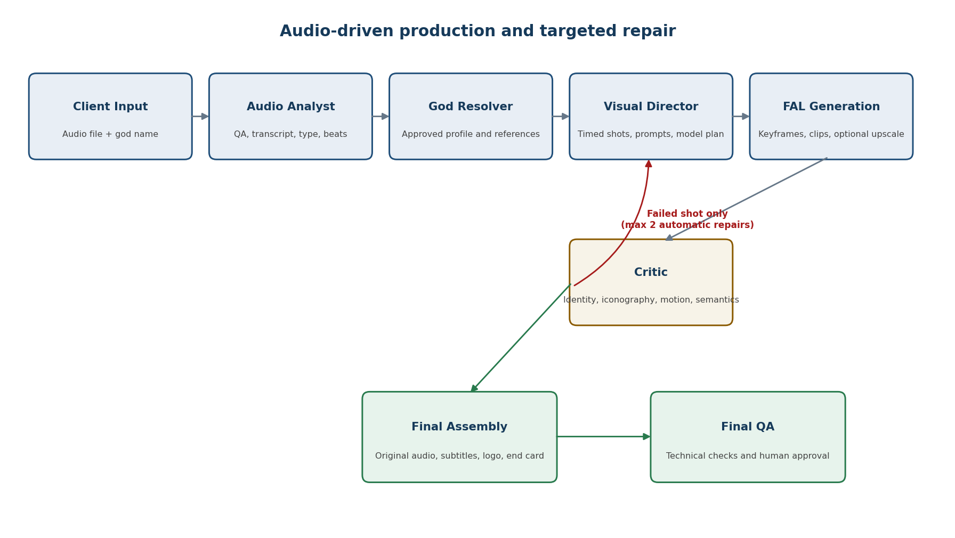
Figure 1. Audio-driven production with a shot-level repair loop.

5. User experience
The user should not navigate a general filmmaking system for this job. Audio-driven production is presented as a guided Series workflow with a compact batch grid and exception-first review.
Workspace | Purpose | Primary actions
Series Setup | Define shared brand, output, quality, model and cost policies. | Configure and lock defaults
Batch Intake | Upload one or many audio files and map a god to each file. | Upload, validate, replace
Transcript Review | Resolve uncertain words, lyrics, mantras and god mismatches. | Edit, approve, reject
Clip Detail | Inspect the timeline, beats, shot plan and asset versions. | Edit, lock, generate
Exception Queue | Display only failed or low-confidence transcripts and media. | Accept, repair, change model
Delivery | Preview final clips and export approved outputs and reports. | Approve, download, export batch

5.1 Client upload form
Field | Behaviour
Audio | Required. Accept supported audio formats and preserve the source file unchanged.
God | Required controlled selection from active God Profiles; do not accept an unvalidated free-text production value.
Clip ID | Generated automatically; optional client reference may be imported in batch.
Everything else | Inherited from the active Series profile and derived automatically.

6. Functional requirements

6.1 Series configuration
ID | Requirement | Priority
SR-01 | Create one Series containing the 70 clips and shared defaults. | Must
SR-02 | Configure aspect ratio, resolution, frame rate, logo, subtitle style and end card. | Must
SR-03 | Configure stage-level model profiles, fallbacks, concurrency and budgets. | Must
SR-04 | Lock approved Series settings and version later changes. | Must
SR-05 | Show the downstream impact before a locked Series setting is changed. | Should

6.2 Audio ingestion and quality checks
ID | Requirement | Failure behaviour
AU-01 | Validate format, codec, duration, channels, sample rate and decodability server-side. | Reject with a clear reason.
AU-02 | Create an immutable SourceAudio record with checksum and rights declaration. | Do not start paid work without a durable source.
AU-03 | Detect silence, clipping, excessive noise and duplicate content. | Flag for review; never overwrite the source.
AU-04 | Create a normalized working copy only when Series policy enables it. | Retain and reference the original separately.
AU-05 | Lock the accepted source as the master timeline for the clip. | Later stages may not replace it silently.
AU-06 | Flag audio outside the configured duration range. | Require manual accept, reject or split decision.

6.3 Transcription and alignment
ID | Requirement | Acceptance behaviour
TR-01 | Detect language and speech regions before transcription. | Store detected language and confidence.
TR-02 | Return full text plus word- or segment-level timestamps. | Every subtitle phrase maps to audio time.
TR-03 | Apply God Profile vocabulary and up to the provider-supported key-term limit. | Religious terms are retained with confidence.
TR-04 | Optionally isolate vocals when background music materially harms transcription. | Use isolated audio only for analysis, never final delivery.
TR-05 | Compare a fallback transcription when confidence is low or the content is mantra/song. | Disagreement creates an exception.
TR-06 | Require human approval for Sanskrit mantra/shloka and low-confidence lyrics. | Paid visual generation remains blocked.
TR-07 | Preserve raw and corrected transcript versions with editor identity. | Approved text is immutable; corrections create a new version.

6.4 Audio analysis and routing
ID | Requirement
AN-01 | Classify audio as narration, mantra/shloka, bhajan/song, prayer/quote, dialogue or mixed.
AN-02 | Extract primary meaning, emotional arc, secondary characters, locations and events.
AN-03 | Create time-coded semantic beats using transcript, silence and musical/energy changes.
AN-04 | Map every proposed visual beat to a spoken, lyrical, musical or emotional interval.
AN-05 | Compare supplied god with transcript; block an unexplained mismatch.
AN-06 | Do not fabricate a literal narrative for mantra, prayer or non-narrative music.
AN-07 | Return all results through a versioned structured-output schema.

6.5 Production-mode routing
Detected content | Required visual treatment | Typical shot count
Mythological narration | Sequential scenes aligned to story events | 5-8
Mantra or shloka | Hero deity, temple, symbols and restrained meditative movement | 3-5
Bhajan or devotional song | Verse/chorus visual rhythm with recurring devotional motifs | 4-7
Short prayer or quote | One hero composition plus supporting symbolic shots | 2-4
Dialogue | Speaker-aware scenes; activate Dialogue Room only if genuinely required | Scene-dependent

6.6 God Profile Registry
ID | Requirement
GP-01 | Provide a controlled registry of active gods and approved aliases.
GP-02 | Store canonical appearance, clothing, iconography, weapons, vehicles, poses and companions.
GP-03 | Store prohibited combinations and religious/cultural restrictions.
GP-04 | Store approved front, three-quarter, full-body, action and blessing references.
GP-05 | Store transcription vocabulary, prompt fragments, negative rules and reviewer notes.
GP-06 | Store compatible image/video models and optional tested LoRA metadata.
GP-07 | Require profile approval before a god becomes selectable for production.
GP-08 | Version profile changes; existing approved clips retain the exact profile version used.

6.7 LoRA policy
- Use approved reference images before training or attaching a LoRA.
- Do not train a LoRA per clip.
- Consider a LoRA when the same god recurs extensively and reference-only identity failure remains material.
- Record compatible base model, trigger phrase, strength range, licence, training dataset and known conflicts.
- Disable a LoRA-model pairing when it repeatedly reduces approval rate.

6.8 Time-coded visual planning
ID | Requirement
VP-01 | Create ordered shots whose total duration equals the master audio duration within render tolerance.
VP-02 | Avoid cuts inside words, phrases or essential musical resolutions.
VP-03 | Store start/end time, audio meaning, visual purpose, subject, setting, action and camera for every shot.
VP-04 | Store start state, intended end state, references, generation mode, model profile and QA rules.
VP-05 | Reserve suitable safe area for subtitles and top-left branding.
VP-06 | Choose deterministic pan/zoom/parallax when generative motion adds insufficient value.
VP-07 | Limit high-risk action shots and identify an economical fallback treatment.
VP-08 | Run feasibility, duration, continuity and iconography preflight before paid generation.

6.9 Keyframe generation
ID | Requirement
KF-01 | Generate two initial candidates per shot unless policy chooses one for a low-risk shot.
KF-02 | Use the exact God Profile version and approved references selected by the shot plan.
KF-03 | Reject incorrect identity, iconography, anatomy, modern objects and embedded text before video generation.
KF-04 | Automatically select a candidate only when score and confidence exceed configured thresholds.
KF-05 | Keep all candidates and their prompts, parameters, costs and review outcomes.
KF-06 | Allow a human to approve, reject, edit prompt, change model or select an alternate.

6.10 Video generation
ID | Requirement
VG-01 | Animate only an approved keyframe or an explicitly approved reference set.
VG-02 | Use capability-based FAL operations rather than exposing provider payloads in the core schema.
VG-03 | Disable generated audio when supported; otherwise discard it during assembly.
VG-04 | Support start/end images or multiple references when the selected model provides them.
VG-05 | Use duration and motion instructions from the shot plan and record the exact returned duration.
VG-06 | Use premium motion only for shots whose action or creative importance justifies it.
VG-07 | Upscale only accepted assets or the accepted final output, not rejected candidates.
VG-08 | Store provider request ID, model, parameters, seed, cost, result and parent keyframe.

6.11 Creative QA and targeted repair
Failure class | Checks | Repair action
Identity | Correct god, face, colours and body form | Strengthen/change reference; regenerate keyframe
Iconography | Weapons, clothing, vehicles, poses and companions | Correct plan/prompt/profile reference
Anatomy | Limbs, hands, face, tail and body integrity | Regenerate or edit keyframe
Semantic match | Visual represents the current audio beat | Return shot to Visual Director
Motion | Natural action, no drift, morphing or frozen failure | Reduce motion, shorten shot or switch model
Continuity | Consistent identity, setting and states across adjacent shots | Reuse references/start-end frames
Timing | Generated duration fits assigned interval | Trim/retime or regenerate only that shot
Text | No AI-generated gibberish or unwanted lettering | Regenerate visual; captions remain deterministic

6.12 Subtitle generation
- Generate subtitle phrases only from the approved transcript and timestamps.
- Keep subtitle text editable and versioned independently from generated visuals.
- Support plain captions, word highlighting and optional Sanskrit-plus-Hindi treatment when approved.
- Limit lines and phrase length according to the active visual-safe-area profile.
- Do not split deity names or compound religious terms incorrectly.
- Run spelling, timing, overlap, contrast and safe-area checks after rendering.

6.13 Assembly and delivery
ID | Requirement
AS-01 | Compose approved clips against the locked original audio timeline.
AS-02 | Add subtitles, logo, transitions, approved overlays and end card deterministically.
AS-03 | Reserve end-card time in planning or overlay the CTA without arbitrarily extending audio.
AS-04 | Validate duration, dimensions, frame rate, corruption, black/frozen frames and missing shots.
AS-05 | Validate audio presence, start/end alignment, clipping policy and absence of generated audio.
AS-06 | Block delivery when mandatory transcript, religious, asset or technical approvals are missing.
AS-07 | Export MP4, subtitle file, production JSON, asset manifest and cost summary.
AS-08 | Retain final version, source mapping and review history after delivery.

7. Three logical AI roles
Role | Responsibility | Does not do
Audio Analyst | Transcript interpretation, type, meaning, entities, emotion and timed beats | Does not rewrite the supplied audio
Visual Director | Shot plan, continuity, prompts, references, model profile and preflight | Does not approve its own output
Critic / Repair Controller | Independent scoring, failure classification, minimal repair and escalation | Does not regenerate the full video for a local defect

The roles are schemas, prompts and permissions inside the production core, not separate services. A different model should preferably perform criticism from the model used for directing.

8. Batch behaviour for 70 clips
Capability | Requirement
Bulk upload | Upload multiple files and map god names through a simple grid or import manifest.
Parallel early stages | Run audio QA, transcription and analysis concurrently across clips within limits.
Approval gates | Do not begin video generation until required transcript/profile/plan gates pass.
Concurrency | Configure independent limits for transcription, LLM, image, video, upscale and render jobs.
Exception-first review | Show only uncertain or failed items by default; allow full review during pilot.
Cost control | Estimate before each paid stage and stop new work at Series/clip/stage ceilings.
Resume | Restart from the last durable checkpoint after application, worker or provider interruption.
Batch export | Download approved clips, subtitles and status/cost report without exporting failed clips.

8.1 Production states
Uploaded -> Audio QA -> Transcribing -> Transcript Review -> Analysing -> Shot Planning -> Keyframes -> Video Generation -> Asset Review -> Assembly -> Final QA -> Approved. Failed and Cancelled are terminal unless a new version is created.

9. Architecture
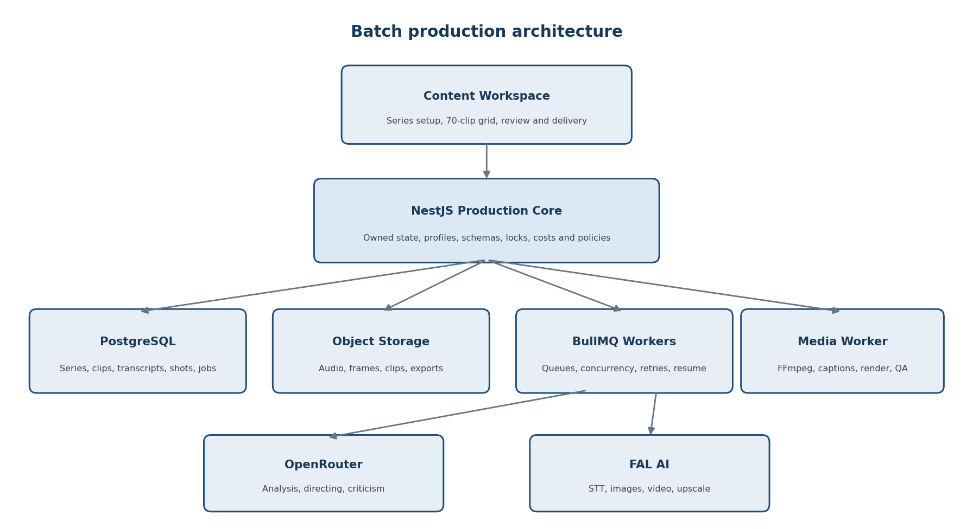
Figure 2. Owned production core with replaceable intelligence and media providers.

9.1 Component responsibilities
Component | Responsibility
React Content Workspace | Series setup, batch grid, transcript/shot editing, exception review and delivery.
NestJS Production Core | Schemas, state transitions, locks, permissions, cost policy, adapters and audit.
PostgreSQL | Series, clips, profiles, transcripts, beats, shots, jobs, reviews, costs and approvals.
Object storage | Original audio, working copies, references, keyframes, generated clips and exports.
Redis/BullMQ | Asynchronous jobs, queues, retries, concurrency, delayed polling and resume.
Media Worker | Audio inspection, optional separation, FFmpeg assembly, subtitles and technical QA.
OpenRouter adapter | Structured Audio Analyst, Visual Director and Critic requests with fallbacks.
FAL adapter | Speech-to-text, image/video generation, status/webhooks, result normalization and upscale.

9.2 Provider-neutral operations
Operation | Purpose
transcribeAudio | Return transcript, word/segment timestamps, language and confidence.
analyseAudioContent | Return typed clip classification, entities, beats, meaning and risks.
planShots | Return a schema-valid time-coded production plan.
generateImage / editImage | Create or correct keyframes through configured FAL endpoints.
generateVideo / transformVideo | Animate an approved keyframe or reference set.
evaluateAsset | Score media against shot, profile, references and QA rubric.
planRepair | Return smallest repair scope, instruction, model action and escalation.
upscaleAsset | Upscale only accepted shots or final renders.
assembleTimeline | Compose the final deterministic audiovisual output.

10. Core data model
Entity | Key contents
Series | Quantity, brand/output defaults, quality mode, budgets, providers and state.
Clip | Client reference, god, source audio, type, state, duration, exceptions and final asset.
SourceAudio | Checksum, rights, duration, technical metadata, original and working-copy locations.
TranscriptVersion | Raw/corrected text, words, timestamps, language, confidence and approval.
AudioAnalysis | Classification, summary, entities, emotion, beats, risks and evidence.
GodProfileVersion | Canonical depiction, references, restrictions, lexicon, models and LoRA data.
ShotPlanVersion | Ordered shots, timecodes, meanings, actions, camera, references and model plan.
GenerationJob | Capability, provider, model, payload hash, attempt, status, external ID and cost.
AssetVersion | Parent, prompt, references, parameters, media metadata, score and approval.
ReviewResult | Rubric, evidence, issue class, confidence, decision and repair instruction.
TimelineVersion | Ordered assets, original audio, captions, overlays, render and final checks.

11. Job reliability and cost controls
- Assign an internal job ID and deterministic idempotency key to every external request.
- Deduplicate callbacks and prevent terminal job states from regressing.
- Distinguish transient provider errors from invalid input and creative rejection.
- Copy completed external media into owned storage before marking a job durable.
- Track estimate, provider price basis, calculated actual, repair spend and variance.
- Stop new paid work when the projected clip, stage or Series ceiling would be exceeded.
- Display cost impact before a human changes to a premium model.

12. Security, privacy and rights
- Encrypt provider credentials and never expose them to the browser.
- Use short-lived, scoped media URLs and validate all uploaded media before parsing.
- Require an audio-rights declaration and preserve it with the SourceAudio record.
- Restrict project, profile, transcript, asset and export access server-side.
- Redact credentials and unnecessary personal data from prompts, payload logs and errors.
- Record the commercial-use status and licence constraints of models, LoRAs and reference assets.
- Apply provider-side deletion/retention controls when supported without removing required internal audit history.

13. Non-functional requirements
Area | Requirement
Availability | Provider failures affect only dependent stages; editing and review remain available.
Performance | Interactive actions return promptly; transcription and media work run asynchronously.
Scalability | Workers and concurrency scale independently by job class and provider limit.
Observability | Trace upload through transcript, plan, generation, review, repair, assembly and cost.
Data integrity | Original audio and approved versions are immutable; changes create new versions.
Accessibility | Keyboard-accessible actions, labelled controls, visible focus and non-colour-only states.
Maintainability | Provider payload details remain in adapters rather than core creative schemas.
Testing | Contract tests, audio fixtures, state-machine tests and Owner/Reviewer UI journeys.

14. Acceptance criteria
- A clip can be created with only a valid audio file and an active god selection.
- The original audio remains byte-identifiable and is used as the final master track.
- The system creates a timestamped transcript and blocks low-confidence mantra/lyric production until approval.
- A supplied god/transcript mismatch creates a blocking exception rather than automatic media generation.
- Every planned shot maps to an exact audio interval and the planned durations cover the complete audio.
- Only approved God Profile versions and compatible model/LoRA entries can be used.
- An incorrect keyframe is rejected before video generation.
- A failed clip regenerates only the affected shot and preserves approved siblings.
- After two automatic repairs, the same failure requires human review or an explicit model switch.
- Subtitles are derived from approved text, remain editable and are not embedded by image/video generation.
- The final MP4 contains the correct audio, shots, logo, subtitles/end card and passes technical checks.
- The Series dashboard reports accurate status, exceptions and cost for all 70 clips.

15. Delivery plan
Stage | Scope | Exit condition
Foundation | Series/clip schema, state machine, storage, jobs, providers, profiles | Durable resumable jobs and passing adapter tests
Audio path | Upload, QA, transcript, alignment, analysis and exceptions | Representative audio fixtures pass
Planning | God resolver, beat mapping, shot schema, preflight and editing | Plans exactly cover audio timeline
Media path | Keyframes, candidate selection, FAL video and asset lineage | One clip generates end to end
QA and repair | Rubrics, critic, targeted retry and escalation | Failed shot repairs without rebuilding siblings
Assembly | Original audio, captions, logo, end card, render and technical QA | Representative outputs pass
Batch hardening | 70-clip grid, concurrency, budgets, exports and role journeys | Release acceptance suite passes

15.1 Production rollout
Wave | Quantity | Review policy | Purpose
Pilot | 5 | Review every transcript, keyframe, clip and final | Calibrate modes, profiles and models
Calibration | 10 | Automatic selection allowed; review all final clips | Measure failures, cost and reviewer time
Production | 55 | Exception-first production; human final viewing required | Complete remaining clips in batches of 10-15

16. Decisions fixed by this document
- Client input is restricted to audio plus god name for the default workflow.
- The supplied audio is immutable and controls the final timeline.
- Scriptwriting, Dialogue Room and TTS are removed from the default audio-driven path.
- Three logical AI roles are used: Audio Analyst, Visual Director and Critic/Repair Controller.
- God Profile Registry and transcript review are mandatory control mechanisms.
- Keyframes must be approved before paid video generation.
- Generated native audio is disabled or discarded.
- Subtitles and branding are deterministic overlays.
- Automatic repair is shot-level and limited to two attempts by default.
- Every final clip is watched by a human before client delivery.
- The 70 clips are produced as one Series through pilot, calibration and production waves.

17. Initial provider profiles
Model names are configuration, not hard-coded business logic. The initial catalogue should benchmark the following candidates and retain measured approval rate, latency, cost and failure patterns.
Capability | Initial candidates | Selection note
Speech-to-text | FAL ElevenLabs Scribe V2; FAL Wizper/Whisper v3 | Use word timestamps and god-specific key terms
Image | Approved FAL reference/edit model; FLUX-compatible LoRA path if required | Choose by profile, identity and commercial policy
Premium image-to-video | FAL Kling Video v3 Pro | Use for high-value action and controlled start/end imagery
Reference/longer video | FAL Seedance 2.5 Reference-to-Video | Use for multi-reference continuity when testing supports it
Upscale | Approved FAL video upscaler | Run only after creative acceptance
Planning/QA | Stage-specific OpenRouter models with independent critic | Require strict JSON schemas and fallbacks

18. Reference links
- FAL Scribe V2: https://fal.ai/models/fal-ai/elevenlabs/speech-to-text/scribe-v2/api
- FAL Kling v3 Pro Image-to-Video: https://fal.ai/models/fal-ai/kling-video/v3/pro/image-to-video
- FAL Seedance 2.5 Reference-to-Video: https://fal.ai/models/bytedance/seedance-2.5/reference-to-video
- FAL asynchronous queue: https://fal.ai/docs/documentation/model-apis/inference/queue
- FAL webhooks: https://fal.ai/docs/documentation/model-apis/inference/webhooks
- OpenRouter structured outputs: https://openrouter.ai/docs/guides/features/structured-outputs
- OpenRouter model fallbacks: https://openrouter.ai/docs/guides/routing/model-fallbacks

