PRODUCT REQUIREMENTS DOCUMENT
AI Content Production - Content Tab
  - Idea or short inspiration video to quality-checked, repairable video production
Field | Value
Version | 1.0
Date | 25 August 2026
Status | Implementation-ready baseline
Audience | Product, engineering, design and QA teams
Primary integrations | OpenRouter for language/vision intelligence; FAL AI for media generation

Scope decision: Only inspiration/reference videos shorter than 5 minutes may be uploaded for automated analysis. The system must reject a source video whose duration is 5:00 or longer. This limit applies to analysed input media, not necessarily to the final production target.

1. Executive summary
The Content tab will become a single production workspace that converts either a written idea or a short inspiration video into a structured story, natural dialogue, a scene-and-shot plan, generated media, a review queue and an assembled master video. The product will own the creative schemas, quality rules, repair logic, versions and provider history. External AI providers will remain replaceable execution dependencies behind internal adapters.
The first release will be a modular monolith: React for the workspace, NestJS for the production core, PostgreSQL for structured state, object storage for media, Redis/BullMQ for asynchronous jobs and FFmpeg-based workers for analysis, assembly and deterministic technical checks. It will not embed multiple overlapping open-source orchestration products.

2. Product goals and principles
- Create one coherent workflow from brief to approved final video without manual prompt copying.
- Produce dialogue that sounds spoken and situational rather than generic, declarative or translated.
- Regenerate only the failed shot, sentence or asset; never rebuild the complete production for a local failure.
- Use stage-specific model policies and approved LoRAs instead of unrestricted model or internet-LoRA selection.
- Keep providers replaceable while retaining production knowledge, quality history and lineage in the owned core.
- Expose complexity only when it helps a user make a decision; otherwise run it in the background.

2.1 Success measures
Measure | Initial target
Workflow completion | A user can move from accepted input to exported master without copying prompts between tools.
Revision efficiency | At least 80% of generation failures are repaired at shot/asset level, not by full-project regeneration.
Dialogue gate | No scene proceeds to paid media generation until dialogue passes naturalness and speakability checks or is manually approved.
Traceability | Every generated asset records prompt, model, endpoint, parameters, cost, parent version and review result.
Provider resilience | A configured fallback can replace an unavailable OpenRouter or FAL model without changing project data.
Technical output | Final exports pass resolution, duration, audio, subtitle-safe-area, missing-scene and corruption checks.

3. Scope

3.1 In scope for MVP
- New project from a text idea, optional script, images or one inspiration video shorter than 5 minutes.
- Local extraction of video metadata, scene boundaries, representative frames and transcript before LLM analysis.
- Concept options, story beats, character/environment/style bible and explicit locking of approved content.
- Dialogue Room with character objectives, knowledge boundaries, subtext, line-level critique and targeted rewrites.
- Scene and shot timeline with duration, action, camera, dialogue, audio, prompt, model plan, LoRA plan and status.
- FAL-backed image, image-edit, image-to-video, text-to-video, speech/lip-sync where required, upscaling and supported LoRA operations.
- OpenRouter-backed analysis, writing, structured planning, visual criticism and repair planning.
- Exception-first review queue, versions, lineage, cost tracking, targeted repair and final FFmpeg assembly.
- Owner and Reviewer roles, project-level permissions and provider/budget settings outside the Content tab.

3.2 Explicitly out of scope for MVP
- Analysis of an inspiration/reference video with duration of 5:00 or longer.
- Automatic publishing to social channels.
- Unrestricted downloading of LoRAs or models from public sites during production.
- A separate microservice per agent, a visual dependency-graph editor, or a general-purpose workflow builder.
- ComfyUI or self-hosted generation as a required production dependency; a future adapter may add it.
- More than two automatic repair attempts for the same failure without human review or a deliberate model switch.
- Full multi-tenant billing, complex enterprise role hierarchies or marketplace capabilities.

3.3 Input and output boundaries
Item | Requirement
Idea | Plain text; may include audience, language, genre, tone, style and desired outcome.
Inspiration video | One file per analysis run; duration_ms < 300000. At exactly 300000 ms or above, reject before upload processing.
Optional references | Images, script, audio, documents and brand rules may be attached independently of the video duration rule.
Target duration | User-configurable. The system must calculate whether planned shot durations equal the target within configured tolerance.
Primary output | Approved master MP4 plus subtitles, production JSON and an asset manifest.
Aspect ratios | 9:16 required for MVP; architecture must permit 16:9 and 1:1 profiles without schema changes.
Languages | Hindi and English in MVP; Hindi dialogue quality is a priority. Other languages remain configurable later.

4. User experience and information architecture
The Content tab is a single workspace with five ordered sections. A compact header shows project status, target duration, estimated/actual cost, active jobs and unresolved exceptions. The bible opens as a drawer from Story and Scene Timeline rather than as a separate application.
Section | Purpose | Primary actions
1. Brief | Capture idea, references, target and constraints. | Analyse, validate input, propose concepts
2. Story | Develop and lock the narrative foundation. | Compare, rewrite, approve, lock
3. Scene Timeline | Operate the scene/shot production plan. | Edit, generate, approve, regenerate
4. Review Queue | Show only failed, uncertain or manually requested items. | Accept, repair, change model, return upstream
5. Final Timeline | Assemble approved clips, audio, captions and transitions. | Preview, render, validate, export

4.1 End-to-end workflow
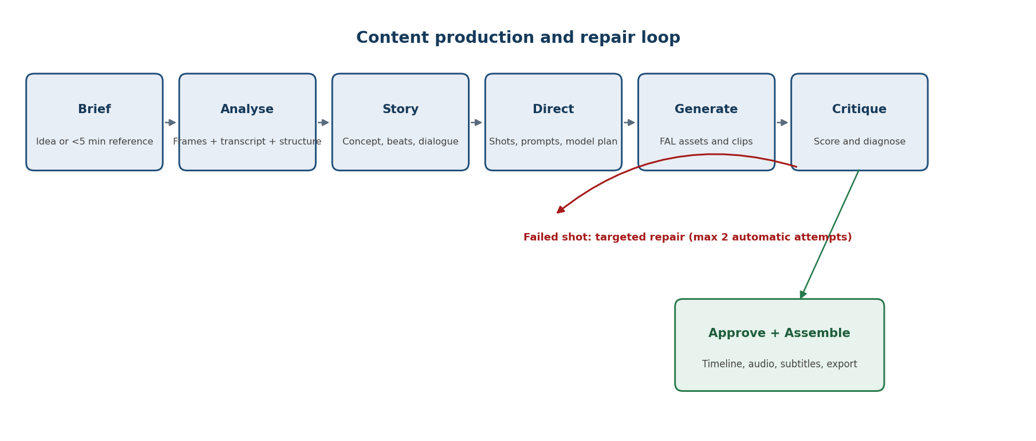
Figure 1. Production stages and the targeted repair loop.
- Idea path: the Producer creates concepts directly from the brief.
- Inspiration path: deterministic extraction runs first; an OpenRouter vision model receives selected frames, transcript and metadata rather than the full raw video.
- Only approved story/dialogue is converted into shots and sent to paid media generation.
- The Critic diagnoses each failure and chooses the smallest repair scope: line, prompt, image, clip, audio or shot plan.
- After two automatic failures, the item becomes a human exception unless policy authorizes a different model.

5. Functional requirements

5.1 Brief and intake
ID | Requirement | Priority
BR-01 | Allow a project to start from an idea with no media attachment. | Must
BR-02 | Allow an inspiration video only when validated duration is strictly below 5 minutes. | Must
BR-03 | Read duration from server-side media metadata; do not trust a client-supplied duration. | Must
BR-04 | Reject non-decodable media, unsupported codecs and files at or above the duration limit with a clear reason. | Must
BR-05 | Capture target length, language, aspect ratio, genre, audience, tone, quality mode and budget ceiling. | Must
BR-06 | Permit optional script, images, audio, documents and brand rules as additional references. | Should
BR-07 | Create an immutable source record and checksums for every accepted reference. | Must

5.2 Inspiration-video analysis
To minimize dependency, MVP analysis will not require a direct raw-video cloud API. The media worker extracts objective evidence locally, and OpenRouter models analyse a structured evidence bundle.
ID | Requirement | Acceptance behaviour
AN-01 | Extract codec, frame rate, dimensions, audio presence and exact duration. | Metadata stored before analysis begins.
AN-02 | Detect scene/shot boundaries and select representative frames. | Every detected segment has timestamps and at least one frame reference.
AN-03 | Extract a timestamped transcript and identify speech, narration, music and silence where feasible. | Transcript or explicit no-speech result is stored.
AN-04 | Send frames, transcript and metadata to a stage-approved multimodal model through OpenRouter. | No raw-video capability is assumed in the provider contract.
AN-05 | Produce hook, synopsis, story beats, characters, locations, pacing, visual language, camera patterns and audio style. | Output conforms to the versioned analysis schema.
AN-06 | Separate transferable inspiration from elements that should not be copied. | Analysis labels structure/style cues versus literal protected elements.
AN-07 | Show uncertainty and missing evidence rather than inventing detail. | Every uncertain result carries evidence and confidence.

5.3 Story and production bible
ID | Requirement
ST-01 | Generate 2-3 concept options with premise, hook, intended emotion, approximate duration and generation complexity.
ST-02 | Create logline, synopsis, beats and scene objectives from the selected concept.
ST-03 | Maintain character, environment, prop, costume and style definitions as versioned bible entities.
ST-04 | Track what each character knows, suspects, wants and hides at each scene boundary.
ST-05 | Allow users to lock any approved field; agents may not silently overwrite locked content.
ST-06 | Before story lock, check causal logic, pacing, originality, duration feasibility, motivation and continuity.
ST-07 | Show downstream impact before an approved story or bible item is changed.

5.4 Dialogue Room
Dialogue quality is a separate approval gate inside the Screenwriter role. It must operate before shot generation so weak lines do not trigger expensive media work.
ID | Requirement | Pass condition
DL-01 | Define each speaker's vocabulary, temperament, relationship history and speaking rhythm. | Lines remain attributable to the intended speaker.
DL-02 | Define the immediate objective and knowledge boundary for every speaking character. | No character states knowledge they do not possess.
DL-03 | Draft conversation turn-by-turn with each response reacting to the previous line. | No disconnected declarations or monologues disguised as exchange.
DL-04 | Critique exposition, cliches, generic heroism, translated phrasing, repetition and vague words. | Failed lines are listed with reasons and alternatives.
DL-05 | Check natural Hindi speakability and optional temporary table-read audio. | Dialogue can be spoken within scene duration.
DL-06 | Rewrite only failed lines while preserving approved meaning and locked facts. | Unfailed lines remain unchanged unless explicitly unlocked.
DL-07 | Use a critic model different from the writer when the configured model catalogue permits it. | Writer and critic model IDs are recorded.

5.5 Scene and shot timeline
ID | Requirement
SH-01 | Represent scenes and shots separately, each with ordered IDs and versioned status.
SH-02 | Store duration, purpose, subject, setting, action, start/end state, camera, dialogue, audio and transition for every shot.
SH-03 | Compile provider-specific prompts from owned shot data; provider syntax must not pollute the core schema.
SH-04 | Assign model capability, model candidate, generation mode, references, seed policy and optional LoRA plan.
SH-05 | Run preflight checks for duration, feasibility, continuity, identity, required references and expected outcome.
SH-06 | Allow generation for one shot, selected shots, one scene or all ready shots.
SH-07 | Display approval status, active job, latest cost, retry count and unresolved issue inline.
SH-08 | Prevent deletion of an approved asset that is used by downstream shots without impact confirmation.

5.6 Media generation and FAL adapter
FAL AI is the primary MVP media execution provider. The core must call capability-based operations so endpoint changes remain isolated inside configuration and adapter code.
Operation | Required behaviour
generateImage | Create candidate keyframes from text and approved references.
editImage | Inpaint, outpaint, restyle or correct an existing approved image.
generateVideo | Create text-to-video or image-to-video clips using the selected generation profile.
transformVideo | Apply supported video-to-video correction, stylization or extension.
generateSpeech | Create narration/dialogue audio where the selected provider capability is approved.
lipSync | Apply only when a visible speaker and approved dialogue require it.
trainLora | Start an approved LoRA training workflow with dataset, consent/licence and budget checks.
upscaleAsset | Upscale or restore approved images/clips without replacing their lineage.

- All FAL submissions must be asynchronous, idempotent and resumable.
- Webhook results must be authenticated, deduplicated and matched to the submitted job.
- Provider payloads and raw responses must be stored with sensitive values redacted.
- A timeout or provider failure must not advance the production state.

5.7 Review queue and repair
ID | Requirement
RV-01 | Queue only failed, low-confidence, policy-required or manually flagged items by default.
RV-02 | Show the generated asset beside intended outcome, references, critic evidence, scores and repair proposal.
RV-03 | Support Accept, Regenerate, Edit plan, Change model, Keep as alternate and Return upstream.
RV-04 | Classify failure scope as dialogue, prompt, reference, image, motion, identity, audio, timing, shot plan or story.
RV-05 | Repair the smallest affected object and preserve approved siblings.
RV-06 | Allow at most two automatic repair attempts per failure signature by default.
RV-07 | After the limit, require human review or an explicit policy-authorized model switch.
RV-08 | Store original, critique, repair instruction and all candidates for comparison and rollback.

5.8 Final timeline and export
ID | Requirement
FN-01 | Place only approved clips/audio on the final timeline unless a user explicitly overrides.
FN-02 | Support narration, dialogue, music, effects, subtitles, transitions, logo and end card layers.
FN-03 | Render deterministic overlays such as Hindi text and subtitles outside generative video frames.
FN-04 | Validate missing shots, order, target duration tolerance, black frames, frozen frames, corruption and resolution.
FN-05 | Validate audio presence, clipping, loudness policy, silence anomalies and audiovisual duration alignment.
FN-06 | Validate subtitle spelling, timing, line length and safe-area placement.
FN-07 | On final failure, reopen only the affected asset or shot and recompose after approval.
FN-08 | Export master MP4, subtitle file, production JSON, asset manifest and cost summary.

6. Four logical AI roles
The roles below are prompts, schemas and permissions inside the production core, not independent services. Different stages may use different OpenRouter models.
Role | Owns | May send work back to
Producer / Analyst | Input understanding, concepts, audience, style, reference evidence | User when input is invalid or ambiguous
Screenwriter | Story, characters, continuity and Dialogue Room | Producer for concept/structure defects
Director | Scenes, shots, prompts, model/LoRA plan and preflight | Screenwriter for story/dialogue infeasibility
Critic / Repair Controller | Asset scoring, diagnosis, repair scope and final creative checks | Director, Screenwriter or Producer according to failure scope

6.1 Stage gates and loop rules
Gate | Required checks | Failure action
Story | Logic, pacing, originality, duration, motivation | Rewrite affected beat/scene
Dialogue | Reaction, voice, subtext, speakability, knowledge | Rewrite failed lines
Shot preflight | Timing, continuity, feasibility, references | Repair shot plan
Image | Identity, style, composition, anatomy, setting | Regenerate/edit image
Clip | Motion, drift, action, camera, artifacts, lip-sync | Regenerate clip or change model
Audio | Pronunciation, emotion, timing, clipping, noise | Regenerate sentence/track
Final | Completeness, continuity, subtitles, mix, integrity | Recompose or reopen failed item

7. Architecture
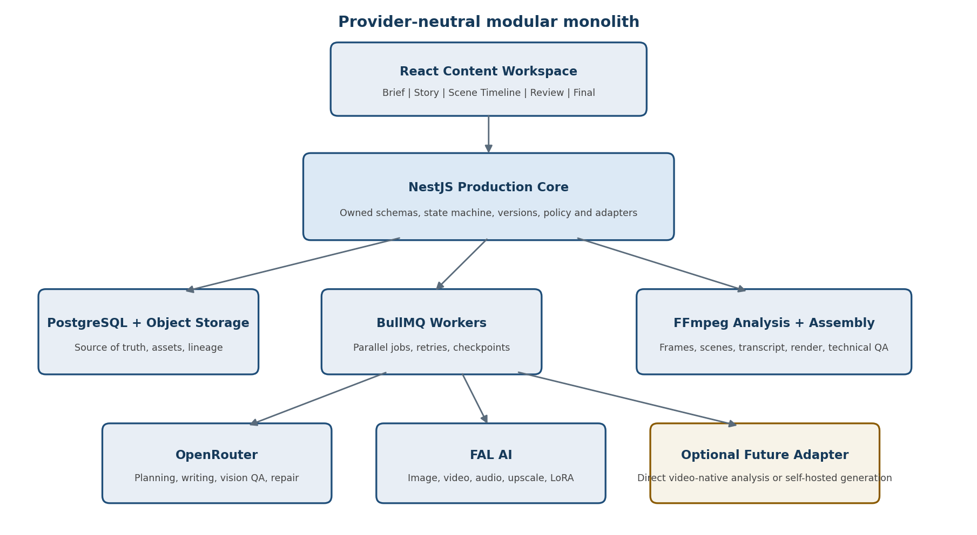
Figure 2. MVP architecture with owned production core and replaceable providers.

7.1 Component responsibilities
Component | Responsibility
React workspace | Content editing, approvals, review queue, timeline, status and cost visibility.
NestJS production core | Projects, schemas, permissions, locks, state transitions, versions, lineage, policy and adapters.
PostgreSQL | Structured source of truth for projects, creative objects, jobs, reviews, costs and model history.
Object storage | Source files, extracted frames, generated media, exports and immutable asset versions.
Redis/BullMQ | Asynchronous jobs, concurrency, retries, scheduled polling and resumable checkpoints.
Media worker | FFmpeg/scene detection/transcription integration, media validation, deterministic assembly and technical QA.
OpenRouter adapter | Model catalogue, structured LLM/vision requests, fallbacks, budgets and response normalization.
FAL adapter | Capability-based media operations, queue submission, webhooks, status and result normalization.

7.2 Why no mandatory direct Gemini dependency in MVP
Because analysed inspiration videos are now restricted to under 5 minutes, the MVP can reliably preprocess them into a compact evidence bundle: scene boundaries, selected frames, transcript and audio/media metadata. This bundle can be analysed through OpenRouter without requiring a third production provider. The internal analyzeVideo contract must still allow a future video-native adapter if quality testing shows a material advantage.
Dependency policy: OpenRouter and FAL AI are required external providers for MVP. Any direct video-native cloud API or self-hosted generation engine is optional and must plug into an existing internal interface.

8. Model routing and LoRA policy

8.1 Model registry
The application must select by capability and policy before using LLM judgement. Each registered model profile stores:
- Provider, endpoint/model ID, modality and supported operation.
- Maximum input/output limits, resolution, duration and aspect ratios.
- Reference-image, editing, audio, lip-sync and LoRA compatibility.
- Expected cost, latency, quality tier, fallback and concurrency limits.
- Best-use tags, known weaknesses, historical approval rate and regeneration rate.
- Commercial-use status and any project-level restrictions.

8.2 Selection sequence
- Filter by required capability and hard technical constraints.
- Apply project budget, latency, quality and licence policy.
- Rank by historical acceptance and regeneration performance for similar shots.
- Let the Director choose between the top candidates only when creative judgement is material.
- Record the chosen model, parameters, reason, cost and outcome for learning and audit.

8.3 LoRA registry and selection
Policy | Requirement
Approved catalogue | Only LoRAs present in the internal registry may be attached or trained automatically.
Registry data | Base-model compatibility, type, trigger phrase, tested strength, licence, examples, workflow and known conflicts.
When to use | Recurring major identity or approved recurring visual style after reference-only attempts are insufficient.
When not to use | One-off backgrounds, camera movement that the model supports natively, or identity already stable with references.
Training gate | Requires adequate dataset, consent/licence record, expected reuse and approved budget.
Failure control | A LoRA that repeatedly reduces acceptance is disabled for the relevant model/profile pending review.

9. Core data model
Entity | Key contents
Project | Brief, target, language, aspect ratio, budget, quality mode, state and users.
SourceAsset | Type, duration, checksum, metadata, object location, rights status and analysis status.
Analysis | Evidence bundle, transcript, shots, summary, style, pacing, confidence and source references.
StoryVersion | Concept, logline, synopsis, beats, scenes, validation and locks.
BibleEntity | Character/environment/prop/style definition, references, voice and approved version.
DialogueVersion | Speakers, objectives, knowledge, subtext, lines, timing, scores and approval.
Scene / Shot | Order, duration, intent, continuity state, action, camera, dialogue, audio and generation plan.
GenerationJob | Capability, provider, model, payload hash, status, attempt, cost and external job ID.
AssetVersion | Parent, prompt, parameters, seed, references, media metadata, cost and approval status.
ReviewResult | Rubric scores, evidence, issue type, confidence, decision and repair instruction.
TimelineVersion | Ordered approved assets, audio layers, overlays, transitions, render status and export manifest.
Model / LoRA profile | Capabilities, compatibility, policy, costs, history, licence and active status.

9.1 State model
At each level, state transitions must be explicit and auditable. Recommended common states are Draft, Ready, Generating, Review Required, Approved, Failed and Superseded. Locked objects may be superseded only by creating a new version; they are never mutated in place.

10. APIs and job behaviour

10.1 Provider-neutral internal contracts
Contract | Minimum responsibility
analyzeEvidence | Analyse transcript, frames and metadata into a typed reference analysis.
generateStructuredText | Return schema-conformant concept, story, dialogue, shot or review objects.
evaluateAsset | Score an image/clip/audio item against intended outcome and references.
planRepair | Return issue class, smallest repair scope, instructions and escalation policy.
generateImage / editImage | Create or modify image assets and normalize provider responses.
generateVideo / transformVideo | Create or modify clips and normalize queue/status/result handling.
generateSpeech / lipSync | Create or align speech while retaining sentence-level lineage.
trainLora / upscaleAsset | Run approved auxiliary media workflows with explicit cost gates.

10.2 Job reliability requirements
- Every submission receives an internal job ID and deterministic idempotency key.
- Callbacks and polling updates are deduplicated and cannot regress a terminal job state.
- Retry policy distinguishes transient network/provider errors from invalid inputs and creative rejection.
- User cancellation stops unsent work and marks in-flight provider work as cancellation-requested when direct cancellation is unavailable.
- Completed external results are copied to owned object storage before the job is considered durable.
- Projects resume from the last completed checkpoint after worker or application restart.

11. Cost and usage controls
Control | Requirement
Estimate | Show estimated range before batch generation and LoRA training.
Project ceiling | Block new paid jobs when projected spend exceeds the approved project ceiling.
Per-stage ceiling | Allow separate limits for analysis, writing, images, clips, audio, repair and final render.
Repair budget | Track repair spend separately and stop automatic retries at policy limit.
Model switch | Display estimated cost impact before a human switches to a higher-cost model.
Audit | Record estimate, actual provider charge where available, internal calculated cost and variance.

12. Security, privacy and rights
- Provider credentials are encrypted, kept outside project content and never exposed to the browser.
- Signed media URLs are short-lived and scoped to the relevant asset and operation.
- Uploads are scanned/validated before processing, and media parsers run with resource limits.
- Source and generated assets have explicit ownership/rights status; unverified rights block external publishing workflows added later.
- Prompts, logs and provider responses redact credentials and unnecessary personal data.
- Project access is enforced server-side for every asset, job, review and export operation.
- Retention and deletion policies remove provider-side temporary assets when supported while preserving the owned audit record required by policy.

13. Non-functional requirements
Area | Requirement
Availability | A provider outage degrades only affected capabilities; editing and review remain available.
Performance | UI actions that do not start AI/media work return promptly; long operations always run as jobs with progress.
Scalability | Workers scale independently by job class and support per-provider concurrency/rate limits.
Observability | Trace a user action through job, provider call, asset, review, repair and cost record.
Data integrity | Approved and locked versions are immutable; asset hashes and parent relationships are retained.
Accessibility | Keyboard-accessible review actions, labelled controls, visible focus and non-colour-only statuses.
Maintainability | Provider-specific fields remain in adapter payloads, not core project tables.
Testing | Use contract tests for adapters, fixture media for analysis, deterministic state tests and UI journey tests by role.

14. Acceptance criteria
- An idea-only project can reach an approved shot plan without any inspiration video.
- A 4:59.999 video is accepted if otherwise valid; a 5:00.000 video is rejected before analysis with a clear message.
- An accepted video produces metadata, shot boundaries, representative frames, transcript/no-speech result and structured reference analysis.
- The system can create and lock a story, bible and dialogue version; later agents cannot overwrite locked fields silently.
- Dialogue criticism identifies at least the failed lines and rewrites only those lines while retaining character knowledge and scene intent.
- A shot can be generated through FAL, reviewed, rejected, repaired and regenerated without affecting approved neighbouring shots.
- Model and LoRA selection is restricted to active compatible registry entries and records the selection reason.
- A provider timeout or duplicate callback does not create duplicate assets or invalid state transitions.
- Final assembly blocks missing/unapproved mandatory shots and exports only after technical checks pass or an authorized override is recorded.
- The exported manifest links every final segment to its approved asset, generation job, model, cost and review decision.

15. Delivery sequence
Phase | Deliverable | Exit condition
1. Foundation | Core schema, project states, storage, jobs, providers, costs and audit | Jobs survive restart; adapters pass contract tests
2. Brief + analysis | Idea intake and <5-minute evidence extraction/analysis | Boundary and fixture tests pass
3. Story + dialogue | Story versions, bible, locks, Dialogue Room and quality gates | Approved dialogue cannot be silently changed
4. Scene production | Timeline, prompt compiler, model registry and FAL operations | One shot completes end-to-end
5. Critic + repair | Review queue, rubrics, targeted repair, retries and escalation | Failed shot repairs without rebuilding siblings
6. Final assembly | Audio/subtitles/timeline, FFmpeg render, QA and export manifest | Representative projects export successfully
7. Hardening | Role journeys, budgets, rate limits, resilience, security and observability | Release acceptance suite passes

16. Product decisions fixed by this document
- The existing Content tab remains the production workspace; story, media and review are not split into separate products.
- Reference-video analysis is limited to duration_ms < 300000.
- MVP uses local evidence extraction plus OpenRouter analysis; direct raw-video cloud analysis is not mandatory.
- OpenRouter is the intelligence gateway and FAL AI is the primary media-generation gateway.
- The application owns creative objects, versions, model/LoRA policy, quality rubrics and repair history.
- There are four logical AI roles and one targeted repair loop, not many independent autonomous services.
- Only approved registry entries may be used for models and LoRAs.
- Automatic repair is limited to two attempts by default; the next action is human review or an explicit model switch.
- The architecture is a modular monolith with asynchronous workers, not a microservice or general workflow-platform build.

17. Assumptions to validate during implementation
- The current application already provides project identity and an existing Content-tab route that can be extended.
- S3-compatible object storage, PostgreSQL and Redis are available or can be provisioned.
- Provider accounts and commercial-use decisions for chosen models will be configured before production use.
- Hindi/Sanskrit religious wording and pronunciation may require an approved human reviewer and approved audio library.
- Initial UI supports Owner and Reviewer; additional roles can be added without changing version/approval semantics.

